
This Draft for Review (DFR) is distributed to the ECSS community for Public Review .

START of Public Review: 29 October 2015
End of Public Review: 11 January 2016

DISCLAIMER
This document is an ECSS Draft Standard. It is subject to change without any notice and may not be referred to as an ECSS Standard until published as such.
Space product assurance
ECSS Secretariat
ESA-ESTEC
Requirements & Standards Division
Noordwijk, The Netherlands

Crimping of high-reliability electrical connections

Foreword
This Standard is one of the series of ECSS Standards intended to be applied together for the management, engineering and product assurance in space projects and applications. ECSS is a cooperative effort of the European Space Agency, national space agencies and European industry associations for the purpose of developing and maintaining common standards. Requirements in this Standard are defined in terms of what shall be accomplished, rather than in terms of how to organize and perform the necessary work. This allows existing organizational structures and methods to be applied where they are effective, and for the structures and methods to evolve as necessary without rewriting the standards.
This Standard has been prepared by the ECSS Executive Secretariat, endorsed by the Document and Discipline Focal points, and approved by the ECSS Technical Authority.
Disclaimer
ECSS does not provide any warranty whatsoever, whether expressed, implied, or statutory, including, but not limited to, any warranty of merchantability or fitness for a particular purpose or any warranty that the contents of the item are error-free. In no respect shall ECSS incur any liability for any damages, including, but not limited to, direct, indirect, special, or consequential damages arising out of, resulting from, or in any way connected to the use of this Standard, whether or not based upon warranty, business agreement, tort, or otherwise; whether or not injury was sustained by persons or property or otherwise; and whether or not loss was sustained from, or arose out of, the results of, the item, or any services that may be provided by ECSS.
Published by: ESA Requirements and Standards Division
ESTEC, P.O. Box 299,
2200 AG Noordwijk
The Netherlands
Copyright: 2015 © by the European Space Agency for the members of ECSS
Change log
ECSS-Q-70-26A  13 February 2001 | First issue  Transforming ESA PSS-01-726 into an ECSS Standard
ECSS-Q-70-26B | Never issued
ECSS-Q-ST-70-26C  31 July 2008 | Second issue  Changes to ECSS-Q-70-26A are:  - Redrafting of ECSS-Q-70-26A in conformance with ECSS drafting rules and new template.  - The requirements of the original clauses 4, 5, 6, 7, and 8 were moved to the clause 5.  - New clause 5.6 “Document requirements“.  - Informative material moved to clause 4 and informative Annex A “Crimp configurations and tools”.
ECSS-Q-ST-70-26C Rev.1  21 October 2015 | Second issue Revision 1  Changes with respect to the previous version are identified with revision tracking.  Main changes are::  - Implementation of Change requests  - …  Added requirements:  …  Modified requirements:  …  Deleted requirements:  …  Editorial corrections:  …  The Change log will be filled in before publication of the Standard.

Table of contents
Change log 3
1 Scope 7
2 Normative references 9
3 Terms, definitions and abbreviated terms 11
3.1 Terms defined in other standards 11
3.2 Terms specific to the present standard 11
3.3 Abbreviated terms 12
4 Principles 13
4.1 General 13
4.2 Crimp configuration 13
5 Requirements 15
5.1 Preparatory conditions 15
5.1.1 Facilities 15
5.1.2 Tools and equipment 16
5.2 Crimping operations for specific interconnections 17
5.2.1 General 17
5.2.2 Material selection 18
5.2.3 Process review and documentation 19
5.2.4 Contact barrel and single wire crimping 19
5.2.5 Contact barrel and multiple wire crimping 20
5.2.6 Ferrule shield crimping 21
5.2.7 Lug and splice wire crimping 22
5.3 Requirements for crimp configuration qualification 23
5.3.1 General 23
5.3.2 Qualification process test procedure 23
5.3.3 Sealing and marking 25
5.3.4 Batch to batch variation 25
5.4 Test methods 25
5.4.1 General 25
5.4.2 <<deleted>> 25
5.4.3 Tensile strength 26
5.4.4 Metallography 31
5.5 Quality assurance 31
5.5.1 General 31
5.5.2 Personnel training and certification 32
5.5.3 Workmanship 33
5.5.4 Visual inspection 34
5.5.5 Shift performance inspection and test for harness manufacturing 36
5.5.6 Calibration of crimping tools 37
5.5.7 Records 38
5.5.8 Nonconformance 39
5.5.9 Spacecraft crimping modification and repair integration 39
5.6 Document requirements 40
Annex A (informative) Crimp configurations and tools 41
Bibliography 48

Figures
Figure 1-1: Specific interconnections in this Standard 8
Figure 5-1: Example of a typical connector barrel and single wire crimping 20
Figure 5-2: Example of a typical connector barrel and multi-wire crimping 21
Figure 5-3: Example of a typical ferrule shield crimping 22
Figure 5-4: Examples of typical lug and splice wire crimping 23
Figure 5-5: Qualification process test procedure flow chart 24
Figure 5-6: <<deleted>> 25
Figure 5-7: <<deleted>> 26
Figure 5-8: Quality control during crimping operation 33
Figure 5-9: Visible workmanship standards 34
Figure 5-10: Workmanship examples and crimp micro-sections 34

Figure A-1 : Confined irregular-octagon crimp (compactive) 42
Figure A-2 : Dimpled confined octagon crimp (compactive) 42
Figure A-3 : Regular-hexagon crimp (compactive) 42
Figure A-4 : Semicircular one- or two-indent crimp (dispersive) 42
Figure A-5 : Four-indent crimp (dispersive) 42
Figure A-6 : Typical test fixture for testing lug and splice crimps 47

Tables
Table 5-1: Equipment for verification process 17
Table 5-2: <<deleted>> 26
Table 5-3: Typical ultimate axial strength for compactive and dispersive crimped joints manufactured using qualified ESCC wires 29

Table A-1 : Guideline for selector setting - Four-indent crimp (dispersive) - Single wire 43
Table A-2 : Guideline for selector setting - Four-indent crimp (dispersive) - Two wires 44
Table A-3 : Guideline for selector setting – Four-indent crimp (dispersive) – Two different wires 45
Table A-4 : Guideline for selector setting – Four-indent crimp (dispersive) – Single wire 45
Table A-5 : Guideline for selector setting – Four-indent crimp (dispersive) – Two identical wires 46
Table A-6 : Guideline for die selection – Regular hexagon (compactive ) – Ferrule coaxial shield crimp 46

Scope
This Standard specifies:
- Requirements for the following crimping wire connections intended for high reliability electrical connections for use on spacecraft and associated equipment operating under high vacuum, thermal cycling and launch vibration:
- removable contacts, single wire
- removable contacts, multiple wires
- coaxial contacts, ferrules
- lugs and splices.
These are the most common used crimping wire terminations and are represented in Figure 1-1.
- The general conditions to be met for the approval of terminations other than the above mentioned ones.
Additional forms of crimps, not covered in this standard, are listed (not exhaustively) in the informative Annex A.
- Product assurance provisions for both the specific and the generic terminations mentioned above.
- Training and certification requirements for operators and inspectors (clause 5.5.2), additional to those specified in ECSS-Q-ST-20.
This standard may be tailored for the specific characteristics and constraints of a space project, in conformance with ECSS-S-ST-00.
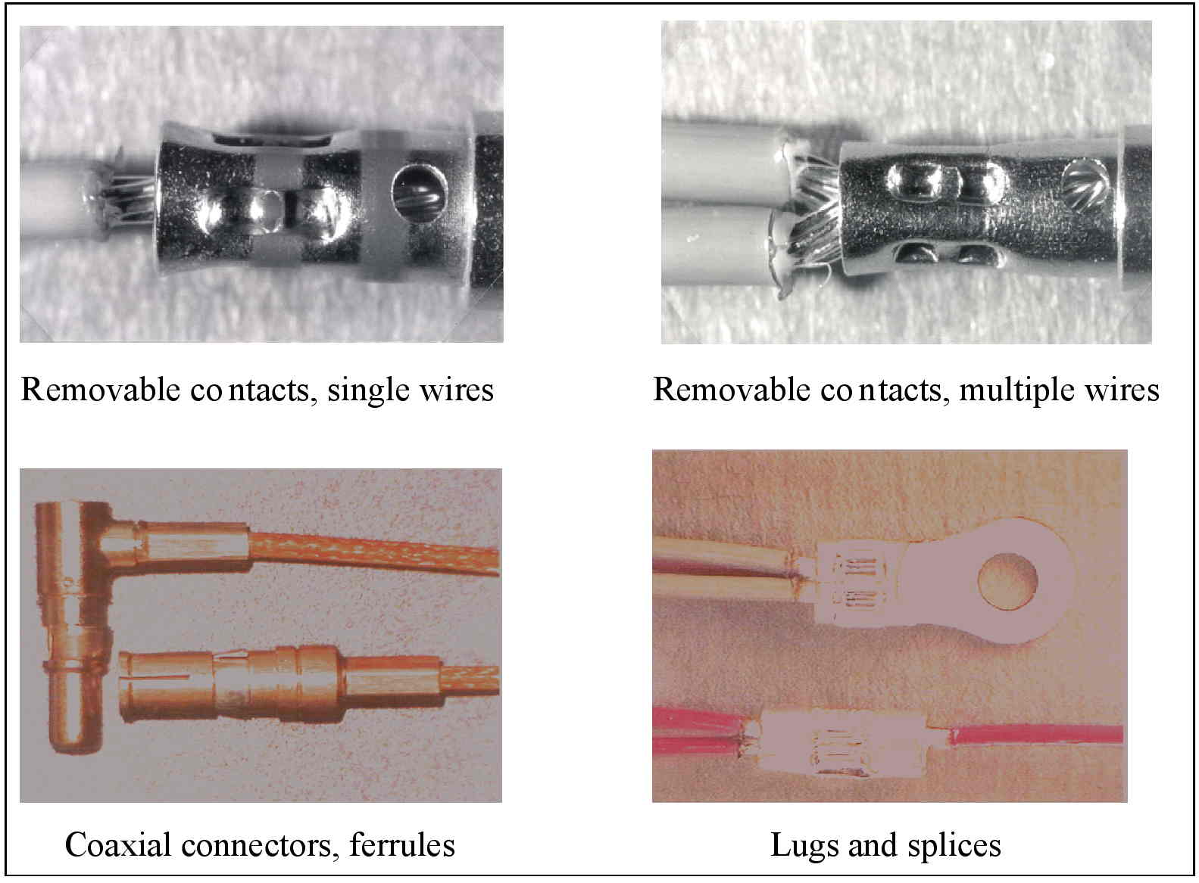
Figure 1-1: Specific interconnections in this Standard

Normative references
The following normative documents contain provisions which, through reference in this text, constitute provisions of this ECSS Standard. For dated references, subsequent amendments to, or revisions of any of these publications do not apply. However, parties to agreements based on this ECSS Standard are encouraged to investigate the possibility of applying the most recent editions of the normative documents indicated below. For undated references the latest edition of the publication referred to applies.

ECSS-S-ST-00-01 | ECSS system - Glossary of terms
ECSS-Q-ST-10-09 | Space product assurance - Nonconformance control system
ECSS-Q-ST-20 | Space product assurance - Quality assurance
ECSS-Q-ST-60 | Space product assurance - Electrical, electronic and electromechanical (EEE) components
ECSS-Q-ST-70 | Space product assurance - Materials, mechanical parts and processes
ECSS-Q-ST-70-01 | Space product assurance – Cleanliness and contamination control
ECSS-Q-ST-70-08 | Space product assurance - Manual soldering of high-reliability electrical connections
ECSS-Q-ST-70-38 | Space product assurance - High-reliability soldering for surface-mount and mixed technology
ECSS-Q-ST-70-71 | Space product assurance - Data for selection of space materials and processes
SAE-AS-22520, 24 October 2011 | Crimping tools, , wire termination, general specification for
NASA-STD-8739.4/CHG3  09/05/2006 | Crimping, Interconnection cables, harnesses and wiring
SAE-AS-7928B  10 March 2011 | Terminals, lugs, splices, conductor, crimp style, copper, general specification for
SAE-AS-81824C  11 November 2013 | Splices, electric, permanent, crimp style, copper, insulated, environment resistant
ISO 7500-1:2004 | Metallic materials - Verification of static uniaxial testing machines - Part 1: tension/compression testing machines - Verification and calibration of the force-measuring system

Terms, definitions and abbreviated terms

Terms defined in other standards
- For the purpose of this Standard, the terms and definitions from ECSS-S-ST-00-01 apply, in particular for the following terms:
  - acceptance
  - analysis
  - batch
  - component
  - conformance
  - contaminant

- For the purpose of this Standard, the terms and definitions from ECSS-Q-ST-60-05 apply, in particular for the following terms:
  - process identification document (PID)
- For the purpose of this Standard, the terms and definitions from ECSS-Q-ST-70-08 apply, in particular for the following terms:
  - electrical connection

Terms specific to the present standard
- adjustable indenter tool
crimping ratcheting tool which has an adjustable part (setting variable) that indents or compresses the conductor barrel or ferrule
- crimping tool
mechanical tool used for permanently attaching a wire termination device to a conductor by pressure deformation or by reshaping the barrel around the conductor to establish good electrical and mechanical contact
- ferrule
short metal tube used to make crimp connections to the outer conductor of shielded or coaxial cables
- intrinsic wire strength
tensile strength of a wire used into a crimped assembly, determined by a specific pull test
- lug
metallic tube with drilled flange projection for fixing to a connection point
- splice
method for joining two or more conductors to each other
- terminal
metallic device that is used to make an electrical connection

Abbreviated terms
For the purpose of this Standard, the abbreviated terms from ECSS-S-ST-00-01 and the following apply:
Abbreviation | Meaning
AWG | American wire gauge
DRD | document requirement definition
IPA | iso-propyl alcohol
KIP | kitting inspection point
MIP | mandatory inspection point
NCR | nonconformance report
PID | process identification document
QA | quality assurance
RFA | request for approval
RFW | request for waiver
RH | relative humidity

Principles

General
This Standard is structured such that the necessary level of quality is achieved, consistently maintained and high reliability of the end product assured. The following principles are covered:
- Preparatory conditions to determine the availability of facilities, tools and equipment, along with obligatory hazard and health precautions.
- Specific interconnections, as identified in the Scope above, are then covered in detail including
- Material selection, and
- Process identification and documentation.
- New crimp combinations beyond those identified in the scope above.
- Test methods and acceptance criteria for both specific and generic types of interconnections are specified.
- Quality assurance measures for both the operator and the inspector are prescribed
- Training and certification of personnel,
- Calibration of tools and equipment,
- Workmanship standards and acceptance criteria,
- Inspection criteria and sequence,

- Records from material incoming inspection through delivery of the end product, including KIP, MIP, travellers, log books, traceability samples and the handling of deviations by RFA or NCR.
It is important to perform the work taking into account health and safety regulations, and in particular the national standards on this subject.

Crimp configuration
Crimp configuration is defined as combination of:
- crimp item (lug, splice, contact, ferrule) defined by its procurement specification
- number and type of wires (material, size, finish batch if not ESA qualified wire ) defined by the procurement specification
- crimping tool based on the association of its standardized tool reference, setting and locator possible used

Requirements

Preparatory conditions

Facilities

Overview
The requirements in this clause can generally be met by using cleanrooms. It is not, however, mandatory to use a cleanroom.
Function of supplier and customer business agreement.

Facility cleanliness
          - The supplier shall provide cleaning services for production facilities where high reliability crimping is performed.
          - Production facilities where high reliability crimping is performed shall be maintained in a clean and tidy conditions.
          - Loose material that can cause contamination of the crimped connection shall be removed.
For example: Dirt, dust, oils and cut wire strands.
          - Furniture shall be kept to a minimum in the work areas and be arranged to allow easy and thorough cleaning of the floor.
          - Working surfaces shall be covered with an easily cleaned hard top or have a replaceable surface of clean, non-contaminating silicone-free paper.

Environmental conditions
          - The crimping area shall have a controlled environment, which limits entry of contamination.
          - The area shall be continuously controlled as follows:
            - room temperature: (22 ± 3) °C;
            - relative humidity: (55 ± 15) %.
          - The workstations shall not be exposed to draughts.
          - Fresh air shall be supplied to the room through a filtering system with positive pressure difference with regard to adjacent rooms.
          - The exhaust air shall be suitably restricted.

Lighting requirements
          - The supplier shall ensure adequate illumination conditions of the crimp workstations.
          - The light intensity shall be 1 080 lux on the work surface.
          - 90 % of the work area shall be shadow-less and without severe reflections.

Tools and equipment

Crimping tools
          - The supplier shall provide the tooling necessary for continued high quality crimping.
          - Tools used shall employ an integral ratcheting mechanism, which controls the crimping operation in conformance to SAE-AS-22520.
The mechanism ensures that, once the operation is started, the tool cannot be opened until the crimping cycle is complete.
          - Tools shall be marked to show the size and type of termination for which it is calibrated.
          - Tool calibration shall be verified in conformance with the clause 5.5.5 requirements.
          - Proper operation of the integral ratcheting mechanism or the positive stops on pneumatic tools shall be verified as defined in clause 5.5.6.
          - Before starting a crimping process on a new terminal size and wire type, the tool used for crimping of the previous wire type shall be returned to the tool store.
          - If the tool settings seals are broken, the tool shall be removed from the work place and returned immediately for recalibration.
          - Tools used in the crimping operation shall be clean; excess lubricants shall be removed before crimping starts.
          - Tools shall be individually labelled.
This identification is recorded in the manufacturing connector follow up sheet.

Insulation strippers
          - The supplier shall provide the tooling necessary to avoid damage to the conductor.
          - The selection of thermal or precision cutting devices, manual or automatic power-driven, shall ensure integrity of the conductor strands.
          - Wire stretching by use of mechanical strippers shall be avoided.
          - The conductor shall not be twisted, ringed, nicked, cut or scored by stripping operation.
          - Both thermal and mechanical stripping tools shall be calibrated periodically on sample evaluation during a production run.
          - Exposure of underlying material shall be a cause for rejection.

Cutters and pliers
          - The supplier shall provide the tooling necessary for precision wire trimming and cutting.
          - The cutter used for trimming conductor wire shall shear sharply and consistently to produce a clean, flat, smooth-cut surface along the entire cut edge.
          - Twisting action during cutting operation shall be avoided.
          - <<deleted>>
          - The cutting edges of pliers shall be regularly checked for damage and maintained in a sharp condition.

Test and monitoring equipment
          - The supplier shall provide the equipment specified in Table 5-1 necessary for verification activities specified in clausd 5.4.3.
Table 5-1: Equipment for verification process
Performance tests activity | Equipment characteristic
<<deleted>> | <<deleted>>
Tensile strength (in conformance with clause 5.4.3 requirements) | Tensile testing machine conforming to ISO 7500 class 1 or better. Axial load applied at a rate of (25 – 50) mm/min ±2 mm/min
Visual inspection | Magnification ×7 to ×40
Monitoring requirements of the process
Temperature | 15 °C to 30 °C, accurate to ±1 °C
Relative humidity (RH) | 40 % to 70 %, accurate to ±1 %

Crimping operations for specific interconnections

General
          - The supplier shall visually examine wires, terminals and connector contacts for cleanliness, absence of oil films and freedom from tarnish or corrosion before assembly.
          - The supplier shall perform cleaning of the work pieces using IPA.
          - Further cleaning or other treatment shall not be carried out.
          - The supplier shall handle work pieces with clean lint free gloves or finger cots.
          - Before a crimping activity, tools at the operator’s station shall be verified to conform to those selected in accordance with the applicable PID or processes.
          - All conductor strands shall be inserted cleanly into the barrel without any buckling.
          - Strands shall not be left outside or cut back to reduce the conductor diameter to fit an undersized barrel.
          - The supplier shall use tools specific to the crimping contacts configuration SAE-AS-22520 tool type .
Examples of crimping parameters are given in A.2.1.1.Table A-1 to A.2.1.1.Table A-6
          - The supplier shall take provisions to avoid degradation of the silver plated wire caused by tarnish during storage.
          - <<deleted>>.
<<deleted>>.
          - The crimping of single solid strand wires shall not be used.

Material selection
          - The supplier shall use silver plated copper multi stranded wire and braided shield cable in crimp type connectors.
          - In cases where other types of wire and wire finishes are used a request for approval (RFA) in conformance with DRD from Annex D from ECSS-Q-ST-70 shall be provided to the customer for approval
Examples of wire and wire finishes include nickel- or tin-plated wires, stainless steel, phosphor bronze, copper, constantan, and nickel alloys.
          - The supplier shall use high strength copper alloy wire for 24 AWG, 26 AWG and 28 AWG crimped joints.
Soft or annealed copper wire are not acceptable for crimped joints of 24 AWG, 26 AWG and 28 AWG size.
          - The supplier shall use space-qualified components having gold plated finishes in conformance with ECSS-Q-ST-60.
          - Specific items such as ferrules, splices contacts and lugs shall be purchased to SAE-AS-7928 specification.
          - When gold plating is not available the finish shall be in conformance with ECSS-Q-ST-70-71.
Ferrules, splice contacts and lugs supporting an external nickel layer can be used in case there is no alternative finish, although tool wear is accelerated.
          - Cadmium, chromate-coated cadmium and non-fused tin-plating shall not be used.

Process review and documentation
          - The supplier shall perform a review of all the materials, tools and techniques planned to be used to ensure conformance to requirements of this standard and as a means of identifying potential problems.
Type of wire includes material, number of strands, plating metal, type and thickness of insulation.
          - Dies, setting of controls for the length of strip in automatic stripping machines and the selection of specific locators or positioners for crimping tools, shall be selected to meet process requirements.
The requirement is valid for power driven and manual crimping processes as well as for size and tolerance for crimping tools.
          - The results of the review shall be documented in a specific internal procedure.

Contact barrel and single wire crimping
          - The supplier shall give preference to the selection of single stranded wire interconnections.
          - The supplier shall not use strands of wire doubled back or false wires to increase the conductor diameter.
          - The supplier shall use a specific contact to be compatible with the cross-sectional area of the wire.
Examples of a specific contact include reduced, normal or enlarged barrel.
          - For 28 AWG up to 16 AWG wire sizes, the insulation clearance shall be maintained between 0,3 mm and 1,0 mm.
          - The insulation clearance for larger size wires than 16 AWG shall not exceed 2 mm.
No minimum insulation clearance is specified except that the conductor wire is visible to permit inspection.
          - On D-sub contacts, a transparent shrink fit insulation sleeve shall be applied over the rear of the contact and the wire insulation both to cover the insulation clearance and to prevent any risk of a short circuit.
Examples of crimping parameters are given in Table A-1. An example of a typical contact barrel and an example of single wire crimping is shown in Figure 5-2.
          - The use of potting, to ensure insulation at the rear of connectors with removable contacts, shall not be used except when authorized by the customer through RFA..

- 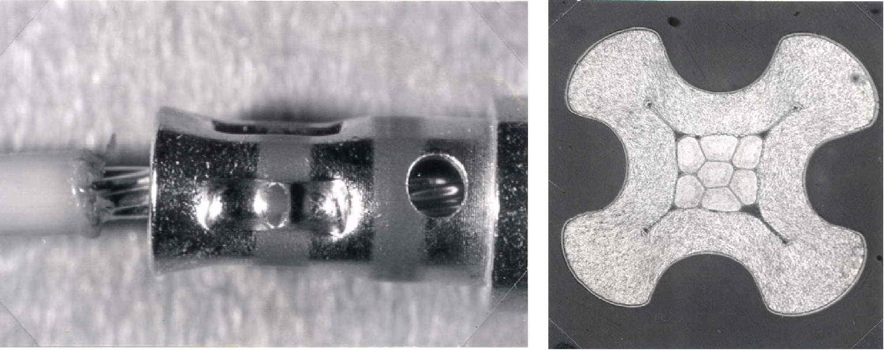
Figure 5-2: Example of a typical connector barrel and single wire crimping

Contact barrel and multiple wire crimping
          - Requirements of this clause shall be applied when single stranded wire crimping cannot be used.
          - The maximum number of functional wires in one crimp barrel shall be two without the addition of false wires to increase the conductor section.
          - The sum of the two nominal conductor sections shall be compatible with the crimp barrel used
2 × 24 AWG is approximately equal to 1 × 20 AWG.
          - Both conductors shall be of the same material and support the same plating finish.
1 For example: Both are silver and not a combination of silver and nickel
2 Before introduction into the barrel strands can be inserted straight into the barrel or twisted together to obtain a “single” conductor.
          - Axial strength measurements shall be performed in compliance with requirements in clause 5.4.3.2.
Examples of crimping parameters are given in A.2.1.1.Table A-2 and an example of a typical contact barrel and multi-wire crimping is shown in Figure 5-3.
          - For separate conductors introduced straight into the barrel the following shall apply:
            - the actual strength measurement is performed on one of the wires (the smaller, if two different sizes are used);
            - the axial strength requirement is as quoted in Table 5-5 for the actual size of wire pulled, assuming a barrel size equal to that wire’s gauge.
Examples of crimping parameters are given in Table A-1 and an example of a typical connector barrel and multi-wire crimping is shown in Figure 5-3.
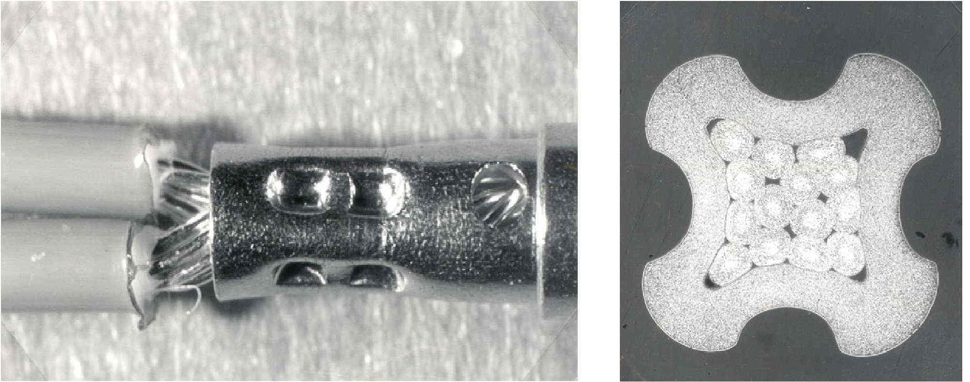
Figure 5-3: Example of a typical connector barrel and multi-wire crimping

Ferrule shield crimping
          - The shielding wires on coaxial cables shall be braided.
          - Axial strength measurements shall be performed in compliance with requirements from clause 5.4.3.3.
          - <<deleted, moved to 1.1.1www>>
<<deleted>>.
          - Only one braided shield shall be crimped in one ferrule connection.
          - The braid end shall only be located at the ferrule crimp level in order to prevent any risk of short circuit between central pin and braid strands.
          - Following crimping, the assembly shall be protected by shrink tubing.
Examples of crimping parameters are given in A.2.1.1.Table A-6 and an example of a typical ferrule shield crimping is shown in Figure 5-4.
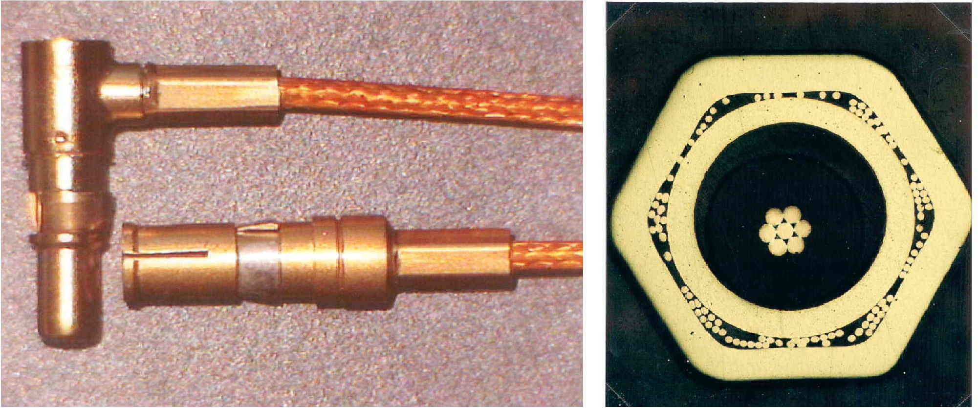

Figure 5-4: Example of a typical ferrule shield crimping

Lug and splice wire crimping
          - Only tools specified by the manufacturer of the terminals shall be used.
          - The maximum number of wires shall be ten on the same assembly.
          - Seven wires maximum shall be on the same side.
          - All conductors shall be of the same material and within a size range of 4 wire gauges on the same side.
          - In case the number of conductors on the same side is more than two all conductors shall be positioned parallel in the terminal barrel before crimping.
          - Axial strength measurements shall be performed in compliance with requirements from clause 5.4.3.3.

          - <<deleted>>
<<deleted>>
          - Following crimping, the assembly shall be protected by shrink tubing.
Examples of typical lug and splice wire crimpings are shown in Figure 5-5.
          - In case the number of conductors on the same side is limited to two then the conductors may be twisted together to form a single conductor.
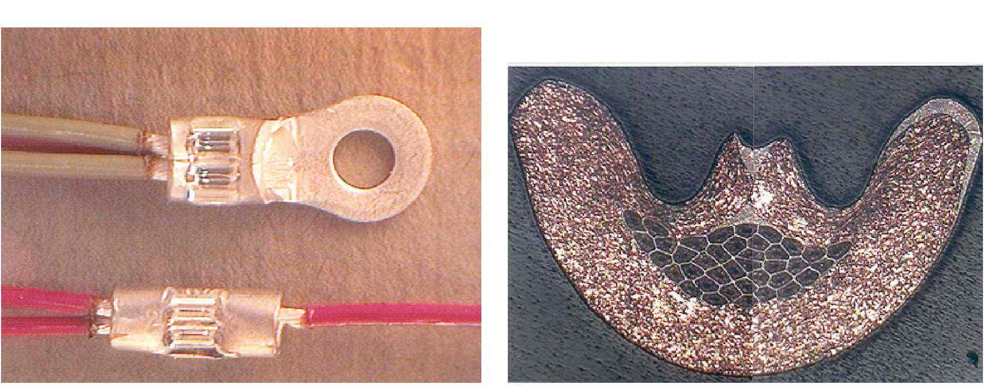
Figure 5-5: Examples of typical lug and splice wire crimping

Requirements for crimp configuration qualification

General
          - All crimp configurations shall be qualified in compliance with requirements from clause 5.3.2.
          - The supplier shall document the data of successful process qualification in the a specific internal procedure to ensure continued high quality of production performance.
          - <<deleted>>
          - Any change to an element of the qualified crimp configuration specified in requirement 1.1.1gggg shall be qualified.

Qualification process test procedure
          - The supplier shall perform tensile strength tests on samples prepared at a number of tool settings, in conformance with the requirements specified in clause 5.4 and in conformance with the following processError: Reference source not found:
            - Ten samples prepared at the point specified by the crimping tool manufacturer as a starting point for calibrating tools in conformance with A.2.1.1.Table A-1 to A.2.1.1.Table A-6.
            - The tool indenter opening is then adjusted in convenient increments above and below this point, and ten samples pulled at each increment.
            - <<deleted>
            - A plot is made with increments being close enough together to obtain a smooth curve.
            - The maximum in tensile strength is then determined and evaluated as per Table 5-3 and Table 5-5.
            - The optimum tool setting lies approximately in the middle of the flat top portion of the tensile-strength plotFigure 5-7.
          - The supplier shall validate satisfactory results achieved from the final tool setting at the operating point on a minimum of ten samples in conformance with the methods defined in clause 5.4 and according to the following process:
            - Tensile strength tests are performed on five samples corresponding to the operating point.
            - <<deleted>>
            - Metallographic tests are performed on a minimum of three samples corresponding to the operating point.
            - Not tested samples are retained for reference.
<<deleted>>

          - Test data shall be recorded in a qualification report.
          - The qualification report shall include the results of the search for the optimum tool setting specified in requirement 1.1.1kkkk.
Figure 5-6 presents a flow chart of the Qualification process test procedure of clause 5.3.2.
Figure 5-6: Qualification process test procedure flow chart

Sealing and marking
          - The supplier shall seal and mark calibrated tools in conformance with clause 5.5.6.3 requirements.

Batch to batch variation

Wires qualified by ESCC
          - For wires qualified by ESCC the qualified tool set-up may be used without additional validation when different batches of wires are used..

Wires not qualified by ESCC
          - For wires not qualified by ESCC the qualified optimum set-up shall be confirmed for each new batch of wire in conformance with the following qualification process:
            - Tensile strength tests are performed on five samples corresponding to the operating point,
            - A further five samples are produced at tool settings above and below the operating point and tensile tested.
          - The average result at the operating point shall be higher or equal to the result obtained in 1.1.1.12,
          - In case the average result at the operating point is lower than the result obtained in 1.1.1.12 the qualification process specified in the requirements from clause 5.3.2 shall be repeated.

Figure 5-7: <<deleted>>

Test methods

General
          - The supplier shall submit samples to the tests specified in clauses 5.4.3 and 5.4.4 .
The number of samples is dependent on the specific process requirement (in conformance with clauses 5.3.2 ,5.3.4, 5.5.5 and 5.5.6.2 requirements).
          - Test samples shall meet the requirements of clause 5.5.4.1.
          - Records of all results shall be tabulated in conformance with 5.5.7.

<<deleted>>
          - <<deleted>>.
          - <<deleted>>
          - <<deleted>>.

Figure 5-8: <<deleted>>
Table 5-3: <<deleted>>

Tensile strength

General
          - The supplier shall use a tensile testing device with characteristics in conformance with Table 5-1.
          - The connections shall be loaded until failure occurs.
          - The value at failure shall be recorded, together with the information as to whether the failure was “pull-out”, “broke in crimp” or “break in wire”.
          - The required ultimate axial strengths for compacted and dispersive crimped joints shall be as shown in Table 5-5Table 5-5 and in clauses 5.4.3.2 and 5.4.3.3.
          - The clamping of the free bare ends of wire or metallic braided shield directly in the clamping fixtures of the tensile machine shall not be used.
1 The insulation can be stripped approximately 2 cm on test specimens to promote visual inspection of the mode of failure in the tensile test.
2 <<deleted>>.
3 A typical test fixture for testing ferrule lug splice and contact crimps is shown in Figure A-1.

Contact barrel wire crimping
          - The required axial strength of the crimped assembly shall be 75 % of the intrinsic wire strength as determined in clause 5.4.3.2.
Examples of typical values of intrinsic wire strength of ESCC qualified wires and the 75% requirement are detailed in Table 5-5.
          - <<deleted>>Table 5-5.
          - In case of two crimped wires, axial strength measurements shall be performed on one of the two inserted wires and the axial strength be 75 % of the intrinsic strength of the wire tested.
          - If two different wire gauges are used then the test specified in 1.1.1ggggg shall be performed on the smaller of the two.
          - Only one tensile test per sample shall be performed.

Ferrule
          - The required axial strength of the crimped assembly shall be 75 % of the intrinsic wire or braid strength as specified in clause 5.4.3.5.

            - Axial strength measurements shall be performed only on the shield after removal of the core dielectric.

Lug and splice
          - The required axial strength of the crimped assembly shall be 75 % of the intrinsic wire or braid strength as specified in clause 5.4.3.5.
          - In the case of several equal wire sizes crimped into the same barrel axial strength measurements shall be performed on only one wire per sample.
          - In the case of different wire sizes crimped into the same barrel axial strength measurements shall be performed on only one wire per sample from the smallest gauge
          - In the case where opposed wires are tested a specifically designed test fixture shall be used.
A typical test fixture is shown in A.3.1Figure A-1
          - Only one tensile test per sample shall be performed.

Characterisation of intrinsic wire strength
          - Intrinsic strength of wire or metallic braided shields shall be determined as follows:
            - a minimum of ten samples of 200 mm length from the wire batch to be used for the crimped assembly are prepared for testing by first stripping the insulation from both ends of the wire,
            - for metallic braided shield axial strength measurements are performed only on the shield after removal of the core dielectric,
            - to avoid wire or metallic braided shield strands damage in the clamping area, suitable end tabs, such as soldered splice are used,
            - the samples are tested to failure at a rate of (20 – 50) mm/min,
            - the maximum load achieved is recorded,
            - in case of failure in the clamps the result is discarded,
            - intrinsic wire strength is calculated by averaging a minimum of ten valid tests.

Table 5-5: Typical ultimate axial strength for compactive and dispersive crimped joints manufactured using qualified ESCC wires
AWG | Number and size of braids (∅ in mm) |  |  | Conductor section in mm² | Minimum tensile resistance for crimps with the following composition
AWG | Kapton | Tefzel | Teflon/Kapton | Conductor section in mm² | Silver-plated pure copper | Silver-plated copper alloy
AWG | 3901/001-002 | 3901/012 | 3901/019 | Conductor section in mm² | Silver-plated pure copper | Silver-plated copper alloy
28 | 19 x 0,08 | 7 x 0,12 | 7 x 0,127 | 0,095 | - | 35 N
26 | 19 x 0,10 | 19 x 0,10 | 19 x 0,10 | 0,15 | - | 45 N
24 | 19 x 0,12 | 19 x 0,12 | 19 x 0,12 | 0,22 | - | 60 N
22 | 19 x 0,16 | 19 x 0,15 | 19 x 0,15 | 0,38 | 65 N | -
20 | 19 x 0,20 | 19 x 0,20 | 19 x 0,20 | 0,6 | 110 N | -
18 | 19 x 0,25 | 19 x 0,25 | - | 0,93 | 170 N | -
16 | 19 x 0,30 | 19 x 0,30 | 19 x 0,30 | 1,34 | 250 N | -
14 | 27 x 0,30 | 37 x 0,25 | - | 1,91 | 330 N | -
12 | 45 x 0,30 | 37 x 0,32 | 37 x 0,32 | 3,18 | 550 N | -
10 | - | - | - | 5,30 | 850 N | -
8 | - | - | - | 8,98 | 1500 N | -
6 | - | - | - | 13,4 | 2300 N | -
4 | - | - | - | 21,8 | 3750 N | -
2 | - | - | - | 33,5 | - | -
1 | - | - | - | 41,8 | - | -
0 | - | - | - | 53 | - | -

Metallography
          - The supplier shall employ a certified laboratory to perform the metallographic tests described below.
          - The customer shall approve the certification status of the laboratory.
          - The joint to be sectioned shall be mounted in a low exotherm resin capable of being moulded without the application of external pressure.
          - The joint shall be oriented that the wire is perpendicular to the polishing surface.
          - The specimen shall be ground with the aid of appropriate grades of silicon carbide papers, in order to expose the mid-section of the joint.
          - This section shall then be polished with successively finer grades of diamond paste down to 1 µm.
          - To aid microscopic examination, the polished section shall be very lightly etched with an accepted chemical reagent specific to the composition of the materials being crimped.
          - The section shall be examined in both as-polished and etched states using a metallographic microscope at a magnification up to ×400.
          - The following acceptance criteria shall be met:
            - Each micro section is free from contamination;
            - The crimp barrel is evenly deformed;
            - Voids occupy less than 10 % of the cross sectioned area of the wire volume;
            - The wires and barrel appear as a gas-tight joint and conform to the workmanship sample prepared during qualification;
            - All wires are deformed from their circular cross section;
            - There are no indentations or fracturing of the deformed receptacle barrel or its plated finish.
For ferrule shield crimping the requirements of 1.1.1.13. and 5. are not applicable.
2 <<deleted>>.

Quality assurance

General
          - The supplier shall install a Quality Assurance (QA) function in conformance with the requirements as defined in ECSS-Q-ST-20.
          - The quality control process shall be as specified in Figure 5-9.

Personnel training and certification

Training program
          - The supplier shall employ trained and qualified personnel for all stripping and crimping operations implementing and maintaining a skill matrix.
          - The supplier shall develop, maintain and implement a training programme, in conformance with ECSS-Q-ST-20.
The aim of the training programme is to provide for excellence of workmanship and personnel skills, careful and safe operations, and improvement of the quality of crimped joints.

Certification
          - Trained personnel, performing crimping operations, shall be certified according to a customer approved process
          - The certification of personnel shall be based upon objective evidence of crimp quality, resulting from test and inspection of the crimped joints.
          - Operators or inspectors shall be re-certified in cases of repeatedly unacceptable quality levels and changes in crimping techniques, parameters or required skills.
          - The supplier shall perform training and certification at a school authorized by the customer.
          - Certification shall be valid for a period of two years.

Documentation
          - The supplier shall maintain records of the training and certification status of crimping operators and inspection personnel.
Personnel trained and certified
(in conformance with clause 5.5.2)
Control of compatibility of parts, crimping and stripping tools
(in conformance with clauses 5.1.2.1 and 5.1.2.2)
Crimp configuration qualified
(in conformance with clause 5.3.1
Crimping tool calibrated using go/no-go gauges and sample crimps
(in conformance with subclause 5.5.6.2
Definition of tool setting parameters
(in conformance with clauses 5.5.6.2b)
Pre-crimp inspection of wire and barrels
(in conformance with clause 5.5.4.1)
Remove stripping tool from the area and repair/recalibrate or reject as necessary
nonconformance
Performance inspection and test of crimping operations
(in conformance with subclause 5.5.5)
All production crimps performed with the crimp tool concerned since its last acceptable sampling shall be rejected
nonconformance
Crimping operation
Post-crimp inspection
(in conformance with clause 5.5.4.2
REJECT
ACCEPT
nonconformance

Figure 5-9: Quality control during crimping operation

Workmanship
          - The supplier shall prepare standards consisting of satisfactory work samples (in conformance with the Figure 5-10 and Figure 5-11)
          - The supplier shall have readily available visual aids, which clearly illustrate the quality characteristics of all crimped connections utilized.
          - Defects such as those listed in clause 5.5.4.2 and shown in Figure 5-10 shall be included as examples.
          - The operator shall discard production crimps which are defective.
          - Defective test samples shall not be discarded.
Figure 5-10: Visible workmanship standards
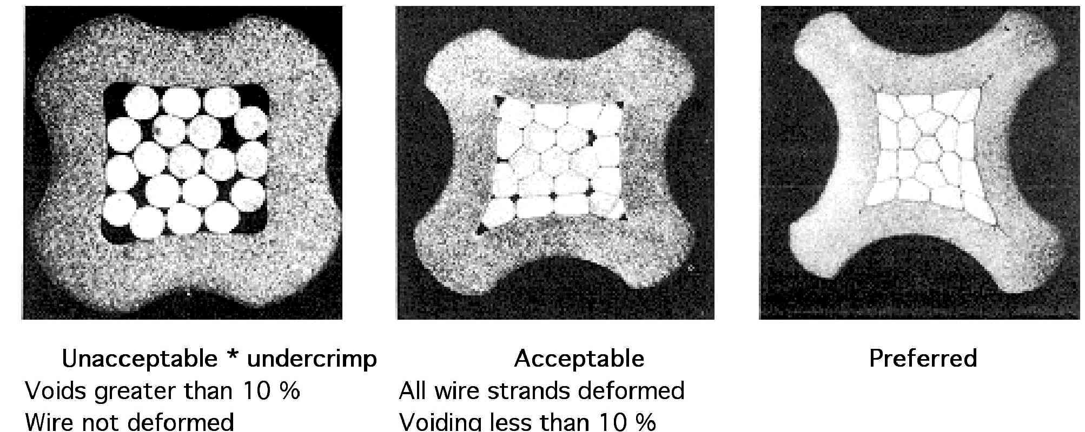
Figure 5-11: Workmanship examples and crimp micro-sections

Visual inspection

Pre-crimp inspection (performed by the operator)
          - The wire shall be examined for no evidence of nicks, rings, broken strands, untwisted lay or not-removed insulation in the area of the crimp before the stripped wire is inserted into the crimped item barrel.
          - Damaged wires where the base material is exposed shall not be used.
          - Contacts and terminal barrels that show evidence of the presence of tarnish, corrosion or physical damage, including bent contacts, shall not be used.
          - Inspection shall check that the combination of wire size and type and crimp item are in accordance with the drawing or control document.

Post-crimp inspection (performed by quality assurance)
          - The QA inspector shall carry out inspection with the use of a binocular microscope having a minimum linear magnification of ×7.
Further examination of surface characteristics can be performed at higher magnifications.
          - The inspector shall not physically disturb parts and conductor leads to help inspection.
          - The following acceptance criteria shall be met;
            - Wire insulation is not damaged by the crimping operation;
            - The conductor is visible in the inspection hole when an inspection hole is provided; in the case of lugs and splices the free end of the conductor is visible at the exit point;
            - The crimp barrel has no unintentional sharp edges, peeled metal, burrs, cracked platings or cuts after crimping;
            - All functional parts, including all retention clips or locking devices, are operational after the crimp has been made;
            - No tarnished or corroded crimped item are present;
            - No misplaced crimps, as determined by marks found on areas not designed to take crimping, are present
            - No undercrimps or overcrimps are present;
<<deleted>>
            - The detection of an under crimp or over crimp shall cause the stop of manufacturing as follows:
              - operations at that work place ,
              - rejection of all production crimps made since the last verification or pull test,
              - investigation of tools, wire and crimp item to determine the cause of failure.
            - No bent contacts are present.
            - Wire strands are not damaged as a result of the crimping operation.
            - The insulation clearance complies with the requirements 1.1.1ggg and 1.1.1hhh.
          - Failure to meet the acceptance criteria of 1.1.1uuuuuu shall be cause for rejection.

General
          - 100 % visual inspection shall be performed by Quality Assurance.
          - Pre-crimp inspection may be performed by an operator who has successfully followed and passed an internal training scheme which has been implemented by QA as specified in 5.5.2.

Shift performance inspection and test for harness manufacturing
          - <<deleted>>
          - <<deleted>>.
          - <<deleted>>
          - <<deleted>>
          - <<deleted>>.
          - <<deleted>>
          - <<deleted>>.
<<deleted>>
          - <<deleted>>
          - <<deleted>>
          - <<deleted>>.
          - Prior to the start of a new harness manufacturing the following shall be done:
            - the tool settings are determined for all crimp combinations, wire and contact, that are planned to be used during the project,
            - crimping tools are dedicated to one crimping combination, wire and contact, and have individual identification,
            - crimping tools are validated at start of manufacture and traceability noted in its correspondent log book,
            - crimp configuration settings are locked on each contact crimping tool.
Ideally, crimping tools are dedicated to one project.
          - At the start of harness manufacturing the following shall be done:
            - four samples of each of the different configurations are produced at the optimum setting,
            - three samples are pull tested,
            - the fourth sample is retained as control,
            - all results are recorded in the dedicated tool log book.
          - Intermediate tool inspections of a harness manufacturing shall be done as follows:
            - at the start of each new shift cleanliness control of the active part of the tool and “go / no-go” checks are performed,
            - for manufacturing runs of less than 500 crimps per week the revalidation of the tools is performed each 500 crimp operations or 2 months, whichever is earlier,
            - the results are recorded in the dedicated tool log book in accordance with 1.1.1sssssss.
          - For manufacturing runs of more than 500 crimps per week the following shall be done:
            - cleanliness control of the active part of the tool and “go/ no-go” checks are performed,
            - tensile test on not less than four samples each 500 crimp operations are performed,
            - revalidation of the tools is performed each 1500 crimp operations or 2 months, whichever is earlier,
            - the results are recorded in the dedicated tool log book in accordance with 1.1.1sssssss.
          - At the end of the harness manufacturing the following shall be done:
            - four samples of each of each of the different configurations are produced at the optimum setting,
            - three samples are pull tested,
            - the fourth sample is retained as control,
            - all results are recorded in the dedicated tool log book.

Calibration of crimping tools

General
          - The QA organization of the supplier shall ensure that each crimping tool and measuring equipment is calibrated as indicated in the subsequent sub clauses.
          - The QA organization of the supplier shall record any suspected and actual equipment failure as a project nonconformance report
Based on past nonconformance reports previous results can be examined to ascertain whether or not re-inspection or retesting is required.
          - The QA organization of the supplier shall notify the customer of the nonconformance details.
          - The supplier’s calibration procedure shall include the requirements specified in this clause for tool calibration.

Validation
          - The QA organization of the supplier shall ensure that crimping tools, both manual and powered, are calibrated when initially set up for each specific wire size, connection size and type prior to first use.
          - Calibration shall be verified in conformance with the following check-list:
            - cleanliness control of the active part of the tool (e.g. indenters);
            - set up with the aid of the “go/no-go” gauge in conformance with specified conditions;
            - tests in conformance with the clause 5.4 requirements on not less than four samples.
          - After satisfactory verification of calibration the tool status shall be documented in a “tool calibration sheet” to ensure tool traceability.
          - This traceability shall be established by periodic analysis of the corresponding data from the performance inspection and tests (in conformance with clause 5.5.5 requirements),
<<deleted>>
          - A significant drift in test results shall result in tool rejection.
Such a tool is generally labelled "out-of-calibration tool" (in conformance with clause 5.5.6.4 requirements).

Sealing and marking
          - The supplier shall provide sealing for calibrated crimping tools to ensure against unauthorized alteration of adjustment settings.
          - A wire and lead seal method shall be used if the tool has provisions for it;
          - In case requirement 1.1.1xxxxxxx cannot be implemented, the tool shall be sealed by a non-reusable decal seal, which, if the calibrated setting is altered, is visibly damaged.
          - Seals shall be placed on all external adjustment points of the tool.

Out-of-calibration tools
          - Tools that are out of calibration shall be returned to the tool facility for readjustment and calibration.
          - Tools that are worn or damaged shall be identified as rejected and removed from the fabrication area.

Records
          - The supplier shall maintain traceability throughout the process from incoming inspection to final test, including details of test equipment, tools and personnel employed in performing the task.
          - Quality records and logbooks shall be retained for at least ten years
          - Quality records and logbooks shall contain the following information:
            - the as-built and test configuration list (waiver and deviation summary);
            - nonconformance reports and corrective actions;
            - copy of the visual inspection and performance test results with reference to the relevant procedure, personnel and tools used;
            - records of the training, testing and certification status of crimping operators in conformance with clause 5.5.3 requirements.

Nonconformance
          - The QA organization of the supplier shall disposition any nonconformance which is observed in respect of the process in conformance with the quality assurance requirements, in conformance with ECSS-Q-ST-10-09.
          - Failure of a crimping tool to pass any requirement specified in clause 5.1.2.1 shall require rejection of all crimps made by that tool since it was last tested successfully for acceptance.

Spacecraft crimping modification and repair integration
          - Crimping tools shall be dedicated to one operator.
          - Crimping tools shall have individual identification.
          - Crimping tools shall be validated every 12 months.
          - Results of validation specified in the requirement 1.1.1jjjjjjjj shall be recorded in its dedicated log book.
          - The supplier should keep a logbook for each tool.
          - The logbook shall show the quantity of parts crimped since each calibration and since each “go/no-go” operation.
          - In case the supplier does not maintain a log book for each crimping tool the following shall be performed by each operator:
            - prepare four samples at the beginning of a shift or before a series of crimping operations of which:
              - three samples are submitted to the tensile strength test as specified in the requirements from the clause 5.4.3, and
              - the fourth sample is retained for reference and traceability purposes in conformance with requirements from clause 5.5.6.2.
            - at the end of the operation four samples are crimped of which:
              - three samples are submitted to the tensile strength test as specified in the requirements from the clause 5.4.3, and
              - the fourth sample is retained for reference and traceability purposes in conformance with requirements from clause 5.5.6.2.
          - A crimping tool shall be changed whenever a wire size or contact size is changed.
          - After a change of a crimping tool, as specified in the requirement 1.1.1oooooooo, the operator shall, unless the tool has a current validation, prepare four samples at the start of the operation, of which:

            - three samples are submitted to the tensile strength test as specified in the requirements from the clause 5.4.3, and
            - the fourth sample is retained for reference and traceability purposes in conformance with requirements from clause 5.5.6.2.
          - The supplier shall perform an analysis of shift performance test results, in comparison with initial tool calibration results, to determine any drift in tool performance.

Document requirements
          - The supplier shall produce documentation for:
            - Process identification, in a PID or a specific internal procedure and RFA,
            - Inspection,
            - Traceability,
            - Testing, both procedures and records,
            - Logbooks, and
            - Calibration.
          - The format of the documents shall be in accordance with the deliverables item list defined in the business agreement.
No specific DRD requirements emerge from this Standard.
- (informative)
Crimp configurations and tools
  - Overview of crimp configurations
Many crimp interconnection technologies are currently available for space applications. Confined or compactive crimps are made by a tool, which exerts an even pressure around the receptacle barrel circumference such that even deformation is applied on all sides; the only means of stress relief is by elongation of the barrel and wire (in conformance with A.2.1.1.Table A-1 to A.2.1.1.Table A-6).
Non-confined or dispersive crimps result from compression of the receptacle barrel with an indenter die having one or two indents or, alternatively, by two or four radially opposed indenter dies (in conformance with Figure A-4 and Figure A-5).
The achievement of an acceptable crimped joint is controlled by the tools and materials used, but workmanship - the manner in which they are employed - is also important. Items that constitute workmanship are those under the control of the operator. They include careful butting of the wire against the stop in the stripping operation to ensure correct insulation gap, loading of a connector pin in the positioner to the full distance, inserting the stripped wire into the connector pin barrel or terminal until it shows in the inspection hole or through the contact in the case of crimp lugs and re-twisting the strands not more than the natural lay, if disturbed during the stripping operation.
              - : Confined irregular-octagon crimp (compactive)
              - : Dimpled confined octagon crimp (compactive)
              - : Regular-hexagon crimp (compactive)
              - : Semicircular one- or two-indent crimp (dispersive)
              - : Four-indent crimp (dispersive)
  - Typical settings of crimping tools
For the type of crimping covered in this Standard typical tool selector settings are applicable. Those are, however, only indicative and require effective calibration or validation before use for production of high-reliability crimps, in conformance with clause 5.5.6
Tables for the different types of crimp configuration are shown below. They include reference to the tooling and selector settings by wire and barrel sizes.
For the specific case of lug and splice configurations where opposed wires are tested (in conformance with clause requirements) a typical test fixture is shown in A.3.1Figure A-1.
                - : Guideline for selector setting - Four-indent crimp (dispersive) - Single wire
Connector | Wire gauge (AWG) | Wire barrel contact size | Crimping tool / Selector setting
Connector | Wire gauge (AWG) | Wire barrel contact size | M22520/2-01 | M22520/1/01 | M300-BT
D * SUB | 8 | 8 - 8 | - | - | 6
D * SUB | 10 | 8 - 10 | - | - | 5
D * SUB | 12 | 8 - 14/12 | - | - | 2
D * SUB | 16 | 20 - 18 | 7 | -
D * SUB | 18 | 20 - 18 | 6 | - | -
D * SUB |  |  |  | - | -
D * SUB | 20 | 20 - 20 | 7 | - | -
D * SUB | 22 | 20 - 20 | 6 | - | -
D * SUB | 24 | 20 - 20 | 5 | - | -
D * SUB | 26 | 20 - 26 | 6 | - | -
D * SUB | 28 | 20 - 26 | 6 | - | -
D * SUB | 22 | 22 - 22 | 4 | - | -
D * SUB | 24 | 22 - 22 | 3 | - | -
D * SUB | 26 | 22 – 22 | 2 | - | -
D * SUB | 28 | 22 – 22 | 1 | - | -
MIL-C 38999 | 12 | 12 - 12 | - | 8 | -
MIL-C 38999 | 14 | 12 - 12 | - | - | -
MIL-C 38999 | 16 | 12 - 12 | - | 7 | -
MIL-C 38999 | 16 | 16 - 16 | - | 6 | -
MIL-C 38999 | 18 | 16 - 16 | - | 5 | -
MIL-C 38999 | 20 | 16 - 16 | - | 4 | -
MIL-C 38999 | 20 | 20 - 20 | 7 | 3 | -
MIL-C 38999 | 22 | 20 - 20 | 6 | 2 | -
MIL-C 38999 | 24 | 20 - 20 | 5 | 1 | -
MIL-C 38999 | 22 | 22 - 22 | 4 | - | -
MIL-C 38999 | 24 | 22 - 22 | 3 | - | -
MIL-C 38999 | 26 | 22 - 22 | 2 | - | -
MIL-C 38999 | 28 | 22 - 22 | 1 | - | -
DBAS | 12 | 12 - 12 | - | 8 | -
DBAS | 14 | 12 - 12 | - | 7 | -
DBAS | 16 | 16 - 16 | - | 6 | -
DBAS | 18 | 16 - 16 | - | 5 | -
DBAS | 20 | 16 - 16 |  | 4 | -
DBAS | 20 | 20 - 20 | 7 | - | -
DBAS | 22 | 20 - 20 | 6 | - | -
DBAS | 24 | 20 - 20 | 5 | - | -
DBAS | 26 | 20 - 26 | 6 | - | -
DBAS | 28 | 20 - 26 | 5 | - | -
HE801 | 22 | 22 - 22 | 5
HE801 | 24 | 22 - 22 | 4
HE801 | 26 | 22 - 22 | 4
                - : Guideline for selector setting - Four-indent crimp (dispersive) - Two wires
Connector | Wire gauge (AWG) | Wire barrel contact size | Crimping tool / Selector setting
Connector | Wire gauge (AWG) | Wire barrel contact size | M22520/2-01 | M22520/1/01 | M300-BT
D*SUB
D*SUB | 12 + 12 | 8 - 8 | - | - | 6
D*SUB | - | 8 - 10 | - | - | -
D*SUB | 16 + 16 | 8 - 14/12 | - | - | 3
D*SUB | 20 + 20 | 20 - 18 | 7 | - | -
D*SUB | 22 + 22 | 20 - 18 | 6 | - | -
D*SUB | 24 + 24 | 20 - 20 | 6 | - | -
D*SUB | 26 + 26 | 20 - 20 | 5 | - | -
D*SUB | 28 + 28 | 20 - 20 | 4 | - | -
DBAS | - | 12 - 12 | - | - | -
DBAS | 20 + 20 | 16 - 16 | - | 6 | -
DBAS | 24 + 24 | 20 -20 | 6 | - | -
DBAS | 26 + 26 | 20 - 20 | 5 | - | -
DBAS | 28 + 28 | 20 - 20 | 4 | - | -

                - : Guideline for selector setting – Four-indent crimp (dispersive) – Two different wires
Connector | Wire gauge (AWG) | Wire barrel contact size | Crimping tool / Selector setting
Connector | Wire gauge (AWG) | Wire barrel contact size | M22520/2-01 | M22520/1/01 | M300-BT
D*SUB | - | 8 - 8 | - | - | -
D*SUB | 12 + 16 | 8 - 10 | - | - | 5
D*SUB | - | 8 – 14/12 | - | - | -
D*SUB | 20 + 22 | 20 - 18 | 6 | - | -
D*SUB | 22 + 24 | 20 - 20 | 8 | - | -
D*SUB | 22 + 26 | 20 - 20 | 7 | - | -
D*SUB | 24 + 26 | 20 - 20 | 6 | - | -
D*SUB | 26 + 28 | 20 - 20 | 4 | - | -
D*SUB | 26 + 28 | 22 - 22 | 4
DBAS | - | 12 - 12 | - | - | -
DBAS | - | 16 - 16 | - | - | -
DBAS | 26 + 28 | 20 -20 | 5 | - | -

                - : Guideline for selector setting – Four-indent crimp (dispersive) – Single wire
Connector | Wire gauge (AWG) | Wire barrel contact size | Crimping tool / Selector setting
Connector | Wire gauge (AWG) | Wire barrel contact size | M22520/2-01
MDMA | 24 | 24 – 24 | 3
MDMA | 26 | 24 – 26 | 2
MDMA | 28 | 24 - 26 | 2

                - : Guideline for selector setting – Four-indent crimp (dispersive) – Two identical wires
Connector | Wire gauge (AWG) | Wire barrel contact size | Crimping tool / Selector setting
Connector | Wire gauge (AWG) | Wire barrel contact size | M22520/2-01
Connector | 28 + 28 | 24 -24 | 3

                - : Guideline for die selection – Regular hexagon (compactive ) – Ferrule coaxial shield crimp
Coaxial sort | Coaxial cable reference | M22520/5-01 Crimping tool Die / Slot selection |  | M22520/10-01 Crimping tool Die / Slot selection
D*SUB | RG 178 BU | M22520/5-03 | B | M22520/10-05 | B
D*SUB | RG 196 AU | M22520/5-03 | B | M22520/10-05 | B
D*SUB | RGL-196 #28 | M22520/5-03 | B | M22520/10-05 | B
D*SUB | 50 CIS | M22520/5-03 | A | M22520/10-05 | A
D*SUB | 50 CIS BLG | M22520/5-03 | A | M22520/10-05 | A
SMA | 50 CIS | M22520/5-03 | A | M22520/10-05 | A
SMA | 50 CIS BLG | M22520/5-03 | A | M22520/10-05 | A
SMA | 50 CIS DTR | M22520/5-03 | A | M22520/10-05 | A

  - Typical test fixture for pull tests
For the specific case of lug and splice configurations where opposed wires are tested, see clause , a typical test fixture is shown in Figure A-1.
              - : Typical test fixture for testing lug and splice crimps

Bibliography
ECSS-S-ST-00 | ECSS system — Description and implementation and general requirements

