1. (normative)  
   Technology plan (TP) - DRD
   1. DRD identification
      1. Requirement identification and source document

This DRD is called from ECSS-E-ST-10, requirement 5.6.7b.

* + 1. Purpose and objective

The objective of the technology plan (TP) is to define the approach, methods, procedures, resources and organization to evaluate the ability of a critical technology to meet the intended requirements. Also, the objective of this plan is to ensure effective preparation of the technologies necessary for a timely implementation of the system, in accordance to the requirements imposed by the specific characteristics of the relevant product.

It is established for each item of the function tree (as defined in ECSS-E-ST-10, Annex H), and highlights the technical requirements, and the critical technology of each item.

The TP is part of the system engineering plan (SEP) (as defined in ECSS-E-ST-10, Annex D).

* 1. Expected response
     1. Scope and content

Introduction

The TP shall contain a description of the purpose, objective, content and the reason prompting its preparation (e.g. programme or project reference and phase).

Applicable and reference documents

The TP shall list the applicable and reference documents in support to the generation of the document and include the reference to the following applicable documents:

SEP

Technology matrix (as defined in ECSS-E-ST-10, Annex F)

Function tree

Specification tree.

Project overview

The TP shall contain a summary of the main aspects of:

project objectives and constraints (i.e. section <3.1> of ECSS-E-ST-10, Annex D "SEP DRD");

product evolution logic (i.e. section <<3.2> of ECSS-E-ST-10, Annex D "SEP DRD");

project phase(s), reviews and planning (i.e. section <3.3> of ECSS-E-ST-10, Annex D "SEP DRD"),

Procurement approach (i.e. section <3.4> of ECSS-E-ST-10, Annex D "SEP DRD")

Tasks description

TP expected outputs

The TP expected output shall be an answer concerning the possibility for using the identified or needed technology to perform a function.

TP inputs

For each system function, the TP input shall be:

technical requirements,

the selected technology or technological element and its TRL,

the list of the identified project risks and critical aspects, and

the schedule for Engineering activities.

TP tasks

The TP shall establish and describe the necessary activities to complete the acquisition of each technology or technological element, including verification strategies and methods, and the link to product assurance aspects.

The TP shall define the model philosophy for each technology or technological element, based on an assessment on the maturity status and on the criticality of the technology with respect to functions' requirements.

The TP shall describe the technology development activities, their required or possible interrelations and timings, as necessary for the satisfactory acquisition of the technologies and procurement of the technological elements.

The TP shall identify technical milestones, showing their interactions and relationships with the SEP milestones.

Responsibilities and organization

The TP shall contain the following:

definition of the entities participating in the engineering activities and the corresponding functions according to the SEP;

identification of key engineering roles and responsibilities for each technology or technological element.

TP interfaces

The TP shall describe the external and internal interfaces in conformance to the SEP.

Technology issues

The TP shall describe, for any identified technology risk and related critical aspects for the project, the specific actions taken for risk mitigation based on identified technology readiness level (TRL).

The TP shall include the TRSL by using the template in Figure E-1, and listing:

the critical function, with reference to the Function tree,

the name of the technology or element(s) implementing such a function,

current declared and verified TRL, as defined in ECSS-E-AS-11,

reference to the TRA report confirming the declared TRL,

date of the report,

key points to support TRL declared in column [3],

forward plan for TRL evaluation, indicating the target TRL, the phase or date at which such target TRL is expected, and status of the planning to achieve the target TRL,

during phases A & B, indication whether or not the technology/element is a candidate for the CIL.

* 1. 1 The key point in column [6] are normally few lines summarizing the TRL assessment report referenced in column [4].
  2. 2 At the end of Phase B, the TRSL is introduced as part of the CIL.

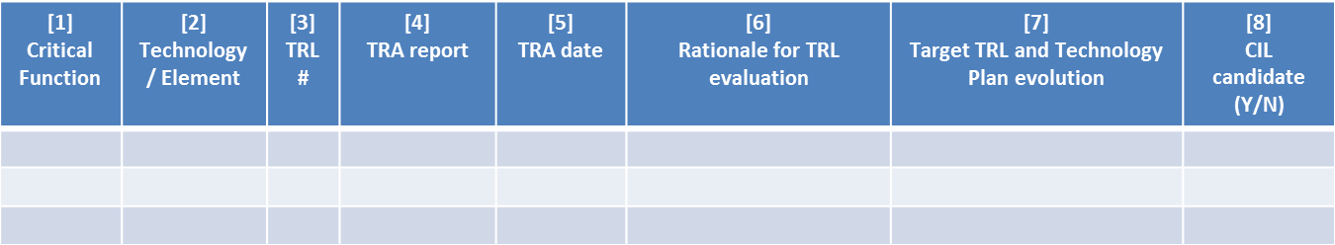

: TRSL template

* + 1. Special remarks

The content of the TP may be merged with the content of the SEP.

The TP shall introduce the related activities, to be conducted during all phase(s) of the project.