- (normative)
Interface Control Document (ICD) – DRD
  - DRD identification
    - Requirement identification and source document
This DRD is called from ECSS-E-ST-10-24, requirement 5.4d.
    - Purpose and objective
The purpose of the ICD is to define the design of the interface(s) ensuring compatibility among involved interface ends by documenting form, fit, and function.
The Interface Control Document (ICD) can be, either:
- a single self-standing document defining the interface.
- a single document, referencing other documents (e.g. IDD, single-end ICD, interface drawings), which define separately the involved interface ends.
- a single document, annexing a set of IDDs (or single-end ICDs), made integrally and jointly applicable to all the involved interface ends. In this case, the entire set of documents (issued by the suppliers, coordinated by the customer and approved by all the involved actors) is integrally and jointly controlling the interface: therefore, the rules and requirement hereafter specified are intended to be applicable either to the single ICD or jointly to the entire set of documents, depending on the selected approach.
The ICD is managed by the customer (or his delegate) and concurred by all the involved actors.
The ICD is used:
  - to document the interface definition,
  - to control the evolution of the interface,
  - to document the design solutions to be adhered to, for a particular interface,
  - as one of the means to ensure that the supplier design (and subsequent implementation) are consistent with the interface requirements,
  - as one of the means to ensure that the designs (and subsequent implementation) of the participating interface ends are compatible.
  - Expected response
    - Scope and content
          - Introduction
          - The ICD shall contain a description of the purpose, objective, content and the reason prompting its preparation.
          - Responsibility
          - The responsibilities of the interfacing organizations for development of the ICD shall be stated.
          - The document approval authority (including change approval authority) shall be defined.
          - The interface ends responsible shall be stated.
          - Applicable and reference documents
          - The ICD shall list the applicable and reference documents and standards in support to the generation of the document.
          - The relationship and precedence of the ICD to other programme documents shall be clearly defined.
          - The ICD shall include the following references:
            - Product tree (as defined in ECSS-M-ST-10 Annex B),
            - Specification tree (as defined in ECSS-E-ST-10).
          - Definition of terms and abbreviated terms
          - The applicable dictionary or glossary and the meaning of specific terms or abbreviation utilized in ICD shall be defined.
          - Interface definition
          - The interface responsible shall establish a complete and exhaustive list of technical characteristics of the interface to be reflected in the interface definition/data.
Informative Annex E lists a number of example aspects to be considered in interface definition. The list is meant to be used as a starting point but cannot be considered exhaustive.
          - For each identified and specified interface, the interface responsible accounting for the contribution of the involved actors shall define interface characteristics in terms of:
            - interface plane definition,
            - interface behaviour identification, including limitation of use,
            - interface description using tables, figures, drawings, models, data base as appropriate,
            - data affecting the interface definition,
            - units of measure including scale of measure,
            - tolerances or required accuracies,
            - in case of using non-SI quantities or units, conversions and conversions.
1 Examples for item 1 are: mounting surface (between hardware products), Application Program Interface (between software products), communication network (between data systems).
2 Examples for item 2 are: static, dynamic, nominal/off nominal, state machine. Possible limitation of use is coming from a decrease of capability.
3 Example of item 3 are: mechanical drawing, interface 3D CAD model, electrical circuit schematic, software API, software architectural or detailed design document.
4 Examples for item 4 are: dimensions, tolerances, coordinates, voltage, data format, temperature, load, heat flow, material, surface treatment, external standard reference.
          - The ICD shall detail the interface definition between two (or more) interface ends.
          - The ICD shall be grouped by contractual, discipline or product decomposition (product tree).
          - Each ICD version shall identify the incorporated approved CR.
          - The interface definitions shall be grouped per pair of interface ends having a common interface plane.
          - In case the ICD addresses more than one interface, the interface definition shall be grouped either per physical/logical interface, or per nature of interface.
1 An example of physical/logical grouping is arranging the interface data by a pair of interface ends (see Figure B-1).
2 An example of grouping by nature is arranging the interface data by discipline such as mechanical, electrical, thermal and software/data (see Figure B-1).
3 It is a good practice to group the interface requirements by the interface natures defined in Annex E.
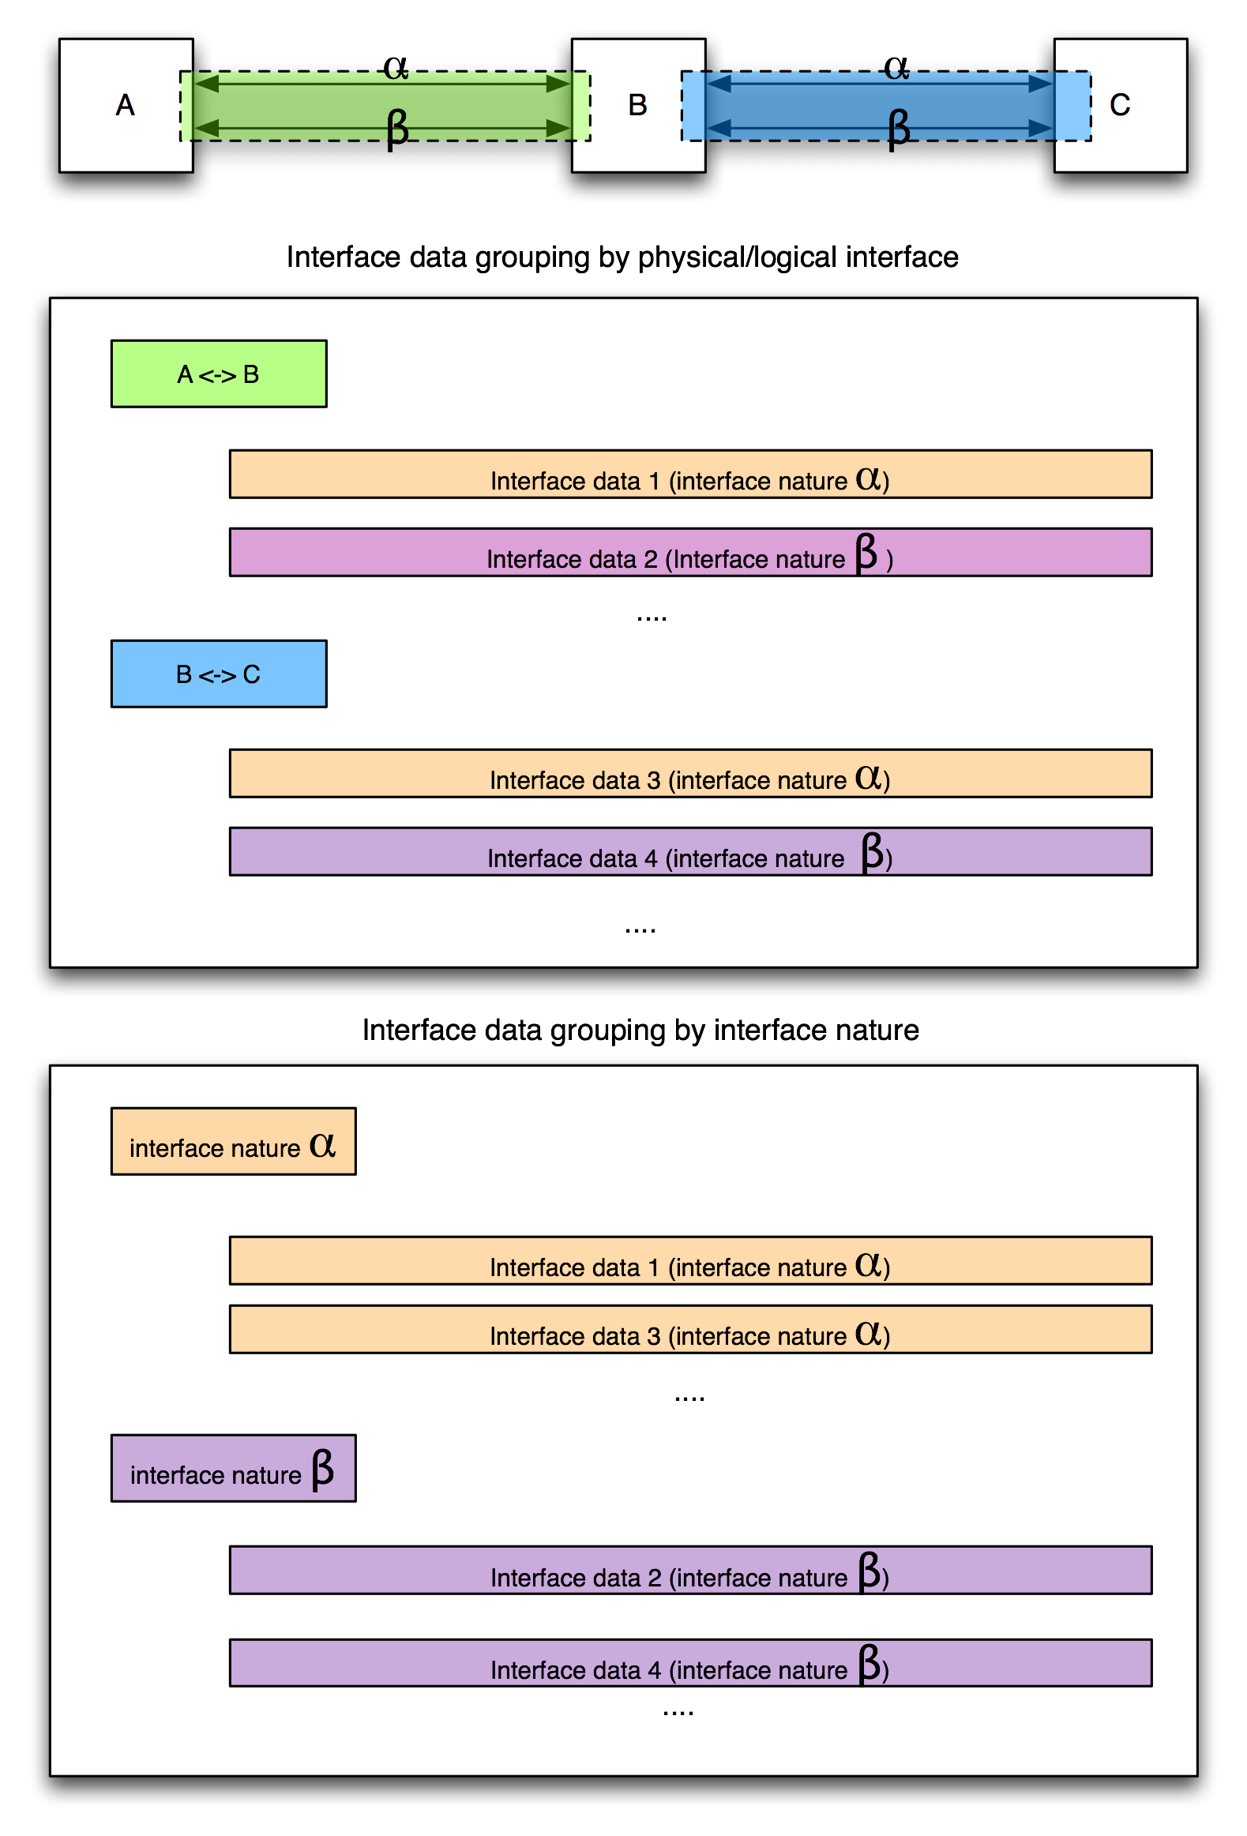
              - : Examples of interface data grouping in ICDs
    - Special remarks
None.

