
Space engineering
ECSS Secretariat
ESA-ESTEC
Standards Section
Noordwijk, The Netherlands

Structural design and verification of pressurized hardware
Foreword
ECSS is a cooperative effort of the European Space Agency, national space agencies and European industry associations for the purpose of developing and maintaining common standards. Requirements in this Standard are defined in terms of what shall be accomplished, rather than in terms of how to organize and perform the necessary work. This allows existing organizational structures and methods to be applied where they are effective, and for the structures and methods to evolve as necessary without rewriting the standards.
This Standard has been prepared by the ECSS-E-ST-32-02C Working Group, reviewed by the ECSS Executive Secretariat and approved by the ECSS Technical Authority.
Disclaimer
ECSS does not provide any warranty whatsoever, whether expressed, implied, or statutory, including, but not limited to, any warranty of merchantability or fitness for a particular purpose or any warranty that the contents of the item are error-free. In no respect shall ECSS incur any liability for any damages, including, but not limited to, direct, indirect, special, or consequential damages arising out of, resulting from, or in any way connected to the use of this Standard, whether or not based upon warranty, business agreement, tort, or otherwise; whether or not injury was sustained by persons or property or otherwise; and whether or not loss was sustained from, or arose out of, the results of, the item, or any services that may be provided by ECSS.
Published by: ESA Standards Section
ESTEC, P.O. Box 299,
2200 AG Noordwijk
The Netherlands
Copyright: 2025© by the European Space Agency for the members of ECSS
Change log
ECSS-E-ST-32-02A | Never issued
ECSS-E-ST-32-02B | Never issued
ECSS-E-ST-32-02C  31 July 2008 | First issue
ECSS-E-ST-32-02C Rev. 1  15 November 2008 | First issue revision 1.  Changes with respect to version C (31 July 2008) are identified with revision tracking.  Main changes are:  - The definitions of MEOP and MDP have been removed and references to the ECSS-E-ST-32 Standard have been done.
ECSS-E-ST-32-02C Rev.2  15 October 2025 | First issue revision 2.  Main changes with respect to ECSS-E-ST-32-02C Rev. 1 (15 November 2008) are the following:  - Change requests were implemented, addressing the following topics:  Normative language improvements; new MSPE categories; similarity; stress rupture; damage control; composite hardware; LBB and safe life requirements; hardware not addressed; harmonization with other standards; pressure cycling; analysis report; loads other than pressure; ECF; analysis only; sealed/hazardous fluid container requirements harmonization (w.r.t. ECSS-E-ST-32-01); safe pressure; internal vs. differential pressure; process vs product qualification; welding reduced inspection; terminology updates (NDI → NDT); pressure vessel definition; additive manufacturing; definitions.  - Improved alignment with current similar standards, while heritage approaches are retained as much as possible (often subject to approval).  - Scope: Expanded the list of exclusions. Clarified applicability of additive manufacturing and other standards. Emphasized that most pressurized hardware is defined as hardware that ‘primarily contains internal pressure’.  - Clarified that experience with several pressurized hardware categories in space applications is limited and tailoring is expected (non-metal lined COPV, CPV, COPS, CPS, COPC, COSPE).  - Added the new ECSS-Q-ST-70-15 (NDT) to the normative references.  - Added new definitions (ECF, homogeneous non-metallic liner, stress rupture) and updated existing definitions (hazardous fluid container, pressure vessel, sealed container, special pressurized equipment).  - Many clarifications are added or updated in Notes throughout the standard.  - The flow charts are updated and renumbered. The bibliography is expanded.  Selected updates of the generic clauses (4.1-4.2 and 5):  - 4.1.2: now contains normative (shall) statements.  - 4.2.2: renamed to ‘Fracture control and fracture critical parts’ reflecting a wider scope.  - 4.2.3.1.b: includes compliance with e.g. range safety requirements, which can result in specific safety factors or acceptance tests.  - 4.2.3.1.i: added to specify explicitly that the operating procedures address damage control.  - 4.2.5: safety factors are now consolidated in 2 new tables and updated.  - 5.2: generalized the definition of load cases, and provided more explicit links to ECSS-E-ST-32 and ECSS-E-ST-32-01.  - 5.2.j: added to address explicitly the effect of sustained loading (incl. ageing, creeping and stress rupture).  - 5.3: updates to the LBB failure mode demonstration clause.  - 5.4.1.i: added to address similarity considerations.  Selected updates of the clauses addressing specific categories of pressurized hardware (4.3-4.6):  - LBB failure mode and safe life demonstration applicability is updated throughout.  - Qualification and acceptance test requirements are updated throughout.  - MSPE requirements (4.6.1) are realigned with other standards and requirement gaps are addressed.  - Loop heat pipes and capillary pumped loops added to the heat pipes category of metallic SPE (4.6.1).  NOTE: Due to the number of changes it was decided to create a new DOORS module that is not linked to the previous version.
Table of contents
Change log 3
1 Scope 8
2 Normative references 10
3 Terms, definitions, and abbreviated terms 11
3.1 Terms from other standards 11
3.2 Terms specific to the present standard 11
3.3 Abbreviated terms 21
3.4 Symbols 22
3.5 Nomenclature 22
4 General requirements 23
4.1 Classification 23
4.1.1 General 23
4.1.2 Classification of pressurized hardware 24
4.2 General 26
4.2.1 Leak tightness 26
4.2.2 Fracture control and fracture critical parts 27
4.2.3 Operation and maintenance 28
4.2.4 Service life extension, reactivation and re-acceptance 31
4.2.5 Factors of safety tables 34
4.3 Pressure vessels 37
4.3.1 Factors of safety 37
4.3.2 Metallic pressure vessels 38
4.3.3 COPV with metallic liner 44
4.3.4 COPV with homogeneous non metallic liner and CPV 50
4.4 Pressurized structures 58
4.4.1 Factors of safety 58
4.4.2 Metallic pressurized structures 58
4.4.3 COPS with metallic liner 64
4.4.4 COPS with homogeneous non metallic liner and CPS 70
4.5 Pressure components 77
4.5.1 Metallic pressure components 77
4.5.2 COPC with metallic liner 83
4.5.3 COPC with homogeneous non-metallic liner 89
4.6 Special pressurized equipment 96
4.6.1 Metallic special pressurized equipment 96
4.6.2 COSPE with metallic liner 104
4.6.3 COSPE with homogeneous non metallic liner 110
5 Specific requirements 117
5.1 Overview 117
5.2 Structural engineering 117
5.3 LBB failure mode demonstration 122
5.3.1 General 122
5.3.2 Demonstration of LBB by analysis 123
5.3.3 Demonstration of LBB by test using coupons 124
5.3.4 Demonstration of LBB by test using full-scale or sub-scale article 125
5.3.5 Report of LBB demonstration 126
5.4 Qualification tests 127
5.4.1 General 127
5.4.2 Proof pressure test 130
5.4.3 Leak test 130
5.4.4 Vibration test 131
5.4.5 Pressure cycling test 131
5.4.6 Design burst pressure test 132
5.4.7 Burst test 132
5.5 Acceptance tests 133
5.5.1 General 133
5.5.2 Proof pressure test 134
5.5.3 Leak test 135
5.6 Composite material characterization 135
5.7 Inspection 136
5.7.1 General 136
5.7.2 Inspection techniques for composite over-wraps and composites 137
Bibliography 139

Figures
Figure 4-1: Breakdown of PH types covered by this Standard 23
Figure 4-2: Flowchart describing PH classifications covered by this Standard 24
Figure 4-3: Summary of classifications of PH covered by this Standard 25
Figure 4-4: Development approach of MPV 40
Figure 4-5: Development approach of COPV with metallic liner (relevant also for COPC and COSPE with metallic liner) 49
Figure 4-6: Development approach of COPV with homogeneous non metallic liner (Relevant also for COPC and COSPE with homogeneous non-metallic liner) 56
Figure 4-7: Development approach of CPV 57
Figure 4-8: Development approach of MPS 61
Figure 4-9: Development approach of COPS with metallic liner 69
Figure 4-10: Development approach of COPS with homogeneous non metallic liner 75
Figure 4-11: Development approach of CPS 76
Figure 4-12: Development approach of MPC (Relevant also for MSPE heat pipes, loop heat pipes, capillary pumped loops) 82
Figure 4-13: Development approach of metallic sealed containers (Relevant also for non-hazardous leakage applications of MSPE cryostats (Dewars) and batteries) 100
Figure 4-14: Development approach of metallic hazardous fluid containers (Relevant also for hazardous leakage applications of MSPE cryostats (Dewars) and batteries) 101

Tables
Table 4-1: Factors of safety for unmanned missions 34
Table 4-2: Factors of safety for human spaceflight 35

Scope
This Standard specifies the structural design verification of metallic and non-metallic pressurized hardware which includes pressure vessels, pressurized structures, pressure components (such as valves, pumps, lines, fittings, and hoses), and special pressurized equipment (e.g. batteries, heat pipes, cryostats, sealed containers, hazardous fluid container). Pressurized hardware is defined as hardware that ‘primarily contains internal pressure’, and therefore pressurized hardware (other than pressurized structures) that are subjected to significant loads other than internal pressure can require tailoring of the standardized structural design verification approach.
This standard provides a minimum set of requirements. Some topics are not covered fully by this standard. Topics not fully covered by this standard include:
- External supports and structural interfaces;
- Solid propellant motor cases;
- The following launcher liquid propulsion equipment: combustion chamber, gas generator, pre burner, turbopump, nozzle extension, igniter, mechanisms (according to ECSS-E-ST-35-03C, Liquid propulsion for launchers);
- Expulsion devices, including bladders and diaphragms;
- Functional requirements like rapid expulsion, cleanliness;
To some extent, rapid expulsion can be considered as unique environment (see 5.4.1k).
- Pressure components that experience significant non-pressure loads, for example bellows, flexible lines, thrusters;
For more information on bellows and flexible lines, see e.g. Goyal, V. et al (2021) and NASA-HDBK-5010A volume 2.
- Relief devices, for example burst disks and relief valves;
- Pyro valves;
For more information, see e.g. ECSS-E-ST-33-11C and JSC-67723 (the latter for aspects specifically relevant for human spaceflight).
- Pressure system passivation, including definition of safe pressure;
- Demisability during re-entry;
- Inflatable pressurized hardware;
- Composite pressure components and composite special pressurized equipment;
- Non-metallic, non-composite pressurized hardware, including windows;
Note that homogeneous non-metallic liners are covered to some extent.
- Seals.
Objectives of the associated verification process are primarily to demonstrate the qualification of design and performance, as meeting all specified requirements, and to ensure that the flight hardware is free from workmanship defects and acceptable for flight.
This Standard applies to all space products and in particular to launch vehicles, transfer vehicles, re-entry vehicles, spacecraft, space station, landing probes and rovers, sounding rockets, payloads and instruments.
This standard, similar to other current pressurized hardware standards, does not cover in detail the requirements for application of additive manufacturing to pressurized hardware. The ECSS-Q-ST-70-80 is a good starting point, but the relevant structural standards, e.g. ECSS-E-ST-32 and ECSS-E-ST-32-01, and emerging standards at e.g. NASA indicate that the most critical applications, especially in case of applications in human spaceflight, can require more effort than currently required as minimum by ECSS-Q-ST-70-80 (for example NASA-STD-6030, NASA-HDBK-5026).
This standard may be tailored for the specific characteristics and constraints of a space project in conformance with ECSS-S-ST-00.
Tailoring can involve complementing or replacing requirements of this standard with those of other standards that are made applicable, like ANSI/AIAA S-080 and ANSI/AIAA S-081 and NASA-STD-5019 or similar fracture control requirements documents. This can be especially relevant for human spaceflight applications.

Normative references
The following normative documents contain provisions which, through reference in this text, constitute provisions of this ECSS Standard. For dated references, subsequent amendments to, or revision of any of these publications, do not apply. However, parties to agreements based on this ECSS Standard are encouraged to investigate the possibility of applying the more recent editions of the normative documents indicated below. For undated references, the latest edition of the publication referred to applies.

ECSS-S-ST-00-01 | ECSS system – Glossary of terms
ECSS-E-ST-10-02 | Space engineering – Verification
ECSS-E-ST-10-03 | Space engineering – Testing
ECSS-E-ST-32 | Space engineering – Structural general requirements
ECSS-E-ST-32-01 | Space engineering – Fracture control
ECSS-E-ST-32-08 | Space engineering – Materials
ECSS-E-ST-32-10 | Space engineering – Structural factors of safety for spaceflight hardware
ECSS-Q-ST-20 | Space product assurance – Quality assurance
ECSS-Q-ST-70 | Space product assurance – Materials, mechanical parts and processes
ECSS-Q-ST-70-15 | Space product assurance – Non-destructive testing

Terms, definitions, and abbreviated terms

Terms from other standards
- For the purpose of this Standard, the terms and definitions from ECSS-S-ST-00-01 apply and in particular the following:
  - customer
Normally, the customer ensures that the requirements of the safety authority are taken into account.
- For the purpose of this Standard, the terms and definitions from ECSS-E-ST-32 apply and in particular the following:
  - maximum design pressure (MDP)
  - maximum expected operating pressure (MEOP)
  - service life
The current service life definition of ECSS-E-ST-32 is primarily aimed at hardware that is subjected to NDT and subsequent crack-growth analysis. In other cases, where, for example, fatigue initiation analysis or testing is performed, it can be appropriate to extend the service life beyond that, as relevant. The service life includes both operating and non-operating events, as relevant for the safe and reliable performance of the pressurized wall.
- For the purpose of this Standard, the terms and definitions from ECSS-E-ST-32-01 apply.

Terms specific to the present standard
- autofrettage
vessel sizing operation where pressure driven deflection is used to plastically yield the metal liner into the overlying composite in order to induce initial compressive stress states in the metal liner
1 Autofrettage is considered to be part of the manufacturing process and is conducted prior to acceptance test.
2 Monitoring the structural response of the vessel during this operation, especially the permanent set, can provide valuable insight into the liner's plastic behaviour and integrity.
- boss
zone of a pressure vessel or a pressurized structure ensuring functional interfaces of the hardware with the pressurized system
Examples of functional interfaces are fluid connections and mechanical interfaces. The boss is generally located in the dome region of the pressurized wall.
- burst factor (j_{burst})
multiplying factor applied to the maximum design pressure (MDP), to obtain the design burst pressure
The burst factor corresponds to an ultimate factor of safety.
- burst pressure
pressure level at which collapse, rupture or unstable fracture of the pressurized hardware occurs
- composite over-wrap
layers of fibre-based composite material applied onto a liner, sustaining significant pressure and environmental loads
- composite over-wrapped pressure vessel (COPV)
pressure vessel with a fibre-based composite structure fully or partially encapsulating a liner
For example:
- the liner can be metallic or not.
- the liner ensures the leak tightness of the vessel.
- composite over-wrapped pressurized component (COPC)
pressurized component with a fibre-based composite system fully or partially encapsulating a liner
1 For example:
- the liner can be metallic or not.
- the liner ensures the leak tightness of the vessel.
2 In this standard COPC are treated very similar to COPV because heritage is limited. A tailored approach agreed between customer and supplier, who also represent relevant safety authorities, can be appropriate. The tailored approach includes for example similarity with the requirements for metallic PC while addressing also concerns associated with composite elements.
- composite over-wrapped pressurized structure (COPS)
pressurized structure with a fibre-based composite system fully or partially encapsulating a liner
For example:
- the liner can be metallic or not.
- the liner ensures the leak tightness of the vessel.
- composite over-wrapped special pressurized equipment (COSPE)
special pressurized equipment with a fibre-based composite system fully or partially encapsulating a liner
1 For example:
- the liner can be metallic or not.
- the liner ensures the leak tightness of the vessel.
2 In this standard COSPE are treated very similar to COPV because heritage is limited. A tailored approach agreed between customer and supplier, who also represent relevant safety authorities, can be appropriate. The tailored approach includes for example similarity with the requirements for metallic SPE while addressing also concerns associated with composite elements.
- composite pressure vessel (CPV)
pressure vessel whose structural wall is fully composed with fibre based composite material
For example:
- the permeation barrier can be ensured by a coating on the internal or the external shape of the composite wall, or by the composite wall itself, or by both.
- low-pressure liquid hydrogen tank without liner.
- composite pressurized structure (CPS)
pressurized structure whose structural wall is fully composed with fibre based composite material
For example:
- the permeation barrier can be ensured by a coating on the internal or external shape of the composite wall, or by the composite wall itself, or by both.
- low-pressure liquid hydrogen structural tank without liner.
- critical flaw
specific flaw with a size such that unstable growth occurs under the specific operating load and environment
- cryostat
vacuum-jacketed container designed to keep its contents at a low (cryogenic) temperature
Cryostat is also known as a Dewar, named after its inventor.
- design burst pressure
differential pressure to be withstood by the pressurized hardware without burst in the applicable operating environment
The design burst pressure is equal to the product of the MDP and the burst factor.
- differential pressure
internal pressure minus external pressure
- environmental correction factor (ECF)
a multiplying factor applied to account for the change in material properties associated with the difference between the test environment and the operating environment
1 The ECF is generally determined by the ratio of the relevant strength property at test temperature and dimensioning temperature, but it can be necessary to consider other phenomena.
2 The ECF for the proof test, cycle test and burst test can be different. For a test with fracture objective, using a cracked test article, the ECF is normally based on fracture properties.
3 In most cases, temperature is the dominant environmental effect defining the ECF.
4 ECF smaller than 1 are usually not applied.
- external pressure
absolute pressure outside the pressurized hardware
- fibre failure
rupture or kinking of a bundle of filaments
There are two fibre failure modes: under tension (fibre rupture) and under compression (kinking).
- fitting
pressure component of a pressurized system utilized to connect lines, other pressure components or pressure vessels within the system
- hazardous fluid container
metallic pressurized container, compartment or housing that primarily contains internal pressure and that is individually sealed to contain a fluid with an energy level smaller than 19310 Joules, and with a pressure smaller than 0,15 MPa, which can create a hazard if released.
1 Clause 8.2.6 of ECSS-E-ST-32-01 specifies limited fracture control verification approaches, as well as reduced proof and burst factor requirements, for metallic hazardous fluid containers that respect these stored energy and pressure limits. For other hazardous fluid containers clause 8.2.6 of ECSS-E-ST-32-01 specifies that they are treated and certified the same as pressure vessels.
2 For hazardous fluid containers subjected to significant loads not caused by internal pressure, acceptance proof and leak testing with only internal pressure can be inadequate.
3 Sometimes tailoring is applied when agreed between customer and supplier, who also represent relevant safety authorities, for example by similarity with the requirements for pressure components, rather than applying pressure vessel requirements.
- homogeneous non-metallic liner
a liner fabricated with a polymeric material, either thermoset or thermoplastic.
1 Examples include polyvinyl chloride, polyethylene, polyamide, and polytetrafluoroethylene. More brittle polymers like epoxy and phenolic are generally less suitable for application as liner for pressurized hardware.
AIAA G-082-2022 can provide useful additional information.
2 Requirements for non-metallic liner materials other than polymeric materials are not covered by this standard and need to be addressed by tailoring.
- hydrogen embrittlement
mechanical and environmental process that results from the initial presence or absorption of excessive amounts of hydrogen in metals
Usually it occurs in combination with residual or applied tensile stresses.
- impact damage
induced defect caused by an object strike on the pressurized hardware or pressurized hardware strike on an object
Delamination in the composite over-wrap of a COPV, dent in the metallic liner of a COPV.
- inter-fibre failure
micro-cracking in the matrix of a composite material, or at the interface filament-matrix of a composite material
- internal pressure
absolute pressure inside the pressurized hardware
- leak-before-burst (LBB)
fracture mechanics design concept, showing that any potentially critical flaw grows through the wall of a pressurized system and cause pressure relieving leakage at MDP without burst (catastrophic failure)
LBB is not intended as a safety measure against over-pressurization or combined loads.
- liner
part of pressurized hardware serving as a mandrel during the manufacturing of the over-wrap and as fluid permeation barrier when in contact with the stored fluid
For example:
- when the liner is made of metallic material, it can carry significant pressure and environmental loads.
- when the liner is made of homogeneous non metallic material, it usually does not carry significant pressure and environmental loads.
- line
tubular pressurized hardware of a pressurized system provided as means for transferring fluids between components of the system
Flex hoses are included.
- mechanical damage
induced flaw in pressurized hardware item which is caused by surface abrasions, cuts or impacts
The pressurized hardware item can be a metallic, homogeneous non metallic or composite item.
- metallic pressure vessel (MPV)
pressure vessel fully composed of metallic material
- metallic pressurized structure (MPS)
pressurized structure fully composed of metallic material
- metallic pressurized component (MPC)
pressurized component fully composed of metallic material
- metallic special pressurized equipment (MSPE)
special pressurized equipment fully composed of metallic material
- non-hazardous LBB (NHLBB) failure mode
leak-before-burst (LBB) behaviour that does not result in a hazard
For example: LBB behaviour with a leak of liquid or gas that is not toxic, reactive or flammable and that does not fulfil a safety critical function.
- pressure component (PC)
component in a pressurized system, other than a pressure vessel, pressurized structure, or special pressurized equipment that is designed largely by the internal pressure
1 For example:
- lines, fittings, gauges, valves, bellows, and hoses.
2 For pressure components subjected to significant loads not caused by internal pressure, acceptance proof and leak testing with only internal pressure can be inadequate.
3 Classification as pressure component of components that exceed energy or pressure limits of the pressure vessel definition, is normally subject to agreement between customer and supplier, who also represent relevant safety authorities, on a case by case basis. Successful heritage of the applied design features and processes, together with relatively high safety factors on pressure specified for pressure components, can support acceptability of such hardware.
4 This standard only addresses MPC and COPC (see Figure 4-1)
- pressure vessel (PV)
pressurized hardware designed primarily for the storage of pressurized fluid with an energy level greater than or equal to 19310 Joules, or with a pressure greater than or equal to 0,69 MPa, or with a pressure greater than or equal to 0,10 MPa which can create a hazard if released
1 E.g. the stored energy can be calculated by the formula for the reversible adiabatic (isentropic) expansion of the confined gas:
where:
E is the stored energy;
P₁ is the internal pressure;
P₂ is the external pressure;
V is the pressurized volume;
γ is the ratio of specific heat of the gas.
2 Whether a pressurized hardware is considered to be ‘designed primarily for the storage of pressurized fluid’ can be subjective. Classification as pressure vessel or otherwise of pressurized hardware, that exceed energy or pressure limits of this definition, is normally subject to agreement between customer and supplier, who also represent relevant safety authorities, on a case by case basis.
- pressurized hardware (PH)
hardware item that primarily contains internal pressure
1 E.g. included are pressure vessels, pressurized structures, pressure components and special pressurized equipment.
2 For pressurized hardware subjected to significant loads not caused by internal pressure, acceptance proof and leak testing with only internal pressure can be inadequate.
- pressurized structure (PS)
structure designed to carry both internal pressure and vehicle structural loads
1 E.g. launch vehicle main propellant tanks, crew cabins and manned modules.
2 Whether a pressurized hardware is considered to be pressurized structure can be subjective. Classification as pressure vessel or pressurized structure of pressurized hardware, that exceed energy or pressure limits of the pressure vessel definition, is normally subject to agreement between customer and supplier, who also represent relevant safety authorities, on a case by case basis. Increased proof and burst factors can sometimes apply, for example when people are working nearby.
- pressurized system
system which consists of pressure vessels, or pressurized structures, or both, and other pressure components, that are exposed to and structurally designed largely by the acting pressure
1 For example:
- a pressurized system is often called a pressure system.
- electrical or other control devices for system operations are not included.
2 For a pressurized system subjected to significant loads not caused by internal pressure, acceptance proof and leak testing with only internal pressure can be inadequate.
- proof factor (j_{proof})
multiplying factor applied to MDP to obtain design proof pressure
- proof pressure
product of MDP and proof factor
- proof test
test of flight hardware under proof load or pressure to give evidence of satisfactory workmanship and material quality or to establish the initial crack sizes in the hardware
- sealed container
metallic pressurized container, compartment or housing that primarily contains internal pressure and that is individually sealed to contain a fluid or to maintain an internal gaseous environment with an energy level smaller than 19310 Joules, and with a pressure smaller than 0,69 MPa, which will not create a hazard if released
1 E.g. electronics housing
2 Clause 8.2.5 of ECSS-E-ST-32-01 specifies limited fracture control verification approaches, as well as reduced proof and burst factor requirements, for metallic ‘low risk’ sealed containers that have a stored energy potential that does not exceed 19310 joules, have a pressure wall that is verified leak before burst, and have an MDP less than 0,30 MPa.
3 For sealed containers subjected to significant loads not caused by internal pressure, acceptance proof and leak testing with only internal pressure can be inadequate.
4 Sometimes tailoring is applied when agreed between customer and supplier, who also represent relevant safety authorities, for example by similarity with the requirements for pressure components, rather than applying safe life requirements.
- sizing pressure
pressure to which composite over-wrapped pressurized hardware is subjected with the intent of yielding its metallic liner or a portion of the liner
E.g. the sizing pressure also refers to the pressure applied during autofrettage.
- special pressurized equipment (SPE)
pressurized hardware that primarily contains internal pressure and for which a special development and verification approach applies
1 For example:
- Classification as special pressurized equipment is subject to customer approval, per 4.1.2f.
- heat pipes, loop heat pipes, capillary pumped loops, cryostats, sealed containers and hazardous fluid container.
2 For special pressurized equipment subjected to significant loads not caused by internal pressure, acceptance proof and leak testing with only internal pressure can be inadequate.
3 Classification as special pressurized equipment of components that exceed energy or pressure limits of the pressure vessel definition, is normally subject to agreement between customer and supplier, who also represent relevant safety authorities, on a case-by-case basis.
4 This standard only addresses MSPE and COSPE (see Figure 4-1).
- stress rupture
sudden failure mode for composite structural items that can occur at normal operating pressures and environments
This failure mode can occur while at stress levels below ultimate strength for an extended time. It can affect COPV, CPV, COPS, CPS, COPC and COSPE. The failure mechanism is complex, not well understood, and difficult to accurately predict or detect prior to failure. Pressure, duration of time at pressure, and environment experienced contribute to the degradation of the fiber and/or the fiber-matrix interface, particularly around accumulations of fiber breaks, and these increase the probability of stress rupture of composite structural items.
Refer also to the Bibliography, for example NASA/SP-2011-573 and 'Deceptively Complex: COPVs Remain a Challenge for Engineers to Unravel'.
- unique environment
environment that is not otherwise addressed in this standard. Such conditions can include exposure to extremely high or low temperatures or temperature gradients, high levels of radiation, ultraviolet light, or exposure to atomic oxygen. Such conditions can also arise from exposures during assembly, integration, testing, and launch site preparation.
This is sometimes called ‘unique operating environments’, for example in AIAA standards.
- visual damage threshold (VDT)
lowest impact energy level applied to a composite item that creates an indication that is detectable by an inspector using an unaided visual technique
No quantitative reliability nor confidence level is associated with this technique.

Abbreviated terms
For the purpose of this Standard, the abbreviated terms from ECSS-S-ST-00-01 and the following apply:

Abbreviation | Meaning
BAI | residual burst strength after impact
COPC | composite over-wrapped pressurized component
COPS | composite over-wrapped pressurized structures
COSPE | composite over-wrapped special pressurized equipment
COPV | composite over-wrapped pressure vessel
CPS | composite pressurized structure
CPV | composite pressure vessel
DLL | design limit load
DUL | design ultimate load
DYL | design yield load
ECF | environmental correction factor
FCI | fracture critical item
FLLI | fracture limited life item
FOS | factor of safety
ISS | international space station
LBB | leak-before-burst
MDP | maximum design pressure
MEOP | maximum expected operating pressure
MPC | metallic pressurized component
MPS | metallic pressurized structure
MPV | metallic pressure vessel
MSPE | metallic special pressurized equipment
NDT | non-destructive testing
NHLBB | non-hazardous leak-before-burst
PFCI | potential fracture-critical item
PC | pressure component
PH | pressurized hardware
PV | pressurized pressure vessel
PS | pressurized structure
SPE | special pressurized equipment
VDT | visual damage threshold

Symbols
j_{burst} value of burst factor
j_{proof} value of proof factor
FOSU value of ultimate factor of safety
FOSY value of yield factor of safety

Nomenclature
The following nomenclature applies throughout this document:
- The word “shall” is used in this Standard to express requirements. All the requirements are expressed with the word “shall”.
- The word “should” is used in this Standard to express recommendations. All the recommendations are expressed with the word “should”.
It is expected that, during tailoring, recommendations in this document are either converted into requirements or tailored out.
- The words “may” and “need not” are used in this Standard to express positive and negative permissions, respectively. All the positive permissions are expressed with the word “may”. All the negative permissions are expressed with the words “need not”.
- The word “can” is used in this Standard to express capabilities or possibilities, and therefore, if not accompanied by one of the previous words, it implies descriptive text.
In ECSS “may” and “can” have completely different meanings: “may” is normative (permission), and “can” is descriptive.
- The present and past tenses are used in this Standard to express statements of fact, and therefore they imply descriptive text.

General requirements

Classification

General
The pressurized hardware treated in this Standard are categorized in Figure 4-1.
As mentioned in the Scope of this standard, tailoring can involve complementing or replacing requirements of this standard with those of other standards that are made applicable, like ANSI/AIAA S-080 and ANSI/AIAA S-081 and NASA-STD-5019 or similar fracture control requirements documents. This can be especially relevant for human spaceflight applications, as also addressed in 8.2.1a. of ECSS-E-ST-32-01.
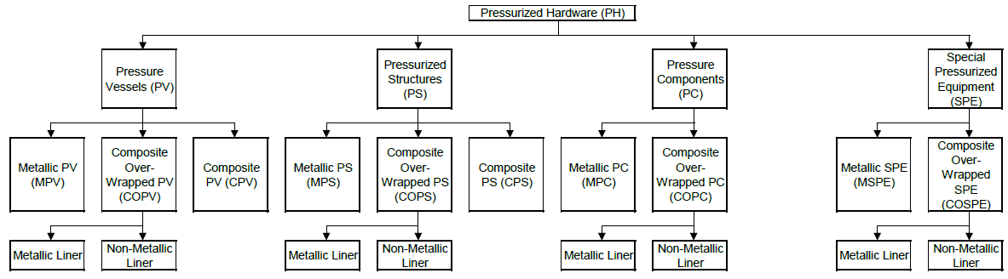
Figure 4-1: Breakdown of PH types covered by this Standard

Classification of pressurized hardware
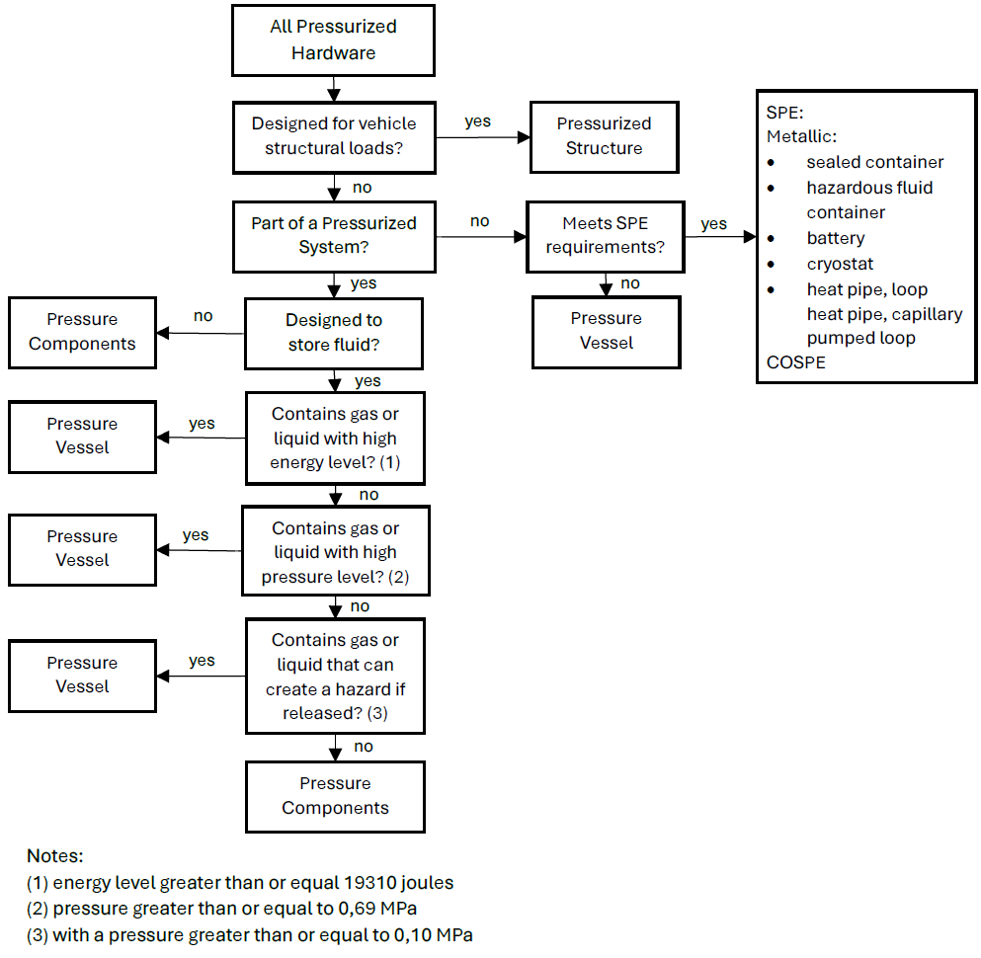
Figure 4-2: Flowchart describing PH classifications covered by this Standard

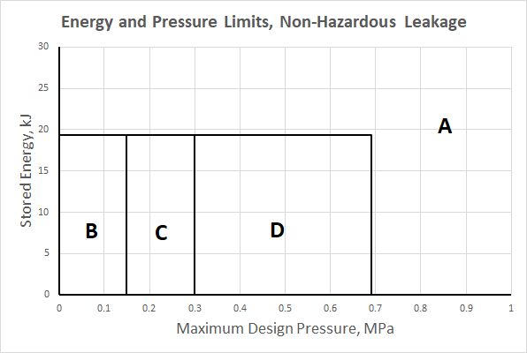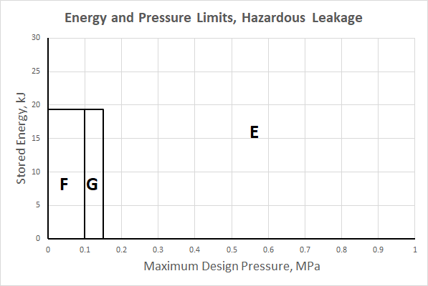
Pressurized hardware with non-hazardous leakage.  Region A (MDP>0,69MPa or E>19,3kJ):  - pressurized structures (4.4)  - pressure components (4.5)  - pressure vessels (4.3)  - SPE: metallic heat pipes, loop heat pipes, capillary pumped loops (4.6.1); composite overwrapped SPE (4.6.2 and 4.6.3)  Region B (MDP<0,15MPa and E<19,3kJ):  - pressurized structures (4.4)  - pressure components (4.5)  - SPE: metallic heat pipes, loop heat pipes, capillary pumped loops, and some sealed containers, cryostats, batteries (4.6.1); composite overwrapped SPE (4.6.2 and 4.6.3)  Region C (MDP 0,15-0,30MPa and E<19,3kJ):  - pressurized structures (4.4)  - pressure components (4.5)  - SPE: metallic heat pipes, loop heat pipes, capillary pumped loops, and some sealed containers, cryostats, batteries (4.6.1); composite overwrapped SPE (4.6.2 and 4.6.3)  Region D (MDP 0,30-0,69MPa and E<19,3kJ):  - pressurized structures (4.4)  - pressure components (4.5)  - SPE: metallic heat pipes, loop heat pipes, capillary pumped loops, and some sealed containers, cryostats, batteries (4.6.1); composite overwrapped SPE (4.6.2 and 4.6.3) | Pressurized hardware with hazardous leakage.  Region E (MDP>0,15MPa or E>19,3kJ):  - pressurized structures (4.4)  - pressure components (4.5)  - pressure vessels (4.3)  - SPE: metallic heat pipes, loop heat pipes, capillary pumped loops (4.6.1); composite overwrapped SPE (4.6.2 and 4.6.3)  Region F (MDP<0,10MPa and E<19,3kJ):  - pressurized structures (4.4)  - pressure components (4.5)  - SPE: metallic heat pipes, loop heat pipes, capillary pumped loops, and hazardous fluid containers, cryostats, batteries (4.6.1); composite overwrapped SPE (4.6.2 and 4.6.3)  Region G (MDP 0,10-0,15MPa and E<19,3kJ):  - pressurized structures (4.4)  - pressure components (4.5)  - pressure vessels (4.3)  - SPE: metallic heat pipes, loop heat pipes, capillary pumped loops, and hazardous fluid containers, cryostats, batteries (4.6.1); composite overwrapped SPE (4.6.2 and 4.6.3)
The approaches for composite overwrapped pressure components and SPE are essentially the same as pressure vessels, unless tailoring is agreed.
Exceptions can be agreed on a case-by-case basis by customer and supplier, who also represent relevant safety authorities.
This figure is simplified and does not address all nor supersede any requirements of this standard.
Figure 4-3: Summary of classifications of PH covered by this Standard
ECSS-E-ST-32-02_1660001
          - Pressurized hardware shall be classified in accordance with the flowchart of Figure 4-2.
ECSS-E-ST-32-02_1660002
          - All classes of pressurized hardware (PH) shall meet the requirements specified in clause 4.2.
ECSS-E-ST-32-02_1660003
          - All pressure vessels (PV) shall meet the requirements specified in clause 4.3.1 and one of the following depending on the hardware type: 4.3.2, 4.3.3, 4.3.4.
ECSS-E-ST-32-02_1660004
          - All pressurized structures (PS) shall meet the requirements specified in clause 4.4.1 and one of the following depending on the hardware type: 4.4.2, 4.4.3, 4.4.4.
ECSS-E-ST-32-02_1660005
          - All pressure components (PC) shall meet the requirements specified in clause 4.5.1 or 4.5.2 or 4.5.3 depending on the hardware type.
ECSS-E-ST-32-02_1660006
          - Classification as special pressurized equipment (SPE) shall be subject to approval from the customer.
Some SPE types can exceed the pressure or energy limits of the pressure vessel definition. Normally, the customer ensures that the requirements of the safety authority are taken into account.
ECSS-E-ST-32-02_1660007
          - All special pressurized equipment (SPE) types shall meet the requirements specified in clause 4.6.1 or 4.6.2 or 4.6.3 depending on the hardware type.
ECSS-E-ST-32-02_1660008
          - For hardware that does not meet all applicable requirements of one of the classes, the applicable requirements shall be agreed between customer and supplier as part of tailoring.

General

Leak tightness
ECSS-E-ST-32-02_1660009
          - The maximum acceptable leak and permeation rates of the pressurized hardware versus pressure values shall be established through a detailed analysis of the pressurized system to which the pressurized hardware belongs.
Permeation can generally be considered insignificant for metallic or metallic lined pressurized hardware. A combination of analysis and test is expected as verification method. The qualification leak test of 5.4.3 can be included as objective to contribute to the verification of the permeation requirement. AIAA G-082-2022 can provide useful additional information on permeation.
Hazardous fluid content is not always permitted for pressurized hardware that is fully non-metallic or non-metallic lined and potentially allows significant permeation.
ECSS-E-ST-32-02_1660010
          - Leak and permeation rates of all pressurized hardware shall conform to the level specified in 4.2.1a.
ECSS-E-ST-32-02_1660011
          - Leak rate of all pressurized hardware shall be such that operation of the system is ensured throughout the specified lifetime.
Pressurized hardware containing hazardous fluid reach end of safe-life when leakage occurs.
ECSS-E-ST-32-02_1660012
          - The permeation requirement specified in 4.2.1a and 4.2.1b shall be verified by a method agreed with the customer.

Fracture control and fracture critical parts
ECSS-E-ST-32-02_1660013
          - Fracture critical item classification and verification shall be performed in conformance with ECSS-E-ST-32-01.
When pressurized hardware is classified as fracture critical, it is subjected to the implementation of the fracture critical item tracking, control, verification and documentation procedures specified in ECSS-E-ST-32-01.
ECSS-E-ST-32-02_1660014
          - Fracture control for non-fracture critical PFCI shall be implemented in conformance with ECSS-E-ST-32-01.
1 Not all pressurized hardware are fracture critical but they can still require implementation of fracture control measures. The ECSS-E-ST-32-01 requests a fracture control plan which describes the planned fracture control activities.
2 In case a safe life demonstration by test is foreseen, requirement 6.3.1.b of ECSS-E-ST-32-01 requests that the methodology applied for evaluation by test is subject to customer approval. Additional guidance on damage tolerance verification specifically of pressurized hardware by test can be found, for example, in ANSI/AIAA S-080A-2018, ANSI/AIAA S-081B-2018, AIAA G-082-2022 and NASA-HDBK-5010A.

Operation and maintenance

Operating procedures
ECSS-E-ST-32-02_1660015
          - Operating procedures shall be established for all pressurized hardware.
ECSS-E-ST-32-02_1660016
          - The procedures specified in 4.2.3.1a shall be compatible with the safety requirements and personnel control requirements at the facility where the operations are conducted.
This includes compliance with range safety requirements, transportation requirements. These can drive specific safety factors or acceptance tests.
ECSS-E-ST-32-02_1660017
          - Step-by-step directions shall be written with such a detail to unambiguously describe the operation.
ECSS-E-ST-32-02_1660018
          - Schematics identifying the location and pressure limits of a relief valve and burst disc, shall be provided.
ECSS-E-ST-32-02_1660019
          - Procedures to ensure compatibility of the pressurizing system with the structural capability of the pressurized hardware shall be established.
ECSS-E-ST-32-02_1660020
          - Prior to initiating or performing a procedure involving hazardous operations with pressure systems, practice runs shall be conducted on non-pressurized systems.
ECSS-E-ST-32-02_1660021
          - Initial tests shall then be conducted at pressure levels not to exceed 50 % of the nominal operating pressure until operating characteristics can be established.
ECSS-E-ST-32-02_1660022
          - Warning signs with the hazard identified shall be posted at the operations facility prior to pressurization.
ECSS-E-ST-32-02_1660023
          - The operating procedures shall incorporate or reference damage control measures.
Damage control measures describe how composite (but also other) pressurized hardware will be protected from detrimental damage due to impacts during manufacturing, handling, transportation, assembly, and integration. The operating procedures also describes how this will be supported by inspections to be performed according to clause 5.7 throughout the life of the vessel. In many cases a dedicated plan is provided or requested, sometimes at higher assembly level, addressing all operations until the hardware is no longer accessible for damage.
For an example of a damage control plan describing damage control measures for a COPV, see JSC 66901. For more examples (including critical thin-walled flexible pressure boundaries, like bellows) refer to NASA-HDBK-5010A.

Safe operating limit
ECSS-E-ST-32-02_1660024
          - Safe operating limits shall be established for pressurized hardware based on analysis and testing employed during its design, development and qualification.
ECSS-E-ST-32-02_1660025
          - The safe operating limits specified in 4.2.3.2a shall be summarized in a format providing visibility of the structural characteristics and capability.
ECSS-E-ST-32-02_1660026
          - The information in the format specified in 4.2.3.2b shall include as a minimum the following data:
            - In a general case
              - fabrication materials;
              - critical design conditions;
              - MDP;
              - nominal operating pressure;
              - proof pressure;
              - design burst pressure;
              - pressurization and depressurization sequence;
              - operational cycle limits;
              - operational system fluid;
              - cleaning agent;
              - NDT techniques employed;
              - extreme thermal and chemical environments;
              - maximum leakage levels versus pressure values;
              - minimum margin of safety;
              - potential failure mode.
            - For pressurized hardware with a non LBB failure mode, additionally to the data included in 4.2.3.2c.1:
              - the critical flaw sizes;
              - the maximum acceptable flaw sizes.
ECSS-E-ST-32-02_1660027
          - Back-up documentation, including at least applicable references to design drawings, detail analyses, inspection records, and test reports, shall be indicated.
ECSS-E-ST-32-02_1660028
          - The minimum internal pressure to guaranty structural stabilization shall be identified and included in the acceptance data package.

Inspection and maintenance
ECSS-E-ST-32-02_1660029
          - The results of stress and safe-life analyses shall be used in conjunction with the results from the structural development and the qualification tests to define quantitative acceptance criteria for inspection and repair.
ECSS-E-ST-32-02_1660030
          - Damage limits shall be established by the supplier for pressurized hardware so that the inspection interval and repair schedule can be established.
ECSS-E-ST-32-02_1660031
          - Analyses of operational data developed per clause 5.7 shall include forecast of remaining life and reassessment of inspection intervals.

Repair
ECSS-E-ST-32-02_1660032
          - All repaired or refurbished hardware shall be submitted to re-acceptance, as specified in clause 4.2.4.3, after each repair and refurbishment to verify their structural integrity.

Storage
ECSS-E-ST-32-02_1660033
          - When pressurized hardware is put into storage:
            - they shall be protected against exposure to adverse environments that can cause corrosion or degrade the material;
            - they shall be protected against mechanical damages;
            - induced stresses due to storage fixture constraints shall be avoided by storage fixture design.
ECSS-E-ST-32-02_1660034
          - If 4.2.3.5a is not met, the hardware shall be submitted to re-acceptance as specified in clause 4.2.4.3 prior to acceptance for use.

Documentation
ECSS-E-ST-32-02_1660035
          - Inspection, maintenance, and operation records shall be kept and maintained throughout the life of the pressurized hardware.
ECSS-E-ST-32-02_1660036
          - As a minimum, the records specified in 4.2.3.6a shall contain the following information:
            - temperature, pressurization history, and pressurizing fluid for both tests and operations;
            - number of pressurization cycles experienced as well as the maximum number in safe-life analysis or test;
            - results of any inspection conducted, including: inspector, inspection dates, inspection techniques employed, location and character of flaws, flaw origin and cause;
            - storage condition;
            - maintenance and corrective action performed from manufacturing to operational use, including refurbishment;
            - sketches and photographs to show areas of structural damage and the extent of repair;
            - acceptance and re-acceptance test performed, including test condition and results;
            - analyses supporting the repair or modification which can influence future use capability.

Service life extension, reactivation and re-acceptance

Service life extension
ECSS-E-ST-32-02_1660037
          - In case of safe-life demonstration, required for the hardware, the service life may be extended after performing a complete NDT, and leak test.
ECSS-E-ST-32-02_1660038
          - In case of fatigue life demonstration, required for the hardware, the service life may be extended without additional test or inspection, if there is available data including at least actual pressure, loads, and environments from the past period of service life, and the evaluation exhibits that the cumulative damage does not reach the specified service life.
ECSS-E-ST-32-02_1660039
          - The new service life shall be determined by fatigue-life or safe-life demonstration as required for the type of pressurized hardware.
ECSS-E-ST-32-02_1660040
          - The service life extension verification programme shall be approved by the customer.
Analytical verification alone is not always sufficient to justify service life extension of pressurized hardware. Additional testing is sometimes requested, for example on representative prototype hardware. Extensive NDT is not always possible, tailoring can be acceptable.

Reactivation
ECSS-E-ST-32-02_1660041
          - Pressurized hardware which is reactivated for use after an extensive period in either an unknown, unprotected, or unregulated storage environment shall meet the requirements specified in clause 4.2.4.3 to ascertain their structural integrity before commitment to flight.
ECSS-E-ST-32-02_1660042
          - A specific inspection for corrosion and incidental damage prior to re-acceptance tests shall be performed.

Re-acceptance
ECSS-E-ST-32-02_1660043
          - All refurbished pressurized hardware shall undergo the same acceptance tests as specified for new hardware in clauses 4.2.5 to 4.6, in order to verify their structural integrity before commitment to flight.
ECSS-E-ST-32-02_1660044
          - If the demonstration specified in 4.2.4.3a is not performed, it shall be demonstrated that the refurbished parts of the pressurized hardware are not affected by the corresponding tests.
ECSS-E-ST-32-02_1660045
          - Pressurized hardware exceeding the specified storage environment shall undergo the acceptance tests specified in clauses 4.2.5 to 4.6 for new hardware.
Specified storage environment includes for example temperature, humidity, time and storage fixture constraints.
ECSS-E-ST-32-02_1660046
          - If the demonstration specified in 4.2.4.3c is not performed, it shall be demonstrated that all concerned parts of the pressurized hardware are not affected by the exceeded storage environment.
ECSS-E-ST-32-02_1660047
          - The re-acceptance verification programme shall be approved by the customer.
Re-acceptance testing alone is not always sufficient to return to service pressurized hardware that is refurbished or exceeds the specified storage environment. Additional justification, sometimes supplemented by additional testing, is requested on a case-by-case basis, for example on representative prototype hardware.

Factors of safety tables
ECSS-E-ST-32-02_1660048
Table 4-1: Factors of safety for unmanned missions
Application and load type  (see NOTE 1) | Proof factor (internal pressure only) | Burst Factor (internal pressure only) | FOSY (combined loads) ª | FOSU (combined loads) ª
PV: Internal pressure | 1,25 | 1,5 | 1,1 | 1,25
PS: Internal pressure | 1,1 | 1,25 | 1,1 | 1,25
MPC: lines and fittings with diameter < 38 mm:  Internal pressure | 1,5 | 4,0 | 1,1 | 1,25
MPC: lines and fittings with diameter ≥ 38 mm:  Internal pressure | 1,5 | 2,5 | 1,1 | 1,25
other MPC (including batteries not meeting the pressure vessel definition):  Internal pressure | 1,5 | 2,5 | 1,1 | 1,25
COPC: Internal pressure | Values specified for PV
MSPE: heat pipes, loop heat pipes and capillary pumped loops:  Internal pressure | 1,5 | 2,5 | 1,1 | 1,25
MSPE: sealed containers, cryostats and batteries (non-hazardous leakage) (see NOTE 2):  Internal pressure | 1,25 | 1,5 | 1,1 | 1,25
MSPE: hazardous fluid containers, cryostats and batteries (hazardous leakage) (see NOTE 2):  Internal pressure | 1,5 | 2,5 | 1,1 | 1,25
COSPE: Internal pressure | Values specified for PV
Mechanical loads  (including external pressure) | N/A | N/A | Values specified in ECSS-E-ST-32-10 | Values specified in ECSS-E-ST-32-10
ª No commonly agreed value within the space community can be provided for verification by analysis only.
NOTE 1 Definition of load cases is addressed in clause 5.2.
NOTE 2 For possible exceptions for MSPE sealed containers and hazardous fluid containers refer to 4.6.1, e.g. Figure 4-13 and Figure 4-14.

ECSS-E-ST-32-02_1660049
Table 4-2: Factors of safety for human spaceflight
Application and load type  (see NOTE 2) | Proof factor (internal pressure only) | Burst Factor (internal pressure only) | FOSY (combined loads) ª | FOSU (combined loads) ª
PV: Internal pressure | 1,25 | 1,5 | 1,1 | 1,4
MPS: Internal pressure | 1,1 | 1,4 | 1,1 | 1,4
COPS & CPS: Internal pressure | 1,2 | 1,4 | 1,1 | 1,4
Manned module:  Internal pressure only | 1,5 | 2,0 | 1,65 | 2,0
Manned module:  Internal pressure in combined load cases | N/A | N/A | 1,1 | 1,4
MPC: lines and fittings with diameter < 38 mm:  Internal pressure | 1,5 | 4,0 | 1,1 | 1,4
MPC: lines and fittings with diameter ≥ 38 mm:  Internal pressure | 1,5 | 2,5 | 1,1 | 1,4
other MPC (including batteries not meeting the pressure vessel definition):  Internal pressure | 1,5 | 2,5 | 1,1 | 1,4
COPC: Internal pressure | Values specified for PV
MSPE: heat pipes, loop heat pipes and capillary pumped loops:  Internal pressure | 1,5 | 2,5 | 1,1 | 1,4
MSPE: sealed containers, cryostats and batteries (non-hazardous leakage) (see NOTE 3):  Internal pressure | 1,25 | 1,5 | 1,1 | 1,4
MSPE: hazardous fluid containers, cryostats and batteries (hazardous leakage) (see NOTE 3):  Internal pressure | 1,5 | 2,5 | 1,1 | 1,4
COSPE: Internal pressure | Values specified for PV
Mechanical loads  (including external pressure) | N/A | N/A | Values specified in ECSS-E-ST-32-10 | Values specified in ECSS-E-ST-32-10
ª No commonly agreed value within the space community can be provided for verification by analysis only
NOTE 1 The FOSY of 1,1 for human spaceflight applications is reduced with respect to the value 1,25 currently specified in ECSS-E-ST-32-10 Table 4-6. This is based on relevant requirements documents, like for example JSC 65828 Rev. B. It is likely that the FOSY value in ECSS-E-ST-32-10 for mechanical loads (including external pressure) of pressurized hardware will be updated similarly. Until then, tailoring of FOSY can be proposed.
NOTE 2 Definition of load cases is addressed in clause 5.2.
NOTE 3 For possible exceptions for MSPE sealed containers and hazardous fluid containers refer to 4.6.1, e.g. Figure 4-13 and Figure 4-14.

Pressure vessels

Factors of safety
ECSS-E-ST-32-02_1660050
          - The values in Table 4-1 and Table 4-2 shall be applied as minimum values of factors of safety for internal pressure of pressure vessels (PV).
to items a and b. Exceptions to the values provided in Table 4-1, Table 4-2 or ECSS-E-ST-32-10 are sometimes specified by the customer or granted with customer approval.
Examples of reasons for exceptions: ground/range safety rules, mitigation of concerns due to time dependent phenomena like creep and for composites stress rupture, human safety during the mission.
When this is the case for a burst factor, the following relations can be used for determination of the proof factor:
j_{proof} = (1 + j_{burst}) / 2 when j_{burst} < 2,0
j_{proof} = 1,5 when j_{burst} > 2,0
ECSS-E-ST-32-02_1660051
          - For loads different from internal pressure, minimum values of factors of safety for ‘pressurized hardware’ shall be applied in conformance with ECSS-E-ST-32-10.
Exceptions to the values provided in Table 4-1, Table 4-2 or ECSS-E-ST-32-10 are sometimes specified by the customer or granted with customer approval.
Examples of reasons for exceptions: ground/range safety rules, mitigation of concerns due to time dependent phenomena like creep, composites stress rupture, human safety during the mission.
When this is the case for a burst factor, the following relations can be used for determination of the proof factor:
j_{proof} = (1 + j_{burst}) / 2 when j_{burst} < 2,0
j_{proof} = 1,5 when j_{burst} > 2,0

Metallic pressure vessels

Development approach
ECSS-E-ST-32-02_1660052
          - Clause 5.2 on structural engineering shall be applied.
Clause 5.2 refers to the requirements of ECSS-E-ST-32, which include requirements on stiffness, strength and stability.
ECSS-E-ST-32-02_1660053
          - If specified, or relevant to comply with 4.2.3.1d, the LBB failure mode shall be demonstrated by analysis or test or both according to clause 5.3.
ECSS-E-ST-32-02_1660054
          - Except in the case specified in 4.3.2.1d, ‘safe life item’ demonstration shall be performed by analysis or test or both in conformance with ECSS-E-ST-32-01.
Relevant requirements can be found, for example, in clauses 8.2.1 (Pressurized hardware General) and 8.2.2 (Pressure vessels) of the ECSS-E-ST-32-01.
ECSS-E-ST-32-02_1660055
          - For pressure vessels with a non-hazardous LBB failure mode, the safe-life demonstration specified in 4.3.2.1c may be replaced by a fatigue life demonstration by analysis or test or both.
This can have an impact on the mission reliability.
If a project is rated highly critical by the customer due to considerations other than safety, safe life to leakage verification of the metallic pressure vessel is sometimes requested instead of, or in addition to, LBB verification.
It is recommended that this agreement is achieved as early as possible, for example in the statement of work and associated baseline requirements, and then reflected in the Fracture Control Plan.
ECSS-E-ST-32-02_1660056
          - In the case specified in 4.3.2.1d, requirements for ‘fatigue analysis’ shall be applied in conformance with 5.2h and ECSS-E-ST-32, considering credible manufacturing imperfections and defects to the extent agreed between customer and supplier.
Requirement 5.2h specifies a scatter factor of 5 for fatigue analysis.
ECSS-E-ST-32-02_1660057
          - Qualification tests shall be conducted according to clause 4.3.2.2 to demonstrate the structural adequacy of the design.
ECSS-E-ST-32-02_1660058
          - For corrosion control and prevention, the requirements in ECSS-E-ST-32 shall apply.
ECSS-E-ST-32 refers to ECSS-Q-ST-70 and related standards.
ECSS-E-ST-32-02_1660059
          - For hydrogen embrittlement phenomena, requirements shall be applied in conformance with ECSS-E-ST-32-08.
ECSS-E-ST-32-02_1660060
          - For material selection, material design allowables and their characterisation, requirements shall be applied in conformance with ECSS-E-ST-32.
ECSS-E-ST-32-02_1660061
          - For ‘process control’, requirements shall be in conformance with ECSS-Q-ST-70.
ECSS-E-ST-32-02_1660062
          - Inspections shall be applied according to clause 5.7.
The development approach is illustrated in Figure 4-4.
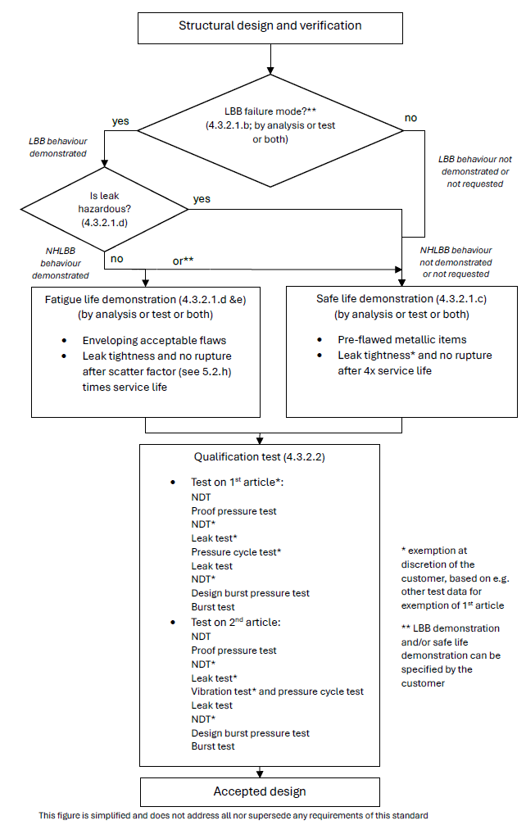
Figure 4-4: Development approach of MPV

Qualification tests
ECSS-E-ST-32-02_1660063
          - A first qualification test article shall be submitted to the following sequence of tests, or alternative sequence agreed between customer and supplier:
            - non-destructive testing (NDT);
            - proof pressure test;
            - leak test;
            - NDT;
            - pressure cycling test;
            - leak test;
            - design burst pressure test;
            - burst test.
This the standard sequence of tests specified in ECSS-E-ST-10-03. Examples of rationale for changes to this sequence are:
- Additional qualification test types (e.g. thermal) or inspection steps (e.g. before burst pressure testing).
- Identified risk that for the particular design the defined specified sequence can be either unconservative or unnecessarily conservative.
- Omission of test types based e.g. on successful heritage/similarity, testing of engineering model or analysis-based verification approach. Examples: pressure cycling test, burst test, NDT steps.
ECSS-E-ST-32-02_1660064
          - The first qualification test article specified in 4.3.2.2a may be deleted with customer approval.
Examples of rationale for deletion of a formal first qualification test article:
- Similarity with a qualified vessel giving confidence in the robustness of the design and manufacturing processes.
- Successful testing of a representative engineering model.
- Additional factors that can be considered: simplicity of the design, actual margins, heritage of the supplier.
ECSS-E-ST-32-02_1660065
          - A second qualification test article shall be submitted to the following sequence of tests, or alternative sequence agreed between customer and supplier:
            - NDT;
            - proof pressure test;
            - leak test;
            - NDT;
            - vibration tests;
            - pressure cycling test;
            - leak test;
            - design burst pressure test;
            - burst test.
This the standard sequence of tests specified in ECSS-E-ST-10-03. Examples of rationale for changes to this sequence are:
- Additional qualification test types (e.g. thermal) or inspection steps (e.g. before burst pressure testing).
- Identified risk that for the particular design the defined sequence can be either unconservative or unnecessarily conservative.
- Omission of test types based on e.g. successful heritage/similarity, testing of engineering model or analysis-based verification approach.
ECSS-E-ST-32-02_1660066
          - The leak test and NDT after proof pressure test, specified in 4.3.2.2c, and the final burst test specified in 4.3.2.2c may be deleted with customer approval.
ECSS-E-ST-32-02_1660067
          - When the vibration loads are enveloped by the other qualification tests, the vibration tests specified in 4.3.2.2c may be deleted with customer approval.
ECSS-E-ST-32-02_1660068
          - Clause 5.4 shall be applied to the qualification tests.
ECSS-E-ST-32-02_1660069
          - The need to apply external loads in combination with internal pressure during qualification testing shall be considered taking into account their relative magnitude, the fatigue and destabilizing effects of external loads.
1 This is considered, for example, for cases where locally or globally non-pressure loads are significant, and applicable yield or ultimate combined load cases are not covered by proof or burst testing, contradicting to some extent the characteristic that pressure loads are dominant, and where it is not acceptable to cover the difference by analysis, similarity, test on design detail, etc. In vibration testing the vibration loads, per axis, will actually apply the strength qualification test factor, but no test factor on pressure.
2 Example: static (spin) testing, mentioned in ECSS-E-ST-10-03, can be an option if qualification cannot be achieved uni-axially during vibration.
ECSS-E-ST-32-02_1660070
          - If external cycling loads are applied, the load shall be cycled to design limit load for four times the predicted number of operating cycles of the most severe design condition.
1 Examples: Destabilizing load with constant minimum internal pressure or maximum additive load with a constant MDP.
The actual cycle life can be complex and is often replaced by a simplified test spectrum, of comparable severity, in the cycling test.
2 Design limit load (DLL) for pressurized hardware is normally defined, in accordance with Figure 4-1 and Table 4-1 of ECSS-E-ST-32-10, as K_{P} x K_{M} x limit load (LL) for pressure load. For loads other than internal pressure the Satellite Test Logic of Figure 4-1 of ECSS-E-ST-32-10 is applied, for example.

Acceptance tests
ECSS-E-ST-32-02_1660071
          - All hardware shall be submitted to the following sequence of tests, or alternative sequence agreed between customer and supplier:
            - initial NDT, in order to establish the initial condition of the hardware;
            - proof pressure test;
            - leak test;
            - final NDT.
For example:
- The NDT prior to proof test can be substituted for that of the manufacturing process.
ECSS-E-ST-32-02_1660072
          - Clause 5.5 shall be applied to the acceptance tests.
ECSS-E-ST-32-02_1660073
          - Final NDT shall be performed on the weld-joints of the MPV as a minimum.

COPV with metallic liner

Development approach
ECSS-E-ST-32-02_1660074
          - Clause 5.2 on structural engineering shall be applied.
For composite hardware this includes consideration of stress rupture (see 5.2j) as well as prevention of failure due to mechanical impact damage (see 4.2.3 on damage control).
ECSS-E-ST-32-02_1660075
          - A stiffness demonstration shall be performed by analysis and test.
ECSS-E-ST-32-02_1660076
          - A strength and stability demonstration shall be performed by analysis and test.
ECSS-E-ST-32-02_1660077
          - If specified, or relevant to comply with 4.3.3.1e, the LBB failure mode shall be demonstrated by analysis or test or both according to clause 5.3.
ECSS-E-ST-32-02_1660078
          - For metallic COPV liners with a non‐hazardous LBB failure mode, the safe‐life demonstration specified in 4.3.3.1f may be replaced by a fatigue life demonstration by analysis or test or both in conformance with 5.2.h and ECSS-E-ST-32, considering credible manufacturing imperfections and defects to the extent agreed between customer and supplier .
This can have an impact on the mission reliability.
If a project is rated highly critical by the customer due to considerations other than safety, safe life to leakage verification of the metallic liner is sometimes requested instead of, or in addition to, LBB verification.
It is recommended that this agreement is achieved as early as possible, for example in the statement of work and associated baseline requirements, and then reflected in the Fracture Control Plan.
ECSS-E-ST-32-02_1660079
          - Except in the case specified in 4.3.3.1e, ‘safe life item’ demonstration shall be performed for the metallic liner by analysis or test or both in conformance with ECSS-E-ST-32-01.
Plastically operating liners, during autofrettage or post autofrettage cycles, can be difficult to verify for crack propagation by analysis only. See for example 7.2.8.i-j and 7.3.b of ECSS-E-ST-32-01.
ECSS-E-ST-32-02_1660080
          - Fatigue-life demonstration shall be performed for the composite over-wrap by analysis or test or both in conformance with ECSS-E-ST-32.
ECSS-E-ST-32-02_1660081
          - Qualification tests shall be conducted according to clause 4.3.3.2 to demonstrate the structural adequacy of the design.
ECSS-E-ST-32-02_1660082
          - For corrosion control and prevention, the requirements in ECSS-E-ST-32 shall apply.
ECSS-E-ST-32 refers to ECSS-Q-ST-70 and related standards.
ECSS-E-ST-32-02_1660083
          - For hydrogen embrittlement phenomena, requirements shall be applied in conformance with ECSS-E-ST-32-08.
ECSS-E-ST-32-02_1660084
          - For material selection, material design allowables and their characterisation, requirements shall be applied in conformance with clause 5.6 and ECSS-E-ST-32.
ECSS-E-ST-32-02_1660085
          - For ‘process control’, requirements shall be in conformance with ECSS-Q-ST-70.
ECSS-E-ST-32-02_1660086
          - Inspections shall be applied according to clause 5.7.
The development approach is illustrated in Figure 4-5.

Qualification tests
ECSS-E-ST-32-02_1660087
          - A first qualification test article shall be submitted to the following sequence of tests, or alternative sequence agreed between customer and supplier:
            - non-destructive testing (NDT);
            - proof pressure test;
            - leak test;
            - NDT;
            - pressure cycling test;
            - leak test;
            - design burst pressure test;
            - burst test.
This the standard sequence of tests specified in ECSS-E-ST-10-03. Examples of rationale for changes to this sequence are:
- Additional qualification test types (e.g. thermal) or inspection steps (e.g. before burst pressure testing).
- Identified risk that for the particular design the defined sequence can be either unconservative or unnecessarily conservative.
- Omission of test types based on e.g. successful heritage/similarity, testing of engineering model or analysis-based verification approach. Examples: pressure cycling test, burst test, NDT steps.
ECSS-E-ST-32-02_1660088
          - The first qualification test article specified in 4.3.3.2a may be deleted with customer approval.
Examples of rationale for deletion of a formal first qualification test article:
- Similarity with a qualified vessel giving confidence in the robustness of the design and manufacturing processes.
- Successful testing of a representative engineering model.
- Additional factors that can be considered: simplicity of the design, actual margins, heritage of the supplier.
ECSS-E-ST-32-02_1660089
          - A second qualification test article shall be submitted to the following sequence of tests, or alternative sequence agreed between customer and supplier:
            - NDT;
            - proof pressure test;
            - leak test;
            - NDT;
            - vibration tests;
            - pressure cycling test;
            - leak test;
            - design burst pressure test;
            - burst test.
This the standard sequence of tests specified in ECSS-E-ST-10-03. Examples of rationale for changes to this sequence are:
- Additional qualification test types (e.g. thermal) or inspection steps (e.g. before burst pressure testing).
- Identified risk that for the particular design the defined sequence can be either unconservative or unnecessarily conservative.
- Omission of test types based on e.g. successful heritage/similarity, testing of engineering model or analysis-based verification approach.
ECSS-E-ST-32-02_1660090
          - The leak test and NDT after proof pressure test specified in 4.3.3.2c, and the final burst test specified in 4.3.3.2c may be deleted with customer approval.
ECSS-E-ST-32-02_1660091
          - When the vibration loads are enveloped by the other qualification tests, the vibration tests specified in 4.3.3.2c may be deleted with customer approval.
ECSS-E-ST-32-02_1660092
          - NDT operations shall be applied to the over-wrap, in addition to NDT on the liner.
ECSS-E-ST-32-02_1660093
          - Clause 5.4 shall be applied to the qualification tests.
ECSS-E-ST-32-02_1660094
          - The need to apply external loads in combination with internal pressure during qualification testing shall be considered taking into account their relative magnitude, the fatigue and destabilizing effects of external loads.
1 This is considered, for example, for cases where locally or globally non-pressure loads are significant, and applicable yield or ultimate combined load cases are not covered by proof or burst testing, contradicting to some extent the characteristic that pressure loads are dominant, and where it is not acceptable to cover the difference by analysis, similarity, test on design detail, etc. In vibration testing the vibration loads, per axis, will actually apply the strength qualification test factor, but no test factor on pressure.
2 Example: static (spin) testing, mentioned in ECSS-E-ST-10-03, can be an option if qualification cannot be achieved uni-axially during vibration.
ECSS-E-ST-32-02_1660095
          - If external cycling loads are applied, the load shall be cycled to design limit load for four times the predicted number of operating cycles of the most severe design condition.
1 For example: destabilizing load with constant minimum internal pressure or maximum additive load with a constant MDP.
The actual cycle life can be complex and is often replaced by a simplified test spectrum, of comparable severity, in the cycling test.
2 Design limit load (DLL) for pressurized hardware is normally defined, in accordance with Figure 4-1 and Table 4-1 of ECSS-E-ST-32-10, as K_{P} x K_{M} x limit load (LL) for pressure load. For loads other than internal pressure the Satellite Test Logic of Figure 4-1 of ECSS-E-ST-32-10C is applied, for example.

Acceptance tests
ECSS-E-ST-32-02_1660096
          - All hardware shall be submitted to the following sequence of tests, or alternative sequence agreed between customer and supplier:
            - initial NDT, in order to establish the initial condition of the hardware;
            - proof pressure test;
            - leak test;
            - final NDT.
For example:
- The NDT prior to proof test can be substituted for that of the manufacturing process.
- Proof test monitoring by acoustic emission is acceptable for composite items (i.e. not for the liner) instead of post testing NDT, with customer approval. Detailed acoustic emission procedures, with proven health monitoring capability, are agreed per NDT plan, in line with the general requirements of clauses 5 and 9 of the ECSS-Q-ST-70-15.
ECSS-E-ST-32-02_1660097
          - Initial NDT operations shall be applied to the over-wrap, in addition to NDT on the liner.
ECSS-E-ST-32-02_1660098
          - Clause 5.5 shall be applied to the acceptance tests.
ECSS-E-ST-32-02_1660099
          - Final NDT shall be performed on the over-wrap of the COPV as a minimum.
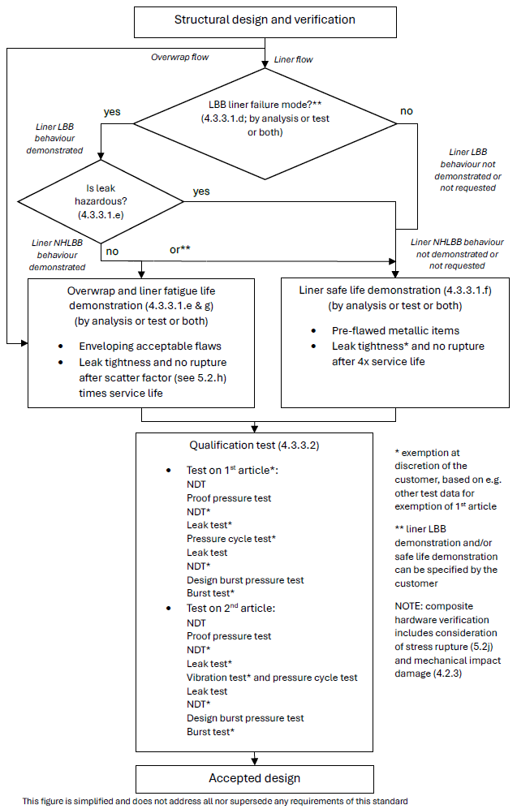
Figure 4-5: Development approach of COPV with metallic liner
(relevant also for COPC and COSPE with metallic liner)

COPV with homogeneous non metallic liner and CPV

Development approach
ECSS-E-ST-32-02_1660100
          - Clause 5.2 on structural engineering shall be applied.
For composite hardware this includes consideration of stress rupture (see 5.2j) as well as prevention of failure due to mechanical impact damage (see 4.2.3 on damage control).
ECSS-E-ST-32-02_1660101
          - A stiffness demonstration shall be performed by analysis and test.
ECSS-E-ST-32-02_1660102
          - A strength and stability demonstration shall be performed by analysis and test.
ECSS-E-ST-32-02_1660103
          - If specified, or relevant to comply with 4.3.4.1e, the LBB failure mode shall be demonstrated using a method agreed with the customer.
Experience with non-metallic lined COPV and CPV is limited in spaceflight applications, and LBB failure mode demonstration according to 5.3 can be difficult or not relevant (see also e and f below). No definite requirements are therefore provided in this standard on whether and how to apply clause 5.3, and specifically 5.3.4 (Demonstration of LBB by test using full-scale article).
ECSS-E-ST-32-02_1660104
          - For COPV liners with a non‐hazardous LBB failure mode, the safe‐life demonstration specified in 4.3.4.1h may be replaced by a fatigue life demonstration by analysis or test or both in conformance with 5.2h and ECSS-E-ST-32, considering credible manufacturing imperfections and defects to the extent agreed between customer and supplier.
1 This can have an impact on the mission reliability.
If a project is rated highly critical by the customer due to considerations other than safety, safe life to leakage verification of the metallic liner is sometimes requested instead of, or in addition to, LBB verification.
It is recommended that this agreement is achieved as early as possible, for example in the statement of work and associated baseline requirements, and then reflected in the Fracture Control Plan.
2 The fulfilment of this requirement is sometimes possible without LBB analysis or test per 5.3, for liners that do not experience significant load when compared to the overwrap. Example: thermoplastic liner, see e.g. AIAA G-082.
ECSS-E-ST-32-02_1660105
          - The CPV shall exhibit a LBB failure mode, if requested by the customer.
Experience with CPV is limited, and LBB demonstration can be difficult or not relevant for the composite wall. No definite guidance is therefore provided in this standard.
ECSS-E-ST-32-02_1660106
          - When the non-metallic liner of the COPV remains in compression up to MDP and surface flaws do not propagate during the LBB test, the flaws pre-fabricated in the liner of the LBB full-scale specimen may be through cracks.
ECSS-E-ST-32-02_1660107
          - Except in the case specified in 4.3.4.1e, ‘safe life item’ demonstration of the liner shall be performed in conformance with ECSS-E-ST-32-01:
            - by test for non-metallic items;
            - by analysis or test or both for metallic items, for example metallic bosses.
Plastically operating metallic parts of liners, during autofrettage or post autofrettage cycles, can be difficult to verify for crack propagation by analysis only. See for example 7.2.8.i-j and 7.3.b of ECSS-E-ST-32-01.
ECSS-E-ST-32-02_1660108
          - Qualification tests shall be conducted according to clause 4.3.4.2 to demonstrate the structural adequacy of the design.
ECSS-E-ST-32-02_1660109
          - For corrosion control and prevention, the requirements in ECSS-E-ST-32 shall apply.
ECSS-E-ST-32 refers to ECSS-Q-ST-70 and related standards.
ECSS-E-ST-32-02_1660110
          - For hydrogen embrittlement phenomena, requirements shall be applied in conformance with ECSS-E-ST-32-08.
ECSS-E-ST-32-02_1660111
          - For material selection, material design allowables and their characterisation, requirements shall be applied in conformance with clause 5.6 and ECSS-E-ST-32.
ECSS-E-ST-32-02_1660112
          - For ‘process control’, requirements shall be in conformance with ECSS-Q-ST-70.
ECSS-E-ST-32-02_1660113
          - Inspections shall be applied according to clause 5.7.
The development approach is illustrated in Figure 4-6 and Figure 4-7.
ECSS-E-ST-32-02_1660114
          - Fatigue-life demonstration shall be performed for the composite over-wrap and wall by analysis or test or both in conformance with ECSS-E-ST-32.

Qualification tests
ECSS-E-ST-32-02_1660115
          - A first qualification test article shall be submitted to the following sequence of tests, or alternative sequence agreed between customer and supplier:
            - non-destructive testing (NDT);
            - proof pressure test;
            - leak test;
            - NDT;
            - pressure cycling test;
            - leak test;
            - design burst pressure test;
            - burst test.
This the standard sequence of tests specified in ECSS-E-ST-10-03. Examples of rationale for changes to this sequence are:
- Additional qualification test types (e.g. thermal) or inspection steps (e.g. before burst pressure testing).
- Identified risk that for the particular design the defined sequence can be either unconservative or unnecessarily conservative.
- Omission of test types based on e.g. successful heritage/similarity, testing of engineering model or analysis-based verification approach. Examples: pressure cycling test, burst test, NDT steps.
ECSS-E-ST-32-02_1660116
          - The first qualification test article specified in 4.3.4.2a may be deleted with customer approval.
Examples of rationale for deletion of a formal first qualification test article:
- Similarity with a qualified vessel giving confidence in the robustness of the design and manufacturing processes.
- Successful testing of a representative engineering model.
- Additional factors that can be considered: simplicity of the design, actual margins, heritage of the supplier.
ECSS-E-ST-32-02_1660117
          - A second qualification test article shall be submitted to the following sequence of tests, or alternative sequence agreed between customer and supplier:
            - NDT;
            - proof pressure test;
            - leak test;
            - NDT;
            - vibration tests;
            - pressure cycling test;
            - leak test;
            - design burst pressure test;
            - burst test.
This the standard sequence of tests specified in ECSS-E-ST-10-03. Examples of rationale for changes to this sequence are:
- Additional qualification test types (e.g. thermal) or inspection steps (e.g. before burst pressure testing).
- Identified risk that for the particular design the defined sequence can be either unconservative or unnecessarily conservative.
- Omission of test types based on e.g. successful heritage/similarity, testing of engineering model or analysis-based verification approach.
ECSS-E-ST-32-02_1660118
          - The leak test and NDT after proof pressure test specified in 4.3.4.2c, and the final burst test specified in 4.3.4.2c may be deleted with customer approval.
ECSS-E-ST-32-02_1660119
          - When the vibration loads are enveloped by the other qualification tests, the vibration tests specified in 4.3.4.2c may be deleted with customer approval.
ECSS-E-ST-32-02_1660120
          - For COPV, NDT operations shall be applied to the over-wrap, in addition to NDT on the liner.
ECSS-E-ST-32-02_1660121
          - For CPV, NDT operations shall be applied to the composite wall.
ECSS-E-ST-32-02_1660122
          - Clause 5.4 shall be applied to the qualification tests.
ECSS-E-ST-32-02_1660123
          - The need to apply external loads in combination with internal pressure during qualification testing shall be considered taking into account their relative magnitude, the fatigue and destabilizing effects of external loads.
1 This is considered, for example, for cases where locally or globally non-pressure loads are significant, and applicable yield or ultimate combined load cases are not covered by proof or burst testing, contradicting to some extent the characteristic that pressure loads are dominant, and where it is not acceptable to cover the difference by analysis, similarity, test on design detail, etc. In vibration testing the vibration loads, per axis, will actually apply the strength qualification factor, but no test factor on pressure.
2 Example: static (spin) testing, mentioned in ECSS-E-ST-10-03, can be an option if qualification cannot be achieved uni-axially during vibration.
ECSS-E-ST-32-02_1660124
          - If external cycling loads are applied, the load shall be cycled to design limit load for four times the predicted number of operating cycles of the most severe design condition.
1 Examples: Destabilizing load with constant minimum internal pressure or maximum additive load with a constant MDP.
The actual cycle life can be complex and is often replaced by a simplified test spectrum, of comparable severity, in the cycling test.
2 Design limit load (DLL) for pressurized hardware is normally defined, in accordance with Figure 4-1 and Table 4-1 of ECSS-E-ST-32-10, as K_{P} x K_{M} x limit load (LL) for pressure load. For loads other than internal pressure the Satellite Test Logic of Figure 4-1 of ECSS-E-ST-32-10 is applied, for example.

Acceptance tests
ECSS-E-ST-32-02_1660125
          - All hardware shall be submitted to the following sequence of tests, or alternative sequence agreed between customer and supplier:
            - initial NDT, in order to establish the initial condition of the hardware;
            - proof pressure test;
            - leak test;
            - final NDT.
For example:
- The NDT prior to proof test can be substituted for that of the manufacturing process.
- Proof test monitoring by acoustic emission is acceptable for composite items instead of post testing NDT, with customer approval. Detailed acoustic emission procedures, with proven health monitoring capability, are agreed per NDT plan, in line with the general requirements of clauses 5 and 9 of the ECSS-Q-ST-70-15.
ECSS-E-ST-32-02_1660126
          - For COPV, initial NDT operations shall be applied to the over-wrap, in addition to NDT on the liner.
ECSS-E-ST-32-02_1660127
          - For CPV, NDT operations shall be applied to the composite wall as a minimum.
ECSS-E-ST-32-02_1660128
          - Clause 5.5 shall be applied to the acceptance tests.
ECSS-E-ST-32-02_1660129
          - Final NDT shall be performed on the over-wrap of the COPV as a minimum.
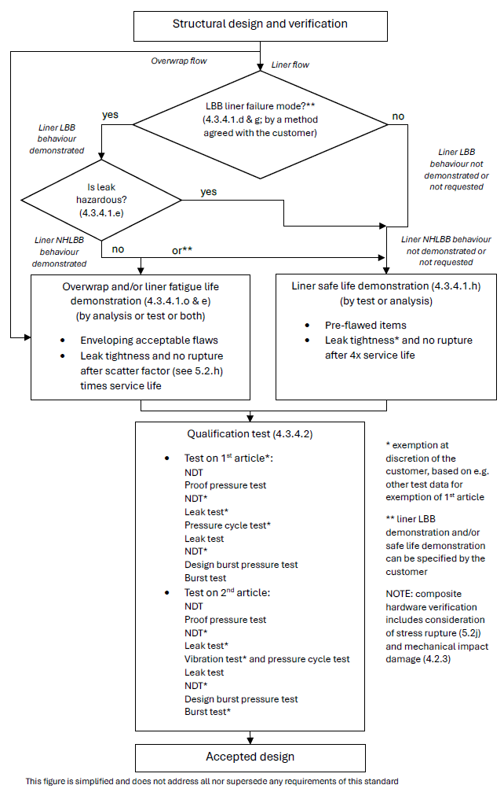
Figure 4-6: Development approach of COPV with homogeneous non metallic liner
(Relevant also for COPC and COSPE with homogeneous non-metallic liner)
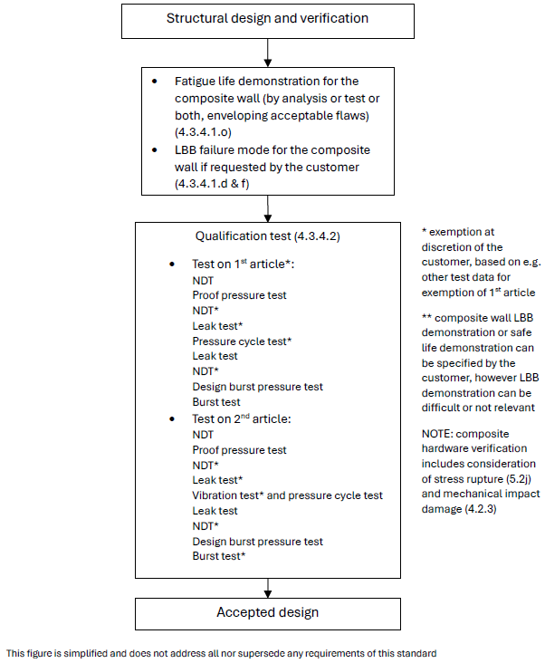
Figure 4-7: Development approach of CPV

Pressurized structures

Factors of safety
ECSS-E-ST-32-02_1660130
          - The values in Table 4-1 and Table 4-2 shall be applied as minimum values of factors of safety for internal pressure of pressurized structures (PS) and manned modules.
Exceptions to the values provided in Table 4-1, Table 4-2 or ECSS-E-ST-32-10 are sometimes specified by the customer or granted with customer approval.
Examples of reasons for exceptions: ground/range safety rules, mitigation of concerns due to time dependent phenomena like creep and for composites stress rupture, human safety during the mission.
ECSS-E-ST-32-02_1660131
          - The values specified in ECSS-E-ST-32-10 for ‘pressurized hardware’ shall be applied as minimum values of factors of safety for loads different from internal pressure.
Exceptions to the values provided in Table 4-1, Table 4-2 or ECSS-E-ST-32-10 are sometimes specified by the customer or granted with customer approval.
Examples of reasons for exceptions: ground/range safety rules, mitigation of concerns due to time dependent phenomena like creep and for composites stress rupture, human safety during the mission.

Metallic pressurized structures

Development approach
ECSS-E-ST-32-02_1660132
          - Clause 5.2 on structural engineering shall be applied.
1 Pressurized structures are both pressurized hardware and structures. It is specifically emphasized here that it is important to ensure that both the specific pressurized hardware requirements of this standard and the structural requirements of the other ECSS structural standards are met.
Solid propellant motor cases are not covered by this standard, unless specified or agreed otherwise.
2 Clause 5.2 refers to the requirements of ECSS-E-ST-32, which include requirements on stiffness, strength and stability.
ECSS-E-ST-32-02_1660133
          - If specified, or relevant to comply with 4.4.2.1.d, the LBB failure mode shall be demonstrated by analysis or test or both according to clause 5.3.
ECSS-E-ST-32-02_1660134
          - Except in the case specified in 4.4.2.1d, ‘safe life item’ demonstration shall be performed by analysis or test or both in conformance with ECSS-E-ST-32-01.
Relevant requirements can be found, for example, in clauses 8.2.1 (Pressurized hardware General) and 8.2.3 (Pressurized structures) of the ECSS-E-ST-32-01.
ECSS-E-ST-32-02_1660135
          - For pressurized structures with a non-hazardous LBB failure mode, the safe-life demonstration specified in 4.4.2.1c may be replaced by a fatigue life demonstration by analysis or test or both, with customer approval.
This can have an impact on the mission reliability.
NHLBB demonstration, either full or partial, can be challenging for pressurized structures, because pressure is most likely not the dominant loading type.
Also, if a project is rated highly critical by the customer due to considerations other than safety, safe life to leakage verification of the metallic pressurized structure is sometimes requested instead of, or in addition to, LBB verification.
It is recommended that this agreement is achieved as early as possible, for example in the statement of work and associated baseline requirements, and then reflected in the Fracture Control Plan.
ECSS-E-ST-32-02_1660136
          - In the case specified in 4.4.2.1d, requirements for ‘fatigue analysis’ shall be applied in conformance with 5.2.h and ECSS-E-ST-32, considering credible manufacturing imperfections and defects to the extent agreed between customer and supplier.
Requirement 5.2h specifies a scatter factor of 5 for fatigue analysis.
ECSS-E-ST-32-02_1660137
          - Qualification tests shall be conducted according to clause 4.4.2.2 to demonstrate the structural adequacy of the design.
ECSS-E-ST-32-02_1660138
          - For corrosion control and prevention,, the requirements in ECSS-E-ST-32 shall apply.
ECSS-E-ST-32 refers to ECSS-Q-ST-70 and related standards.
ECSS-E-ST-32-02_1660139
          - For hydrogen embrittlement phenomena, requirements shall be applied in conformance with ECSS-E-ST-32-08.
ECSS-E-ST-32-02_1660140
          - For material selection, material design allowables and their characterisation, requirements shall be applied in conformance with ECSS-E-ST-32.
ECSS-E-ST-32-02_1660141
          - For ‘process control’, requirements shall be in conformance with ECSS-Q-ST-70.
ECSS-E-ST-32-02_1660142
          - Inspections shall be applied according to clause 5.7.
The development approach is illustrated in Figure 4-8.
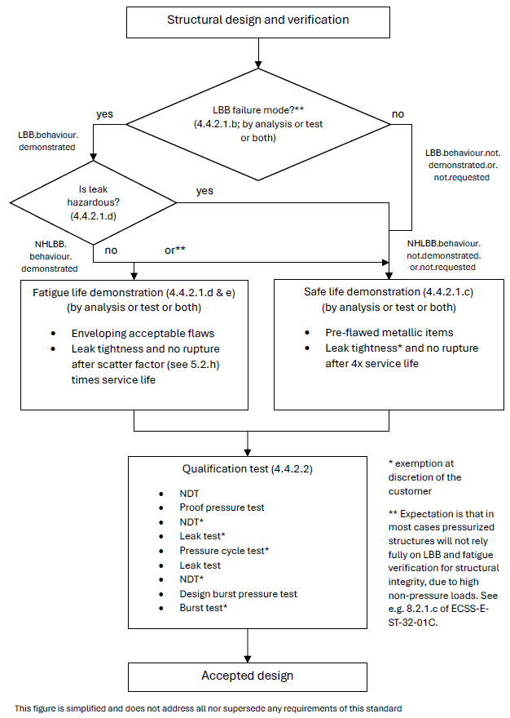
Figure 4-8: Development approach of MPS

Qualification tests
ECSS-E-ST-32-02_1660143
          - The qualification test article shall be submitted to the following sequence of tests, or alternative sequence agreed between customer and supplier:
            - NDT;
            - proof pressure test;
            - leak test;
            - NDT;
            - pressure cycling test;
            - leak test;
            - design burst pressure test;
            - burst test.
This is based on the standard sequence of tests specified in ECSS-E-ST-10-03. Examples of rationale for changes to this sequence are:
- Additional qualification test types (e.g. thermal) or inspection steps (e.g. before burst pressure testing).
- Identified risk that for the particular design the defined sequence can be either unconservative or unnecessarily conservative.
- Omission of test types based e.g. on successful heritage/similarity, testing of engineering model or analysis-based verification approach. Examples: pressure cycling test, burst test, NDT steps.
ECSS-E-ST-32-02_1660144
          - Clause 5.4 shall be applied to the qualification tests.
ECSS-E-ST-32-02_1660145
          - The need to apply external loads in combination with internal pressure during qualification testing shall be considered taking into account their relative magnitude, fatigue and destabilizing effects of external loads, and agreed with the customer.
For a pressurized structure external loads, including thermo-mechanical loads, are normally significant in magnitude and therefore likely to be relevant for the qualification testing. In some cases the difference can be covered by analysis or similarity.
ECSS-E-ST-32-02_1660146
          - If external cycling loads are applied, the load shall be cycled to design limit load for four times the predicted number of operating cycles of the most severe design condition.
1 Examples: Destabilizing load with constant minimum internal pressure or maximum additive load with a constant MDP.
The actual cycle life can be complex and is often replaced by a simplified test spectrum, of comparable severity, in the cycling test.
2 Design limit load (DLL) for pressurized hardware is normally defined, in accordance with Figure 4-1 and Table 4-1 of ECSS-E-ST-32-10, as K_{P} x K_{M} x limit load (LL) for pressure load. For loads other than internal pressure the Satellite Test Logic of Figure 4-1 of ECSS-E-ST-32-10 is applied, for example.

Acceptance tests
ECSS-E-ST-32-02_1660147
          - All hardware shall be submitted to the following sequence of tests, or alternative sequence agreed between customer and supplier:
            - initial NDT, in order to establish the initial condition of the hardware;
            - proof pressure test;
            - leak test;
            - final NDT.
The NDT prior to proof test can be substituted for that of the manufacturing process.
ECSS-E-ST-32-02_1660148
          - Clause 5.5 shall be applied to the acceptance tests.
ECSS-E-ST-32-02_1660149
          - Final NDT shall be performed on the weld-joints of the MPS as a minimum.

COPS with metallic liner

Development approach
ECSS-E-ST-32-02_1660150
          - Clause 5.2 on structural engineering shall be applied.
1 Pressurized structures are both pressurized hardware and structures. It is specifically emphasized here that it is important to ensure that both the specific pressurized hardware requirements of this standard and the structural requirements of the other ECSS structural standards are met.
Solid propellant motor cases are not covered by this standard, unless specified or agreed otherwise.
2 For composite hardware this includes consideration of stress rupture (see 5.2j) as well as prevention of failure due to mechanical impact damage (see 4.2.3 on damage control).
ECSS-E-ST-32-02_1660151
          - A stiffness demonstration shall be performed by analysis and test.
ECSS-E-ST-32-02_1660152
          - A strength and stability demonstration shall be performed by analysis and test.
ECSS-E-ST-32-02_1660153
          - If specified, or relevant to comply with 4.4.3.1e, the LBB failure mode shall be demonstrated by analysis or test or both according to clause 5.3.
Experience with metallic lined COPS is limited in spaceflight applications, and LBB failure mode demonstration according to 5.3 can be difficult or not relevant (see also 4.4.3.1e and 4.4.3.1f below). No definite requirements are therefore provided in this standard on whether and how to apply clause 5.3, and specifically 5.3.4 (Demonstration of LBB by test using full-scale article).
ECSS-E-ST-32-02_1660154
          - For metallic COPS liners with a non‐hazardous LBB failure mode, the safe‐life demonstration specified in 4.4.3.1f may be replaced by a fatigue life demonstration by analysis or test or both in conformance with 5.2h and ECSS-E-ST-32, considering credible manufacturing imperfections and defects to the extent agreed between customer and supplier.
This can have an impact on the mission reliability. Moreover, demonstrating LBB for pressurized structures can be difficult due to the presence of significant non-pressure loads.
If a project is rated highly critical by the customer due to considerations other than safety, safe life to leakage verification of the metallic liner is sometimes requested instead of, or in addition to, LBB verification.
It is recommended that this agreement is achieved as early as possible, for example in the statement of work and associated baseline requirements, and then reflected in the Fracture Control Plan.
ECSS-E-ST-32-02_1660155
          - Except in the case specified in 4.4.3.1e, ‘safe life item’ demonstration shall be performed for the metallic liner by analysis or test or both in conformance with ECSS-E-ST-32-01.
Plastically operating liners, during autofrettage or post autofrettage cycles, can be difficult to verify for crack propagation by analysis only. See for example 7.2.8.i-j and 7.3.b of ECSS-E-ST-32-01.
ECSS-E-ST-32-02_1660156
          - ‘Safe life item’ demonstration shall be performed for the composite overwrap by analysis or test or both in conformance with clause 8.4 of ECSS-E-ST-32-01, unless agreed otherwise with the customer.
For fracture control of the composite overwrap, refer to 8.4 (Composite, bonded and sandwich structures) or possibly 11.2.2.5 (Safe life composite, bonded and sandwich; for non human spaceflight applications) of ECSS-E-ST-32-01. Application of 11.2.2.5 of ECSS-E-ST-32-01 can require a proof test with combined pressure and mechanical loads. Note that 8.2.3.1.c of ECSS-E-ST-32-01 specifies that pressurized structures which have composite overwrap are not implemented for human spaceflight missions without approval of the customer.
ECSS-E-ST-32-02_1660157
          - Qualification tests shall be conducted in conformance with clause 4.4.3.2 to demonstrate the structural adequacy of the design.
ECSS-E-ST-32-02_1660158
          - For corrosion control and prevention, the requirements in ECSS-E-ST-32 shall apply.
ECSS-E-ST-32 refers to ECSS-Q-ST-70 and related standards.
ECSS-E-ST-32-02_1660159
          - For hydrogen embrittlement phenomena, requirements shall be applied in conformance with ECSS-E-ST-32-08.
ECSS-E-ST-32-02_1660160
          - For material selection, material design allowables and their characterisation, requirements shall be applied in conformance with clause 5.6 and ECSS-E-ST-32.
ECSS-E-ST-32-02_1660161
          - For ‘process control’, requirements shall be in conformance with ECSS-Q-ST-70.
ECSS-E-ST-32-02_1660162
          - Inspections shall be applied according to clause 5.7.
The development approach is illustrated in Figure 4-9.

Qualification tests
ECSS-E-ST-32-02_1660163
          - The qualification test article shall be submitted to the following sequence of tests, or alternative sequence agreed between customer and supplier:
            - NDT;
            - proof pressure test;
            - leak test;
            - NDT;
            - pressure cycling test;
            - leak test;
            - design burst pressure test.
This is based on the standard sequence of tests specified in ECSS-E-ST-10-03. Examples of rationale for changes to this sequence are:
- Additional qualification test types (e.g. thermal) or inspection steps (e.g. before burst pressure testing).
- Identified risk that for the particular design the defined sequence can be either unconservative or unnecessarily conservative.
- Omission of test types based on e.g. successful heritage/similarity, testing of engineering model or analysis-based verification approach. Examples: pressure cycling test, burst test, NDT steps.
ECSS-E-ST-32-02_1660164
          - NDT operations shall be applied to the over-wrap, in addition to NDT on the liner.
ECSS-E-ST-32-02_1660165
          - Clause 5.4 shall be applied to the qualification tests.
ECSS-E-ST-32-02_1660166
          - The need to apply external loads in combination with internal pressure during qualification testing shall be considered taking into account their relative magnitude, fatigue and destabilizing effects of external loads, and agreed with the customer.
For a pressurized structure external loads, including thermo-mechanical loads, are normally significant in magnitude and therefore likely to be relevant for the qualification testing. In some cases the difference can be covered by analysis or similarity.
ECSS-E-ST-32-02_1660167
          - If external cycling loads are applied, the load shall be cycled to design limit load for four times the predicted number of operating cycles of the most severe design condition.
1 Example: Destabilizing load with constant minimum internal pressure or maximum additive load with a constant MDP.
The actual cycle life can be complex and is often replaced by a simplified test spectrum, of comparable severity, in the cycling test.
2 Design limit load (DLL) for pressurized hardware is normally defined, in accordance with Figure 4-1 and Table 4-1 of ECSS-E-ST-32-10, as K_{P} x K_{M} x limit load (LL) for pressure load. For loads other than internal pressure the Satellite Test Logic of Figure 4-1 of ECSS-E-ST-32-10 is applied, for example.

Acceptance tests
ECSS-E-ST-32-02_1660168
          - All hardware shall be submitted to the following sequence of tests, or alternative sequence agreed between customer and supplier:
            - initial NDT, in order to establish the initial condition of the hardware;
            - proof pressure test;
            - leak test;
            - final NDT.
For example:
- The NDT prior to proof test can be substituted for that of the manufacturing process.
- Proof test monitoring by acoustic emission is acceptable for composite items instead of post testing NDT, with customer approval. Detailed acoustic emission procedures, with proven health monitoring capability, are agreed per NDT plan, in line with the general requirements of clauses 5 and 9 of the ECSS-Q-ST-70-15.
ECSS-E-ST-32-02_1660169
          - Initial NDT operations shall be applied to the over-wrap, in addition to NDT on the liner.
ECSS-E-ST-32-02_1660170
          - Clause 5.5 shall be applied to the acceptance tests.
ECSS-E-ST-32-02_1660171
          - Final NDT shall be performed on the over-wrap of the COPS as a minimum.
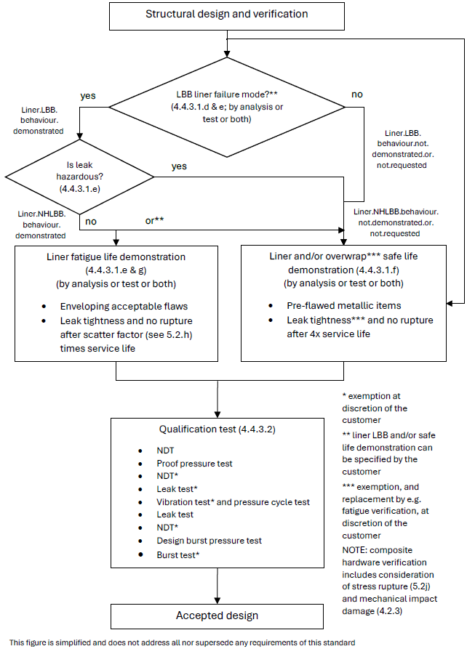
Figure 4-9: Development approach of COPS with metallic liner

COPS with homogeneous non metallic liner and CPS

Development approach
ECSS-E-ST-32-02_1660172
          - Clause 5.2 on structural engineering shall be applied.
1 Pressurized structures are both pressurized hardware and structures. It is specifically emphasized here that it is important to ensure that both the specific pressurized hardware requirements of this standard and the structural requirements of the other ECSS structural standards are met.
Solid propellant motor cases are not covered by this standard, unless specified or agreed otherwise.
2 For composite hardware this includes consideration of stress rupture (see 5.2j) as well as prevention of failure due to mechanical impact damage (see 4.2.3 on damage control).
ECSS-E-ST-32-02_1660173
          - A stiffness demonstration shall be performed by analysis and test.
ECSS-E-ST-32-02_1660174
          - A strength and stability demonstration shall be performed by analysis and test.
ECSS-E-ST-32-02_1660175
          - If specified, or relevant to comply with 4.4.4.1e, the LBB failure mode shall be demonstrated using a method agreed with the customer.
Experience with non-metallic lined COPS and CPS is limited in spaceflight applications, and LBB failure mode demonstration according to 5.3 can be difficult or not relevant (see also e and f below). No definite requirements are therefore provided in this standard on whether and how to apply clause 5.3, and specifically 5.3.4 (Demonstration of LBB by test using full-scale article).
ECSS-E-ST-32-02_1660176
          - For COPS liners with a non‐hazardous LBB failure mode, the safe‐life demonstration specified in 4.4.4.1h may be replaced by a fatigue life demonstration by analysis or test or both in conformance with 5.2h and ECSS-E-ST-32, considering credible manufacturing imperfections and defects to the extent agreed between customer and supplier.
1 This can have an impact on the mission reliability. Moreover, demonstrating LBB for pressurized structures can be difficult due to the presence of significant non-pressure loads.
If a project is rated highly critical by the customer due to considerations other than safety, safe life to leakage verification of the metallic liner is sometimes requested instead of, or in addition to, LBB verification.
It is recommended that this agreement is achieved as early as possible, for example in the statement of work and associated baseline requirements, and then reflected in the Fracture Control Plan.
2 The fulfilment of this requirement is sometimes possible without LBB analysis or test per 5.3, for liners that do not experience significant load when compared to the overwrap. Example: thermoplastic liner, see e.g. AIAA G-082.
ECSS-E-ST-32-02_1660177
          - The CPS shall exhibit a LBB failure mode, if requested by the customer.
Experience with CPS is limited in spaceflight applications, and LBB demonstration can be difficult or not relevant. No definite guidance is therefore provided in this standard.
ECSS-E-ST-32-02_1660178
          - When the non-metallic liner of the COPS remains in compression up to MDP and surface flaws do not propagate during the LBB test, the flaws pre-fabricated in the liner of the LBB full-scale specimen may be through cracks.
ECSS-E-ST-32-02_1660179
          - Except in the case specified in 4.4.4.1.e, ‘safe life item’ demonstration of the liner shall be performed in conformance with ECSS-E-ST-32-01:
            - by test for non-metallic items;
            - by analysis or test or both for metallic items (e.g. metallic bosses).
Plastically operating metallic parts of liners, during autofrettage or post autofrettage cycles, can be difficult to verify for crack propagation by analysis only. See for example 7.2.8.i-j and 7.3.b of ECSS-E-ST-32-01.
ECSS-E-ST-32-02_1660180
          - Qualification tests shall be conducted according to clause 4.4.4.2 to demonstrate the structural adequacy of the design.
ECSS-E-ST-32-02_1660181
          - For corrosion control and prevention, the requirements in ECSS-E-ST-32 shall apply.
ECSS-E-ST-32 refers to ECSS-Q-ST-70 and related standards.
ECSS-E-ST-32-02_1660182
          - For hydrogen embrittlement phenomena, requirements shall be applied in conformance with ECSS-E-ST-32-08.
ECSS-E-ST-32-02_1660183
          - For materials selection, material design allowables and their characterisation, requirements shall be applied in accordance with clause 5.6 and ECSS-E-ST-32.
ECSS-E-ST-32-02_1660184
          - For ‘process control’, requirements shall be in conformance with ECSS-Q-ST-70.
ECSS-E-ST-32-02_1660185
          - Inspections shall be applied according to clause 5.7.
The development approach is illustrated in Figure 4-10 and Figure 4-11.
ECSS-E-ST-32-02_1660186
          - ‘Safe life item’ demonstration shall be performed for the composite overwrap and the composite wall by analysis or test or both in conformance with clause 8.4 of ECSS-E-ST-32-01, unless agreed otherwise with the customer.
For fracture control of the composite overwrap, refer to 8.4 (Composite, bonded and sandwich structures) or possibly 11.2.2.5 (Safe life composite, bonded and sandwich; for non human spaceflight applications) of ECSS-E-ST-32-01. Application of 11.2.2.5 of ECSS-E-ST-32-01 can require a proof test with combined pressure and mechanical loads. Note that 8.2.3.1.c of ECSS-E-ST-32-01 specifies that pressurized structures which have composite overwrap are not implemented for human spaceflight missions without approval of the customer.

Qualification tests
ECSS-E-ST-32-02_1660187
          - The qualification test article shall be submitted to the following sequence of tests, or alternative sequence agreed between customer and supplier:
            - NDT;
            - proof pressure test;
            - leak test;
            - NDT;
            - pressure cycling test;
            - leak test;
            - design burst pressure test.
This is based on the standard sequence of tests specified in ECSS-E-ST-10-03. Examples of rationale for changes to this sequence are:
- Additional qualification test types (e.g. thermal) or inspection steps (e.g. before burst pressure testing).
- Identified risk that for the particular design the defined sequence can be either unconservative or unnecessarily conservative.
- Omission of test types based on e.g. successful heritage/similarity, testing of engineering model or analysis-based verification approach. Examples: pressure cycling test, burst test, NDT steps.
ECSS-E-ST-32-02_1660188
          - For COPS, NDT operations shall be applied to the over-wrap, in addition to NDT on the liner.
ECSS-E-ST-32-02_1660189
          - For CPS, NDT operations shall be applied to the composite wall.
ECSS-E-ST-32-02_1660190
          - Clause 5.4 shall be applied to the qualification tests.
ECSS-E-ST-32-02_1660191
          - The need to apply external loads in combination with internal pressure during qualification testing shall be considered taking into account their relative magnitude, fatigue and destabilizing effects of external loads, and agreed with the customer.
For a pressurized structure external loads, including thermo-mechanical loads, are normally significant in magnitude and therefore likely to be relevant for the qualification testing. In some cases the difference can be covered by analysis or similarity.
ECSS-E-ST-32-02_1660192
          - If external cycling loads are applied, the load shall be cycled to design limit load for four times the predicted number of operating cycles of the most severe design condition.
1 Examples: Destabilizing load with constant minimum internal pressure or maximum additive load with a constant MDP.
The actual cycle life can be complex and is often replaced by a simplified test spectrum, of comparable severity, in the cycling test.
2 Design limit load (DLL) for pressurized hardware is normally defined, in accordance with Figure 4-1 and Table 4-1 of ECSS-E-ST-32-10, as K_{P} x K_{M} x limit load (LL) for pressure load. For loads other than internal pressure the Satellite Test Logic of Figure 4-1 of ECSS-E-ST-32-10 is applied, for example.

Acceptance tests
ECSS-E-ST-32-02_1660193
          - All hardware shall be submitted to the following sequence of tests, or alternative sequence agreed between customer and supplier:
            - initial NDT, in order to establish the initial condition of the hardware;
            - proof pressure test;
            - leak test;
            - final NDT.
For example:
- The NDT prior to proof test can be substituted for that of the manufacturing process.
- Proof test monitoring by acoustic emission is acceptable for composite items instead of post testing NDT, with customer approval. Detailed acoustic emission procedures, with proven health monitoring capability, are agreed per NDT plan, in line with the general requirements of clauses 5 and 9 of the ECSS-Q-ST-70-15.
ECSS-E-ST-32-02_1660194
          - For COPS, initial NDT operations shall be applied to the over-wrap, in addition to NDT on the liner.
ECSS-E-ST-32-02_1660195
          - For CPS, NDT operations shall be applied to the composite wall as a minimum.
ECSS-E-ST-32-02_1660196
          - Clause 5.5 shall be applied to the acceptance tests.
ECSS-E-ST-32-02_1660197
          - Final NDT shall be performed on the over-wrap of the COPS as a minimum.
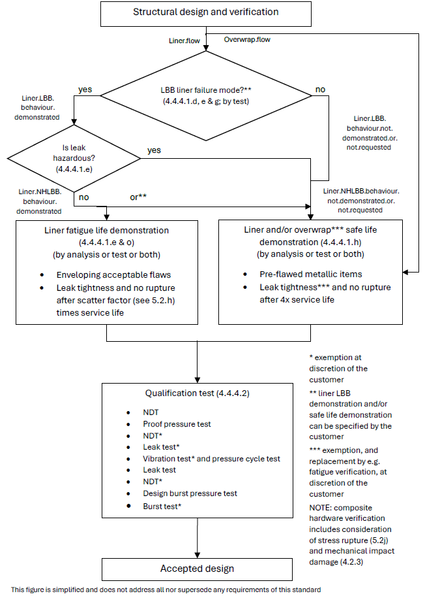
Figure 4-10: Development approach of COPS with homogeneous non metallic liner
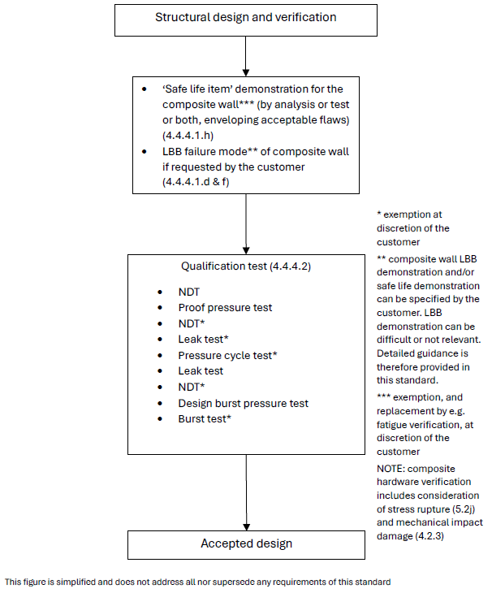
Figure 4-11: Development approach of CPS

Pressure components

Metallic pressure components

Factors of safety
ECSS-E-ST-32-02_1660198
          - The values in Table 4-1 and Table 4-2 shall be applied as minimum values of factors of safety for internal pressure of metallic pressure components (MPC).
ECSS-E-ST-32-02_1660199
          - The values specified in ECSS-E-ST-32-10 for ‘pressurized hardware’ shall be applied as minimum values of factors of safety for loads different from internal pressure.
to items a and b. Exceptions to the values provided in Table 4-1, Table 4-2 or ECSS-E-ST-32-10 are sometimes specified by the customer or granted with customer approval.
Examples of reasons for exceptions: ground/range safety rules, mitigation of concerns due to time dependent phenomena like creep, human safety during the mission.

Development approach
ECSS-E-ST-32-02_1660200
          - Clause 5.2 on structural engineering shall be applied.
1 Thermal, stress and strain analyses and stiffness, strength and stability demonstrations are sometimes substituted with certification from qualified aerospace suppliers, with customer approval.
2 Clause 5.2 refers to the requirements of ECSS-E-ST-32, which include requirements on stiffness, strength and stability.
ECSS-E-ST-32-02_1660201
          - Qualification tests shall be conducted according to clause 4.5.1.3 to demonstrate the structural adequacy of the design.
ECSS-E-ST-32-02_1660202
          - A ‘safe life item’ or ‘nonhazardous LBB failure mode’ demonstration shall be performed by analysis or test or both in conformance with clause 5.3 and ECSS-E-ST-32-01 for metallic pressure components.
1 Relevant requirements can be found, for example, in clauses 8.2.1 (Pressurized hardware General), 8.2.4 (Pressure components, including lines and fittings) and 8.2.7 (Pressurized components with non-hazardous LBB failure mode) of the ECSS-E-ST-32-01. Including in particular 8.2.4.b (proof factor 1,5), 8.2.4.c (inspection of fusion joints) and 8.2.1.b (pressure dominance).
2 If the criteria of clause 8.2.4.b, 8.2.1.b or 8.2.7 of ECSS-E-ST-32-01 are not met, and the fatigue verification in accordance with item d below is considered insufficient, a crack-growth verification based on initial crack size based on applied NDT can apply.
ECSS-E-ST-32-02_1660203
          - Fatigue-life demonstration shall be performed by analysis or test or both in conformance with 5.2.h and ECSS-E-ST-32, considering credible manufacturing imperfections and defects to the extent agreed between customer and supplier.
1 No explicit requirement for safe life analysis is specified in 4.5.1.2c and 4.5.1.2d, for many pressure components proof pressure tested to a factor 1,5 or higher. For applications, with more critical characteristics, some degree of damage tolerance verification is sometimes performed to mitigate the risk of catastrophic failure in service, as well as providing justification for the applied inspection methods and associated acceptance criteria. These characteristics include, for example:
- subjected to significant non-pressure loads,
- subjected to significant fatigue load cycles,
- human spaceflight applications,
- involving materials and processes with increased risk of creating defects, for example welding, but also brazing, casting, additive manufacturing, (custom) forging processes.
Proof and leak testing alone does not always provide sufficient flaw screening.
2 Requirement 5.2h specifies a scatter factor of 5 for fatigue analysis.
ECSS-E-ST-32-02_1660204
          - For corrosion control and prevention, the requirements in ECSS-E-ST-32 shall apply.
ECSS-E-ST-32 refers to ECSS-Q-ST-70 and related standards.
ECSS-E-ST-32-02_1660205
          - For hydrogen embrittlement phenomena, requirements shall be applied in conformance with ECSS-E-ST-32-08.
ECSS-E-ST-32-02_1660206
          - For material selection, material design allowables and their characterisation, requirements shall be applied in conformance with ECSS-E-ST-32.
ECSS-E-ST-32-02_1660207
          - For ‘process control’, requirements shall be in conformance with ECSS-Q-ST-70.
ECSS-E-ST-32-02_1660208
          - Inspections shall be applied according to clause 5.7.
For example:
- The development approach is illustrated in Figure 4-12.
- Failure mode demonstration as per clause 5.3 is sometimes specified by the customer.

Qualification tests
ECSS-E-ST-32-02_1660209
          - Pressure components other than lines and fittings shall be submitted to the following sequence of tests, or alternative sequence agreed between customer and supplier:
            - NDT;
            - proof pressure test;
            - leak test;
            - NDT;
            - vibration tests;
            - pressure cycling test;
            - leak test;
            - design burst pressure test;
            - burst test.
This the standard sequence of tests specified in ECSS-E-ST-10-03. Examples of rationale for changes to this sequence are:
- Additional qualification test types (e.g. thermal) or inspection steps (e.g. before burst pressure testing).
- Identified risk that for the particular design the defined sequence can be either unconservative or unnecessarily conservative.
- Omission of test types based on e.g. successful heritage/similarity, testing of engineering model or analysis-based verification approach. Examples: pressure cycling test, burst test, NDT steps.
ECSS-E-ST-32-02_1660210
          - The pressure cycling test specified in 4.5.1.3.a, and the final burst test specified in 4.5.1.3.a may be deleted with customer approval.
Pressure cycling testing is often waived based on analytical fatigue verification indicating low fatigue damage caused by pressure cycles up to proof pressure level.
ECSS-E-ST-32-02_1660211
          - Metallic lines and fittings may be applied without qualification testing, if the geometry is simple and material properties are well characterised.
Analytical assessment, using conservative or correlated structural models, based on certified material properties, and verified processes like welding and bending can allow to omit formal qualification testing at tube and fitting level.
ECSS-E-ST-32-02_1660212
          - For pressure components clause 5.45.4.1 shall be applied to the qualification tests.
ECSS-E-ST-32-02_1660213
          - The need to apply external loads in combination with internal pressure during qualification testing shall be considered taking into account their relative magnitude, the fatigue and destabilizing effects of external loads.
1 This is considered, for example, for cases where locally or globally non-pressure loads are significant, and applicable yield or ultimate combined load cases are not covered by proof or burst testing, contradicting to some extent the characteristic that pressure loads are dominant, and where it is not acceptable to cover the difference by analysis, similarity, test on design detail, etc. In vibration testing the vibration loads, per axis, will actually apply the strength qualification test factor, but no test factor on pressure.
2 Example: static (spin) testing, mentioned in ECSS-E-ST-10-03, can be an option if qualification cannot be achieved uni-axially during vibration.
ECSS-E-ST-32-02_1660214
          - If external cycling loads are applied, the load shall be cycled to design limit load for four times the predicted number of operating cycles of the most severe design condition.
1 Examples: Destabilizing load with constant minimum internal pressure or maximum additive load with a constant MDP.
The actual cycle life can be complex and is often replaced by a simplified test spectrum, of comparable severity, in the cycling test.
2 Design limit load (DLL) for pressurized hardware is normally defined, in accordance with Figure 4-1 and Table 4-1 of ECSS-E-ST-32-10, as K_{P} x K_{M} x limit load (LL) for pressure load. For loads other than internal pressure the Satellite Test Logic of Figure 4-1 of ECSS-E-ST-32-10 is applied, for example.

Acceptance tests
ECSS-E-ST-32-02_1660215
          - Pressure components shall be submitted to a proof pressure test and a leak test according to clause 5.5.
ECSS-E-ST-32-02_1660216
          - All fusion joints shall be 100 % inspected by means of a NDT method, defined with customer approval, prior and after the proof pressure test.
For cases where this complete inspection of fusion joints cannot be implemented, relevant additional guidance can be found in ECSS-E-ST-32-01, subclause 11.2.2.8, applicable primarily as part of the 'reduced fracture control programme'.
ECSS-E-ST-32-02_1660217
          - Clause 5.5 shall be applied to the acceptance tests.
Proof and leak tests can be performed at the assembled pressurized system level.

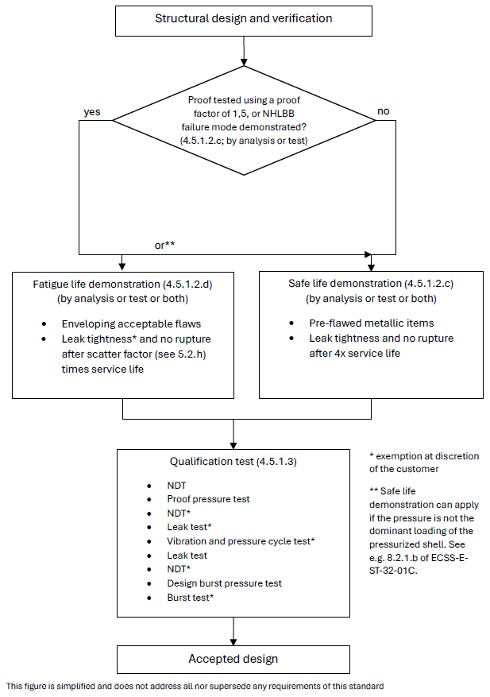
Figure 4-12: Development approach of MPC
(Relevant also for MSPE heat pipes, loop heat pipes, capillary pumped loops)

COPC with metallic liner

Factors of safety
ECSS-E-ST-32-02_1660218
          - The values in Table 4-1 and Table 4-2 shall be applied as minimum values of factors of safety for internal pressure of composite overwrapped pressurized components (COPC).
Exceptions to the values provided in Table 4-1, Table 4-2 or ECSS-E-ST-32-10 are sometimes specified by the customer or granted with customer approval.
Examples of reasons for exceptions: ground/range safety rules, mitigation of concerns due to time dependent phenomena like creep and for composites stress rupture, human safety during the mission.
When this is the case for a burst factor, the following relations can be used for determination of the proof factor:
j_{proof} = (1 + j_{burst}) / 2 when j_{burst} < 2,0
j_{proof} = 1,5 when j_{burst} > 2,0
The FoS specified for COPC are defined the same as for pressure vessels, because no established alternate approach exists yet. Development of a tailored approach (in agreement with the customer/safety authority) is expected, based on FoS similar to the ones of metallic pressure components (proof 1,5, burst 2,5 or more), but addressing additional concerns associated with for example barely visible impact damage and thermo-mechanical loads. Fulfilling the pressure vessel requirements can be impractical.
ECSS-E-ST-32-02_1660219
          - The values specified in ECSS-E-ST-32-10 for ‘pressurized hardware’ shall be applied as minimum values of factors of safety for loads different from internal pressure.
Exceptions to the values provided in Table 4-1, Table 4-2 or ECSS-E-ST-32-10 are sometimes specified by the customer or granted with customer approval.
Examples of reasons for exceptions: ground/range safety rules, mitigation of concerns due to time dependent phenomena like creep and for composites stress rupture, human safety during the mission.
The FoS specified for COPC are defined the same as for pressure vessels, because no established alternate approach exists yet. Development of a tailored approach (in agreement with the customer/safety authority) is expected, based on FoS similar to the ones of metallic pressure components (proof 1,5, burst 2,5 or more), but addressing additional concerns associated with for example barely visible impact damage and thermo-mechanical loads. Fulfilling the pressure vessel requirements can be impractical.

Development approach
ECSS-E-ST-32-02_1660220
          - Clause 5.2 on structural engineering shall be applied.
For composite hardware this includes consideration of stress rupture (see 5.2j) as well as prevention of failure due to mechanical impact damage (see 4.2.3 on damage control).
ECSS-E-ST-32-02_1660221
          - A stiffness demonstration shall be performed by analysis and test.
ECSS-E-ST-32-02_1660222
          - A strength and stability demonstration shall be performed by analysis and test.
ECSS-E-ST-32-02_1660223
          - If specified, or relevant to comply with 4.5.2.2e, the LBB failure mode shall be demonstrated by analysis or test or both according to clause 5.3.
ECSS-E-ST-32-02_1660224
          - For metallic COPC liners with a non‐hazardous LBB failure mode, the safe‐life demonstration specified in 4.5.2.2f may be replaced by a fatigue life demonstration by analysis or test or both in conformance with 5.2h and ECSS-E-ST-32, considering credible manufacturing imperfections and defects to the extent agreed between customer and supplier.
This can have an impact on the mission reliability.
If a project is rated highly critical by the customer due to considerations other than safety, safe life to leakage verification of the metallic liner is sometimes requested instead of, or in addition to, LBB verification.
It is recommended that this agreement is achieved as early as possible, for example in the statement of work and associated baseline requirements, and then reflected in the Fracture Control Plan.
ECSS-E-ST-32-02_1660225
          - Except in the case specified in 4.5.2.2e, ‘safe life item’ demonstration shall be performed for the metallic liner by analysis or test or both in conformance with ECSS-E-ST-32-01.
Plastically operating liners, during autofrettage or post autofrettage cycles, can be difficult to verify for crack propagation by analysis only. See for example 7.2.8.i-j and 7.3.b of ECSS-E-ST-32-01.
ECSS-E-ST-32-02_1660226
          - Fatigue-life demonstration shall be performed for the composite over-wrap by analysis or test or both in conformance with ECSS-E-ST-32.
ECSS-E-ST-32-02_1660227
          - Qualification tests shall be conducted according to clause 4.5.2.3 to demonstrate the structural adequacy of the design.
ECSS-E-ST-32-02_1660228
          - For corrosion control and prevention, the requirements in ECSS-E-ST-32 shall apply.
ECSS-E-ST-32 refers to ECSS-Q-ST-70 and related standards.
ECSS-E-ST-32-02_1660229
          - For hydrogen embrittlement phenomena, requirements shall be applied in conformance with ECSS-E-ST-32-08.
ECSS-E-ST-32-02_1660230
          - For material selection, material design allowables and their characterisation, requirements shall be applied in conformance with clause 5.6 and ECSS-E-ST-32.
ECSS-E-ST-32-02_1660231
          - For ‘process control’, requirements shall be in conformance with ECSS-Q-ST-70.
ECSS-E-ST-32-02_1660232
          - Inspections shall be applied according to clause 5.7.
The development approach is illustrated in Figure 4-5.

Qualification tests
ECSS-E-ST-32-02_1660233
          - A first qualification test article shall be submitted to the following sequence of tests, or alternative sequence agreed between customer and supplier:
            - non-destructive testing (NDT);
            - proof pressure test;
            - leak test;
            - NDT;
            - pressure cycling test;
            - leak test;
            - design burst pressure test;
            - burst test.
This the standard sequence of tests defined in ECSS-E-ST-10-03. Examples of rationale for changes to this sequence are:
- Additional qualification test types (e.g. thermal) or inspection steps (e.g. before burst pressure testing).
- Identified risk that for the particular design the defined sequence can be either unconservative or unnecessarily conservative.
- Omission of test types based on e.g. successful heritage/similarity, testing of engineering model or analysis-based verification approach. Examples: pressure cycling test, burst test, NDT steps.
ECSS-E-ST-32-02_1660234
          - The first qualification test article specified in 4.5.2.3a may be deleted with customer approval.
Examples of rationale for deletion of a formal first qualification test article:
- Similarity with a qualified vessel giving confidence in the robustness of the design and manufacturing processes.
- Successful testing of a representative engineering model.
- Additional factors that can be considered: simplicity of the design, actual margins, heritage of the supplier.
ECSS-E-ST-32-02_1660235
          - A second qualification test article shall be submitted to the following sequence of tests, or alternative sequence agreed between customer and supplier:
            - NDT;
            - proof pressure test;
            - leak test;
            - NDT;
            - vibration tests;
            - pressure cycling test;
            - leak test;
            - design burst pressure test;
            - burst test.
This the standard sequence of tests defined in ECSS-E-ST-10-03. Examples of rationale for changes to this sequence are:
- Additional qualification test types (e.g. thermal) or inspection steps (e.g. before burst pressure testing).
- Identified risk that for the particular design the defined sequence can be either unconservative or unnecessarily conservative.
- Omission of test types based on e.g. successful heritage/similarity, testing of engineering model or analysis-based verification approach.
ECSS-E-ST-32-02_1660236
          - The leak test and NDT after proof pressure test specified in 4.5.2.3c, and the final burst test specified in 4.5.2.3c may be deleted with customer approval.
ECSS-E-ST-32-02_1660237
          - When the vibration loads are enveloped by the other qualification tests, the vibration tests specified in 4.5.2.3c may be deleted with customer approval.
ECSS-E-ST-32-02_1660238
          - NDT operations shall be applied to the over-wrap, in addition to NDT on the liner.
ECSS-E-ST-32-02_1660239
          - Clause 5.4 shall be applied to the qualification tests.
ECSS-E-ST-32-02_1660240
          - The need to apply external loads in combination with internal pressure during qualification testing shall be considered taking into account their relative magnitude, the fatigue and destabilizing effects of external loads.
1 This is considered, for example, for cases where locally or globally non-pressure loads are significant, and applicable yield or ultimate combined load cases are not covered by proof or burst testing, contradicting to some extent the characteristic that pressure loads are dominant, and where it is not acceptable to cover the difference by analysis, similarity, test on design detail, etc. In vibration testing the vibration loads, per axis, will actually apply the strength qualification test factor, but no test factor on pressure.
2 Example: static (spin) testing, mentioned in ECSS-E-ST-10-03, can be an option if qualification cannot be achieved uni-axially during vibration.
ECSS-E-ST-32-02_1660241
          - If external cycling loads are applied, the load shall be cycled to design limit load for four times the predicted number of operating cycles of the most severe design condition.
1 Examples: Destabilizing load with constant minimum internal pressure or maximum additive load with a constant MDP.
The actual cycle life can be complex and is often replaced by a simplified test spectrum, of comparable severity, in the cycling test.
2 Design limit load (DLL) for pressurized hardware is normally defined, in accordance with Figure 4-1 and Table 4-1 of ECSS-E-ST-32-10, as K_{P} x K_{M} x limit load (LL) for pressure load. For loads other than internal pressure the Satellite Test Logic of Figure 4-1 of ECSS-E-ST-32-10 is applied, for example.

Acceptance tests
ECSS-E-ST-32-02_1660242
          - All hardware shall be submitted to the following sequence of tests, or alternative sequence agreed between customer and supplier:
            - initial NDT, in order to establish the initial condition of the hardware;
            - proof pressure test;
            - leak test;
            - final NDT.
For example:
- The NDT prior to proof test can be substituted for that of the manufacturing process.
- Proof test monitoring by acoustic emission is acceptable for composite items instead of post testing NDT, with customer approval. Detailed acoustic emission procedures, with proven health monitoring capability, are agreed per NDT plan, in line with the general requirements of clauses 5 and 9 of the ECSS-Q-ST-70-15.
ECSS-E-ST-32-02_1660243
          - Initial NDT operations shall be applied to the over-wrap, in addition to NDT on the liner.
ECSS-E-ST-32-02_1660244
          - Clause 5.5 shall be applied to the acceptance tests.
ECSS-E-ST-32-02_1660245
          - Final NDT shall be performed on the over-wrap of the COPC as a minimum.

COPC with homogeneous non-metallic liner

Factors of safety
ECSS-E-ST-32-02_1660246
          - The values in Table 4-1 and Table 4-2 shall be applied as minimum values of factors of safety for internal pressure of composite overwrapped pressurized components (COPC).
Exceptions to the values provided in Table 4-1 and Table 4-2 or ECSS-E-ST-32-10 are sometimes specified by the customer or granted with customer approval.
Examples of reasons for exceptions: ground/range safety rules, mitigation of concerns due to time dependent phenomena like creep and for composites stress rupture, human safety during the mission.
When this is the case for a burst factor, the following relations can be used for determination of the proof factor:
j_{proof} = (1 + j_{burst}) / 2 when j_{burst} < 2,0
j_{proof} = 1,5 when j_{burst} > 2,0
The FoS specified for COPC are defined the same as for pressure vessels, because no established alternate approach exists yet. Development of a tailored approach (in agreement with the customer/safety authority) is expected, based on FoS similar to the ones of metallic pressure components (proof 1,5, burst 2,5 or more), but addressing additional concerns associated with for example barely visible impact damage and thermo-mechanical loads. Fulfilling the pressure vessel requirements can be impractical.
ECSS-E-ST-32-02_1660247
          - The values specified in ECSS-E-ST-32-10 for ‘pressurized hardware’ shall be applied as minimum values of factors of safety for loads different from internal pressure.
Exceptions to the values provided in Table 4-1 and Table 4-2 or ECSS-E-ST-32-10 are sometimes specified by the customer or granted with customer approval.
Examples of reasons for exceptions: ground/range safety rules, mitigation of concerns due to time dependent phenomena like creep and for composites stress rupture, human safety during the mission.
The FoS specified for COPC are defined the same as for pressure vessels, because no established alternate approach exists yet. Development of a tailored approach (in agreement with the customer/safety authority) is expected, based on FoS similar to the ones of metallic pressure components (proof 1,5, burst 2,5 or more), but addressing additional concerns associated with for example barely visible impact damage and thermo-mechanical loads. Fulfilling the pressure vessel requirements can be impractical.

Development approach
ECSS-E-ST-32-02_1660248
          - Clause 5.2 on structural engineering shall be applied.
For composite hardware this includes consideration of stress rupture (see 5.2j) as well as prevention of failure due to mechanical impact damage (see 4.2.3 on damage control).
ECSS-E-ST-32-02_1660249
          - A stiffness demonstration shall be performed by analysis and test.
ECSS-E-ST-32-02_1660250
          - A strength and stability demonstration shall be performed by analysis and test.
ECSS-E-ST-32-02_1660251
          - If specified, or relevant to comply with 4.5.3.2e, the LBB failure mode shall be demonstrated by test using a method agreed with the customer.
Experience with non-metallic lined COPC is limited in spaceflight applications, and LBB failure mode demonstration according to 5.3 can be difficult or not relevant (see also e and f below). No definite requirements are therefore provided in this standard on whether and how to apply clause 5.3, and specifically 5.3.4 (Demonstration of LBB by test using full-scale article).
ECSS-E-ST-32-02_1660252
          - For COPC liners with a non‐hazardous LBB failure mode, the safe‐life demonstration specified in 4.5.3.2g may be replaced by a fatigue life demonstration by analysis or test or both in conformance with 5.2h and ECSS-E-ST-32, considering credible manufacturing imperfections and defects to the extent agreed between customer and supplier.
1 This can have an impact on the mission reliability.
If a project is rated highly critical by the customer due to considerations other than safety, safe life to leakage verification of the metallic liner is sometimes requested instead of, or in addition to, LBB verification.
It is recommended that this agreement is achieved as early as possible, for example in the statement of work and associated baseline requirements, and then reflected in the Fracture Control Plan.
2 The fulfilment of this requirement is sometimes possible without LBB analysis or test per 5.3, for liners that do not experience significant load when compared to the overwrap. Example: thermoplastic liner, see e.g. AIAA G-082.
ECSS-E-ST-32-02_1660253
          - When the non-metallic liner of the COPC remains in compression up to MDP and surface flaws do not propagate during the LBB test, the flaws pre-fabricated in the liner of the LBB full-scale specimen may be through cracks.
ECSS-E-ST-32-02_1660254
          - Except in the case specified in 4.5.3.2e, ‘safe life item’ demonstration of the liner shall be performed in conformance with ECSS-E-ST-32-01:
            - by test for non-metallic items;
            - by analysis or test or both for metallic items, for example metallic bosses.
Plastically operating metallic parts of liners, during autofrettage or post autofrettage cycles, can be difficult to verify for crack propagation by analysis only. See for example 7.2.8.i-j and 7.3.b of ECSS-E-ST-32-01.
ECSS-E-ST-32-02_1660255
          - Qualification tests shall be conducted according to clause 4.5.3.3 to demonstrate the structural adequacy of the design.
ECSS-E-ST-32-02_1660256
          - For corrosion control and prevention, the requirements in ECSS-E-ST-32 shall apply.
ECSS-E-ST-32 refers to ECSS-Q-ST-70 and related standards.
ECSS-E-ST-32-02_1660257
          - For hydrogen embrittlement phenomena, requirements shall be applied in conformance with ECSS-E-ST-32-08.
ECSS-E-ST-32-02_1660258
          - For material selection, material design allowables and their characterisation, requirements shall be applied in conformance with clause 5.6 and ECSS-E-ST-32.
ECSS-E-ST-32-02_1660259
          - For ‘process control’, requirements shall be in conformance with ECSS-Q-ST-70.
ECSS-E-ST-32-02_1660260
          - Inspections shall be applied according to clause 5.7.
ECSS-E-ST-32-02_1660261
          - Fatigue-life demonstration shall be performed for the composite over-wrap by analysis or test or both in conformance with ECSS-E-ST-32.
The development approach is illustrated in Figure 4-6.

Qualification tests
ECSS-E-ST-32-02_1660262
          - A first qualification test article shall be submitted to the following sequence of tests, or alternative sequence agreed between customer and supplier:
            - non-destructive testing (NDT);
            - proof pressure test;
            - leak test;
            - NDT;
            - pressure cycling test;
            - leak test;
            - design burst pressure test;
            - burst test.
This the standard sequence of tests defined in ECSS-E-ST-10-03. Examples of rationale for changes to this sequence are:
- Additional qualification test types (e.g. thermal) or inspection steps (e.g. before burst pressure testing).
- Identified risk that for the particular design the defined sequence can be either unconservative or unnecessarily conservative.
- Omission of test types based on e.g. successful heritage/similarity, testing of engineering model or analysis-based verification approach. Examples: pressure cycling test, burst test, NDT steps.
ECSS-E-ST-32-02_1660263
          - The first qualification test article specified in 4.5.3.3a may be deleted with customer approval.
Examples of rationale for deletion of a formal first qualification test article:
- Similarity with a qualified vessel giving confidence in the robustness of the design and manufacturing processes.
- Successful testing of a representative engineering model.
- Additional factors that can be considered: simplicity of the design, actual margins, heritage of the supplier.
ECSS-E-ST-32-02_1660264
          - A second qualification test article shall be submitted to the following sequence of tests, or alternative sequence agreed between customer and supplier:
            - NDT;
            - proof pressure test;
            - leak test;
            - NDT;
            - vibration tests;
            - pressure cycling test;
            - leak test;
            - design burst pressure test;
            - burst test.
This the standard sequence of tests defined in ECSS-E-ST-10-03. Examples of rationale for changes to this sequence are:
- Additional qualification test types (e.g. thermal) or inspection steps (e.g. before burst pressure testing).
- Identified risk that for the particular design the defined sequence can be either unconservative or unnecessarily conservative.
- Omission of test types based on e.g. successful heritage/similarity, testing of engineering model or analysis-based verification approach.
ECSS-E-ST-32-02_1660265
          - The leak test and NDT after proof pressure test specified in 4.5.3.3c, and the final burst test specified in 4.5.3.3c may be deleted with customer approval.
ECSS-E-ST-32-02_1660266
          - When the vibration loads are enveloped by the other qualification tests, the vibration tests specified in 4.5.3.3c may be deleted with customer approval.
ECSS-E-ST-32-02_1660267
          - NDT operations shall be applied to the over-wrap, in addition to NDT on the liner.
ECSS-E-ST-32-02_1660268
          - Clause 5.4 shall be applied to the qualification tests.
ECSS-E-ST-32-02_1660269
          - The need to apply external loads in combination with internal pressure during qualification testing shall be considered taking into account their relative magnitude, the fatigue and destabilizing effects of external loads.
1 This is considered, for example, for cases where locally or globally non-pressure loads are significant, and applicable yield or ultimate combined load cases are not covered by proof or burst testing, contradicting to some extent the characteristic that pressure loads are dominant, and where it is not acceptable to cover the difference by analysis, similarity, test on design detail, etc. In vibration testing the vibration loads, per axis, will actually apply the strength qualification test factor, but no test factor on pressure.
2 Example: static (spin) testing, mentioned in ECSS-E-ST-10-03, can be an option if qualification cannot be achieved uni-axially during vibration.
ECSS-E-ST-32-02_1660270
          - If external cycling loads are applied, the load shall be cycled to design limit load for four times the predicted number of operating cycles of the most severe design condition.
1 Examples: Destabilizing load with constant minimum internal pressure or maximum additive load with a constant MDP.
The actual cycle life can be complex and is often replaced by a simplified test spectrum, of comparable severity, in the cycling test.
2 Design limit load (DLL) for pressurized hardware is normally defined, in accordance with Figure 4-1 and Table 4-1 of ECSS-E-ST-32-10, as K_{P} x K_{M} x limit load (LL) for pressure load. For loads other than internal pressure the Satellite Test Logic of Figure 4-1 of ECSS-E-ST-32-10 is applied, for example.

Acceptance tests
ECSS-E-ST-32-02_1660271
          - All hardware shall be submitted to the following sequence of tests, or alternative sequence agreed between customer and supplier:
            - initial NDT, in order to establish the initial condition of the hardware;
            - proof pressure test;
            - leak test;
            - final NDT.
For example:
- The NDT prior to proof test can be substituted for that of the manufacturing process.
- Proof test monitoring by acoustic emission is acceptable for composite items instead of post testing NDT, with customer approval. Detailed acoustic emission procedures, with proven health monitoring capability, are agreed per NDT plan, in line with the general requirements of clauses 5 and 9 of the ECSS-Q-ST-70-15.
ECSS-E-ST-32-02_1660272
          - Initial NDT operations shall be applied to the over-wrap, in addition to NDT on the liner.
ECSS-E-ST-32-02_1660273
          - Clause 5.5 shall be applied to the acceptance tests.
ECSS-E-ST-32-02_1660274
          - Final NDT shall be performed on the over-wrap of the COPC as a minimum.

Special pressurized equipment

Metallic special pressurized equipment

Factors of safety
ECSS-E-ST-32-02_1660275
          - The values in Table 4-1 and Table 4-2 shall be applied as minimum values of factors of safety for internal pressure of the different categories of metallic special pressurized equipment (MSPE).
Exceptions to the values provided in Table 4-1, Table 4-2 or ECSS-E-ST-32-10 are sometimes specified by the customer or granted with customer approval.
Examples of reasons for exceptions: ground/range safety rules, mitigation of concerns due to time dependent phenomena like creep, human safety during the mission, selected fracture control approach.
ECSS-E-ST-32-02_1660276
          - The values specified in ECSS-E-ST-32-10 for ‘pressurized hardware’ shall be applied as minimum values of factors of safety for loads different from internal pressure.
Exceptions to the values provided in Table 4-1, Table 4-2 or ECSS-E-ST-32-10 are sometimes specified by the customer or granted with customer approval.
Examples of reasons for exceptions: ground/range safety rules, mitigation of concerns due to time dependent phenomena like creep, human safety during the mission, selected fracture control approach.

Development approach
ECSS-E-ST-32-02_1660277
          - Clause 5.2 on structural engineering shall be applied.
1 Thermal, stress and strain analyses and stiffness, strength and stability demonstrations are sometimes substituted with certification from qualified aerospace suppliers, with customer approval.
2 Clause 5.2 refers to the requirements of ECSS-E-ST-32, which include requirements on stiffness, strength and stability.
ECSS-E-ST-32-02_1660278
          - Qualification tests shall be conducted according to 4.6.1.3 to demonstrate the structural adequacy of the design.
ECSS-E-ST-32-02_1660279
          - A ‘safe life item’ or ‘nonhazardous LBB failure mode’ demonstration shall be performed by analysis or test or both in conformance with clause 5.3 and ECSS-E-ST-32-01 for metallic special pressurized equipment.
1 For metallic sealed containers, cryostats and batteries (non-hazardous leakage) relevant subclauses of ECSS-E-ST-32-01 include 6.3.2 (Safe life items) or 8.2.5 (Low risk sealed containers) and 8.2.1 (Pressurized hardware - General). Sealed containers, and hence also cryostats and batteries, with MDP >0,3 MPa or which cannot be demonstrated as NHLBB according to 5.3 (i.e. do not meet clause 8.2.5 of ECSS-E-ST-32-01), are verified as safe life items (per 6.3.2 of ECSS-E-ST-32-01).
2 For metallic heat pipes, loop heat pipes, capillary pumped loops relevant subclauses of ECSS-E-ST-32-01 include 8.2.4 (Pressure components), 8.2.7 (Pressurized components with nonhazardous LBB failure mode) and 8.2.1 (Pressurized hardware - General). Including in particular 8.2.4.b (proof factor 1,5), 8.2.4.c (inspection of fusion joints) and 8.2.1.b (pressure dominance).
3 For metallic hazardous fluid containers, cryostats and batteries (hazardous leakage) relevant subclauses of ECSS-E-ST-32-01 include 8.2.6 (Hazardous fluid containers) and 8.2.1 (Pressurized hardware - General). Including in particular 8.2.1.b (pressure dominance). Clause 8.2.6 of ECSS-E-ST-32-01 considers hazardous fluid containers with MDP >0,15 MPa as pressure vessels. ‘Nonhazardous LBB failure mode’ demonstration does not apply to hazardous fluid containers due to the hazardous content.
4 If the criteria of 8.2.4.b, 8.2.1.b or 8.2.7 of ECSS-E-ST-32-01 are not met, and the fatigue verification in accordance with item g below is considered insufficient, a crack-growth verification based on initial crack size based on applied NDT can apply.
ECSS-E-ST-32-02_1660280
          - Fatigue-life demonstration shall be performed by analysis or test or both in conformance with ECSS-E-ST-32, considering credible manufacturing imperfections and defects to the extent agreed between customer and supplier.
No explicit requirement for safe life analysis is defined in 4.6.1.2c and 4.6.1.2d, for many SPE items proof pressure tested to a factor 1,5 or higher. For applications, with more critical characteristics, some degree of damage tolerance verification is sometimes performed to mitigate the risk of catastrophic failure in service, as well as providing justification for the applied inspection methods and associated acceptance criteria. These characteristics include, for example:
- subjected to significant non-pressure loads,
- subjected to significant fatigue load cycles,
- human spaceflight applications,
- involving materials and processes with increased risk of creating defects, for example welding, but also brazing, casting, additive manufacturing, (custom) forging processes.
Proof and leak testing alone does not always provide sufficient flaw screening.
ECSS-E-ST-32-02_1660281
          - For corrosion control and prevention, the requirements in ECSS-E-ST-32 shall apply.
ECSS-E-ST-32 refers to ECSS-Q-ST-70 and related standards.
ECSS-E-ST-32-02_1660282
          - For hydrogen embrittlement phenomena, requirements shall be applied in conformance with ECSS-E-ST-32-08.
ECSS-E-ST-32-02_1660283
          - For material selection, material design allowables and their characterisation, requirements shall be applied in conformance with ECSS-E-ST-32.
ECSS-E-ST-32-02_1660284
          - For ‘process control’, requirements shall be in conformance with ECSS-Q-ST-70.
ECSS-E-ST-32-02_1660285
          - Inspections shall be applied according to clause 5.7.
1 The development approach for metallic sealed containers is illustrated in Figure 4-13.
2 The development approach for metallic cryostats (or Dewars) and batteries is illustrated in Figure 4-13 (non-hazardous leakage) and Figure 4-14 (hazardous leakage).
3 The development approach for metallic heat pipes, loop heat pipes, capillary pumped loops is illustrated in Figure 4-12.
4 The development approach for metallic hazardous fluid containers is illustrated in Figure 4-14.
5 Failure mode demonstration as per clause 5.3 is sometimes specified for heat pipes, loop heat pipes, capillary pumped loops by the customer.
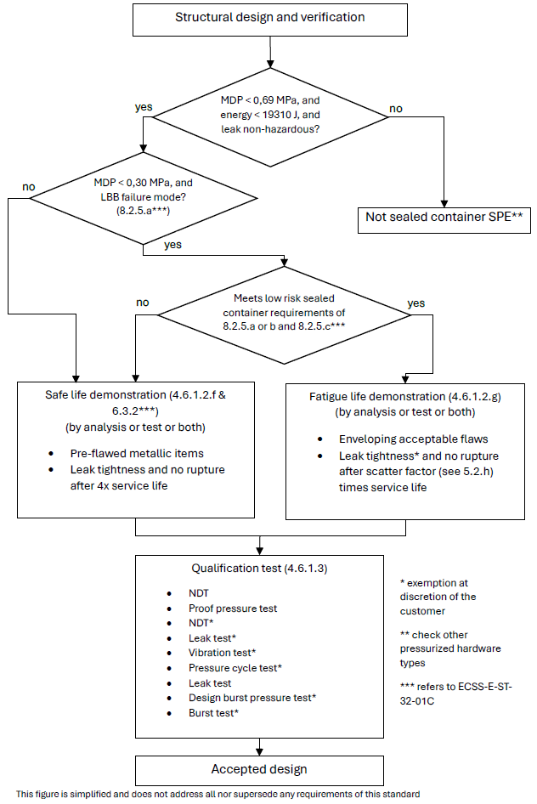
Figure 4-13: Development approach of metallic sealed containers
(Relevant also for non-hazardous leakage applications of MSPE cryostats (Dewars) and batteries)
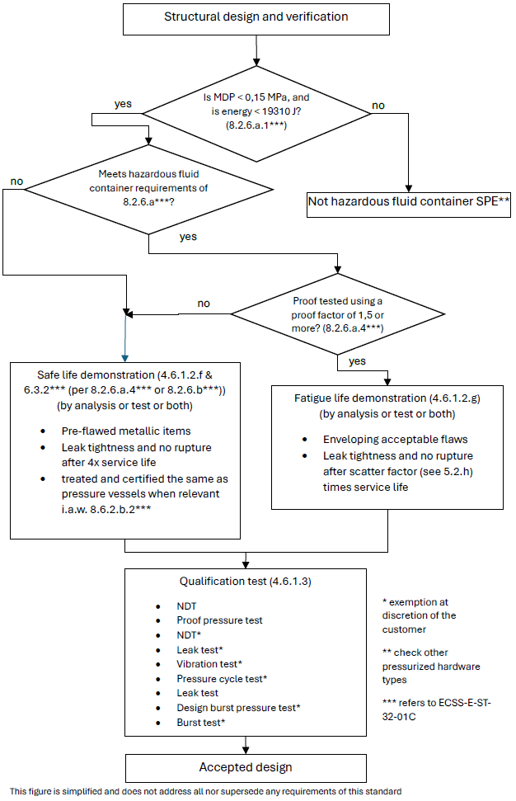
Figure 4-14: Development approach of metallic hazardous fluid containers
(Relevant also for hazardous leakage applications of MSPE cryostats (Dewars) and batteries)

Qualification tests
ECSS-E-ST-32-02_1660286
          - All metallic SPE shall be submitted to the following sequence of tests, or alternative sequence agreed between customer and supplier:
            - NDT;
            - proof pressure test;
            - leak test;
            - NDT;
            - vibration tests;
            - pressure cycling test;
            - leak test;
            - design burst pressure test;
            - burst test.
This the standard sequence of tests defined in ECSS-E-ST-10-03. Examples of rationale for changes to this sequence are:
- Additional qualification test types (e.g. thermal) or inspection steps (e.g. before burst pressure testing).
- Identified risk that for the particular design the defined sequence can be either unconservative or unnecessarily conservative.
- Omission of test types based on e.g. successful heritage/similarity, testing of engineering model or analysis-based verification approach. Examples: pressure cycling test, burst test, NDT steps.
ECSS-E-ST-32-02_1660287
          - Clause 5.4 shall be applied to the qualification tests.
ECSS-E-ST-32-02_1660288
          - The need to apply external loads in combination with internal pressure during qualification testing shall be considered taking into account their relative magnitude, the fatigue and destabilizing effects of external loads.
1 This is considered, for example, for cases where locally or globally non-pressure loads are significant, and applicable yield or ultimate combined load cases are not covered by proof or burst testing, contradicting to some extent the characteristic that pressure loads are dominant, and where it is not acceptable to cover the difference by analysis, similarity, test on design detail, etc. In vibration testing the vibration loads, per axis, will actually apply the strength qualification test factor, but no test factor on pressure.
2 Example: static (spin) testing, mentioned in ECSS-E-ST-10-03, can be an option if qualification cannot be achieved uni-axially during vibration.
ECSS-E-ST-32-02_1660289
          - If external cycling loads are applied, the load shall be cycled to design limit load for four times the predicted number of operating cycles of the most severe design condition.
1 Examples: Destabilizing load with constant minimum internal pressure or maximum additive load with a constant MDP.
The actual cycle life can be complex and is often replaced by a simplified test spectrum, of comparable severity, in the cycling test.
2 Design limit load (DLL) for pressurized hardware is normally defined, in accordance with Figure 4-1 and Table 4-1 of ECSS-E-ST-32-10, as K_{P} x K_{M} x limit load (LL) for pressure load. For loads other than internal pressure the Satellite Test Logic of Figure 4-1 of ECSS-E-ST-32-10 is applied, for example.

Acceptance tests
ECSS-E-ST-32-02_1660290
          - Metallic SPE shall be submitted to a proof pressure test, except for those meeting the requirements of 8.2.5a or 8.2.5.b.1 of ECSS-E-ST-32-01.
Requirement 8.2.5.a of ECSS-E-ST-32-01 addresses sealed containers with MDP not exceeding 0,15 MPa, while 8.2.5.b.1 addresses sealed containers with MDP between 0,15 MPa and 0,30 MPa.
ECSS-E-ST-32-02_1660291
          - Metallic SPE shall be submitted to a leak test at MDP, unless agreed otherwise with the customer.
in cases where leak testing is impractical, e.g. after sealing the item, alternative acceptance or process control practices are agreed that provide adequate assurance of absence of detrimental leakage.
ECSS-E-ST-32-02_1660292
          - Fusion joints shall be 100 % inspected by means of a NDT method, defined with customer approval, prior and after the proof pressure test.
For cases where this cannot be implemented, relevant additional guidance can be found in ECSS-E-ST-32-01 clause 11.2.2.8, applicable primarily as part of the 'reduced fracture control programme'.
ECSS-E-ST-32-02_1660293
          - Clause 5.5 shall be applied to the acceptance tests.
Proof and leak tests can be performed at the assembled pressurized system level.

COSPE with metallic liner

Factors of safety
ECSS-E-ST-32-02_1660294
          - The values in Table 4-1 and Table 4-2 shall be applied as minimum values of factors of safety for internal pressure of composite overwrapped special pressurized equipment (COSPE).
Exceptions to the values provided in Table 4-1, Table 4-2 or ECSS-E-ST-32-10 are sometimes specified by the customer or granted with customer approval.
Examples of reasons for exceptions: ground/range safety rules, mitigation of concerns due to time dependent phenomena like creep and for composites stress rupture, human safety during the mission.
When this is the case for a burst factor, the following relations can be used for determination of the proof factor:
j_{proof} = (1 + j_{burst}) / 2 when j_{burst} < 2,0
j_{proof} = 1,5 when j_{burst} > 2,0
The FoS specified for COSPE are defined the same as for pressure vessels, because no established alternate approach exists yet. Development of a tailored approach (in agreement with the customer/safety authority) is expected, based on FoS similar to the ones of metallic pressure components (proof 1,5, burst 2,5 or more), but addressing additional concerns associated with for example barely visible impact damage and thermo-mechanical loads. Fulfilling the pressure vessel requirements can be impractical.
ECSS-E-ST-32-02_1660295
          - The values specified in ECSS-E-ST-32-10 for ‘pressurized hardware’ shall apply as minimum values of factors of safety for loads different from internal pressure.
Exceptions to the values provided in Table 4-1, Table 4-2 or ECSS-E-ST-32-10 are sometimes specified by the customer or granted with customer approval.
Examples of reasons for exceptions: ground/range safety rules, mitigation of concerns due to time dependent phenomena like creep and for composites stress rupture, human safety during the mission.
The FoS specified for COSPE are defined the same as for pressure vessels, because no established alternate approach exists yet. Development of a tailored approach (in agreement with the customer/safety authority) is expected, based on FoS similar to the ones of metallic pressure components (proof 1,5, burst 2,5 or more), but addressing additional concerns associated with for example barely visible impact damage and thermo-mechanical loads. Fulfilling the pressure vessel requirements can be impractical.

Development approach
ECSS-E-ST-32-02_1660296
          - Clause 5.2 on structural engineering shall be applied.
For composite hardware this includes consideration of stress rupture (see 5.2j) as well as prevention of failure due to mechanical impact damage (see 4.2.3 on damage control).
ECSS-E-ST-32-02_1660297
          - A stiffness demonstration shall be performed by analysis and test.
ECSS-E-ST-32-02_1660298
          - A strength and stability demonstration shall be performed by analysis and test.
ECSS-E-ST-32-02_1660299
          - If specified, or relevant to comply with 4.6.2.2e, the LBB failure mode shall be demonstrated by analysis or test or both according to clause 5.3.
ECSS-E-ST-32-02_1660300
          - For metallic COSPE liners with a non‐hazardous LBB failure mode, the safe‐life demonstration specified in 4.6.2.2f may be replaced by a fatigue life demonstration by analysis or test or both in conformance with 5.2h and ECSS-E-ST-32, considering credible manufacturing imperfections and defects to the extent agreed between customer and supplier .
This can have an impact on the mission reliability.
If a project is rated highly critical by the customer due to considerations other than safety, safe life to leakage verification of the metallic liner is sometimes requested instead of, or in addition to, LBB verification .
It is recommended that this agreement is achieved as early as possible, for example in the statement of work and associated baseline requirements, and then reflected in the Fracture Control Plan.
ECSS-E-ST-32-02_1660301
          - Except in the case specified in 4.6.2.2e, ‘safe life item’ demonstration shall be performed for the metallic liner by analysis or test or both in conformance with ECSS-E-ST-32-01.
Plastically operating liners, during autofrettage or post autofrettage cycles, can be difficult to verify for crack propagation by analysis only. See for example 7.2.8.i-j and 7.3.b of ECSS-E-ST-32-01.
ECSS-E-ST-32-02_1660302
          - Fatigue-life demonstration shall be performed for the composite over-wrap by analysis or test or both in conformance with ECSS-E-ST-32.
ECSS-E-ST-32-02_1660303
          - Qualification tests shall be conducted in conformance with clause 4.6.2.3 to demonstrate the structural adequacy of the design.
ECSS-E-ST-32-02_1660304
          - For corrosion control and prevention, the requirements in ECSS-E-ST-32 shall apply.
ECSS-E-ST-32 refers to ECSS-Q-ST-70 and related standards.
ECSS-E-ST-32-02_1660305
          - For hydrogen embrittlement phenomena, requirements shall be applied in conformance with ECSS-E-ST-32-08.
ECSS-E-ST-32-02_1660306
          - For material selection, material design allowables and their characterisation, requirements shall be applied in conformance with clause 5.6 and ECSS-E-ST-32.
ECSS-E-ST-32-02_1660307
          - For ‘process control’, requirements shall be in conformance with ECSS-Q-ST-70.
ECSS-E-ST-32-02_1660308
          - Inspections shall be applied according to clause 5.7.
The development approach is illustrated in Figure 4-5.

Qualification tests
ECSS-E-ST-32-02_1660309
          - A first qualification test article shall be submitted to the following sequence of tests, or alternative sequence agreed between customer and supplier:
            - non-destructive testing (NDT);
            - proof pressure test;
            - leak test;
            - NDT;
            - pressure cycling test;
            - leak test;
            - design burst pressure test;
            - burst test.
This the standard sequence of tests defined in ECSS-E-ST-10-03. Examples of rationale for changes to this sequence are:
- Additional qualification test types (e.g. thermal) or inspection steps (e.g. before burst pressure testing).
- Identified risk that for the particular design the defined sequence can be either unconservative or unnecessarily conservative.
- Omission of test types based on e.g. successful heritage/similarity, testing of engineering model or analysis-based verification approach. Examples: pressure cycling test, burst test, NDT steps.
ECSS-E-ST-32-02_1660310
          - The first qualification test article specified in 4.6.2.3a may be deleted with customer approval.
Examples of rationale for deletion of a formal first qualification test article:
- Similarity with a qualified vessel giving confidence in the robustness of the design and manufacturing processes.
- Successful testing of a representative engineering model.
- Additional factors that can be considered: simplicity of the design, actual margins, heritage of the supplier.
ECSS-E-ST-32-02_1660311
          - A second qualification test article shall be submitted to the following sequence of tests, or alternative sequence agreed between customer and supplier:
            - NDT;
            - proof pressure test;
            - leak test;
            - NDT;
            - vibration tests;
            - pressure cycling test;
            - leak test;
            - design burst pressure test;
            - burst test.
This the standard sequence of tests defined in ECSS-E-ST-10-03. Examples of rationale for changes to this sequence are:
- Additional qualification test types (e.g. thermal) or inspection steps.
- Identified risk that for the particular design the defined sequence can be either unconservative or unnecessarily conservative.
- Omission of test types based on e.g. successful heritage/similarity, testing of engineering model or analysis-based verification approach.
ECSS-E-ST-32-02_1660312
          - The leak test and NDT after proof pressure test specified in 4.6.2.3c, and the final burst test, specified in 4.6.2.3c may be deleted with customer approval.
ECSS-E-ST-32-02_1660313
          - When the vibration loads are enveloped by the other qualification tests, the vibration tests specified in 4.6.2.3c may be deleted with customer approval.
ECSS-E-ST-32-02_1660314
          - NDT operations shall be applied to the over-wrap, in addition to NDT on the liner.
ECSS-E-ST-32-02_1660315
          - Clause 5.4 shall be applied to the qualification tests.
ECSS-E-ST-32-02_1660316
          - The need to apply external loads in combination with internal pressure during qualification testing shall be considered taking into account their relative magnitude, the fatigue and destabilizing effects of external loads.
1 This is considered, for example, for cases where locally or globally non-pressure loads are significant, and applicable yield or ultimate combined load cases are not covered by proof or burst testing, contradicting to some extent the characteristic that pressure loads are dominant, and where it is not acceptable to cover the difference by analysis, similarity, test on design detail, etc. In vibration testing the vibration loads, per axis, will actually apply the strength qualification test factor, but no test factor on pressure.
2 Example: static (spin) testing, mentioned in ECSS-E-ST-10-03, can be an option if qualification cannot be achieved uni-axially during vibration.
ECSS-E-ST-32-02_1660317
          - If external cycling loads are applied, the load shall be cycled to design limit load for four times the predicted number of operating cycles of the most severe design condition.
1 Examples: Destabilizing load with constant minimum internal pressure or maximum additive load with a constant MDP.
The actual cycle life can be complex and is often replaced by a simplified test spectrum, of comparable severity, in the cycling test.
2 Design limit load (DLL) for pressurized hardware is normally defined, in accordance with Figure 4-1 and Table 4-1 of ECSS-E-ST-32-10, as K_{P} x K_{M} x limit load (LL) for pressure load. For loads other than internal pressure the Satellite Test Logic of Figure 4-1 of ECSS-E-ST-32-10 is applied, for example.

Acceptance tests
ECSS-E-ST-32-02_1660318
          - All hardware shall be submitted to the following sequence of tests, or alternative sequence agreed between customer and supplier:
            - initial NDT, in order to establish the initial condition of the hardware;
            - proof pressure test;
            - leak test;
            - final NDT.
For example:
- The NDT prior to proof test can be substituted for that of the manufacturing process.
- Proof test monitoring by acoustic emission is acceptable for composite items instead of post testing NDT, with customer approval. Detailed acoustic emission procedures, with proven health monitoring capability, are agreed per NDT plan, in line with the general requirements of clauses 5 and 9 of the ECSS-Q-ST-70-15.
ECSS-E-ST-32-02_1660319
          - Initial NDT operations shall be applied to the over-wrap, in addition to NDT on the liner.
ECSS-E-ST-32-02_1660320
          - Clause 5.5 shall be applied to the acceptance tests.
ECSS-E-ST-32-02_1660321
          - Final NDT shall be performed on the over-wrap of the COSPE as a minimum.

COSPE with homogeneous non metallic liner

Factors of safety
ECSS-E-ST-32-02_1660322
          - The values in Table 4-1 and Table 4-2 shall be applied as minimum values of factors of safety for internal pressure of composite overwrapped special pressurized equipment (COSPE).
Exceptions to the values provided in Table 4-1, Table 4-2 or ECSS-E-ST-32-10 are sometimes specified by the customer or granted with customer approval.
Examples of reasons for exceptions: ground/range safety rules, mitigation of concerns due to time dependent phenomena like creep and for composites stress rupture, human safety during the mission.
When this is the case for a burst factor, the following relations can be used for determination of the proof factor:
j_{proof} = (1 + j_{burst}) / 2 when j_{burst} < 2,0
j_{proof} = 1,5 when j_{burst} > 2,0
The FoS specified for COSPE are defined the same as for pressure vessels, because no established alternate approach exists yet. Development of a tailored approach (in agreement with the customer/safety authority) is expected, based on FoS similar to the ones of metallic pressure components (proof 1,5, burst 2,5 or more), but addressing additional concerns associated with for example barely visible impact damage and thermo-mechanical loads. Fulfilling the pressure vessel requirements can be impractical.
ECSS-E-ST-32-02_1660323
          - The values specified in ECSS-E-ST-32-10 for ‘pressurized hardware’ shall be applied as minimum values of factors of safety for loads different from internal pressure.
Exceptions to the values provided in Table 4-1, Table 4-2 or ECSS-E-ST-32-10 are sometimes specified by the customer or granted with customer approval.
Examples of reasons for exceptions: ground/range safety rules, mitigation of concerns due to time dependent phenomena like creep and for composites stress rupture, human safety during the mission.
The FoS specified for COSPE are defined the same as for pressure vessels, because no established alternate approach exists yet. Development of a tailored approach (in agreement with the customer/safety authority) is expected, based on FoS similar to the ones of metallic pressure components (proof 1,5, burst 2,5 or more), but addressing additional concerns associated with for example barely visible impact damage and thermo-mechanical loads. Fulfilling the pressure vessel requirements can be impractical.

Development approach
ECSS-E-ST-32-02_1660324
          - Clause 5.2 on structural engineering shall be applied.
For composite hardware this includes consideration of stress rupture (see 5.2j) as well as prevention of failure due to mechanical impact damage (see 4.2.3 on damage control).
ECSS-E-ST-32-02_1660325
          - A stiffness demonstration shall be performed by analysis and test.
ECSS-E-ST-32-02_1660326
          - A strength and stability demonstration shall be performed by analysis and test.
ECSS-E-ST-32-02_1660327
          - If specified, or relevant to comply with 4.6.3.2e, the LBB failure mode shall be demonstrated by test using a method agreed with the customer.
Experience with non-metallic lined COSPE is limited in spaceflight applications, and LBB failure mode demonstration according to 5.3 can be difficult or not relevant (see also e and f below). No definite requirements are therefore provided in this standard on whether and how to apply clause 5.3, and specifically 5.3.4 (Demonstration of LBB by test using full-scale article).
ECSS-E-ST-32-02_1660328
          - For COSPE liners with a non‐hazardous LBB failure mode, the safe‐life demonstration specified in 4.6.3.2g may be replaced by a fatigue life demonstration by analysis or test or both in conformance with 5.2h and ECSS-E-ST-32, considering credible manufacturing imperfections and defects to the extent agreed between customer and supplier.
1 This can have an impact on the mission reliability.
If a project is rated highly critical by the customer due to considerations other than safety, safe life to leakage verification of the metallic liner is sometimes requested instead of, or in addition to, LBB verification.
It is recommended that this agreement is achieved as early as possible, for example in the statement of work and associated baseline requirements, and then reflected in the Fracture Control Plan.
2 The fulfilment of this requirement is sometimes possible without LBB analysis or test per 5.3, for liners that do not experience significant load when compared to the overwrap. Example: thermoplastic liner, see e.g. AIAA G-082.
ECSS-E-ST-32-02_1660329
          - When the non-metallic liner of the COSPE remains in compression up to MDP and surface flaws do not propagate during the LBB test, the flaws pre-fabricated in the liner of the LBB full-scale specimen may be through cracks.
ECSS-E-ST-32-02_1660330
          - Except in the case specified in 4.6.3.2e, ‘safe life item’ demonstration of the liner shall be performed in accordance with ECSS-E-ST-32-01:
            - by test for non-metallic items;
            - by analysis or test or both for metallic items, for example metallic bosses.
Plastically operating metallic parts of liners, during autofrettage or post autofrettage cycles, can be difficult to verify for crack propagation by analysis only. See for example 7.2.8.i-j and 7.3.b of ECSS-E-ST-32-01.
ECSS-E-ST-32-02_1660331
          - Qualification tests shall be conducted according to clause 4.6.3.3 to demonstrate the structural adequacy of the design.
ECSS-E-ST-32-02_1660332
          - For corrosion control and prevention, the requirements in ECSS-E-ST-32 shall apply.
ECSS-E-ST-32 refers to ECSS-Q-ST-70 and related standards.
ECSS-E-ST-32-02_1660333
          - Embrittlement control shall be applied in accordance with ECSS-E-ST-32-08.
ECSS-E-ST-32-02_1660334
          - For materials selection, material design allowables and their characterisation, requirements shall be applied in conformance with clause 5.6 and ECSS-E-ST-32.
ECSS-E-ST-32-02_1660335
          - For ‘process control’, requirements shall be in conformance with ECSS-Q-ST-70.
ECSS-E-ST-32-02_1660336
          - Inspections shall be applied according to clause 5.7.
The development approach is illustrated in Figure 4-6.
ECSS-E-ST-32-02_1660337
          - Fatigue-life demonstration shall be performed for the composite over-wrap by analysis or test or both in conformance with ECSS-E-ST-32.

Qualification tests
ECSS-E-ST-32-02_1660338
          - A first qualification test article shall be submitted to the following sequence of tests, or alternative sequence agreed between customer and supplier:
            - non-destructive testing (NDT);
            - proof pressure test;
            - leak test;
            - NDT;
            - pressure cycling test;
            - leak test;
            - design burst pressure test;
            - burst test.
This the standard sequence of tests defined in ECSS-E-ST-10-03. Examples of rationale for changes to this sequence are:
- Additional qualification test types (e.g. thermal) or inspection steps (e.g. before burst pressure testing).
- Identified risk that for the particular design the defined sequence can be either unconservative or unnecessarily conservative.
- Omission of test types based on e.g. successful heritage/similarity, testing of engineering model or analysis-based verification approach. Examples: pressure cycling test, burst test, NDT steps.
ECSS-E-ST-32-02_1660339
          - The first qualification test article specified in 4.6.3.3a may be deleted with customer approval.
Examples of rationale for deletion of a formal first qualification test article:
- Similarity with a qualified vessel giving confidence in the robustness of the design and manufacturing processes.
- Successful testing of a representative engineering model.
- Additional factors that can be considered: simplicity of the design, actual margins, heritage of the supplier.
ECSS-E-ST-32-02_1660340
          - A second qualification test article shall be submitted to the following sequence of tests, or alternative sequence agreed between customer and supplier:
            - NDT;
            - proof pressure test;
            - leak test;
            - NDT;
            - vibration tests;
            - pressure cycling test;
            - leak test;
            - design burst pressure test;
            - burst test.
This the standard sequence of tests defined in ECSS-E-ST-10-03. Examples of rationale for changes to this sequence are:
- Additional qualification test types (e.g. thermal) or inspection steps.
- Identified risk that for the particular design the defined sequence can be either unconservative or unnecessarily conservative.
- Omission of test types based on e.g. successful heritage/similarity, testing of engineering model or analysis-based verification approach.
ECSS-E-ST-32-02_1660341
          - The leak test and NDT after proof pressure test specified in4.6.3.3c, and the final burst test specified in 4.6.3.3c may be deleted with customer approval.
ECSS-E-ST-32-02_1660342
          - When the vibration loads are enveloped by the other qualification tests, the vibration tests specified in 4.6.3.3c may be deleted with customer approval.
ECSS-E-ST-32-02_1660343
          - NDT operations shall be applied to the over-wrap, in addition to NDT on the liner.
ECSS-E-ST-32-02_1660344
          - Clause 5.4 shall be applied to the qualification tests.
ECSS-E-ST-32-02_1660345
          - The need to apply external loads in combination with internal pressure during qualification testing shall be considered taking into account their relative magnitude, the fatigue and destabilizing effects of external loads.
1 This is considered, for example, for cases where locally or globally non-pressure loads are significant, and applicable yield or ultimate combined load cases are not covered by proof or burst testing, contradicting to some extent the characteristic that pressure loads are dominant, and where it is not acceptable to cover the difference by analysis, similarity, test on design detail, etc. In vibration testing the vibration loads, per axis, will actually apply the strength qualification test factor, but no test factor on pressure.
2 Example: static (spin) testing, mentioned in ECSS-E-ST-10-03, can be an option if qualification cannot be achieved uni-axially during vibration.
ECSS-E-ST-32-02_1660346
          - If external cycling loads are applied, the load shall be cycled to design limit load for four times the predicted number of operating cycles of the most severe design condition.
1 Examples: Destabilizing load with constant minimum internal pressure or maximum additive load with a constant MDP.
The actual cycle life can be complex and is often replaced by a simplified test spectrum, of comparable severity, in the cycling test.
2 Design limit load (DLL) for pressurized hardware is normally defined, in accordance with Figure 4-1 and Table 4-1 of ECSS-E-ST-32-10, as K_{P} x K_{M} x limit load (LL) for pressure load. For loads other than internal pressure the Satellite Test Logic of Figure 4-1 of ECSS-E-ST-32-10 is applied, for example.

Acceptance tests
ECSS-E-ST-32-02_1660347
          - All hardware shall be submitted to the following sequence of tests, or alternative sequence agreed between customer and supplier:
            - initial NDT, in order to establish the initial condition of the hardware;
            - proof pressure test;
            - leak test;
            - final NDT.
For example:
- The NDT prior to proof test can be substituted for that of the manufacturing process.
- Proof test monitoring by acoustic emission is acceptable for composite items instead of post testing NDT, with customer approval. Detailed acoustic emission procedures, with proven health monitoring capability, are agreed per NDT plan, in line with the general requirements of clauses 5 and 9 of the ECSS-Q-ST-70-15.
ECSS-E-ST-32-02_1660348
          - Initial NDT operations shall be applied to the over-wrap, in addition to NDT on the liner.
ECSS-E-ST-32-02_1660349
          - Clause 5.5 shall be applied to the acceptance tests.
ECSS-E-ST-32-02_1660350
          - Final NDT shall be performed on the over-wrap of the COSPE as a minimum.

Specific requirements

Overview
This clause presents the detail of requirements used in the development approach, qualification and acceptance of pressurized hardware.
These requirements are specific requirements in the sense that their applicability depends on the category of pressurized hardware, as presented in clauses 4.2.5 to 4.6.
The following requirements are included:
- structural engineering;
- failure mode demonstration;
- damage control of pressurized hardware, see also 4.2.3;
- qualification tests;
- acceptance tests;
- composite over-wrap material characterisation;
- inspection.

Structural engineering
ECSS-E-ST-32-02_1660351
          - The structural design and verification of pressurized hardware shall be in conformance with ECSS-E-ST-32.
1 Some structural topics are not explicitly addressed in this standard because they are addressed in ECSS-E-ST-32, which addresses for example:
Verification by analysis (4.6.2), including modelling aspects (4.6.2.2, including correlation, with DRD);
Verification by test (4.6.3);
Strength (4.3.2);
Stiffness (4.3.5);
Buckling/stability (4.3.4, 4.6.2.10);
Fatigue (4.6.2.8, 4.6.3.11);
Bonded joints (4.6.2.12);
Material design allowables (4.5.8);
Deliverables (4.10, including structural reports, with DRDs).
2 Some qualification and acceptance tests can be driven by the ECSS-E-ST-32 (and not necessarily by ECSS-E-ST-10-03 which does not cover fully the structural subsystem) for items which are significantly structurally loaded by non-pressure loads. Example: A composite skirt fulfils as well ECSS-E-ST-32 clause 4.6.4, which requests an acceptance test to limit load, unless agreed otherwise. Also, ECSS-E-ST-10-03 states that a structural proof test can be considered for pressure vessel if not covered by higher level test (e.g. sinusoidal with full tanks).
3 Some related ECSS standards limit the scope of applicability of the ECSS-E-ST-32-02 to particular types of pressurized hardware. Examples:
- The scope of ECSS-E-ST-32-02 states that solid propellant motor cases are not covered by this standard. These are addressed by ECSS-E-ST-35-02.
- ECSS-E-ST-35-03, subclause 9.6 on mechanical design.
4 Adhesive bonding, of liners for example, is a potential critical process for integrity of pressurized hardware. See NESC Technical Bulletin 20-07 ‘Evaluating and Mitigating Liner Strain Spikes in COPVs’ for an example of issues that can be encountered in case of plastic deformation.
ECSS-E-ST-32-02_1660352
          - The effect of each operating parameter of the system and any external loads and environments shall be considered for MDP determination.
Examples of these parameters are pressure regulator lock-up characteristics, valve actuation and water hammer.
ECSS-E-ST-32-02_1660353
          - Proof pressure and design burst pressure shall be derived from the MDP using the factor of safety given in clause 4.
ECF in accordance with 5.4.1c or 5.5.1b apply as well.
ECSS-E-ST-32-02_1660354
          - The range of internal pressure shall be taken into account in the stiffness analysis .
Example of such an analysis is a natural frequency analysis.
ECSS-E-ST-32-02_1660355
          - As a minimum, any item of pressurized hardware shall possess, throughout the respective service life of the hardware in the expected operating environments, a positive margin of safety, in conformance with ECSS-E-ST-32, considering the following:
            - proof pressure is withstood without detrimental deformation;
            - design burst pressure is withstood without experiencing rupture or fibre failure;
            - combined loads are evaluated using the following safety factors per clause 4.2.6 of ECSS-E-ST-32:
              - those defined in Table 4-6 of ECSS-E-ST-32-10 for all load contributors, excluding internal pressure and relieving load components;
              - those defined in clause 4 for internal pressure;
              - no safety factor for relieving loads.
Examples, a non-exhaustive list, of load combinations to be evaluated:
- DYL and simultaneous internal pressure multiplied by FOSY for internal pressure.
- MDP multiplied by FOSY for internal pressure and simultaneous loads, multiplied by FOSY for mechanical and thermal loads.
- DUL and simultaneous internal pressure multiplied by FOSU for internal pressure.
- MDP multiplied by FOSU for internal pressure and simultaneous loads multiplied by FOSU for mechanical and thermal loads.
- DUL and simultaneous external pressure multiplied by FOSU for mechanical and thermal loads.
- If the load cases described above are not enveloping the most critical applicable load interaction, it can be appropriate to evaluate more load combinations. MDP is defined in terms of absolute internal pressure, whereas for hardware where pressurized compartments interact it can be appropriate to use pressure differential or gauge pressure.
ECSS-E-ST-32-02_1660356
          - The minimum internal pressure to guaranty structural stabilization shall be identified and included in the acceptance data package.
ECSS-E-ST-32-02_1660357
          - The pressurized hardware shall possess, throughout its service life in the expected operating environments, a positive margin of safety for stability, in conformance with ECSS-E-ST-32, considering the following:
            - proof pressure is withstood without detrimental deformation;
            - design burst pressure is withstood without experiencing failure;
            - combined loads are evaluated using the following safety factors per clause 4.2.6 of ECSS-E-ST-32:
              - those defined in Table 4-6 of ECSS-E-ST-32-10 for all load contributors, excluding internal pressure and relieving load components;
              - those defined in clause 4 for internal pressure;
              - no safety factor for relieving loads.
1 Examples, a non-exhaustive list, of load combinations to be evaluated:
- DUL and simultaneous external pressure multiplied by FOSU for pressure loads, without experiencing collapse when pressurized to the minimum anticipated operating pressure.
- DUL and simultaneous internal pressure without experiencing collapse.
- If the load cases described above are not enveloping the most critical applicable load interaction for stability aspects, it can be appropriate to evaluate more load combinations. MDP is defined in terms of absolute internal pressure, whereas for hardware where pressurized compartments interact it can be appropriate to use pressure differential or gauge pressure.
2 Per 4.3.4 of ECSS-E-ST-32 this requirement addresses stability in the sense of no buckling of the structure.
ECSS-E-ST-32-02_1660358
          - A scatter factor of five (5) shall be used in fatigue analysis.
1 This tailors the fatigue requirements specified in ECSS-E-ST-32 (4.5.18, 4.6.2.8, 4.6.3.11)
2 This is considered equivalent to allowing a maximum cumulative fatigue damage of 0,8 using a scatter factor 4, as specified in other pressurized hardware standards.
ECSS-E-ST-32-02_1660359
          - Limit loads, design limit loads and associated load cases shall be defined, in agreement with the customer.
1 Refer to ECSS-E-ST-32, 4.2.7 and 4.2.8.
2 This includes definition of MEOP and MDP values (see definitions in ECSS-E-ST-32). Note that MDP includes K_{M} and K_{P}, but not KQ, K_{MP} and K_{LD} according to Figure 4-1 of ECSS-E-ST-32-10. For loads other than internal pressure the Satellite Test Logic of Figure 4-1 of ECSS-E-ST-32-10 is applied, for example.
3 MEOP or MDP can be specified by the customer, or derived, for example, from an analysis of the pressurized system.
4 MDP is equal to or larger than MEOP. Via the factors K_{P} and K_{M}, MDP accounts for uncertainties that are not already accounted for in MEOP. ECSS-E-ST-32-10 mentions a typical K_{M} of 1,0 for internal pressure loads for pressurized hardware. Note that a different K_{M}>1 can apply to the finite element analysis of the pressurized hardware, especially for verification of non-pressure loads.
5 Fault tolerance requirements are sometimes specified by the customer for MEOP.
6 Different components and locations in a pressurized system can have different MEOPs and MDPs. For example, due to pressure transient peaks, barriers, regulators.
7 Historically the MDP definition of ECSS-E-ST-32 can differ from other standards, and it is difficult to achieve full consistency. Example: MDP in NASA standards or similar are equivalent to MEOP per ECSS-E-ST-32 definition (including fault tolerance)
ECSS-E-ST-32-02_1660360
          - The strength verification of the pressurized hardware shall take into account variations of the material properties as a function of time and environment under sustained loading, using methodology agreed with the customer.
This includes effects of ageing, creeping and stress rupture.
Creep can occur at relatively low temperatures in for example: polymeric matrix and adhesive materials and organic fibres, like aramid fibres. Creep in matrix or fibres can trigger stress rupture.
Additional information on stress rupture can be found in NASA/SP-2011-573, ANSI/AIAA S-081B-2018, AFSPCMAN 91-710, etc.

LBB failure mode demonstration

General
ECSS-E-ST-32-02_1660361
          - The choice of the demonstration methodology, analysis or test or both, shall conform to the requirements on LBB failure mode demonstration specified in clauses 4.2 to 4.5 according to the type of pressurized hardware.
For example:
- LBB failure mode may be demonstrated by similarity with an existing analysis or test with customer approval.
- For new designs, without heritage, the demonstration by test is sometimes specified by the customer.
ECSS-E-ST-32-02_1660362
          - When LBB failure mode is demonstrated by test, coupons, sub-scale or full-scale articles with prefabricated flaws shall be used as test specimens, in accordance with ECSS-E-ST-32-01.
Requirement 6.3.1.b of ECSS-E-ST-32-01 specifies that the methodology applied for evaluation by test is subject to customer approval.
ECSS-E-ST-32-02_1660363
          - The LBB failure mode shall be demonstrated for the structural items of the pressurized hardware, which serve as a fluid permeation barrier and which are primarily designed by pressure loads.
For example:
- For composite over-wrapped pressurized hardware, the liner is the fluid permeation barrier.
- For composite over-wrapped pressurized hardware, the boss area can be primarily designed by shear.
- For CPV and CPS, the composite wall itself is considered as the fluid permeation barrier.
ECSS-E-ST-32-02_1660364
          - When the LBB failure mode demonstration is performed for metallic items, fracture mechanics principles shall be employed, in accordance with ECSS-E-ST-32-01.
ECSS-E-ST-32-02_1660365
          - Areas where the LBB failure mode is not demonstrated shall be designed according to safe-life requirements as per ECSS-E-ST-32-01.
ECSS-E-ST-32-02_1660366
          - For composite and composite over-wrapped pressurized hardware, potential degradation of the composite strength by the leaking fluid shall be accounted for in the failure mode demonstration.
ECSS-E-ST-32-02_1660367
          - For composite overwrapped hardware the LBB assessment shall show that the overwrap design is such that if the liner develops a leak, the composite allows the leaking fluid to pass through it so that composite rupture will not occur for pressures at or below MDP.

Demonstration of LBB by analysis
ECSS-E-ST-32-02_1660368
          - It shall be shown that, at MDP, an initial surface crack with a flaw shape (a/c), ranging from 0,2 to 1,0, meets the following conditions:
            - it does not fail as a surface crack; and
            - it grows through the wall of the hardware to become a through crack with a length greater than or equal to 10 times the wall thickness of the metallic hardware item and remains stable.
For example:
- For a part-through surface crack, the crack aspect ratio is the ratio (a/c) of crack depth (a) to half crack length (c). For a part-through corner crack, the crack aspect ratio is the ratio (a/c) of crack depth (a) to crack length (c).
- If no assumption is made about the initial surface crack size, the specified range a/c between 0,2 and 1,0 leads to a maximum through crack length of 2 c = 10 t (for a = t, where t is the wall thickness).
ECSS-E-ST-32-02_1660369
          - When LBB demonstration is based on a through crack with a length less than 10 times the wall thickness in accordance with 5.3.2a.2, the considered initial crack size shall be justified.
Justification of initial surface crack size can be based on NDT capability or on a crack whose depth is as close as possible to the wall thickness, within the range of a/c specified in 5.3.2a.

Demonstration of LBB by test using coupons
ECSS-E-ST-32-02_1660370
          - Coupons shall duplicate the materials and the thickness of the metallic hardware items.
Materials addressed include parent metals, weld joints, and heat affected zones.
ECSS-E-ST-32-02_1660371
          - The coupon tests shall duplicate the loading conditions of the metallic hardware items.
Loading conditions include stress state aspects of bi-axial, compressive stresses parallel to crack plane. Often uni-axial specimens are used which represent critical stress or strain conditions.
ECSS-E-ST-32-02_1660372
          - The flaws shall be surface cracks and the flaw shape of the pre-fabricated surface cracks shall range from a/c = 0,2 to 1,0.
For the definition of a part-through surface crack, and a part-through corner crack see the NOTE in 5.3.2a.
ECSS-E-ST-32-02_1660373
          - The initial surface crack size shall be justified.
Justification of initial surface crack size can be based on NDT capability or on a crack whose depth is as close as possible to the wall thickness, within the range of a/c specified in 5.3.3c.
ECSS-E-ST-32-02_1660374
          - Stress (or strain) cycles shall be applied to the specimens with the maximum stress (or strain) corresponding to the MDP level and minimum stress (or strain) kept to zero, or actual minimum stress (or strain), until the surface crack grows through the specimen's thickness to become a through crack.
ECSS-E-ST-32-02_1660375
          - It shall be shown that the length of the through crack becomes equal to or greater than 10 times the specimen's thickness and remains stable at MDP.

Demonstration of LBB by test using full-scale or sub-scale article
ECSS-E-ST-32-02_1660376
          - The full-scale or sub-scale article shall be representative of the flight hardware, and approved by the customer based on a documented rationale.
It can be difficult to provide full evidence of LBB behaviour with only a single leaking crack. Sometimes multiple articles are to be tested, or the test results complemented by analytical assessment.
ECSS-E-ST-32-02_1660377
          - The type and initial size of pre-fabricated flaws shall be justified.
Justification of initial flaw size can be based on NDT capability or on a crack whose depth is as close as possible to the wall thickness, within the range of a/c specified in 5.3.4c.
ECSS-E-ST-32-02_1660378
          - For pre-flawed metallic items, the flaws shall be surface cracks and the aspect ratio of the pre-fabricated surface cracks shall range from a/c = 0,2 to 1,0.
For the definition of a part-through surface crack, and a part-through corner crack see the NOTE in 5.3.2a.
ECSS-E-ST-32-02_1660379
          - For pre-flawed composite items (liner or walls), the flaws may be through cracks with a length greater than or equal to 10 times the wall thickness of the item, if agreed between customer and supplier.
ECSS-E-ST-32-02_1660380
          - Location and orientation of pre-fabricated flaws shall be the most critical with regard to LBB response.
ECSS-E-ST-32-02_1660381
          - Pressure cycles shall be applied to the pressurized hardware, with the upper pressure equal to MDP and the lower pressure greater than or equal to zero.
ECSS-E-ST-32-02_1660382
          - After a flaw has grown through the thickness to become a through flaw and leakage has been detected, internal pressure shall be increased up to MDP.
ECSS-E-ST-32-02_1660383
          - At least one of the following conditions shall be satisfied after 5.3.4g has been met:
- no burst occurs at MDP and leak rate is equal to or greater than a value defined with customer approval. This criteria is applicable to composite over-wrapped pressurized hardware, or
- the length of the through crack in the item becomes equal to or greater than 10 times the wall thickness of the item and remains stable at MDP. This criteria is only applicable to metallic and fully composite pressurized hardware.
ECSS-E-ST-32-02_1660384
          - Test fluid shall be compatible with the materials used in the hardware and not pose a hazard to test personnel.
ECSS-E-ST-32-02_1660385
          - The full-scale test shall duplicate the loading conditions and pressurization medium (gas or liquid) of the flight hardware.
E.g. loading conditions include stress state aspects of bi-axial, compressive stresses parallel to crack plane.

Report of LBB demonstration
ECSS-E-ST-32-02_1660386
          - When LBB is demonstrated by analysis an analysis report in conformance with ECSS-E-ST-32, Annex E, Fracture control analysis, shall be prepared, including a description of the loading spectra, assumed initial flaw sizes, crack growth models, and fatigue crack growth rates.
ECSS-E-ST-32-02_1660387
          - When LBB is demonstrated by test, a test report shall be prepared in conformance with ECSS-E-ST-10-02.

Qualification tests

General
ECSS-E-ST-32-02_1660388
          - ‘General requirements’ and ‘Qualification testing’ requirements shall apply in conformance with ECSS-E-ST-10-03.
1 According to Table 5-1 of ECSS-E-ST-10-03 the following tests can apply for qualification of pressurized hardware (categories c-f):
- Functional and performance
- Humidity
- Life (if not covered by pressure cycling test)
- Burn-in
- Physical properties
- Static load, Spin, Sine burst (one of the three types of test is performed if not covered by the sinusoidal vibration test)
- Random, acoustic, sine vibration and shock
- Pressure testing (leak, proof, cycling and burst)
- Micro-vibration generated environment
- Thermal testing
- Various Electrical / RF (incl. bonding)
- Audible noise
Only the tests that are most relevant in practice for the structural verification of the pressurized wall are explicitly addressed in this pressurized hardware standard.
2 Pressurization rates and hold times during qualification testing are not always specified in this standard. Deviation from mission and ground acceptance test representative qualification test conditions are agreed between customer and supplier, in line with ECSS-E-ST-10-03.
ECSS-E-ST-32-02_1660389
          - When the hardware mounting induces axial or radial restrictions on the pressure driven expansion of the hardware, the pressure test fixture shall simulate the structural response or reaction loads of the flight mounting.
ECSS-E-ST-32-02_1660390
          - When a qualification test is conducted in environment other than the environment expected for the design loads, the impact of the change of material properties in this environment shall be taken into account by adjustment of the pressure and load level by an ECF agreed by the customer.
Application of ECF is in line with 4.6.3.2.f of ECSS‐E‐ST‐32 and also ECSS-E-ST-10-03.
Examples:
Design Burst Pressure = BF x ECF_{burst} x MDP
Proof Pressure = Proof Factor x ECF_{proof} x MDP
Cycling test pressure = ECF_{cycling} x pressure
Environmental effects considered include, but are not limited to, those induced by temperature, and humidity.
The applied test loading is factored up to take account of the environmentally induced degradation of the material properties and/or environmentally induced loadings (e.g. thermoelastic induced loads). Test factors less than one are not applied unless explicitly justified and agreed with the customer.
The magnitude of the applied ECF is based on reliable and applicable material data. Where such data does not exist, dedicated samples or sub-scale articles are manufactured and tested to define representative material property relationships.
Sometimes no convenient test environment nor ECF can be defined, for example due to high gradients in strength or temperature, and an alternative approach is agreed between customer and supplier.
ECSS-E-ST-32-02_1660391
          - When NDT is performed in the qualification tests, it shall meet clause 5.7.
ECSS-E-ST-32-02_1660392
          - The test fluids shall not deteriorate the test article.
ECSS-E-ST-32-02_1660393
          - The test fluids shall not pose a hazard to the test personnel.
ECSS-E-ST-32-02_1660394
          - When the strength properties of the materials depend on the fluid to be stored in the flight hardware, this specific fluid shall be used to pressurize the qualification test articles if the effect of the fluid cannot be addressed by an ECF as defined in 5.4.1c.
For example when the stored fluid is liquid hydrogen.
ECSS-E-ST-32-02_1660395
          - In case of changing the manufacturing process, the qualification tests shall be repeated unless it is demonstrated that the new manufacturing process maintains or improves material and geometrical characteristics.
For example, CMH-17-1G, Vol. 1, section 8.4.1 addresses equivalence criteria for composite material.
ECSS-E-ST-32-02_1660396
          - Omission of dedicated qualification test hardware shall be based on
            - similarity to a previously tested qualification model that is sufficiently similar in design, processing, installation configuration, and required test loading, and
            - on documented rationale approved by the customer.
1 The rationale can also address qualification gaps of the heritage hardware versus the new specification, which is covered by for example PFM testing.
2 For additional guidance on verification by similarity, see ECSS-E-ST-10-02 (clause 5.2.2.3), and for example AIAA S-110A, ATR-2005(5128)-1, NASA/SP-2011-573.
ECSS-E-ST-32-02_1660397
          - Pressurized hardware shall be instrumented during qualification testing in order to provide engineering data for validation of dynamic behaviour and structural margins of safety.
The type and amount of instrumentation required typically depends on the criticality of the phenomena. Examples:
Pressure vessel with low margin on burst factor 1,5 typically requires more instrumentation than simple equipment with generous margin on burst factor 2,5.
Dynamic loads can be more or less sensitive to variation in natural frequency.
The model will typically describe the performance of the hardware with minimum characteristics, whereas this is typically not the case for the hardware subjected to the qualification testing, therefore the performance of the tested hardware is typically better than that predicted by the model.
ECSS-E-ST-32-02_1660398
          - Unique environments that can affect the performance of the pressurized hardware shall be included in the qualification test programme.

Proof pressure test
ECSS-E-ST-32-02_1660399
          - During the proof pressure test, the load level shall be maintained for 5 minutes as a minimum.
The proof pressure test load level includes pressure level and external load level.
ECSS-E-ST-32-02_1660400
          - External loads in combination with internal pressures during proof testing during qualification shall be applied, unless based on evaluation of the relative magnitude, the destabilizing effect, or both, of stresses due to the external load it can be justified that this is not significant for the verification by test of structural margins.
ECSS-E-ST-32-02_1660401
          - The pressurized hardware shall not leak, rupture, or experience detrimental deformation during the proof test.

Leak test
ECSS-E-ST-32-02_1660402
          - During the leak test, the pressure level shall be maintained at MDP or greater for a duration which is sufficient to ensure leakage rates are both stable and reliably measured.
ECSS-E-ST-10-03 requests that the pressure is maintained for 30 minutes as minimum. Further requirements on leak testing can be found in ECSS-Q-ST-70-15. Further guidance can be found in ECSS-E-HB-10-03. The duration necessary for stable leak rates to be achieved from composite overwrapped vessels is sensitive to the overwrap properties (e.g. thickness, matrix cracking) Also, it can take time for liquid residue from prior testing to clear a leak path.
ECSS-E-ST-32-02_1660403
          - For qualification ‘leak test’, requirements shall be in conformance with ECSS-E-ST-10-03.
Exceptions to the values provided in 5.4.3a and 5.4.3b are sometimes specified by the customer or granted with customer approval.

Vibration test
ECSS-E-ST-32-02_1660404
          - Vibration testing shall be conducted in accordance with ECSS-E-ST-10-03 at the most critical combination or combinations of pressure condition and vibration environment.
Adequate coverage of critical criteria (e.g. strength, stability, natural frequencies, cavitation) can necessitate repeating vibration tests at more than one internal pressure. In many cases the proof test scopes the structural integrity of the pressurized wall and vibration testing can be performed at a reduced pressure. For example, system test at low pressure ('empty tank testing') can be specified.
ECSS-E-ST-32-02_1660405
          - Operational conditions (e.g. fluid density, and filling ratio) shall be taken into account in the test configuration.

Pressure cycling test
ECSS-E-ST-32-02_1660406
          - Pressure cycling shall be performed for four times the number of pressure cycles in one service life and include at least 50 cycles ranging from zero differential pressure to MDP or higher and back to zero differential pressure.
1 The service life includes all phases of the tank life spectrum, i.e. equipment and higher level testing, tank loading, launch, in-flight cycles etc. Contingency cycles are included if necessary.
2 If a tank (for example a COPV) is subjected to an autofrettage cycle prior to acceptance testing, the life factor four is not applied to this cycle in the pressure cycling test. ECSS-E-ST-32-01 (7.2.8.j) requires that for the autofrettage cycle the maximum possible crack growth is considered in the safe life calculation (or test) unless adequate NDT is applied afterwards.
ECSS-E-ST-32-02_1660407
          - Only cycles having a peak operating pressure that creates a liner tensile stress shall be considered in the life cycle test of composite over-wrapped pressurized hardware.
Liner tensile stress is created when the stress created by the pressure exceeds the compressive metal liner pre-stress imposed by the over-wrap, as a result of vessel autofrettage.
ECSS-E-ST-32-02_1660408
          - Pressure cycles of the service life that are not ranging from zero differential pressure to MDP or higher and back to zero differential pressure can be grouped and replaced by a number of pressure cycles which have the same or higher maximum pressure and pressure range causing at least the same fatigue damage.
5.4.1c and 5.4.1g apply here also. Application of ECF is in line with 4.6.3.2.f of ECSS‐E‐ST‐32 and also ECSS-E-ST-10-03.

Design burst pressure test
ECSS-E-ST-32-02_1660409
          - During the design burst pressure test, the design burst pressure level shall be maintained for 30 seconds as a minimum.
ECSS-E-ST-32-02_1660410
          - No structural failure, collapse shall occur prior to the end of the design burst pressure application.
1 If leakage occurs during the design burst pressure test, above the proof pressure, the acceptability will be agreed between customer and supplier.
2 According to ECSS-E-ST-10-03, after burst pressure, no space segment equipment or any of its parts is used for further qualification activities or as flight hardware.

Burst test
ECSS-E-ST-32-02_1660411
          - The pressure shall be increased until burst occurs.
ECSS-E-ST-32-02_1660412
          - The burst pressure shall be recorded.
ECSS-E-ST-32-02_1660413
          - The measured burst pressure, failure location and failure mechanism shall be as predicted.
The qualification tested hardware generally does not represent flight hardware that is manufactured to minimum acceptable geometric and material properties. The requested minimum burst pressure in the test is therefore often adjusted, based on actual properties of the qualification article, in order to demonstrate that flight hardware manufactured to minimum acceptable geometric and material properties will meet the design burst pressure requirement.

Acceptance tests

General
ECSS-E-ST-32-02_1660414
          - ‘General requirements’ and ‘Acceptance testing’ requirements shall apply in conformance with ECSS-E-ST-10-03.
1 According to Table 5-3 of ECSS-E-ST-10-03 the following tests can apply for acceptance of pressurized hardware (categories c-f):
- Functional and performance
- Burn-in
- Physical properties
- Static load
- Random vibration
- Leak and proof
- Micro-vibration generated environment
- Thermal testing
- Various Electrical / RF (incl. bonding)
- Audible noise
Only the tests that are most relevant in practice for the structural verification of the pressurized wall are explicitly addressed in this pressurized hardware standard.
2 Pressurization rates and hold times during acceptance testing are not always specified in this standard. Deviation from mission representative test conditions are agreed between customer and supplier, in line with ECSS-E-ST-10-03.
ECSS-E-ST-32-02_1660415
          - When an acceptance test is conducted in environment other than the environment expected for the design loads, the impact of the change of material properties in this environment shall be taken into account by adjustment of the pressure and load level by an ECF agreed by the customer.
Application of ECF is in line with 4.6.3.2.f of ECSS‐E‐ST‐32 and also ECSS-E-ST-10-03.
Examples:
Proof Pressure = Proof Factor x ECFproof x MDP
Environmental effects considered include, but are not limited to, those induced by temperature, and humidity.
The applied test loading is factored up to take account of the environmentally induced degradation of the material properties and/or environmentally induced loadings (e.g. thermoelastic induced loads). Test factors less than one are not applied unless explicitly justified and agreed with the customer.
The magnitude of the applied ECF is based on reliable and applicable material data. Where such data does not exist, dedicated samples or sub-scale articles are manufactured and tested to define representative material property relationships.
Sometimes no convenient test environment nor ECF can be defined, for example due to high gradients in strength or temperature, and an alternative approach is agreed between customer and supplier.
ECSS-E-ST-32-02_1660416
          - When NDT is performed in the acceptance tests, it shall meet clause 5.7.
ECSS-E-ST-32-02_1660417
          - When the strength properties of the materials depends on the fluid to be stored in the flight hardware, this specific fluid shall be used to pressurize the test articles during acceptance testing if the effect of the fluid cannot be addressed by an ECF as defined in 5.5.1b.
For example when the stored fluid is liquid hydrogen.

Proof pressure test
ECSS-E-ST-32-02_1660418
          - During the proof pressure test, the load level (i.e. pressure level, external load level) shall be maintained for 5 minutes as minimum.
ECSS-E-ST-32-02_1660419
          - External loads in combination with internal pressures during proof testing during acceptance shall be applied, unless evaluated based on evaluation of the relative magnitude, the destabilizing effect, or both, of stresses due to the external load it can be justified that this is not significant for the verification by test of structural margins.
This is considered, for example, for cases where locally or globally non-pressure loads are significant, contradicting to some extent the characteristic that pressure loads are dominant, and where it is not accepted to omit the difference during acceptance testing. For instance: This can avoid inadequate flaw screening of welds, which are not covered by adequate NDT, during acceptance testing.
ECSS-E-ST-32-02_1660420
          - The pressurized hardware shall not leak, rupture, or experience detrimental deformation during the proof test.

Leak test
ECSS-E-ST-32-02_1660421
          - During the leak test, the pressure level shall be maintained at MDP or greater for a duration which is sufficient to ensure leakage rates are both stable and reliably measured.
ECSS-E-ST-10-03 requests that the pressure is maintained for 30 minutes as minimum. Further requirements on leak testing can be found in ECSS-Q-ST-70-15. Further guidance can be found in ECSS-E-HB-10-03. The duration necessary for stable leak rates to be achieved from composite overwrapped vessels is sensitive to the overwrap properties (e.g. thickness, matrix cracking) Also, it can take time for liquid residue from prior testing to clear a leak path.
ECSS-E-ST-32-02_1660422
          - For acceptance ‘leak test’, requirements shall be in conformance with ECSS-E-ST-10-03.
Exceptions to the values provided in 5.5.3a and 5.5.3b are sometimes specified by the customer or granted with customer approval.

Composite material characterization
ECSS-E-ST-32-02_1660423
          - Strength design allowable for the applicable environment shall be generated from at least one of the following tests:
            - elementary testing on samples or coupons, which are verified to be representative of the characteristics of the hardware;
            - bursting of full or sub-scale specimens of different configurations, provided that applicability to the full scale article is demonstrated by analysis or testing;
            - bursting of sub-scale specimens, provided that scaling factor is accounted for and verified;
            - bursting of full-scale specimens.
The requirement asks for a demonstration that the allowables capture the scatter in properties of the actual composite hardware if full scale hardware is not tested. Either directly or by means of e.g. scaling. Further guidance can be found in AIAA S-081 (for COPV) and more generally in CMH-17.
ECSS-E-ST-32-02_1660424
          - Test results from at least two lots of yarns shall be used in the design allowable calculations unless all of the items are fabricated from the same lot of material.
This standard refers to ECSS-E-ST-32 for the definition of allowables. 4.5.8.d and e of ECSS-E-ST-32 address the need for evaluation of the variations from batch to batch. Further guidance can be found in volume 1 of CMH-17, for example see section 8.4.4, Modified coefficient of variation approach, to address the fact that scatter observed during material qualification and allowables generation programs does not fully capture the true material property variability.
ECSS-E-ST-32-02_1660425
          - When the composite wall of the pressurized hardware serves partially or totally as a permeation barrier (e.g. for CPV or CPS), any degradation of the wall due to the contact with the stored fluid shall be accounted for in the design allowable of material strength.
When in contact with liquid hydrogen, the composite wall can experience superficial micro-cracking and degradation of its transverse shear and tensile strength.

Inspection

General
ECSS-E-ST-32-02_1660426
          - An inspection plan shall be established prior to the start of fabrication.
ECSS-E-ST-32-02_1660427
          - For ‘Inspection’ plan, requirements shall be in conformance with ECSS-Q-ST-20 and ECSS-Q-ST-70-15.
ECSS-Q-ST-20, clause 5.5.8, addresses inspection in general, in the context of the manufacturing plan or flow chart. ECSS-Q-ST-70-15 addresses the more specific NDT plan(s).
ECSS-E-ST-32-02_1660428
          - For ‘Inspection of PFCI’, requirements shall be in conformance with ECSS-E-ST-32-01 and ECSS-Q-ST-70-15.
ECSS-E-ST-32-01 provides general fracture control requirements. ECSS-Q-ST-70-15, clause 9, provides the detailed inspection requirements.
ECSS-E-ST-32-02_1660429
          - The inspection plan shall specify inspection points throughout the program, beginning with material procurement, continuing through fabrication, assembly, acceptance proof test and operation, and using the following techniques:
            - procurement of raw materials, in conformance with ECSS-Q-ST-70;
            - procurement of mechanical parts in conformance with ECSS-Q-ST-70;
            - NDT for detecting mechanical damage or flaw, in conformance with clause 5.7.2 and ECSS-E-ST-32-08, ECSS-E-ST-32-01 and ECSS-Q-ST-70-15.
Clause 5.7.2 addresses composite over-wraps and composites specifically. ECSS-E-ST-32-08, 4.6.5 addresses inspection in general. ECSS-E-ST-32-01 provides general fracture control requirements, including on inspection. ECSS-Q-ST-70-15 provides more detailed requirements on non-destructive testing and inspection.
Additional information on composite and lined hardware is available in ASTM E2981 (Composite Overwraps) and ASTM E2982 (Thin-Walled Metallic Liners).
ECSS-E-ST-32-02_1660430
          - Acceptance and rejection criteria shall be established within the inspection plan for each phase of inspection and for each type of inspection.
ECSS-E-ST-32-02_1660431
          - For ‘Detected defects’ outside of the acceptance criteria defined in 5.7.1e, requirements shall be in conformance ECSS-E-ST-32-01.

Inspection techniques for composite over-wraps and composites
ECSS-E-ST-32-02_1660432
          - After application of composite manufacturing process, any composite over-wrapped or composite item of pressurized hardware shall be subjected to the following inspections:
            - visual inspection for detecting impact damage,
            - state-of-the-art NDT techniques for inspecting mechanical damage or flaw induced on the composite.
This support the damage control measures addressed in 4.2.3.1i. Visual inspection is generally repeated until the hardware is no longer accessible for mechanical damage.
ECSS-E-ST-32-02_1660433
          - Visual inspection shall be performed by inspectors, qualified and certified in accordance with ECSS-Q-ST-70-15, who have been trained to detect visible damage on composite or composite over-wrapped pressurized hardware involving the use of actual damaged representative hardware.
ECSS-Q-ST-70-15 clause 5, addresses NDT personnel qualification and certification. Safety authorities sometimes request specific training, for example similar to JSC-CN-24028. Additional guidance can be found in AIAA S-081, latest issue.
ECSS-E-ST-32-02_1660434
          - The NDT procedures are based on using multiple NDT methods to perform survey inspections or diagnostic inspections as follows:
            - survey NDT inspections shall be conducted when the location of the potential damage or flaw zone is unknown;
            - diagnostic NDT inspections shall be performed within a localized suspect zone to characterize the type and extent of the damage or flaw.
ECSS-E-ST-32-02_1660435
          - All NDT techniques, whether used as a single inspection technique or as a combination of methods, shall have the capability to detect impact or flaw that can cause the composite over-wrapped or composite pressurized hardware to fail to meet its requirements.
ECSS-E-ST-32-02_1660436
          - For ‘NDT for composite and bonded parts’, requirements shall be in conformance with ECSS-E-ST-32-01 and ECSS-Q-ST-70-15.
ECSS-E-ST-32-01 provides general fracture control requirements. ECSS-Q-ST-70-15 clause 9.3, provides the detailed inspection requirements for composite and bonded PFCI.
Bibliography
ECSS-S-ST-00 | ECSS system - Description, implementation and general requirements
ECSS-E-ST-33-11 | Space engineering - Explosive subsystems and devices
ECSS-E-ST-35-02 | Space engineering - Solid propulsion for spacecrafts and launchers
ECSS-E-ST-35-03 | Space engineering - Liquid propulsion for launchers
ECSS-Q-ST-70-80 | Space product assurance - Processing and quality assurance requirements for metallic powder bed fusion technologies for space applications
AEROSPACE REPORT NO. ATR-2005(5128)-1 | Operational Guidelines for Spaceflight Pressure Vessels (The Aerospace Corporation, 2005)
SSCMAN 91-710 | Range Safety User Requirements Manual (US Space Systems Command)
AIAA G-082-2022 | Guide: Space Systems - Composite Overwrapped Pressure Vessels with a Plastic Liner
AIAA S-110A | Space Systems — Structures, Structural Items, and Pressurized structures (expected)
ANSI/AIAA S-080A-2018 | Space Systems - Metallic Pressure Vessels, Pressurized Structures, and Pressure Components
ANSI/AIAA S-081B-2018 | Space Systems - Composite Overwrapped Pressure Vessels
ASTM E2981-15 | Standard Guide for Nondestructive Testing of the Composite Overwraps in Filament Wound Pressure Vessels Used in Aerospace Applications
ASTM E2982-14 | Standard Guide for Nondestructive Testing of the Thin-Walled Metallic Liners in Filament Wound Pressure Vessels Used in Aerospace Applications
CMH-17-1G, Vol. 1 | Composite Materials Handbook - Volume 1. Polymer Matrix Composites Guidelines For Characterization Of Structural Materials (SAE, 2012)
CSG-NT-SBU-16687-CNES | CSG Payload Safety Handbook, iss.2 (CNES, 2022)
Goyal, V., Sagrillo, C., Ni, Y. | Key Requirements and Challenges for Space Vehicle Bellows Designs, 2021 AIAA SciTech Forum (AIAA-2021-1618)
JSC 65828 Rev. B, change 1 | Structural Design Requirements And Factors Of Safety For Spaceflight Hardware (NASA, 2014)
JSC 66901 | Damage Threat Assessment (DTA) and Damage Control Plan (DCP) Template for Composite Overwrapped Pressure Vessels (NASA, 2016)
JSC 67723 | Standard For The Control Of Catastrophic Hazards In Human-Rated Spacecraft Propulsion Systems (NASA 2025)
JSC-CN-24028 | Inspection for Damage to Carbon/Epoxy Composite Overwrapped Pressure Vessels (NASA, 2010) See: https://ntrs.nasa.gov/citations/20110014357
Marchenko, A. | Multiscale investigation of room-temperature viscoplasticity and sustained load cracking of Titanium. Influence of hydrogen and oxygen content, Ecole Nationale Supérieure des Mines de Paris, 2015. NNT: 2015ENMP0030. tel-01285515.  See: https://pastel.hal.science/tel-01285515v1
NASA-HDBK-5010A | Fracture Control Implementation Handbook For Spaceflight Hardware Volumes 1 & 2 (2023-2024)
NASA NESC | Deceptively Complex: COPVs Remain a Challenge for Engineers to Unravel, in: 2019 NASA's Engineering and Safety Center Technical Update
NASA NESC Technical Bulletins | See: https://www.nasa.gov/nesc/knowledge-products/nesc-technical-bulletins/ . Examples:  - 09-04 ‘Penetrant NDE Capability’ (2009)  - 14-03 ‘COPV Mechanical Model Validation’ (2014)  - 16-02 ‘Damage Tolerance Life Issues in COPVs with Thin Liners’ (2016)  - 19-02 ‘90/95 POD Radiography Concern for COPVs and Metal Tank Welds’ (2019, see also related https://ntrs.nasa.gov/citations/20230018060 )  - 20-06 ‘Material Compatibility Assessment of Spacecraft Oxidizer Systems’ (2020)  - 20-07 ‘Evaluating and Mitigating Liner Strain Spikes in COPVs’ (2020)  - 21-04 ‘Evaluating Appropriateness of LEFM Tools for COPV and Metal Pressure Vessel Damage Tolerance Life Verification’ (2021)  - 22-01 ‘Detecting Flow-Induced Vibration in Bellows’ (2022)  - 22-03 ‘Treatment of Transient Pressure Events in Space Flight Pressurized Systems’ (2022)  - 24-01 ‘Material Compatibility of Common Aerospace Metals in MMH/MON-3’ (2024)  Other sources of lessons learned include the NASA public lessons learned system (https://llis.nasa.gov/) and the ESA alert system (https://alerts.esa.int/; restricted access)
NASA/SP-2011-573 | Composite Overwrapped Pressure Vessels, A Primer (NASA, 2011)
NASA-STD-5019A | Fracture Control Requirements For Spaceflight Hardware
NASA/TM-2020/5006765 | Composite Overwrapped Pressure Vessel (COPV) Damage Tolerance Life Analysis Methodology and Test Best Practices, 2020 (+ Appendices)
NASA/TM-20210022275 | Treatment of Transient Pressure Events in Space Flight Pressurized Systems (NASA, 2021)
NASA/TM20230013348 | Unconservatism of Linear-Elastic Fracture Mechanics (LEFM) Analysis Post Autofrettage’ (NASA, 2023)

