
Space engineering
ECSS Secretariat
ESA-ESTEC
Requirements & Standards Division
Noordwijk, The Netherlands

Multipaction design and test
Foreword
This Standard is one of the series of ECSS Standards intended to be applied together for the management, engineering and product assurance in space projects and applications. ECSS is a cooperative effort of the European Space Agency, national space agencies and European industry associations for the purpose of developing and maintaining common standards. Requirements in this Standard are defined in terms of what shall be accomplished, rather than in terms of how to organize and perform the necessary work. This allows existing organizational structures and methods to be applied where they are effective, and for the structures and methods to evolve as necessary without rewriting the standards.
This Standard has been prepared by the ECSS-E-20-01A Rev.1 Working Group, reviewed by the ECSS Executive Secretariat and approved by the ECSS Technical Authority.
Disclaimer
ECSS does not provide any warranty whatsoever, whether expressed, implied, or statutory, including, but not limited to, any warranty of merchantability or fitness for a particular purpose or any warranty that the contents of the item are error-free. In no respect shall ECSS incur any liability for any damages, including, but not limited to, direct, indirect, special, or consequential damages arising out of, resulting from, or in any way connected to the use of this Standard, whether or not based upon warranty, business agreement, tort, or otherwise; whether or not injury was sustained by persons or property or otherwise; and whether or not loss was sustained from, or arose out of, the results of, the item, or any services that may be provided by ECSS.
Published by: ESA Requirements and Standards Division
ESTEC, P.O. Box 299,
2200 AG Noordwijk
The Netherlands
Copyright: 2013© by the European Space Agency for the members of ECSS
Change log
ECSS-E-20-01A  5 May 2003 | First issue
ECSS-E-20-01A Rev.1  1 March 2013 | First issue, Revision 1  Changes with respect to version A (5 May 2003) are marked with revision tracking.  Main changes:  - Implementation of Change Requests.  - Deletion of former Annex B “Component venting” and requirements moved to clause 5.5.  - Additional information on “Secondary electron emission” added in clause 5.2.2 and informative Annex E.
Table of contents
Change log 3
Introduction 9
1 Scope 10
2 Normative references 11
3 Terms, definitions and abbreviated terms 12
3.1 Terms and definitions from other standards 12
3.2 Terms and definitions specific to the present standard 12
3.3 Abbreviated terms 15
4 Verification 16
4.1 Verification process 16
4.2 Verification levels 16
4.3 Verification plan 16
4.3.1 Introduction 16
4.3.2 Generation and updating 17
4.3.3 Description 17
4.4 Verification routes 18
4.5 Classification of component type 18
4.6 Single carrier 19
4.6.1 General 19
4.6.2 Margins 19
4.6.3 Route to demonstrate compliance 19
4.7 Multi-carrier 22
4.7.1 General 22
4.7.2 Threshold above peak envelope power 22
4.7.3 Threshold below peak envelope power 23
4.7.4 Route to demonstrate conformance 23
5 Design analysis 26
5.1 Overview 26
5.2 General requirements 26
5.2.1 Field analysis 26
5.2.2 Secondary emission yield data 26
5.3 Critical region identification 27
5.4 Multipaction sensitivity analysis 28
5.5 Venting 28
6 Test conditions 29
6.1 Cleanliness 29
6.2 Pressure 29
6.3 Temperature 30
6.4 Frequencies 30
6.5 Pulse duration 30
6.5.1 General 30
6.5.2 CW units 31
6.5.3 Pulse duration 31
6.6 Electron seeding 31
6.6.1 Multipactor test in CW operation 31
6.6.2 Multipactor test in pulsed operation 31
6.6.3 Multipactor test in multi-carrier operation 32
6.6.4 Seeding sources 32
7 Methods of detection 34
7.1 General 34
7.2 Detection methods 34
7.3 Detection method parameters 34
7.3.1 Sensitivity 34
7.3.2 Rise time 35
8 Test procedures 36
8.1 Test configuration 36
8.2 Test facility validation 36
8.3 Test execution 37
8.3.1 General 37
8.3.2 Test procedure 37
8.4 Acceptance criteria 38
8.4.1 General 38
8.4.2 Multi-carrier test 39
Annex A (informative) Multipaction background 40
A.1 Physics of multipaction 40
A.2 Other physical processes 41
A.3 RF operating environment 41
A.3.1 General 41
A.3.2 CW approach 42
A.3.3 Pulsed approach 42
A.3.4 Multi-carrier approach 42
A.3.5 Multi-carrier multipaction thresholds 43
A.4 Parallel plate multipaction 49
A.4.1 Introduction 49
A.4.2 Woode and Petit results 51
A.5 Coaxial line multipaction 53
A.5.1 Introduction 53
A.5.2 Problem definition 54
A.5.3 Simulations 54
A.5.4 Results 54
Annex B (normative) Cleaning, handling, storage and contamination 57
B.1 Generic process 57
B.1.1 Introduction 57
B.1.2 Cleaning and handling of critical components 57
B.2 Cleaning, handling and storage 57
B.2.1 Introduction 57
B.2.2 Cleaning and handling of critical components 58
B.2.3 Storage of components 59
B.3 Contaminants 60
B.3.1 The effect of contaminants on the multipaction threshold 60
B.3.2 Contamination measurement (wipe test) 60
B.3.3 Summary of test made and the results 60
B.3.4 Summary conclusions to the test 62
B.3.5 Surface verification 62
Annex C (informative) Electron seeding 63
C.1 Introduction 63
C.2 CW test 63
C.3 Pulsed test 63
C.4 Multi-carrier test 63
C.4.1 General 63
C.4.2 Generic multi-carrier test 63
C.4.3 Multi-carrier test with transient detection 64
C.5 Types of seeding sources 65
C.5.1 Overview 65
C.5.2 Radioactive source 65
C.5.3 UV lamp 67
C.5.4 Regulated electron gun 68
C.6 Guidelines for the use of seeding sources 69
Annex D (informative) Test methods 71
D.1 Introduction 71
D.2 General test methods 71
D.2.1 Close to carrier noise 71
D.2.2 Return loss 73
D.2.3 Harmonic noise 76
D.3 Transient tests methods 76
D.3.1 Introduction 76
D.3.2 Signal generation 78
D.4 Test facility validation 83
Annex E (informative) Secondary electron emission 84
E.1 SEY Definition and properties 84
E.2 SEY and multipactor 85
E.3 Factors affecting SEY 87
E.4 SEY testing 88
Bibliography 92

Figures
Figure 4-1: Routes to conformance for single carrier 21
Figure 4-2: Routes to conformance for multi-carrier test 25
Figure 5-1: The susceptibility zone boundaries for examples of aluminium, copper, silver, gold and alodine 1200 used in Annex A 27
Figure A-1 : Total secondary electron emission as a function of the incident electron 49
Figure A-2 : Multipaction susceptibility zones for parallel plates of an example of aluminium 50
Figure A-3 : Multipaction threshold for all materials studied, plotted in a single graph as labelled 55
Figure D-1 : Generic close to carrier noise multipaction test site 72
Figure D-2 : Principal multipaction test set-up for nulling detection method 74
Figure D-3 : Test configuration (mode 1) 77
Figure D-4 : Test configuration (mode 2) 77
Figure D-5 : Detected envelope of a five carrier waveform 80
Figure D-6 : Charge probe 82
Figure E-1 : Typical dependence of SEY coefficients on primary electron energy. 85
Figure E-2 : Energy distribution of emitted electron from Au target surface submitted to 112 eV electron irradiation [23]. 85
Figure E-3 : Experimental arrangement for SEY test with emission collector 89
Figure E-4 : SEY experimental setup (without collector around the sample) 90

Tables
Table 4-1: Classification of component type 19
Table 4-2: Margins applicable to Type 1, 2 and 3 components 19
Table 4-3: Multi-carrier margins applicable to Type 1 components when the single carrier multipaction threshold is above the peak envelope power 23
Table 4-4: Multi-carrier margins applicable to Type 1 components when the single carrier multipaction threshold is below the peak envelope power 23
Table A-1 : Worst case mode order for susceptible gaps for an example of gold 44
Table A-2 : Worst case mode order for susceptible gaps for an example of silver 45
Table A-3 : Worst case mode order for susceptible gaps for an example of aluminium 46
Table A-4 : Worst case mode order for susceptible gaps for an example of alodine 47
Table A-5 : Worst case mode order for susceptible gaps for an example of copper 48
Table A-6 : Constants for the tested materials 53
Table A-7 : Critical voltages for multipaction in 50 Ohms coaxial lines using an example of materials 55
Table C-1 : Rate and energy of injected electrons going through a particular aluminium wall 66

Introduction
Single carrier multipaction has well-established theoretical and testing procedures, and the heritage from proven components enables to define testing margin values as requirements for European space missions. Applying the single carrier margin to peak in-phase multi-carrier signals is recognized as excessively onerous in many cases, but the present understanding of multipaction for multicarrier signals is not well enough established for a reduced limit to be specified. For this reason, the margins for the multi-carrier case are stated as recommendations, with a view to their evolving to requirements in the longer term.
For the purpose of this document, the terms multipaction and multipactor are equivalent.

This document does not include major changes with respect to “issue A”. For full traceability with “issue A”, it has not been revisited for full compliance with the ECSS drafting rules for ECSS Standards. It is the ECSS policy that a document published as “Issue C” is in full compliance with these drafting rules. Therefore the ECSS Technical Authority decided to publish this update as “ECSS-E-20-01A Rev.1”.

Scope
This standard defines the requirements and recommendations for the design and test of RF components and equipment to achieve acceptable performance with respect to multipaction-free operation in service in space. The standard includes:
- verification planning requirements,
- definition of a route to conform to the requirements,
- design and test margin requirements,
- design and test requirements, and
- informative annexes that provide guidelines on the design and test processes.
This standard is intended to result in the effective design and verification of the multipaction performance of the equipment and consequently in a high confidence in achieving successful product operation.
This standard covers multipaction events occurring in all classes of RF satellite components and equipment at all frequency bands of interest. Operation in single carrier CW and pulse modulated mode are included, as well as multi-carrier operations. This standard does not include breakdown processes caused by collisional processes, such as plasma formation.
This standard is applicable to all space missions.
Multipactor in multi-carrier operation is currently being investigated. Hence, please be aware that this document provides only recommendations to multi-carrier operation. These recommendations are provisional and will be reviewed in future versions.
This standard may be tailored for the specific characteristic and constrains of a space project in conformance with ECSS-S-ST-00.

Normative references
The following normative documents contain provisions which, through reference in this text, constitute provisions of this ECSS Standard. For dated references, subsequent amendments to, or revisions of any of these publications do not apply. However, parties to agreements based on this ECSS Standard are encouraged to investigate the possibility of applying the most recent editions of the normative documents indicated below. For undated references the latest edition of the publication referred to applies.

ECSS-S-ST-00-01 | ECSS - Glossary of terms
ECSS-E-ST-10-02 | Space engineering - Verification
ISO 14644-1:1999 | Cleanrooms and associated controlled environments. Classification of air cleanliness
ESCC 20600 Issue 1, February 2003 | ESCC Basic Specification - Preservation, packaging and despatch of ESCC electronic components
ESCC 24900 Issue 1, October 2002 | ESCC Basic Specification - Minimum requirements for controlling environmental contamination of components

Terms, definitions and abbreviated terms

Terms and definitions from other standards
For the purpose of this standard, the terms and definitions from ECSS-S-ST-00-01 apply, in particular the following terms:
bake-out
inspection

Terms and definitions specific to the present standard
- acceptance margin
margin to use for acceptance testing
- acceptance stage
verification stage with the objective of demonstrating that the product is free of workmanship defects and integration errors and ready for its intended use
- analysis uncertainty
numerical value of the uncertainty associated with an analysis
In performing analysis, a conservative approach based on pessimistic assumptions is used when assessing threshold powers for the onset of multipaction.
- assembly (process)
process of mechanical mating of hardware to obtain a low level configuration after the manufacturing process
This definition differs from the definition of “assembly <act>” in ECSS-S-ST-00-01.
- batch acceptance test
test performed on a sample from each batch of flight units to verify that the units conform to the acceptance requirements
For requirements on the sample size, see 1.1.1yyy.
- design margin
theoretically computed margin between the specified power handling of the component and the result of an analysis after the analysis uncertainty has been subtracted
As for the analysis uncertainty, the worst case is used.
- development test
testing performed during the design and development phase which can supplement the theoretical design activities
- gap voltage
voltage in the critical gap
The critical gap corresponds to the most critical location in the space RF component where the multipaction can occur.
- in-process test
testing performed during the manufacture of flight standard equipment
It is carried out with the equipment in an unfinished state or as part or sub assembly that cannot be fully tested when later integrated into the equipment. The tests form part of verification.
- integration
process of physically and functionally combining lower level products to obtain a particular functional configuration
The term product can include hardware, software or both.
- measurement uncertainty
uncertainty with which the specified power level is applied to the test item
- model philosophy
definition of the optimum number and characteristics of physical models to achieve a high confidence in the product verification with the shortest planning and a suitable weighing of costs and risks
- mean power
in case of multi-carrier operation with n carriers, the mean power is the sum of the power of each carrier (P_{i}) :
$$P_{\text{mean}}=\sum_{i=1}^{N}{P_{i}}$$
mean power is also called average power
- peak power
in case of single-carrier operation, the peak power is the maximum power in pulse mode.
In case of duty cycle of 100%, the peak power corresponds to the mean power
- peak envelope power (PEP)
in case of multi-carrier operation with n carriers, the peak envelope power is the maximum power level when all the carriers are in phase
- P20
in case of multi-carrier operation with n carriers, the P20 power is the minimum power level of the multi-carrier signal of a maximized power during a time equal to the 20 gap crossing time
- qualification margin
margin between the specified power level and the power level at which a qualification test is performed, taking into account the measurement uncertainty
- qualification stage
verification stage with the objective of demonstrating that the design conforms to the applicable requirements including qualification margins
- qualification test
testing performed on a single flight standard unit for establishing that a suitable margin exists in the design and built standard
Such suitable margin is the qualification margin.
- review-of-design
verification method using validation of previous records or evidence of validated design documents, when approved design reports, technical descriptions and engineering drawings unambiguously show that the requirement is conformed to
- test margin
margin demonstrated by test
- unit acceptance test
testing carried out on each flight standard unit to verify that the unit conforms to the acceptance requirements
- verification level
product architectural level at which the relevant verification is performed

Abbreviated terms
The following abbreviated terms are defined and used within this Standard:
AC/DC | alternating current/direct current
BAT | batch acceptance test
BSE | back-scattered electron emission
CFRP | carbon-fibre-reinforced plastic
CW | continuous wave
DUT | device under test
ECSS | European Cooperation for Space Standardization
EMC | electromagnetic compatibility
ERS | European remote sensing satellite
ESCC | European Space Components Coordination
FM | flight model
HPA | high power amplifier
IF | intermediate frequency
LNA | low noise amplifier
OMUX | output multiplexer
PIC | particle in cell
PID | process identification document
PIMP | passive intermodulation product
RF | radio frequency
SEE | secondary electron emission
REG | regulated electron gun
RS | radioactive source
TEM | transverse electromagnetic mode
TWTA | travelling wave tube amplifier
UAT | unit acceptance test
UV | ultraviolet
VSWR | voltage standing wave ratio
WG | wave guide

Verification

Verification process
          - The process of verification of the component with respect to multipaction performance shall demonstrate conformance to the margin requirements defined in clause 4.6.
          - Verification of the component with respect to multipaction shall be performed as part of the overall component verification process specified in ECSS-E-ST-10-02.
The requirements contained in this standard are in line with those of ECSS-E-ST-10-02, with tailoring specific to multipaction performance verification.
          - Such verification shall be adequately planned for each component.
It can involve a combination of design analyses, inspections, development testing, in-process testing, qualification testing, batch acceptance testing and unit acceptance testing.

Verification levels
          - Multipaction performance should be verified at the component level.
          - If this is not feasible or practicable, then verification may be performed at the subassembly level.

Verification plan

Introduction
The verification plan is a key document in establishing and documenting confidence to achieve acceptable performance with respect to multipaction. The plan can be a separate document or incorporated into other planning documents.

Generation and updating
          - A verification plan shall be produced in the early part of the design phase.
          - The verification plan specified in 1.1.1f shall be kept up-to-date and under configuration control.
The detailed verification plan adopted for any particular project can depend on the qualification status of the equipment and on the model philosophy or production philosophy adopted.

Description
          - The verification plan shall present a coherent sequence of activities that are proposed in order to provide adequate evidence that the requirement specifications for the product are achieved for each delivered item.
          - The criteria for successful completion of each of the activities shall be stated and the verification plan shall show how the criteria have been selected, in accordance with this standard, such that meeting of all criteria for each proposed activity results in acceptance of the delivered components with respect to multipaction.
          - The verification plan shall be a configured document and, once accepted by the customer, shall only be modified with the customer’s approval.
          - The inputs to the verification plan shall include
            - this standard,
            - the component requirements specification,
            - the proposed design, and
            - the component qualification status with respect to multipaction performance.
          - The plan shall contain:
            - A statement of the applicability of existing qualification status.
            - Description of analyses to be performed (e.g. geometry, excitation, and analysis method), together with a statement of the requested accuracy from analyses, and the minimum design margin shown by the analysis and assumed in the remainder of the plan.
            - Description of development tests to support the analyses or for other purposes, including, for each test, a description of the test item, the measurements to be made and a description of the intended use of the results.
            - Inputs to the overall equipment test plan in terms of a list of tests to be performed on each model, including, for each test, the test configuration, type of signal (CW or pulsed), average and maximum power, diagnostic method, sensitivity, environmental conditions, qualification of personnel involved and acceptance criteria.
            - Inputs to the overall inspection plan, giving details of inspections to be carried out on test items during manufacture, prior to test, after test, at equipment delivery and at the point of integration.
            - Inputs to any process identification document (PID) that is being used to control similarity between different models or between models in a batch.
          - Clause 1.1.1.15, referring to the verification plan, should be reviewed after any detailed analysis is completed and any multipaction-critical areas identified for inspection of dimensions, contamination pre-test and damage post-test.

Verification routes
          - Verification shall be accomplished by one of the following verification routes:
            - Analysis only
            - Qualification tests only
            - Acceptance (batch, or unit or both) tests only
            - Previously qualified components
The relevant margins for all routes are specified in clause 4.6.
          - The route analysis only, specified in 1.1.1.11, shall not be followed unless the following conditions are met:
              - there is a proven heritage of similar qualified designs;
              - the component has a geometry that allows accurate field calculations to be performed with high confidence;
              - the multipaction-critical areas of the component have commonality with an existing design that has established the correlation between analysis and test.

Classification of component type
          - The classification of component types given in Table 4-1 shall be used to determine the applicable multipaction margin in accordance with clause 4.6.
This clause defines a classification of component types according to the materials employed in the construction.
          - In case of doubt when determining the classification of any particular component, the type with a higher number shall be assumed.
Table 4-1: Classification of component type
Type | Characteristics
1 | The RF paths are entirely metallic (with known secondary electron emission properties) or are metallic with a non-dielectric surface treatment that increases the multipaction threshold. Note that this does not preclude the use of coated plastics or CFRP provided that only metal surfaces are subjected to the RF fields.  The components are well vented i.a.w. 1.1.1jj.
2 | The RF paths contain or can contain dielectrics or other materials for which the multipaction performance is well defined.  The components are well vented i.a.w. 1.1.1jj.
3 | Any components not classified as Type 1 or Type 2.

Single carrier

General
This clause states the numerical values of the margins to be used for CW and pulsed systems.

Margins
The margins shown in Table 4-2 for the three different component types shall be applied.
Table 4-2: Margins applicable to Type 1, 2 and 3 components
# | Route | Margin (dB)
# | Route | Type 1 | Type 2 | Type 3
1 | Analysis | 8 | 10 | 12
2 | Qualification test | 6 | 6 | 10
3 | Batch acceptance test | 4 | 4 | 6
4 | Unit acceptance test | 3 | 3 | 4

Route to demonstrate compliance
          - The route to demonstrate conformance to CW and pulsed multipaction requirements illustrated in the flow diagram shown in Figure 4-1 shall be used.
          - The unit shall not be accepted at each stage of the process unless
            - the relevant margins are satisfied, and
            - controls in the production process are such that adequate margins are carried through to the final components.
The stages in the process are analysis, qualification tests and acceptance tests, where the latter can be either batch or unit tests.
          - If any stage of the process is omitted, then it shall be assumed that the margins are not satisfied and the ‘no’ route in the flow diagram (see Figure 4-1) shall be followed.
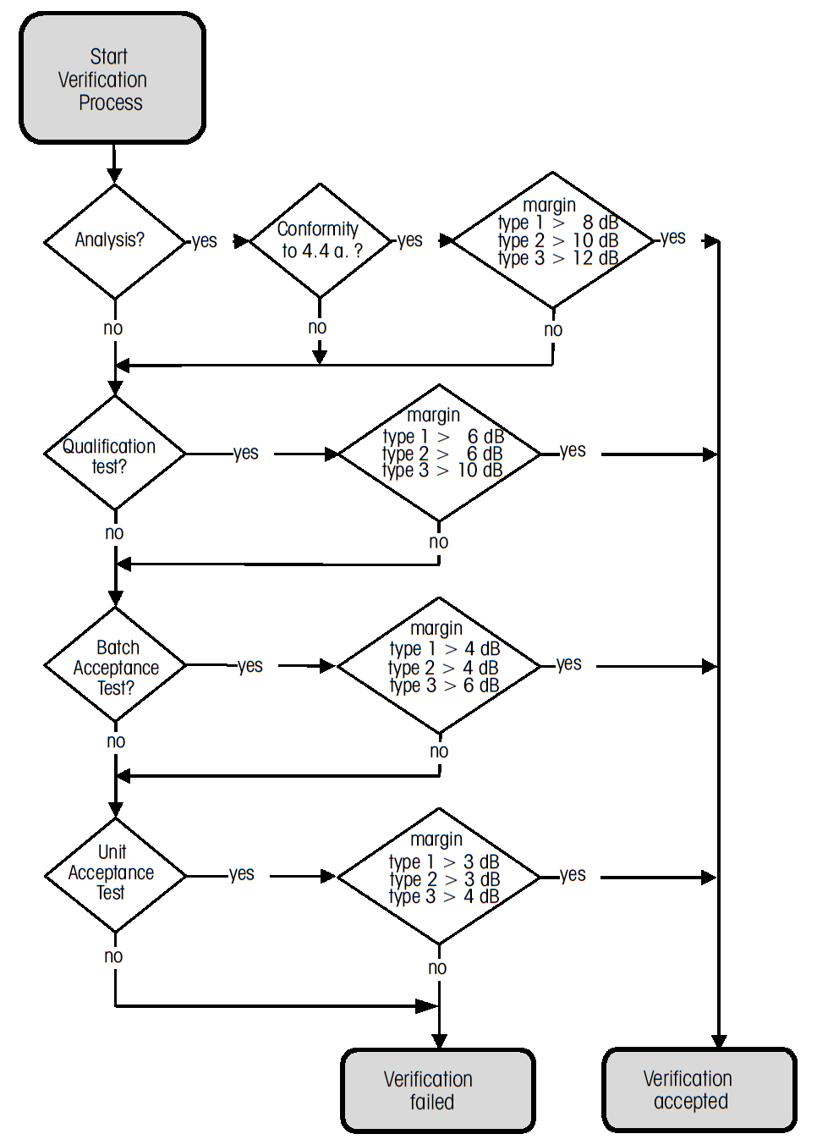
Figure 4-1: Routes to conformance for single carrier

Multi-carrier

General
This clause 4.7 presents recommendations for the verification of multipaction performance under multi-carrier conditions. The purpose of the multi-carrier margin recommendations is to give values which offer low probability for multipaction breakdown without over-designing the parts.
Up to the present time, there is not an applicable theory for multi-carrier operation. The only available criterion for establishing a multipactor discharge in multi-carrier operation is the 20-gap-crossing rule, presented in Annex A.
Multipactor in multi-carrier operation is currently under investigation (using test and numerical means like electron tracking simulators to verify the breakdown levels). Until the outcome of this activity yields a new approach, the 20-gap-crossing rule is provisionally adopted in this document, keeping in mind that all references to it (P₂₀ and others) are intended to be reviewed in future versions.
Margins are only quoted for Type 1 components. Margins for component types 2 and 3 are currently under investigation. Verification for two cases is described in the two following clauses; the first treats the case of the multipaction threshold above the power of a single carrier CW signal whose power is equal to the peak envelope power of the multi-carrier signal, and the second treats the case of the multipaction threshold below the Peak envelope power. The second case becomes more likely as the number of carriers increases.
Multi-carrier verification follows the procedure used for the single carrier case. Margins are defined with respect to a single carrier signal at the lowest frequency in the multi-carrier signal and at peak envelope power, where the peak corresponds to the worst case in-phase signal power.

Threshold above peak envelope power
          - When the single carrier multipaction threshold is above the peak envelope power, margins shown in Table 4-3 should be used.
          - As for the single carrier case, analysis-only verification should not be done unless the appropriate analysis margin and the requirements listed in clause 4.6.3 are met.
Table 4-3: Multi-carrier margins applicable to Type 1 components when the single carrier multipaction threshold is above the peak envelope power
# | Route | Margin (dB) with respect to peak envelope power
1 | Analysis | 6
2 | Qualification test | 3
3 | Batch acceptance test | 0
4 | Unit acceptance test | 0

Threshold below peak envelope power
          - When the single carrier multipaction threshold is below the peak envelope power, the margins shown in Table 4-4 should be used.
1 In this case, the margins are defined with respect to a power level, P₂₀.
2 Informative commentary on the derivation of electron crossing times and P₂₀ for multi-carrier waveforms is given in Annex A.
          - In case analysis fails, a test route should be taken.
Table 4-4: Multi-carrier margins applicable to Type 1 components when the single carrier multipaction threshold is below the peak envelope power
# | Route | Margin (dB) with respect to P20
1 | Analysis | 6
2 | Qualification test | 6
3 | Batch acceptance test | 5
4 | Unit acceptance test | 4

Route to demonstrate conformance
          - The route to demonstrating conformance under multi-carrier multipaction conditions illustrated in the flow diagram shown in Figure 4-2 should be used.
          - The unit should not be accepted at each stage of the process unless:
            - the relevant margins are satisfied, and
            - controls in the production process are such that adequate margins are carried through to the final components.
The stages in the process are analysis, qualification tests and acceptance tests, where the latter can be either batch or unit tests.
          - If any stage of the process is omitted, then it is assumed that the margins are not satisfied and the ‘no’ route in the flow diagram shown in Figure 4-2 should be followed.
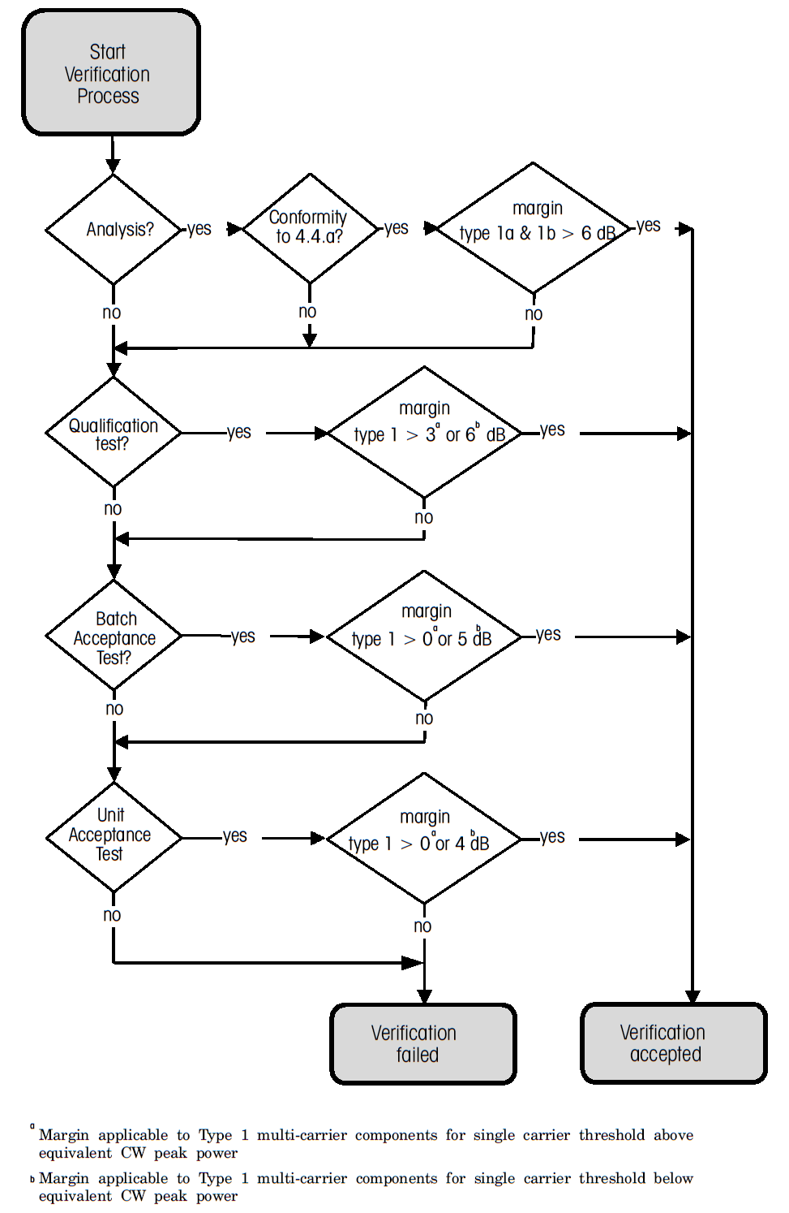
Figure 4-2: Routes to conformance for multi-carrier test

Design analysis

Overview
This clause defines the minimum requirements for performing a satisfactory design analysis with respect to multipaction. These requirements are applicable for all cases where the chosen route to conformance includes analysis. Implementation of such an analysis can vary from sophisticated three-dimensional multipaction simulations to a much simpler estimation process. In all cases, however, a realistic margin (the analysis uncertainty) in the analysis is prescribed to reflect the uncertainty in the analysis method.

General requirements

Field analysis
          - An analysis of the electric field within the whole component shall be performed.
This can be accomplished by using:
- Computer software
- measurements from on appropriate test pieces, or
- estimations from the appropriate use of equivalent circuit models.
A multipaction analysis cannot be performed without a good understanding of the electric fields within the whole component.

Secondary emission yield data
SEY data provided in Annex A are pessimistic figures given for information, as they are related to particular properties (material, coating, surface finish or treatment). It is recommended to base the analysis on more representative data from measurement on the used material, still following the methodology defined in Annex A for the threshold determination.

Critical region identification
          - All regions shall be analyzed to identify the multipaction critical regions.
Multipaction critical regions are determined by a combination of the following factors: high voltages, critical gaps, frequency and secondary emission properties of the material.
          - << deleted >>
          - Reference shall be made to the multipaction zones chart defined in Figure 5-3 which determines the multipaction regions in voltage/frequency-gap space for the relevant materials and geometries.
For additional information, see Annex A.4.2.6.
          - The multipaction critical regions shall be subjected to analysis in order to calculate the predicted multipaction threshold.
          - The analysis referred in 1.1.1ff shall cover all frequencies that are expected for the component in service.
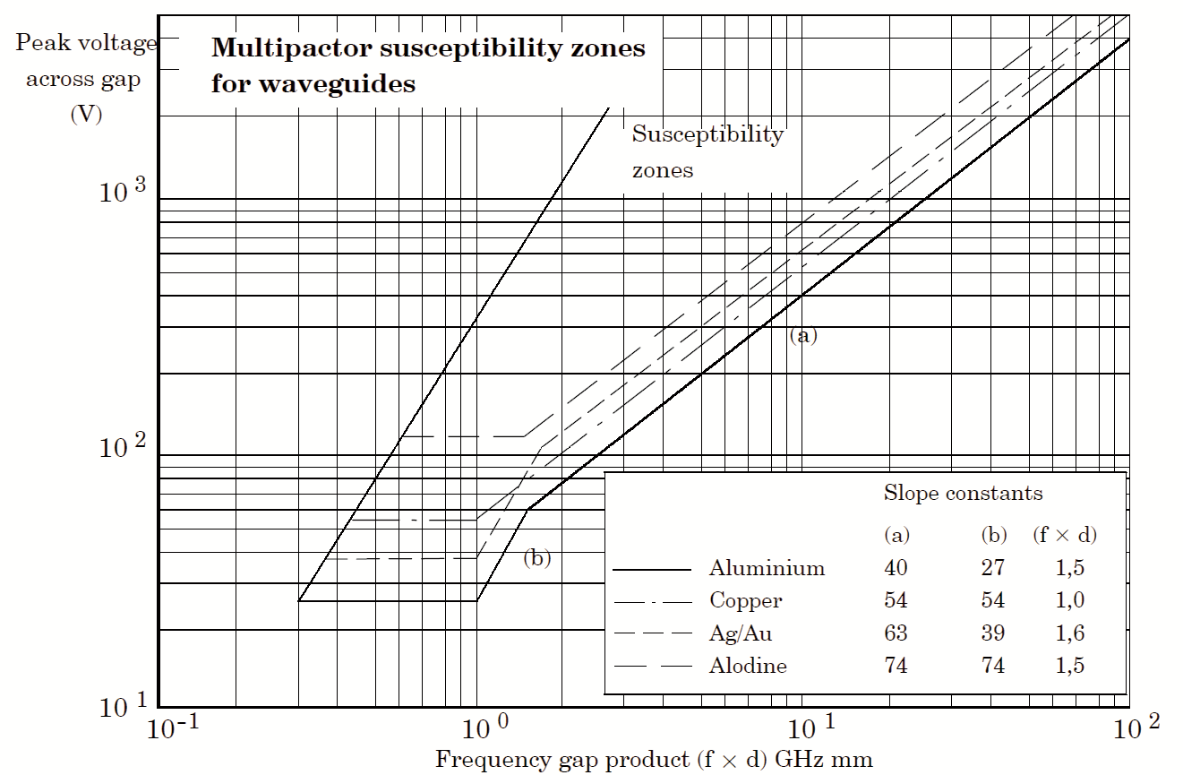
Figure 5-3: The susceptibility zone boundaries for examples of aluminium, copper, silver, gold and alodine 1200 used in Annex A

Multipaction sensitivity analysis
          - Having located and analysed the critical regions, a sensitivity analysis shall be performed to determine the sensitivity of the multipaction threshold to dimensional variation and changes in material properties.
          - The sensitivity analysis referred to in a. shall then be used to determine the correct degree of mechanical tolerance and process control to impose in cases where acceptance tests are not being performed on all flight units.

Venting
          - << deleted >>
          - << deleted >>
          - Components shall be vented such that the pressure within the vented component falls below 1,5 × 10⁻³ Pa before RF power is applied, under both testing and in-orbit conditions.

Test conditions

Cleanliness
          - Airborne particulate cleanliness class 8 as per ISO 14644-1, or better conditions, shall be maintained throughout the component assembly, test, delivery and post-delivery phases.
          - In addition, standard clean room practices for handling flight equipment and for general prevention of contamination, agreed with the customer, shall be strictly applied.
          - Protective covers to prevent the ingress of contaminants should be used.
          - Where surfaces are particularly vulnerable to contamination, specific cleanliness control measures should be applied.
1 For environmental contamination control of components and for preservation, packaging and dispatch of electronic components, see ESCC Basic Specification No. 24900 and ESCC Basic Specification No. 20600.
2 For additional information on cleanliness see Annex B.

Pressure
          - Multipaction testing shall be performed at pressures below 1,5 × 10⁻³ Pa in the critical areas of the component.
This can be achieved by providing an adequate combination of:
- pressure in the vacuum chamber,
- venting design for the component, and
- time for moisture to outgass from the component.
          - A vacuum bake-out should be performed on all components before multipaction testing.
          - The pressure in the vacuum chamber shall be monitored continuously.
          - If as a consequence of the monitoring specified in 1.1.1ss any pressure rise is observed, the RF power shall be switched off and the cause of the pressure rising shall be investigated.

Temperature
          - The thermal conditions for the DUT during multipaction testing shall be representative of the conditions the DUT is to encounter in its operation.
          - Provided the component can handle increased thermal dissipation, higher input power levels may be used.
          - The thermal dissipation in the DUT caused by the selected multipaction test signal profile (CW, pulsed or multi-carrier) shall be analysed.
          - Any DUT failure due to corona discharge produced by out-gassing build-up caused by thermal dissipation in the DUT shall be differentiated from genuine multipaction discharge.

Frequencies
          - If the most critical frequencies are not identified by analysis,
            - non-resonant components should be tested at the lowest frequency of operation, and
            - components containing resonant features should be tested at the centre frequency and at the band edges.
          - Components designed for multi-carrier operation should be subjected to waveforms that seek to simulate as closely as possible the excitation that the component experiences in-orbit.
          - For test purposes, provided that the test conditions are equivalent to or more severe than the operating conditions. the input excitation referred in 1.1.1zz may be modified by reducing the number of carriers whilst maintaining the peak envelope power by increasing the power of the individual carriers, with the mean frequency and frequency spread being such as to maintain the multipaction resonance conditions and to ensure that the widths of the power peaks are not smaller than those for the operational frequency plan.
          - The phases of the multi-carrier signals should be adjusted to provide the worst case conditions at critical gaps in the components.

Pulse duration

General
          - Pulsed testing may be applied in the cases of components operating either in CW or in pulsed mode.
This clause 6.5 covers the requirements for the pulse duration.

CW units
          - If pulse testing is used to test units that experience CW excitation in service, the pulse width shall be at least ten times longer than a characteristic time that is determined by the combination of:
            - the mean time between seed events within the critical regions of the component;
            - the time taken for a multipaction event to grow to a sufficiently high level to be detected.
1 For units that experience CW excitation in service, pulsed testing can be used to achieve the maximum test power whilst keeping the mean power within the specification of the unit and permitting the use of lower cost test equipment.
2 These factors lead to a ’dead time’, during which multipaction cannot be detected with a given set of test conditions and test equipment.
          - The dead time shall be determined for the unit under consideration.
          - << deleted >>

Pulse duration
          - The pulse duration used shall be representative of the longest pulse duration that the unit experiences in service.

Electron seeding

Multipactor test in CW operation
          - An electron seed source need not to be used for CW test.

Multipactor test in pulsed operation
          - An electron seed source shall be used in pulsed testing.
          - There shall be an adequate supply of seed electrons in the multipaction-critical regions of the unit.
          - The presence of the supply of seed electrons referred in 1.1.1jjj shall be verified.

Multipactor test in multi-carrier operation

Overview
There are two types of multipaction events that can occur in a multi-carrier environment:
- Successive peaks in the multi-carrier signal initiate multipaction events in which the electron charge decays completely between signal peaks.
- Successive peaks in the multi-carrier signal initiate multipaction events in which the electron charge fails to decay completely between signal peaks.
The first case can be treated as an extreme of the pulsed case.
The second case is similar to CW multipaction with the multipaction event building up over a much longer time-scale than initially expected.
Both cases need an electron seed source as specified in 1.1.1lll.
An informative commentary on electron seeding is given in B.3.5.
In addition, during the peaks the multipaction event can be at such a low level that it sometimes cannot be recorded by transient detection methods.

Requirements
          - For multicarrier environment an electron seed source shall be used and verified.

Seeding sources
          - At least one of the following seed sources shall be used:
            - Radioactive β source, which produces high-energy electrons that, after impacting with metal surfaces or propagation though metallic walls, yield a supply of low energy seed electrons.
            - UV light source, which produces electrons by the photoemission mechanism.
            - An electron gun, which produces a known beam of electrons where both the energy and flux can be characterized.
            - A charged wire probe, which produces electrons by the point discharge mechanism.
1 UV light illuminating the component inside walls at places close to the critical gap can be used as a seeding source.
2 For additional information in electron seeding, see B.3.5.
          - Verification of the seeding source should be performed by test.
          - When the verification is performed, the following procedure should be used to prove the seeding:
            - Fabricate a test piece of representative physical form, wall materials and wall thickness, but with the internal walls of the multipaction-critical region made from copper or silver-plated aluminium, and a theoretical multipaction threshold 3 dB to 6 dB below the peak test power.
            - Activate the intended seeding source.
            - Test the item for multipaction with a CW signal to determine the threshold.
            - Test the item for multipaction with a pulsed signal, and decrease the pulse width until it is equal to or below that intended for the subsequent test on the formal item.
            - If the following conditions are met, the seeding is proven:
              - consistent multipaction events are recorded, and
              - the threshold is constant with changing pulse width.
            - If conditions in 1.1.1.15 are not met, do the following until these conditions are met:
              - reposition the source, or
              - increase the seeding rate.
The above assumes that the detection method has sufficient sensitivity and response time to detect multipaction during the specified pulse width, that is, that conditions 7.3 are met.

Methods of detection

General
This clause defines the minimum requirements for the detection methods used for multipaction testing. Details of such test methods are included in C.5.1.

Detection methods
          - The detection methods should be selected from the following list:
            - Global methods:
              - Close to carrier noise.
              - Phase noise.
              - Harmonic noise.
              - Microwave nulling.
            - Local methods:
              - Optical.
              - Electron probe.
          - At least two detection methods shall be present in the test configuration and at least one of them shall be a ”global” method.

Detection method parameters

Sensitivity
          - It shall be demonstrated that the detection methods selected are able to detect multipaction events.
          - The demonstration specified in 1.1.1rrr should be proven using the chosen detection methods and:
            - a test piece that shows multipaction at input power levels lower than the peak power to be applied to the deliverable unit, and
            - the same environmental conditions as for the qualification test.
This includes temperature and pressure.

Rise time
          - Each detection method selected shall be shown to have a sufficiently short rise time to detect multipaction events that are initiated by pulses no longer than those to be applied to the deliverable unit.
          - The demonstration specified in 1.1.1ttt should be proven using the chosen detection methods and:
            - a test piece that shows multipaction at input power levels lower than the peak power to be applied to the deliverable unit, and
            - the same environmental conditions as for the qualification test.
This includes temperature and pressure.

Test procedures

Test configuration
          - The multipaction test configuration used shall conform to the following conditions, as a minimum:
            - The basic configuration for each test:
              - is identified in the test procedure either explicitly or by reference to the test plan;
              - includes the level of detail adequate to enable identification of the calibration or validation approach.
            - The detailed test configuration describing the test set-up for each component is included in the test procedure.
            - The test configuration includes
              - continuous monitoring of the power applied to the test item, and
              - a means of accurately calibrating the power monitoring.
            - Continuous thermal monitoring and control is provided for the test item.
            - Continuous pressure monitoring is provided within the vacuum chamber.
            - Detection methods are provided, and the test configuration
              - enables accurate calibration of the detectors, and
              - provides an appropriate thermal environment to enable the calibration to be maintained during the test.
            - The test configuration is adequately validated, as specified in clause 8.2.

Test facility validation
          - A demonstration and validation of the correct functioning of the test configuration shall be performed immediately prior to test and after testing.
1 The reason is that, as specified in 1.1.1kkkk, the criterion for a successful test is a null result, i.e. nothing is detected by the detection system.
2 Informative commentary on validation method is given in Annex D.4.
          - The demonstration specified in 1.1.1www shall be performed at the same environmental conditions as for the qualification test.
This includes temperature and pressure.

Test execution

General
          - The sample size shall be as defined in the source control drawing.
          - Performance of the multipaction test shall be controlled by a detailed test procedure.
          - After each new test configuration is set up, both the transmitter chain and the detector chain shall be calibrated.
          - For extended or multiple tests with a given configuration, the calibration should be periodically revalidated.

Test procedure
          - The vacuum chamber containing the test item shall be evacuated for a sufficiently long period to enable adequate venting and outgassing of the system.
          - The test configuration shall be validated by applying power to multipaction standard and observing the onset of multipaction at the expected power level.
          - The test shall be performed by applying first the lowest test power, and then increasing the power in steps up to the maximum test power, as follows:
            - At each step, hold the power constant for the step duration.
            - Ensure that the maximum test power is the power corresponding to the operational power plus the specified test margin.
            - Ensure that the lowest test power is 10 dB below the maximum power, unless a qualification margin is established, in which case the lowest test power level can be increased up to but no higher than 3 dB below the maximum power.
            - Ensure that the power steps is 1 dB until a point 3 dB below the maximum power is reached; at which point the steps are reduced to 0,5 dB.
            - Ensure that the duration of the steps are:
              - 10 minutes in a CW test, for powers below the component rated value;
              - 5 minutes in a CW test, at powers above the component rated power;
              - the total aggregate duration of the pulses is as per 1.1.1.1.1(a) and 1.1.1.1.1(b), not including the interpulse periods, for pulsed testing.
          - During the test is shall be ensured that:
            - the detectors are continuously monitored, and
            - continuous multipaction discharge are avoided in order to prevent component damage.
          - Any detected pressure rise or unacceptable temperature rise shall cause an interruption of the test until satisfactory conditions are restored.
          - On completion of the test, the validation shall be repeated.
          - After reviewing all the test results, the vacuum chamber shall be returned to ambient pressure by purging with dry nitrogen.
          - The calibration of the transmitter chain and detectors shall be checked to confirm that the calibration is still valid.

Acceptance criteria

General
          - The acceptance criterion for a successful test shall be that no multipaction is detected during the test in any of the detection systems at any input power up to the specified peak level.
It is common experience, however, that as power levels are increased and approach the threshold for the first time that short bursts of multipaction or plasma discharge are detected. The events are not sustained and cannot be repeated. A plausible explanation is that these events are associated with some form of surface conditioning.
          - In cases where multipaction or plasma discharge are detected, as power levels are increased and approach the threshold for the first time, the acceptance criteria shall be that no event occurs after running for one minute and that after that minute the power can be cycled five times between the desired power and 1 dB lower with no detection of multipaction.
          - In cases of discharge specified in 1.1.1llll, the test duration should be doubled for that power level.

Multi-carrier test
For multi-carrier tests, the use of sensitive, short rise time detection methods enables recording of occasional isolated transient events, particularly if a fast seeding environment is provided.
At the present time, the acceptance criteria to apply in this case have not been determined.
- (informative)
Multipaction background
  - Physics of multipaction
Multipaction is a well-understood RF vacuum breakdown mechanism whereby there is a resonant growth of free electron space charge between two surfaces. It has been investigated both theoretically and experimentally over many years; for example see references [1] to [7] listed in the Bibliography. Essential for multipaction are initial seeding free electrons, surfaces where the number of secondary electrons per incident electron is greater than unity for the energies of the incident electrons, and electric fields frequencies and surface separation such that the secondary electrons themselves lead to further growth in electron number when they are incident on surfaces.
A typical multipaction event proceeds as follows:
- Free electrons exist within the RF field region of a component whose dimensions are small compared with the electron mean free path as a result of low pressure within the component.
- The electric field within the component accelerates the free electrons towards an interior surface.
- The electrons impact on the surface with appropriate energies to liberate more secondary emission electrons than were incident.
- The alternating RF field reverses and accelerates the electrons away from surface, reducing the tendency for surface re-absorption of the low energy electrons.
- Steps c. and d. together are such that the number of free electrons is increased by the interaction with the surfaces.
- Moving under the influence of the applied RF electric field and the electron-electron mutual repulsion field, the electrons impact on an interior surface of the component after approximately n half-cycles of the RF field. The number n is the order of the multipaction event and is almost always odd, signifying a multipaction event between two surfaces, for example the two conductors in a vacuum spaced coaxial cable.
- Steps c. to f. are now repeated with an increase in the electron population at each impact causing exponential charge growth to occur until a limiting process such as that caused by the electron-electron mutual repulsion causes the electron cloud to saturate.
The basic physical mechanisms that give rise to a multipaction event are therefore: various processes for generating seed electrons, the mutual interactions between electrons and time varying electromagnetic fields, and the surface physics of secondary electron emission. For the case of simple geometries, such as parallel plates or coaxial surfaces, the resonance conditions can be parameterized in terms of the gap voltage and the frequency-gap product, leading to design tools such as the Hatch-Williams diagram. These cases are explored later in this Annex. For space component applications, the relevant bounds are the lowest bound for multipaction to occur, and since the electron-field interaction is almost electro-static, the bounds given by the Hatch-Williams diagram provide a good initial estimate for more complicated geometries.
  - Other physical processes
Electrical breakdown in RF components can arise from solid surfaces or residual gas as electron sources for discharge. Under space vacuum conditions, electron population growth through resonant secondary emission at surfaces is the predominant process. If the very low pressure conditions corresponding to the ambient space environment are not met, then collisions between the surface emitted secondary electrons and the residual gas modifies the behaviour, leading to multipaction initiated plasma formation. Under such conditions, the range of voltages over which discharges can occur increases. At higher pressures still, RF breakdown can lead to gas discharge even in the absence of multipaction (see references [8] to [10]). Under space vacuum conditions, plasma formation, RF breakdown and arcing are not the primary processes. However, they can affect test conditions, and it is for this reason that venting and vacuum conditions are addressed in other parts of document.
  - RF operating environment
    - General
This clause A.3 defines the various RF operating environments that can be experienced by a high power component, namely:
- true CW operation;
- single modulated carrier;
- pulse modulated operation;
- operation with two or more modulated carriers.
At the detail level, there are a large number of schemes, such as modulation schemes and frequency plans. But rather than exploring these, it is more desirable to reduce the number of approaches to the minimum set described in the following clauses.
    - CW approach
Conceptually, this is the simplest approach and, also, it has the merit of being the worst case, thus minimizing the risk of in-orbit failure. As the worst case approach, it may be applied in all cases. However, the disadvantage of the approach is that, in multi-carrier cases, it can lead to significant over-design and over-test.
The approach simply involves calculating the peak instantaneous power derived from the modulation scheme, or frequency plan, or both; and then making the assumption that the component is operated in a CW manner at a power level equal to the peak instantaneous power so calculated.
    - Pulsed approach
In this approach, the component is treated as if it were excited by a pulse-modulated carrier. There are several motivations for adopting a pulsed test approach, which give rise to differences in detail as illustrated below:
- The pulsed approach is selected because the component is actually intended for operation in a pulse-modulated fashion, for example in a radar system.
- The pulsed approach is selected for testing in order to achieve the testing peak power levels whilst controlling the mean power level for thermal or other reasons to avoid overstressing the component.
- The pulsed approach is selected for testing in order to reduce the cost of the high power source.
- Examples b. and c. really apply to a hybrid between the CW and pulsed approach in which pulsed testing can be used if it can be demonstrated that the pulsed excitation is no less stringent with respect to multipaction than CW testing.
    - Multi-carrier approach
The multi-carrier approach is appropriate for components operated in a multi-carrier environment and where the CW approach is rejected either because it can lead to over design or because the implied power levels can make the testing uneconomic or impracticable. For example, a component under 8 multi-carrier unmodulated CW excitation with 100 W per carrier results in testing at 25600 W input power (assuming a 6 dB margin). Unfortunately, this approach is the most complicated, the least well understood, and so the risks of following this approach are higher.
The essence of the multi-carrier approach is that the component is powered by waveforms that seek to simulate as closely as possible (except for the addition of a margin) the excitation that the component is subjected to in service. Two significant problems arise from this simple concept: firstly there is the question of selecting the actual waveforms to apply from an infinite variety of possible phase conditions of the carriers, and secondly there is the question of the trade-off between sensitivity and resolution of the detection system and the subsequent interpretation of the detected waveforms.
    - Multi-carrier multipaction thresholds
The semi-empirical 20-gap-crossing rule is based on the dependency of the multipactor discharge on the signal envelope, stating that multipactor occurs when the multi-carrier signal envelope exceeds the single carrier multipactor threshold for an interval equal or higher than the time that an electron needs to cross 20 times the gap (see reference [4]). Unfortunately, up to the present time, no experimental results have verified the validity of such a rule as the worst case.
In addition, the 20-gap-crossing rule establishes the multipactor criterion for an optimized multi-carrier envelope during the time interval τ20. But in more recent publications, a new mechanism of long-term multipactor in multi-carrier applications is addressed (see references [20] and[21]), in which the charge accumulates between consecutive periods of the envelope.
For these reasons, new prediction techniques are currently under development. These techniques are based in recent investigations regarding the multipactor theory and numerical software, supported by testing. These new techniques are aiming to calculate the worst case signal and the multipaction threshold for each specific case.
However, until the aforementioned investigations are finished, the 20-gap-crossing rule detailed next will be provisionally used for the multi-carrier analysis.
As the number of carrier frequencies increases, the ratio of peak power to mean power increases, with the consequence that positive margins with respect to the peak power become overly restrictive. However, acceptable multi-carrier multipaction performance can still be realized even though the single carrier margin can be negative. This is the case addressed in this clause.
To establish verification when margins are negative implies a more detailed analysis in which the duration as well as the magnitude of the multi-carrier power peaks is considered. The procedure makes use of the empirical 20-gap-crossing rule which states that detectable multi-carrier events need signal power levels to be maintained above threshold for a period about 20 gap crossings after initial seeding has taken place (see reference [4]). A verification process based on the same heuristic is as follows:
- Compute the mean power P_{mean} and peak power P_{peak} from the frequencies and powers of the specified N carriers assuming in-phase or coherent signals.
- Establish the single carrier multipaction threshold power Pt from the tests, which for the present case is such that P_{mean} < P_{t} < P_{peak}.
- Calculate the (worst case) mode order for the susceptible gaps in the component; in general by performing detailed computations. Detailed calculations for the most used materials are shown in Table A-1 to Table A-5.
- Compute the 20 gap crossing time, τ20, where
τ20 = (20 × mode order)/(2 × mean carrier frequency).
- Compute the power P20 that is the maximum power level of the multi-carrier signal for a peak power duration at least equal to the 20 gap crossing time. This value can be obtained using an optimization method which determines the worst case phase between carriers under the conditions defined by the frequency plan and power per carrier proposed for in-flight conditions (see reference [14]).
                - : Worst case mode order for susceptible gaps for an example of gold
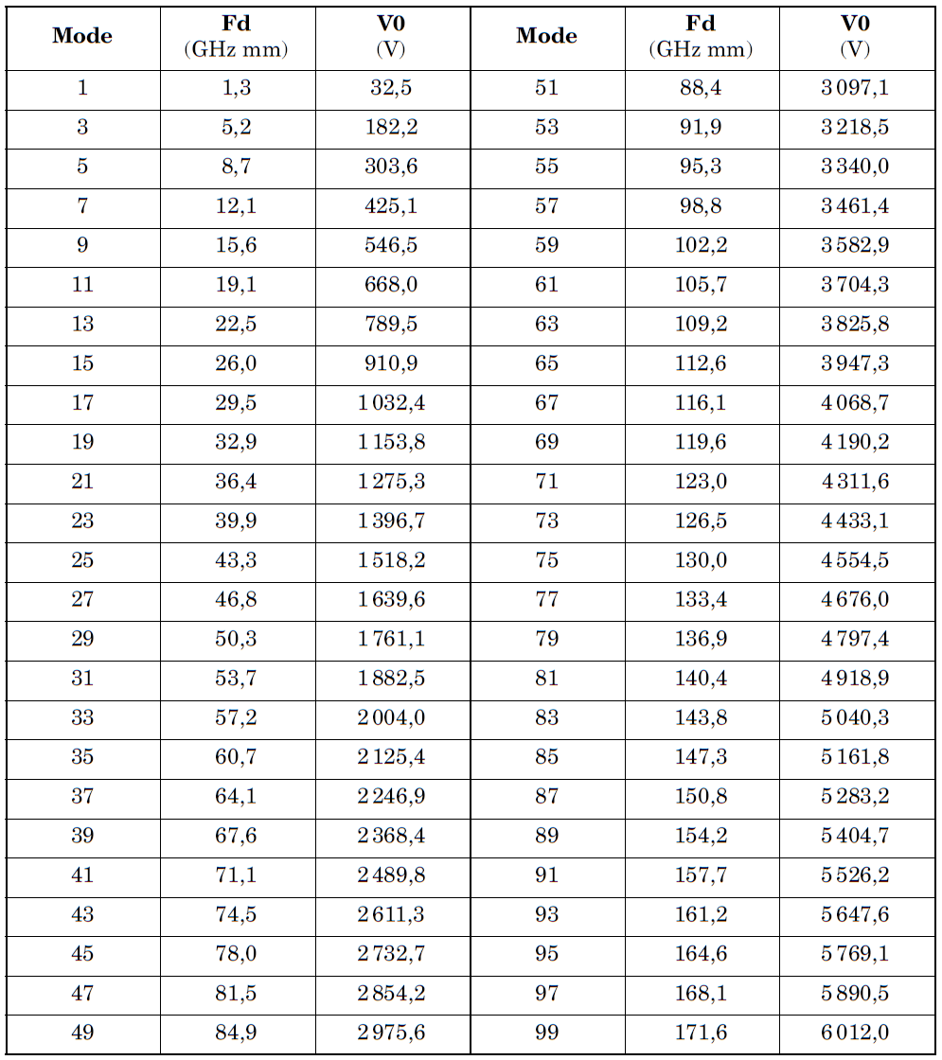
(α _{max}=1,79 E1=150 E2=4000 Slope(a)=64,2 Slope(b)=40,1 Wf1=30,1 Wf2=56,2 - see Table A-1)

                - : Worst case mode order for susceptible gaps for an example of silver
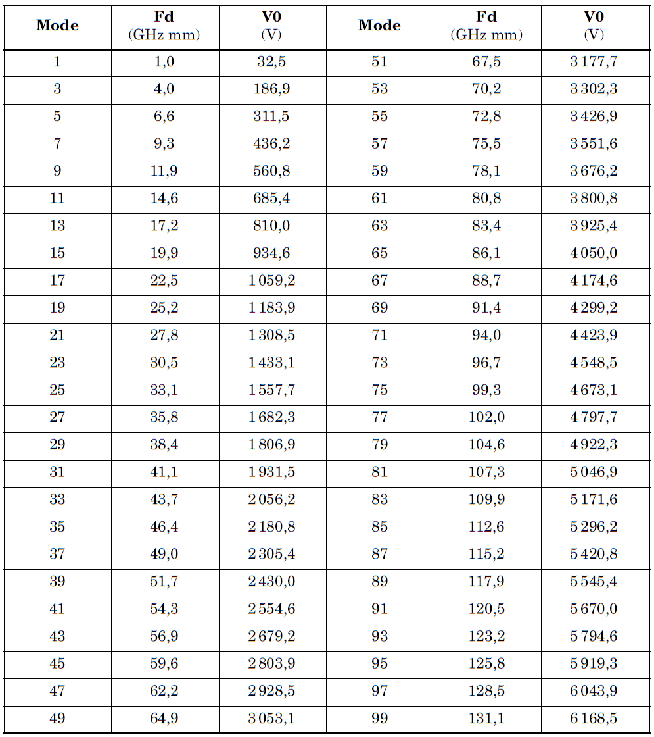
(α _{max}=2,22 E1=30 E2=5000 Slope(a)=62,4 Slope(b)=37,9 Wf1=32,4 Wf2=59,1 - see Table A-1)

                - : Worst case mode order for susceptible gaps for an example of aluminium
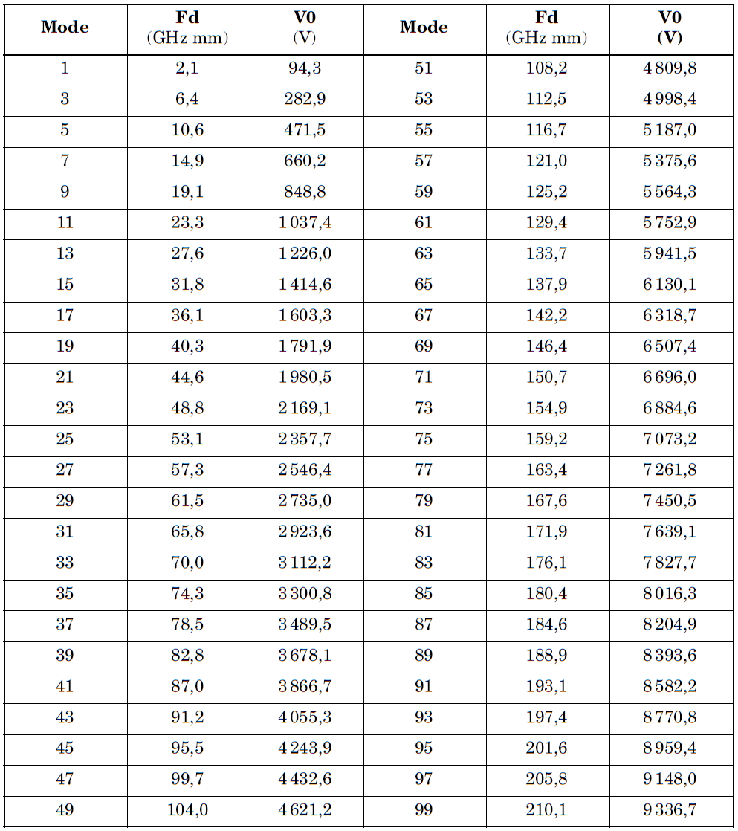
(α _{max}=2,98 E1=30 E2=5000 Slope(a)=39,8 Slope(b)=26,6 Wf1=23,3 Wf2=44,7 - see Table A-1)

                - : Worst case mode order for susceptible gaps for an example of alodine
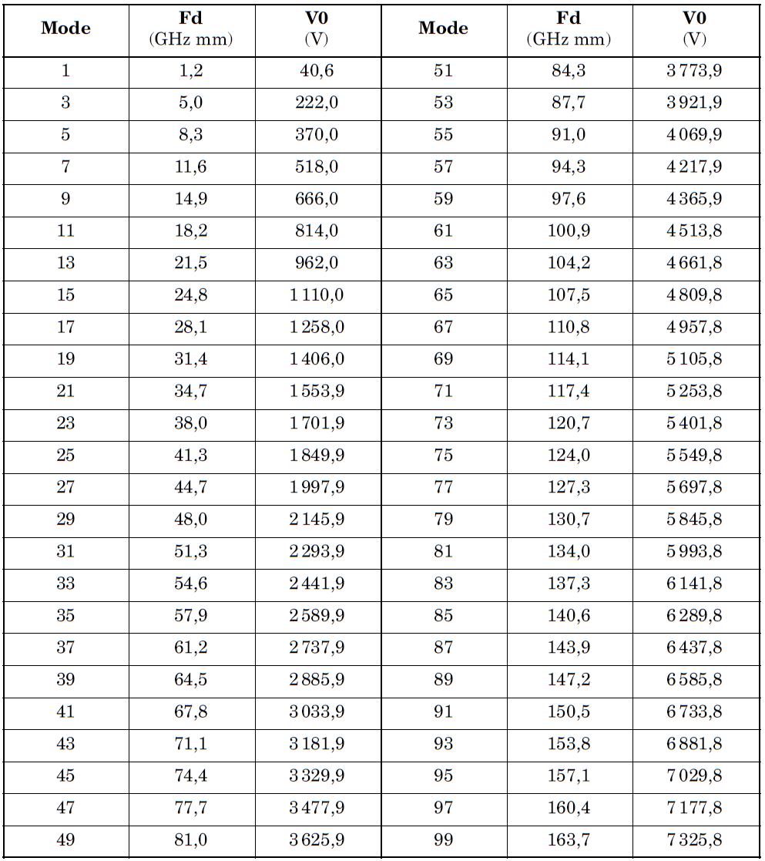
(α _{max}=1,83 E1=41 E2=5000 Slope(a)=73,8 Slope(b)=73,8 Wf1=85,6 Wf2=85,6 - see Table A-1)

                - : Worst case mode order for susceptible gaps for an example of copper
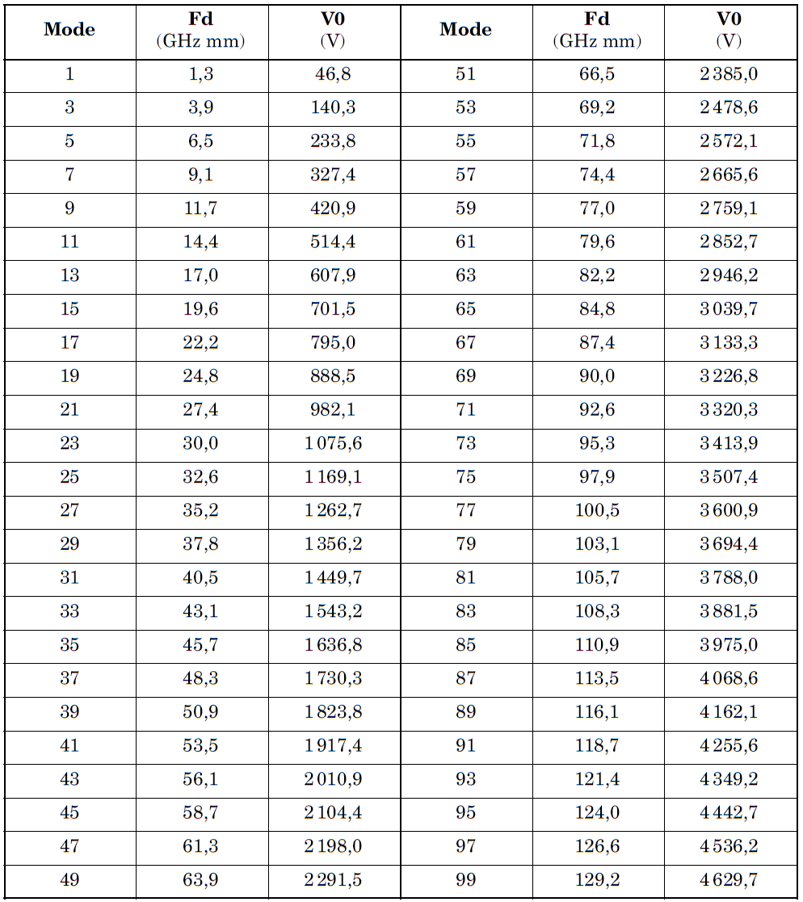
(α _{max}=2,25 E1=25 E2=5000 Slope(a)=54,1 Slope(b)=54,1 Wf1=37,1 Wf2=37,1 - see Table A-1)

  - Parallel plate multipaction
    - Introduction
As stated in A.1, multipaction is the resonant growth of secondary electron population in RF components. When an electron strikes a surface, secondary electrons can be emitted. Secondary electron emission (SEE) has two components: true secondary electrons with relatively low energies (<50 eV) and back-scattered electrons (BSE) with larger energies up to the primary electron energy. For each electron impacting a surface, an average of δ true secondary electrons and an average of η back-scattered electrons are emitted. A fraction ε of the back-scattered electrons are elastically reflected electrons. δ and η are defined as the true secondary emission scattering coefficient and back-scattering emission coefficient, respectively.
Each coefficient depends both on the energy of the incident particle and its angle of incidence. Moreover, all coefficients depend on the material and on how and when material has been treated. For example, baking in vacuum can significantly change SEE because surface impurities are eliminated. In addition, the effect of air exposure (aging) has a strong influence on the SEE properties. For a given material and treatment, a variety of parametrizations for these dependencies are available in the literature (see reference [11]).
The variation of the total secondary emission coefficient σ = δ + ε, with the incident electron energy E_{p} is unimodal, with a maximum σmax at E_{p} = E_{max} and for many materials σ > 1 for a range (E₁, E₂) of E_{p} as illustrated in Figure A-1.
The measured values of these parameters for an example of copper surface (Cu8A in Table V of reference [11]) are σ_{max}= 2,25, E₁ =25 eV, E_{max} = 175 eV and E₂= 5000 eV. Table A-1 gives these values for the most used materials.
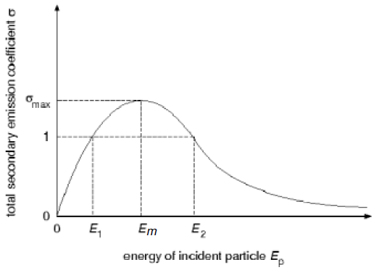
              - : Total secondary electron emission as a function of the incident electron
The conditions for exponential growth of the true secondary electron population are:
- the maximum true secondary electron emission coefficient is greater than unity;
- the incident electron has an energy between E₁ and E₂;
- the phase of the electric field is such that the secondary electron is not accelerated back into the surface from which it is emitted;
- the amplitude and phase of the electric field is such that the secondary electron is accelerated towards the opposite conductor and impacts the surface a half-integral number of wave periods after its emission with energy such that it in turn satisfies conditions a. and b.
The Hatch and Williams theory of parallel plate multipaction (see reference [6]) is based on the above conditions and leads to closed regions in voltage - frequency × gap (V. f × d) parameter space for each odd-order resonance. Woode and Petit (see reference [1]) have experimentally tested a number of materials commonly used in spacecraft components, and have shown that the Hatch and Williams theory is in good agreement with their experiments. Figure A-2, taken from reference [1], shows the zones of susceptibility according to the Hatch and Williams theory (the dashed line, with increasing order at increasing fd product), measured threshold points and a design boundary fitted to the data for a particular type of aluminium, which cannot be considered as generic.
The boundary conditions in this region of the multipaction chart cannot be precisely defined until more experimental verification work is performed.
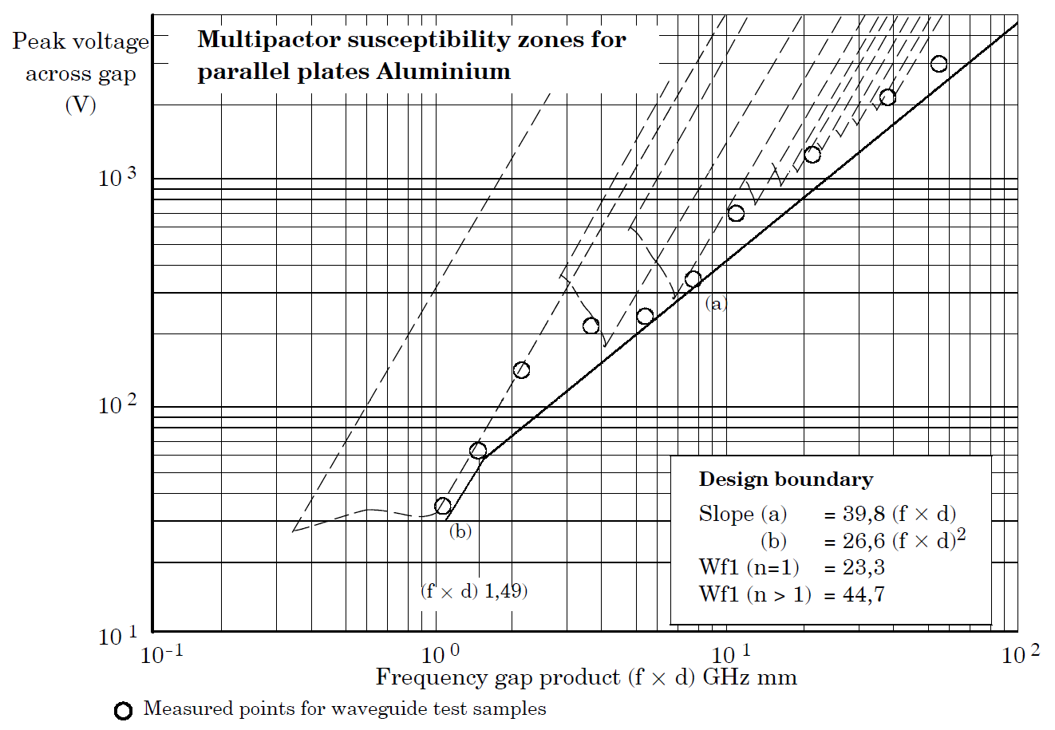
              - : Multipaction susceptibility zones for parallel plates of an example of aluminium
    - Woode and Petit results
      - General
The results summarized below are extracted directly from the ESA working paper by Woode and Petit (see reference [1]). Charts of multipaction susceptibility zones as illustrated in A.4.1Figure A-2 were made for non-standard examples of the materials listed below, and a universal susceptibility chart was constructed from the design boundary envelopes for multipaction threshold for the various materials.
The results from this working paper are illustrative and cannot be considered representative or generic of the material investigated.
      - Materials and surface treatments
The following examples of materials and coatings were investigated:
- Aluminium alloy type Al2024
This is a general purpose machinable alloy used for the construction of RF payload components. These components are normally plated silver or gold but aluminium is used as a reference for the measurements.
- Alodine 1200
This is a chromate conversion surface on aluminium. It is used as a protective coating on aluminium, to be painted or unpainted. It is yellow gold coloured, and the surface thickness is 5 × 102 Å to 7,5 × 103 Å. This coating is used extensively in the construction of spacecraft hardware. It is not normally used for RF components, but has been used for waveguide harnesses.
- Alodine 1500
This is a chromate conversion surface on aluminium as a protective coating, it is used unpainted and is a colourless film. The coating thickness is 5 × 102 Å.
- Oxygen free copper
The surface is not normally used for space hardware but is the base material used for silver and gold plating. The machined surfaces were chemically etched before testing.
- Silver plated oxygen free copper
This is a high purity silver coating, more than 99,9 % pure with no brighteners or stabilisers, coating thickness 7 µm. The typical surface finish is used for high power RF components.
- Gold plated oxygen free copper
This is a high purity gold coating with more than 99,9 % purity, no added brighteners or stabilisers, coating thickness 7 µm. This surface is sometimes used for high power RF components in space.
      - Observations on results
- It was demonstrated that, when performing multipaction tests, the use of a radioactive or free electron source had a determinative roll in obtaining the true multipaction threshold, especially for the small gap samples.
- With aluminium samples with small gaps, very little change in multipaction threshold was noted, either with or without a free electron source.
- The multipaction threshold, at a constant f × d, was the highest for alodine, was the lowest for aluminium, and approximately the same for silver, copper and gold.
- The slope of the results for the different materials followed closely the unity slope expected.
- All the results deviated from a straight line in a similar cyclic manner.
- For alodine, the thresholds at f × d = 1 and at f × d = 0,5 were equal; for all the other materials, the threshold increased as a function of (f × d)².
      - Construction of multipaction susceptibility zone boundaries
Multipaction susceptibility zones for the different non generic materials were constructed from the experimental data. The zone boundaries define the actual multipaction threshold expected, without any margin, except for that of the original measurements made. During component design and testing, allowances were made for the following factors:
- VSWR degradation;
- margin for long-term contamination and handling;
- test measurement errors.
      - Susceptibility zones
In constructing the susceptibility zones from the experimental data, the following assumptions are made:
- A margin of 1 dB has been allowed from the best fit line to the measured points. This allows for inaccuracies in the measurements.
- The change in slope at n = 1 was included for Au, Ag and Al. This was not reported before but, according to experience, is correct for waveguides.
- The change in slope constant at n > 3 noted for Al and Cu was not included, but for marginal designs it can be included.
- Data for each zone boundary is given:
- Slope(a) = C (f × d)
- Slope(b) = C (f × d)²
- Change Point (f × d)
Where C is a constant.
- The constants achieved, slope(a) and slope(b) are given in Table A-1.
                - : Constants for the tested materials
Material | Αmax ª | E1 ª | E2 ª | Em a ª | Slope(a) | Slope(b) | Wf1 | Wf2
Gold | 1,79 | 150 | 4000 | 1000 | 64,2 | 40,1 | 30,1 | 56,2
Silver | 2,22 | 30 | 5000 | 165 | 62,4 | 37,9 | 32,4 | 59,1
Aluminium | 2,98 | 30 | 5000 | 805 | 39,8 | 26,6 | 23,3 | 44,7
Alodine | 1,83 | 41 | 5000 | 180 | 73,8 | 73,8 | 85,6 | 85,6
Copper | 2,25 | 25 | 5000 | 175 | 54,1 | 54,1 | 37,1 | 37,1
αmax = maximum secondary emission coefficient (see A.4.1)
E1 = lowest incident electron energy at [ρ=1] (see A.4.1)
E2 = highest incident electron energy at [ρ=1] (see A.4.1)
Em = incident electron energy for αmax (see A.4.1)
Slope(a) = upper design boundary (see A.4.2.5)
Slope(b) = lower design boundary (see A.4.2.5)
Wf1 and Wf2 are work functions
ª Data for silver and copper are from [1]. Data for aluminium and alodine are from [13].

      - Universal design curve
The basic susceptibility zone boundaries for all of the material examples were plotted on a common axis, given in Figure 5-3 (see 1.1.1ff). Interpreting below f × d = 1, the constant energy locus used in the theory is discarded as it is not verified by experiment. The constant voltage line used is considered a good estimate of the real situation.
  - Coaxial line multipaction
    - Introduction
Multipacting discharge between coaxial copper electrodes was investigated by Woo (see reference [8]). His work showed that, for coaxial lines of low impedance (under 50 Ω), the multipaction susceptibility threshold was similar to that for the parallel plate case. As the impedance of the line was increased, the region of the voltage – (f × d) parameter space over which multipaction occurred decreased.
More recent work by Arter and Hook (see reference [12]) has used a coaxial line particle-in-cell (PIC) computer simulation code with a Monte-Carlo secondary electron emission module that uses experimentally determined secondary electron emission properties. Their calculations agreed with Woode and Petit’s results for copper and reduced to the parallel plate results for low impedance coaxial lines. The results from reference [12] are summarized in A.5.4.
    - Problem definition
The aim of this work was to predict the multipaction thresholds for coaxial transmission lines. Four coatings with different secondary electron emission (SEE) properties were considered, namely copper (Cu), silver (Ag), aluminium (Al) and alodine (Ald). The SEE properties of a coating can vary appreciably according to how it has been treated. It is desirable to work with the worst case material. Hence for copper and silver, the SEE coefficients used corresponded to the samples labelled Cu8A and Ag3A, respectively, in reference [11]. These are as received values that represent the effects of surface contamination. For aluminium and alodine, the criteria used to obtain the worst case materials are low values of E₁ and E_{m}, and high σ_{m} (using the notation of reference [1]). All the chosen values are listed in Table A-1 (note here that the aluminium sample chosen (Al2A) has different secondary emission properties (reference [13]) from those used by Woode and Petit in the assessment of secondary emission in parallel plate geometry (reference [1]).
The coaxial geometry selected was such that the line impedance, Z, was 50 Ω, a value for which experimental results were available. This impedance implies that the inner radius a and outer radius b of the coaxial line are in the ratio b/a ≅ 2,3. In this geometry, twelve threshold calculations were performed for each material at different values of the frequency-gap product f × d (f is the frequency of the applied TEM wave and the gap d = b-a). The f × d products ranged from 0,7 GHz mm to 30 GHz mm.
    - Simulations
Simulations were performed using both a two-dimensional (r-z) PIC code and a one-dimensional axi-symmetric PIC code. Both codes used the same Monte-Carlo secondary emission package to model secondary emission, and both codes gave the same results, indicating that magnetic fields and axial drift effects are not important.
    - Results
The five threshold curves computed are plotted together in Figure A-2 and tabulated in Table A-1. From these, it is clear that aluminium(Al2A) and alodine have very similar multipaction properties. The aluminium materials are superior to silver and copper, which also closely resemble one another. For copper, we have also demonstrated that changing the waveguide gap by an order of magnitude (from d = 1,886 mm to d = 2 cm) has negligible effect, provided the impedance is unchanged.
                - : Critical voltages for multipaction in 50 Ohms coaxial lines using an example of materials
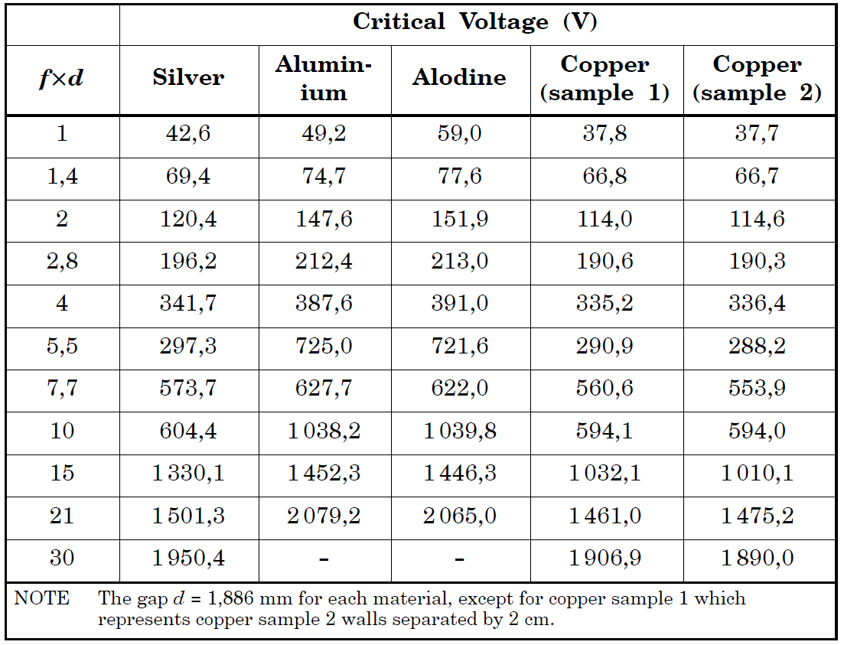

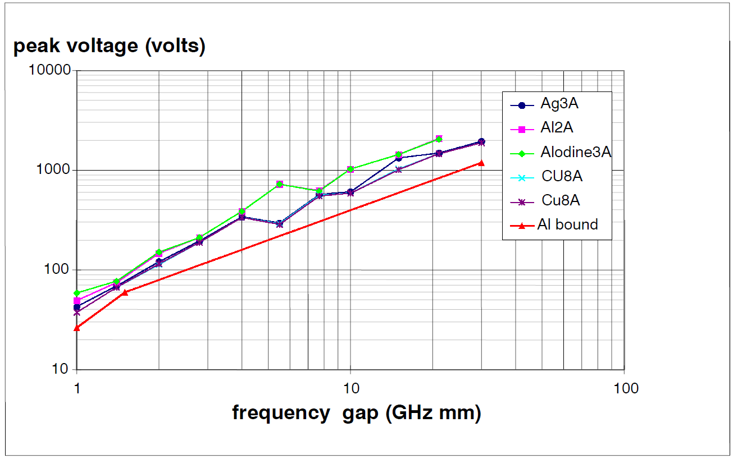
The lower curve labelled ‘AL bound’ is the parallel plate susceptibility zone boundary for Al2024 from reference [1].
              - : Multipaction threshold for all materials studied, plotted in a single graph as labelled
The similarity of the threshold curves for aluminium and alodine merits some comment. The energy E1 at which the secondary emission coefficient σ first becomes greater than unity is normally critical, and since E1 = 41 eV for alodine compared to E1 = 30 eV for aluminium, it is expected that alodine is superior to aluminium, in agreement with practical experience. However, σ reaches its maximum at a value Emax = 805 eV for the Al2A sample, much higher than the corresponding alodine value of Emax = 180 eV. Thus, σ for the aluminium increases much more slowly for E > E1 than σ for the alodine. When the back-scattered fraction η is subtracted from σ to give the true secondary emission coefficient δ for each material, it is found that the δ -curves have almost exactly the same E1. It is entirely reasonable to expect that the back-scattered electrons play a negligible role in multipaction (apart from seeding); hence the computed results are consistent with the input data. It is expected that using a more accurate treatment for σ as a function of primary energy can make aluminium appear significantly worse.
At small f × d, different threshold curves are obtained experimentally for different d. The reason for this remains unclear. At large f × d, there is some evidence that the regions of (V, f × d) space where multipaction occurs become isolated. This makes determining the thresholds very difficult, which argues for more sophisticated search procedures, perhaps involving continuation methods, if detailed two-dimensional calculations of threshold are requested.
It is clear that this computational study is not complete until additional experiments are performed. In addition to validating the numerical model, experimental measurements can help to resolve the issue of the treatment of the SEE properties of aluminium, and can also help to delineate better the multipaction threshold at large values of f × d.
- (normative)
Cleaning, handling, storage and contamination
  - Generic process
    - Introduction
The presence of contaminants within a satellite RF system can contribute significantly to discharges that take place within that system. Discharge can either be multipaction with a lower threshold power than expected or a local ionization discharge from plasma formation at surfaces containing the contaminants.
    - Cleaning and handling of critical components
          - To maintain the integrity of the multipaction tests during in-orbit operation, the following specifications on control of environment contamination of components and on the preservation, packaging and dispatch of electronic components shall be applied:
            - ESCC Basic Specification No. 24900.
            - ESCC Basic Specification No. 20600.
These documents do not address specific multipaction susceptibility issues. For example, it was shown during the ERS satellite test programme and in other tests that significant degradation in multipaction can arise from plastic storage bags.
  - Cleaning, handling and storage
    - Introduction
Multipaction performance cannot be optimized and maintained unless components are cleaned thoroughly before assembly, and handling and storage, through all the stages, are carried out with the utmost care. As explained in B.1.2, multipaction is not specifically covered there, and therefore this clause B.2, covering specific multipaction issues, is applicable in addition to B.1.2.
The presence of contaminants within a satellite high power RF system can contribute in a significant way to discharges that take place within that system. Discharges can be either multipaction, with (usually) a lower threshold power than predicted, or if severe, can degrade into a local ionization discharge. This discharge is observed as a plasma on the surface containing the contaminant and the power absorbed is usually greater than for a multipaction discharge, with a consequent increase in temperature and component loss.
When contamination is present, multipaction usually occurs at a lower threshold due to the reduction of the primary electron energy E1 to achieve a secondary emission coefficient of σ = 1.The reason is that contaminants usually have a greater yield of secondary electrons max than that of the base metal.
One not so well known problem due to contaminants within a high power system is that they can migrate throughout the interconnecting waveguide runs to more critical areas, thus reducing its discharge threshold significantly.
    - Cleaning and handling of critical components
      - cleaning and assembly of multipaction-critical components procedure
          - For the cleaning and assembly of multipaction-critical components the following procedure should be followed:
            - Initial cleaning (e.g. new components, screws and shims):
              - Scrub in Isopropyl Alcohol with cotton buds or lint free tissue.
              - Ultrasonic clean in Isopropyl Alcohol, in 5 minute cycles (minimum).
The number of stages is normally two, but depends on the cleanliness achieved.
            - Cleaning cycles before assembly:
              - For non-crystalline structures, use the following ultrasonic cleaning:
- Immerse parts in a warm Isopropyl Alcohol ultrasonic bath for a minimum time of 5 min.
- Repeat ultrasonic cleaning in warm Isopropyl Alcohol bath.
              - For crystalline structures, or for non-crystalline structures where the ultrasonic cleaning specified in B.2.2.11.(b). above is not used, wipe clean the critical areas with Isopropyl Alcohol on cotton buds.
Ultrasonic baths can damage some component materials. Crystalline structures are particularly susceptible to fracturing with such treatment. Cleaning agents can have an effect on the organic compounds such as glues and epoxy, as they can be dissolved along with the unwanted contaminant.
            - Assembly:
              - Transport to assembly area wrapped in lint free tissue.
              - Blow dry with dry nitrogen to ensure complete removal by evaporation of the solvents.
              - Assemble using cotton gloves.
              - Blow with dry nitrogen to remove dust.
      - Prevented cleaners
          - Glycol Ether based cleaners shall not be used.
    - Storage of components
      - Overview
In the light of results obtained during the ERS satellite test programme and other tests where significant degradation in multipaction occurred due to contamination, the methods used for long term component storage are applicable in the present case.
      - Handling
        - External protection
          - Storage should be performed by using hard plastic boxes rather than plastic bags.
          - If hard plastic boxes are used, they should be cleaned before use with a solvent, such as Isopropyl Alcohol.
          - If plastic bags are used, direct contact of the plastic with the component shall be prevented.
          - To prevent the direct contact of the plastic with the component in the case specified in point B.2.3.2.1.c. above, the component should be well wrapped with lint free tissue.
        - Inert gas
          - With the component in the bag or box, this should be filled with an inert gas such as dry nitrogen so as to exclude the normal atmosphere.
        - Storage environment
          - The protected component should then be kept in a stable environment, as specified in ESCC Basic Specification No. 24900.
  - Contaminants
    - The effect of contaminants on the multipaction threshold
During the ERS-2 programme, a measurement campaign was undertaken using standard test samples. Controlled amounts of contamination were applied to these to try and obtain more quantitative results for its effects on the multipaction threshold. The contaminants used were from volatile substances such as glue and potting compounds used in the space industry and present during normal handling and storage.
The test samples used were regular alodine treated aluminium, 1 mm or 2 mm reduced height waveguide sections. The multipaction threshold was monitored both prior to the contaminant being added and again after the contaminant had been removed. The conclusions from these tests are presented in this clause B.3. For a more detailed description of the tests and test methods used, refer to clause 4.2.0 in reference [1].
    - Contamination measurement (wipe test)
The wipe test is an ESA standard for the detection of organic contamination on surfaces (see reference [17]). There are several variations on this method, but typically:
- The sample is washed in chloroform which has a very low non-volatile residue level.
- This solution is evaporated slowly at room temperature.
- The last remaining drops of solution are transferred to an infrared transparent plate.
- The level of contaminants present on the plate is established by infrared spectroscopy.
The sensitivity of the method is about 2 × 10⁻⁸ g/cm².
In the cases of contamination described below, especially due to the polythene bag lubricant, it was not possible to quantify the surface contaminant present on the multipacting surface using this method. Therefore such methods are not suitable for the determination of the presence of contamination.
The only reliable method known for the detection of all contaminants that can influence multipaction is the multipaction test itself.
    - Summary of test made and the results
The contaminants chosen are from compounds used regularly during the construction of space hardware, and through incorrect handling or storage. These were:
- Potting compound
An example is Solithane 113-30. This is a potting compound used extensively on electronic component and circuits in space. This is also the binder in polyurethane paint used for painting space equipment. The contamination level used was 1 × 10-6 g/cm². For space hardware, a contamination level of 1 × 10-7 g/cm² is considered acceptable.
With this contaminant, a slight increase in breakdown threshold was observed but this was within the measurement error of the test equipment of ±1 dB. On a control sample, this contaminant was seen to completely evaporate within 3 days.
- Epoxy glues
An example is 3M scotchweld. This is a space-qualified epoxy glue used extensively in the construction of space hardware. It is used as the glue in some high power isolators. There was a significant reduction in multipaction threshold, equivalent to 2,2 dB; greater than the measurement error.
- PTFE (Polytetrafluoroethylene) spray
An example is Eriflon PTFE. Used as a low friction coating, it is also used as a release agent in the construction of carbon fibre waveguide components. No significant change in discharge occurred although the surfaces were very well covered with a PTFE film.
- Heat sink compound
An example is Dow Corning Q5-8003. This is space-qualified material and has a low volatility. It is based on silicon compounds filled with heat conductive metal oxides. The multipaction threshold was seen to be reduced by about 2,2 dB from the standard test sample; this did improve slightly with conditioning.
- Dust in critical area from incorrect storage or poor clean room facilities (two measurements)
With dust contamination of 145 µg/g there was no significant decrease in multipaction threshold. With the thicker dust sample of 600 µg/g, this made a significant reduction in multipacting threshold of 2 dB, which is greater than the measurement error margin.
- Fingerprints from handling without cotton gloves.
A slight degradation was noted and discharges were of a regular nature. A drop in threshold of 1,4 dB was on the borderline of measurement error. The contaminant is naturally occurring from oils in the skin and perspiration. Clearly with contaminated fingers this is significantly different.
- Polythene bag lubricant
These bags contain an organic lubricant called Oleamide, which is added to the polymer at a concentration of 700 µg/g when manufactured. This agent diffuses to the surfaces of the polythene to form a low friction film which is replenished as it is worn away, thus preventing the inner surfaces from sticking together.
Direct contact of the bag surface with the multipacting surfaces had the greatest effect: up to 4 dB reduction in observed multipaction threshold. The most significant effect was the hysteresis and variability of the discharge; it changed in a random way with usually a large hysteresis between the discharge starting and finishing.
    - Summary conclusions to the test
It is clear from all of these results that discharges are difficult to avoid if there is not absolute cleanliness of all the components within a high power system. The use in the production of components of the same standards of cleanliness used for hard vacuum devices, such as TWTAs, can avoid problems during the components’ lifetimes.
The following comments can be made:
- The Oleamide contamination from the plastic bags was the most damaging of all the contaminants tested and so this test was repeated many times to check its validity.
- Once it had been initiated, the discharge had a characteristic hysteresis or changeability; this suggests that the initial discharge caused the contamination to migrate.
- By continually allowing a discharge at the higher power levels, some conditioning or cleaning up occurred, but the threshold did not increase to its pre-contaminated value.
- With such contaminated samples, it was not feasible to measure the amount of contamination present using the standard technique described above. For the Oleamide, the amount of contaminant which reduces the multipaction threshold is clearly very small and is probably only a few molecular layers thick.
- The most significant changes occurring were from laboratory contamination, with a reduction in multipaction threshold of up to 4 dB. These are degradations that are not normally expected. Handling and dust can go unnoticed and a plastic bag is usually used to protect a component from contamination, not to cause it.
- Compounds such as epoxy or heat sink compounds within the multipaction discharge zone are not appropriate if multipaction is a major concern. The use of these compounds reduces the effective multipaction threshold to that of untreated aluminium, or below. It was also observed that components from the epoxy showed signs of migration under the action of a discharge.
- When discharges occur at a lower power level due to contamination, the assumption that they are going to clean up during operation is wrong. It can be that the time over which the component can withstand such discharges, without damage, is shorter than the duration of the conditioning cleaning process. This is because of the localized heating that takes place (see case 1).
    - Surface verification
          - It shall be demonstrated that the coating:
            - is uniform throughout the surface, and is free of cracks, and
            - is free of contaminants.
For cleanliness see [39] (ECSS-Q-ST-70-01).
- (informative)
Electron seeding
  - Introduction
The importance of electron seeding depends upon the nature of the test. Four separate cases are considered below, followed by a description of various types of seeding source.
  - CW test
As specified in 6.6.1, an electron seed source is used for CW testing.
  - Pulsed test
As specified in 6.6.2, for pulse testing
- a source of seed electrons is used, and
- it is verified that this source provides an adequately supply of seed electrons.
  - Multi-carrier test
    - General
The content of the next two clauses is preliminary and not based on the same degree of experience and understanding as the CW and pulsed cases.
    - Generic multi-carrier test
In some respects a multi-carrier test is an extreme case of a pulsed test in that if the threshold power is exceeded at all, it is exceeded for very short times as carriers go through conditions of in-phase addition. This tends to suggest that multicarrier tests cannot be performed without an adequate seeding and very fast detectors. However, there are reports of reliable multipaction detection in multi-carrier tests without the use of a seeding source, and further that adding a seeding source makes no difference.
There is a simple explanation to reconcile these apparently contradictory statements. Multi-carrier excitation differs from pulsed testing in that the time-scale between in phase carrier addition is also short and that lower levels of RF field are applied at all times. It was observed in computer simulations that with many types of excitations, particularly in components whose dimensions are such that the onset of multipaction expected is at a high order multipaction mode, successive excursions above threshold generate more electrons than are reabsorbed during the longer periods between the peaks when the power is below threshold. In this way, a multipaction event builds up over a much longer time-scale than initially expected. Such events can indeed be insensitive to seeding and can best be detected by detectors optimized for sensitivity rather than time resolution.
The type of multipaction described above has much in common with CW multipaction events: it is a phenomenon to avoid in-orbit and the acceptance criteria for such a test are similar to the CW case in that the acceptance criterion is that no such multipaction is detected during the test. This leaves the question of much shorter single transient events that have a time-scale comparable with the duration of a single multi-carrier envelope peak; this is the subject of the next clause.
    - Multi-carrier test with transient detection
In many cases, components can be operated in a multi-carrier environment with transient peak powers significantly above the multipaction threshold. Particularly if no seeding is present, the component can operate for many hours with nothing being detected by fast rise time detectors, provided that the conditions for the long-term charge build up described above do not exist. Each transient peak above threshold is effectively isolated from the next peak because any charge cloud created during a transient decays before the next transient peak. Occasionally, it can happen that a seed event occurs at the very start of a high power peak and there is sufficient build up of charge for the event to be detected. Such isolated transient events exist theoretically and were detected experimentally, but only with some difficulty.
It is believed that, at present, no supplier of high power equipment is performing tests capable of detecting such events, but the justification for not performing such tests is not clear. A route to determine the applicability of these tests is to consider the following questions:
- How often are such events going to occur in orbit?
This question can only be answered by obtaining information on the effective seed rate in orbit, which is presently unknown.
- Do individual events impact on system performance?
This question can be assessed either theoretically by computer simulation or empirically by performing appropriate pulsed tests with a pulse duration selected to be representative of the duration of typical high power peaks plus an allowance for the mean time between seed events and the characteristics of the detector. The results of such testing can then be used to model the impact on system performance.
- Do multiple events impact on system performance?
This depends on the answer to question 1, but a meaningful assessment to determine the rate of occurrence of single events to impact upon system performance can be done to determine whether the implied seed rate is at all feasible.
- Do individual events cause component damage?
This issue can be addressed by means of an analysis of the worst case electron bombardment and then making development test measurements on representative surfaces using an electron gun to simulate the event.
- Do multiple events cause component damage?
An approach similar to that described above can be appropriate, or alternatively, the component can be subjected to multipaction testing for many hours applying a high seed rate and then inspected for damage.
Unfortunately, simple generic answers to these questions are not available at the present time.
  - Types of seeding sources
    - Overview
For any type of component, even if the conditions to initiate multipactor are met, it is important to have an initial population of electrons inside the critical gap in order to set-up a discharge. The number of such seeding electrons and their energy determine the probability of a multipactor discharge to take place.
The purpose of this section is to give general guidelines for different electron seeding techniques for successful multipactor testing. The guidelines are intended to cover not only waveguide based structures, but any kind of open and closed microwave devices such as waveguide, planar, or coaxial components. Three kind of electron seeding methods are covered, electron Radioactive Sources (RS), electron emission by photo-electric effect by means of Ultra-Violet (UV) lamps and controlled electron beam injection with Regulated Electron Gun (REG).
Here, the characteristics of each source are treated independently, but it is possible to combine them in the same set-up to improve the seeding performance.
    - Radioactive source
      - Overview
A radioactive source consists in a beta-emitter, typically Sr90, which radiates isotropically high energy electrons. In order to maximize the number of electrons injected in the multipactor discharge area, the RS is placed as close as possible to the critical gap.
In open devices, such as planar components, where there is a direct line of sight between the RS and the gap, the electrons enter directly into the critical region. However, in other cases there are one or more obstacles between the RS and the gap. For example, in waveguide based structures, it is necessary to locate the RS outside of the Device Under Test (DUT). Thus, the radiated electrons need to go through the component walls. As a result, the flux of electrons entering the critical area decreases, and can be ultimately extinguished, depending on the obstacle thickness and material.
The electron production rate and the electron energy distribution of the RS, along with the interaction of electrons with matter, can be analytically modelled. Therefore, it is possible to predict the rate of seeding electrons inside a component given the activity of the source, the distance to the gap and the material and thickness of the obstacles (if they exist).
As an example, consider a typical Sr90 source of 1 mcurie (37 MBeq) acting on a particular aluminium waveguide. The RS is located outside the DUT at 50 mm from the top metal wall. The rate and maximum energy of the injected electrons depend on the thickness of the metal wall and it is shown in Table C-1.
                - : Rate and energy of injected electrons going through a particular aluminium wall
Width (mm) | Rate (electrons/s) | Energy (MeV)
0,1 | 4,24 × 10⁵ | 2,6
0,5 | 2,46 × 10⁵ | 1,95
1 | 1,75 × 10⁵ | 1,7
4 | 9 × 10³ | 0,48
6 | 0 | 0

The electron production rate is proportional to the activity of the source. Therefore, the higher the activity the better in order to have more available electrons for multipactor.
      - Advantages
- It can be used with any type of component. If there is any obstacle, the electrons can pass through, provided it is not too thick (see Table C-1) If possible, it is advisable to reduce its thickness.
- It acts directly on the critical gap.
- It can be used in the intermediate pressure range (for Corona applications).
      - Disadvantages
- The energy of the injected electrons is in the order of MeV. The secondary electron yield of most materials at such energies is quite below unity, and therefore a vast number of injected electrons are absorbed.
- The rate of electron seeding is poor compared with other methods, such as the REG or the UV lamps.
- The radioactive nature of the source makes it dangerous and difficult to manipulate. It needs to be stored in a special fire-resistant container. Only trained operators are allowed to use it.
- The solid angle characteristic of the source has to be known in order to ensure that the source is sufficiently close to the DUT to assure proper seeding of the critical areas
    - UV lamp
      - Overview
The UV light is guided from an UV lamp, placed outside of the vacuum chamber, to the interior of the DUT through an optical fibre. In closed components, such as waveguides, the venting holes are usually employed to introduce the optical fibre into the DUT. Then, the UV light illuminates a region of the inner surfaces, where the electrons are produced by means of the photoelectric effect. The photoelectric effect can be analytically modelled for different materials (silver, gold, copper). Therefore, the rate of produced electrons and their energies can be also analytically predicted. For example, a mercury-vapor lamp of 37 μW impinging on a copper surface would release 5,7 × 10⁹ electrons/s with an emission energy around 4 eV.
      - Advantages
- It can be used with any type of component with adequate access.
- High electron production directly from the inner walls at the right electron energies.
- The rate of electron seeding can be easily controlled (varying the light beam intensity).
- Can be switched on and off without opening the vacuum chamber.
- multiple optical fibres system allows simultaneous electron generation over several areas of a large component.
- It is not dangerous and is easy to set-up. However, adequate eye protection is necessary.
      - Disadvantages
- It is an invasive method. It needs to penetrate into the device. In closed components, existing venting holes can be used.
- Depending on the point of insertion, if the optical fibre does not illuminate directly the critical gap region, the electrons can be produced outside of the multipactor region. In such cases, the seeding is only effective if the electrons spread towards the critical gap.
- A certain UV lamp is valid only for materials with work-function below its photon energy (electrons are generated only if the photon energy is higher than the work function of the material).
    - Regulated electron gun
      - Overview
A regulated electron gun consists basically of a tungsten filament, a Wehnelt cylinder, electrostatic lenses, an iris and an anode. When the current flows through a tungsten filament, the wire starts annealing and electrons are emitted. A certain potential is applied to the Wehnelt cylinder and the emitted electrons form a cloud. This cloud ensures a stable electron beam. Using this device, it is possible to select the energy of the individual electrons (typically from 20 eV to 1000 eV) and the electron density inside the gap. The REG can be installed close to the DUT and must point towards the critical gap. A direct line of sight between the gun and the critical gap is necessary to generate a proper seeding.
In waveguides, it can be coupled at the input port via a compensated waveguide bend. On the other side of the DUT a second compensated bend with an integrated Faraday cup can be mounted to monitor the transmitted electron beam. It is important that the bend is developed to not degrade the RF performance, i.e. it is RF compensated.
One of the critical parts of the setup is to achieve the best possible alignment of the electron beam, especially for very short gaps. A laser beam can be used to fine-tune the position of the electron gun.
      - Advantages
- Good control on electron flux and energy.
- Its manipulation is not dangerous.
- If a Faraday cup is mounted at the other side of the beam, it can be used as an extra multipactor detection method.
      - Disadvantages
- It is bulky and its access to DUT can be inappropriate. Thus, it can be far away from the critical gap or misaligned. In waveguides it is only possible to seed from the ports.
- It can be only used in devices with direct line of sight to the critical gap.
- Difficult to install close to the Device Under Test (DUT).
- For calibration and operation purposes, high vacuum is needed
- In waveguides, it requires RF compensated bends and extra elements in the set-up, which implies extra complexity and difficulty.
- The calibration process can be tedious, particularly for very small gaps.
  - Guidelines for the use of seeding sources
      - Use of radioactive β source
- Determination of the electron seed rate should be performed by measuring the source activity and then computing the low energy yield rate.
The thickness and nature of the material between the electron source and the critical areas is relevant. The electrons can have insufficient energy to penetrate the material. For additional information, see Annex C.5.2.1.
- In the presence of any obstacle between the RS and the critical gap, due to the loss of energy and electron seeding flux, the obstacle thickness should be reduced to at least 1 mm.
Smaller thicknesses increase the electron flux.
- The radioactive source should be placed not more than 5 cm far from the critical gap of the DUT where multipactor is expected to occur.
This is in order to radiate to the walls with maximum field.
- The radioactive source should incorporate a method to block the radiation by switch on and off the source.
This is for safety reasons, since it is desirable to have a radioactive source with an activity as high as possible (at least 1 mcurie, i.e. 37 MBeq).
      - Use of UV light
- When using UV light as seeding source, photons should have direct access inside the component under test.
- When using UV light as seeding source, the point of insertion of the optical fibre into the DUT should be as close as possible to the critical gap.
- When using UV light as seeding source, the light beam should be oriented towards the critical gap.
- When using UV light as seeding source, in waveguides and other closed devices, if there is a direct line of sight from the port to the critical gap, the optical fibre should be inserted at the input ports, oriented along the direction of propagation (typically referred as z-axis).
- When using UV light as seeding source, the lamp intensity should be regulated to ensure the maximum electron seeding flux.
      - Use of electron gun (REG)
- When using a REG as seeding source, it should have access inside the component under test and used only in circuits with direct line of sight to the critical gap.
If there is any obstacle the electron beam does not reach the gap.
- When using an REG as seeding source, it should be calibrated so that the solid angle of the beam covers the whole critical gap.
- When using an REG as seeding source, calibration of the beam energy should be as follows:
  - If the electron beam impinges directly on the critical gap surface, set the energy of the electrons to maximize the secondary emission yield (SEY) of the gap surfaces.
  - If the electron beam passes through the gap, parallel to the surfaces, calibrate the energy of the electron beam to maximize the number of electrons impinging the critical gap.
One of the above mentioned two cases can occur depending of the geometry, as explained below:
- The first case is common in open components, such as planar structures, where the beam can access directly the gap. This guaranties that the maximum number of electrons is generated. The energy necessary depends on the SEY properties of the gap material.
- The second case occurs for example in waveguide based structures, where the beam is fed from the ports. In this case, only the electrons deflected from the straight line will impact with the gap surfaces. This is necessary because if the electron energy is too low, electrons can be unable to reach the critical gap. If it is too high, they can pass through the typical gap with no interaction.
- When calibrating the energy, the energy should be increased in successive steps during the test until the optimum beam energy which minimizes the breakdown threshold is found.
      - Use of charged wire probe
- When using a charged wire probe as seeding source, it should have access inside the component under test.
- When using a charged wire probe as seeding source, the pressure in the vacuum chamber should be below 10⁻⁴ Pa.
This is to ensure constant emission of electrons from the wire.
- (informative)
Test methods
  - Introduction
This Annex briefly describes the test configurations that have been used for multipaction testing. This information was supplied by members of the working group established to produce recommendations for equipment multipaction design and test; contributions are attributed in each case. The last clause of this Annex specifically addresses the techniques used for the detection of transient multipaction, as can be produced in a multi-carrier environment.
The test methods included in this Annex rely on the effect that multipaction has the following characteristics:
- phase noise;
- return loss;
- harmonic noise.
The above are global methods in the sense that the effects can be detected at convenient locations remote from the multipacting region. In addition to these, two local methods of detection, namely optical and electron density, are considered in the final clause of this Annex.
  - General test methods
    - Close to carrier noise
      - Method 1
Below there is a description of the basic test site used to carry out multipaction testing, along with the minimum conditions for carrying out a test. Note that these are minimum conditions, which are only used in the absence of any overriding information in the test procedure, being the specific test procedure tightening these conditions specified on a case by case basis by the engineering design team.
The generic test site shown in Figure D-1 has the following key parameters:
- The spacing between carrier and detection frequencies is set between 100 MHz and 150 MHz.
- The level of sensitivity of the LNA plus spectrum analyser is set to -120 dBm. It can be reduced, but not beyond a minimum value of -100 dBm. The spectrum analyser is set to a 1,0 MHz span and 1,0 kHz bandwidth.
- The isolation provided by the filters between the TWTA and the LNA is 100 dB as a minimum.
Each test site is calibrated before use. This includes a check that the site is able to detect multipaction, and that the site is multipaction-free up to its maximum specified power.
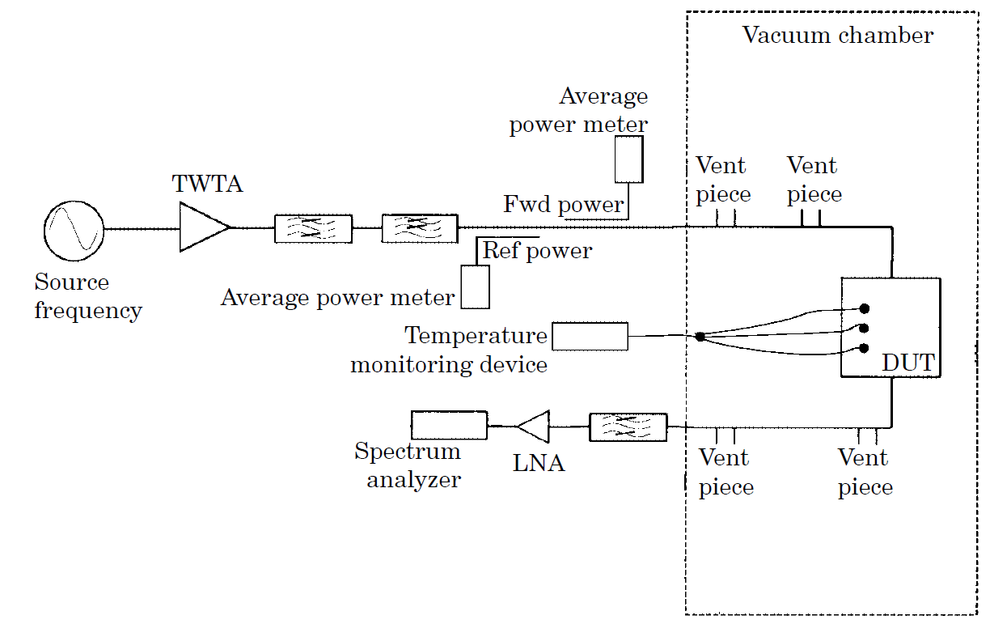
              - : Generic close to carrier noise multipaction test site
The key factors of the test procedure are:
- the method can be used in either CW or pulsed mode, with single or multi-carrier signals;
- the minimum pulse duration for a pulsed test is 2 μs;
- the minimum soak time in hard vacuum (<1,33 × 10⁻³ Pa) is one hour;
- test is suspended if the DUT reaches 120 °C;
- the power is left on for a minimum of 5 min at each level and 60 min at the final level;
- for single carrier tests the peak power level increments, in Watts, are typically:
- up to 1 000: 10, 100, 500, 1000;
- from 1 000 on, the increment is 1000: 1000, 2000, 3000, ...
However, a minimum of 6 increments is always used.
For multi-carrier tests, each carrier is incremented in 6 equally spaced steps to its fully rated power level. The phase of each carrier is adjusted to maintain the in-phase condition. Fast detector diodes and a fast digital storage oscilloscope are used for detection.
Test failure is deemed to have happened if:
- noise spikes recur within 20 % of the power level where they first occurred, after the power was turned off and back on again;
- the noise floor throughout the detection band jumps by more than 10 dB;
- reflected or reverse power suddenly jumps or fluctuates.
A few noise flashes during the initial application of high power are unavoidable in some cases, and does not constitute a failure. These changes are due to a very small amount of foreign material being ionized, or electrical contact changes at waveguide or coaxial interfaces. In the latter case some noise can continue to be generated when the input power or operating temperature are varied. In this situation an alternative method of detection is used to verify if multipaction is occurring or not.
      - Method 2
This method measures the effect on the phase noise, using a double balanced mixer to remove the amplitude-modulated components from the signal. The noise is measured by a mixer working as a phase detector: this mixer collects on one hand the signal of the TWTA output corresponding to the reference channel (f5), and, on the other hand, the signal filtered at the frequency f5 transmitted by the device under test (via a directive coupler).
The IF DC-signal is detected by an oscilloscope.
This technique has the potential for high sensitivity and is compatible with multi-carrier tests thanks to the use of a large IF bandwidth (DC to 4 GHz) double balanced mixer which allows fast signal detection. This kind of mixer is generally used as a pulse modulated generator and has the ability to provide extremely fast switching times, in the order of one nanosecond.
    - Return loss
      - Method 1
The forward-reverse power nulling detection method is a well-proven technique which can be used in either CW or pulsed mode for single or multi-carrier multipaction testing.
The nulling is a global detection method, where the incident power to a DUT is nulled against the reflected power. A multipaction discharge creates an imbalance leading to a loss of the null.
The principal arrangement of a multi-carrier nulling circuit is shown in Figure D-1.
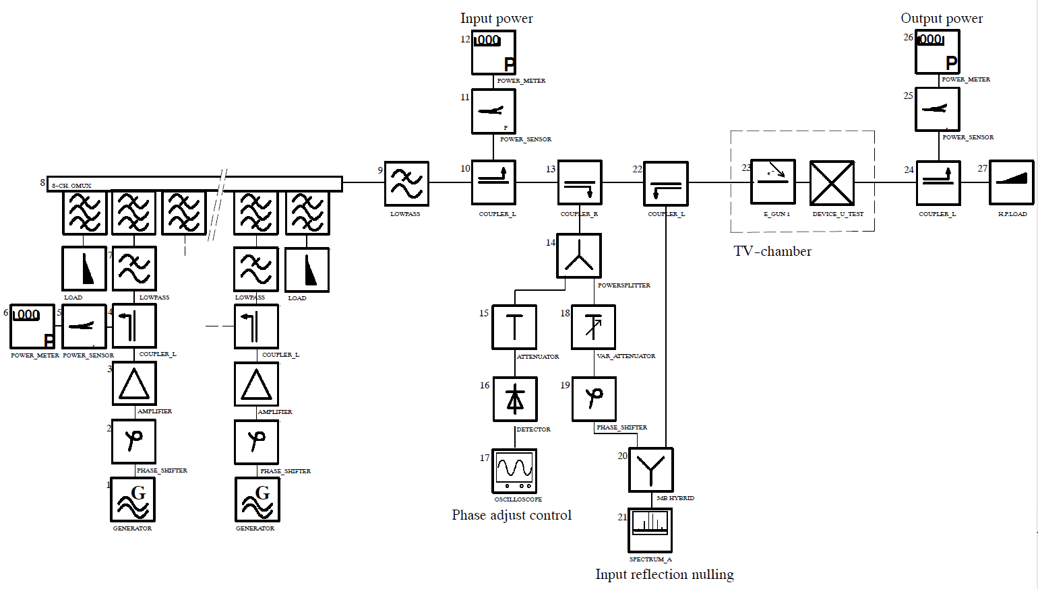
              - : Principal multipaction test set-up for nulling detection method
A reference signal is coupled from the incident power at coupler R and applied to the nulling hybrid. The reflected power from the DUT is coupled at coupler 22 and also applied to the hybrid. A nulling condition is adjusted with a phase-shifter and a variable attenuator. The null-depth can be monitored on the spectrum analyser.
The spectrum analyser is set to a 200 kHz span and a resolution bandwidth of 10 kHz.
When performing a multi-carrier multipaction test, at first the phase conditions of all carriers are adjusted until the well-known peak-voltage envelope signal is obtained.
In a second step the spectrum analyser is tuned to the centre channel of all applied channels. Then the nulling can be performed, starting with the phase adjustment, until the maximum null-depth is obtained.
The typical null-depth which can be achieved is about -60 dBc.
1 This detection method is not suitable for non-reciprocal devices such as isolators.
2 A disadvantage of this method is that, due to changes in temperature of the DUT, an optimum null can be achieved only by frequently retuning the system.
3 The experience is that from all detection methods using spectrum analysers (as third harmonic and noise level detection) the nulling method seems to be the most sensitive one.
      - Method 2
The multipaction phenomenon creates a variation of the VSWR which is measured by a network analyser.
The reference signal (centre frequency of the OMUX) is connected to the reference port of the analyser and the signal reflected by the device under test is connected to the measurement port of the analyser, via a filter centred on the reference frequency.
The techniques described above are similar in that both use a reference and the reflected signal; the difference lies in the method of processing the data. In the first method described, using a nulling technique, phase and amplitude adjustment and signal combination are performed before detection. The second method performs signal comparison at baseband after detection. The former is likely to be more sensitive, and does not rely on a wide measurement dynamic range. However, the latter has the advantage that frequent adjustment of the nulling circuit need not be performed.
    - Harmonic noise
      - Introduction
The detection of noise at the third harmonic of the carrier frequency has often been used for multipaction testing.
      - Third harmonic detection
The multipaction phenomenon generates harmonics of the carriers, which can be detected.
The measurement of the PIMP is done before or after the device under test, thanks to a directive coupler measuring the reflected or transmitted wave followed by a third harmonic transmission filter (WG22 waveguide). The guide after the DUT is a WG17 one (recommended band 10 GHz to 15 GHz) so this detection is put as close as possible to the DUT in order to keep a good sensitivity. The detection is performed by use of a fast rise time diode preceded by a LNA.
The output signal is monitored by a fast digital oscilloscope.
  - Transient tests methods
    - Introduction
This clause describes the test method used in an investigation of multi-carrier multipaction (see reference [18]), and is extracted from the project final report (see reference [4]).
Three variants on the experimental set-up were used:
- For peak powers of less than 4 kW, the test system was configured as shown in Figure D-1 (mode 1).
- For CW operation at power levels in excess of 4 kW the arrangement in Figure D-1 was used in conjunction with a resonant ring power multiplication loop set up in the vacuum chamber.
- When peak powers of greater than 4 kW were used, the system was reconfigured to combine the carriers in an OMUX, this is shown in Figure D-2 (mode 2).
The combination of test configurations enables a relatively flexible operation. This enables a range of signal waveforms to be applied to the device under test by varying the number of carriers and their frequency spacing.

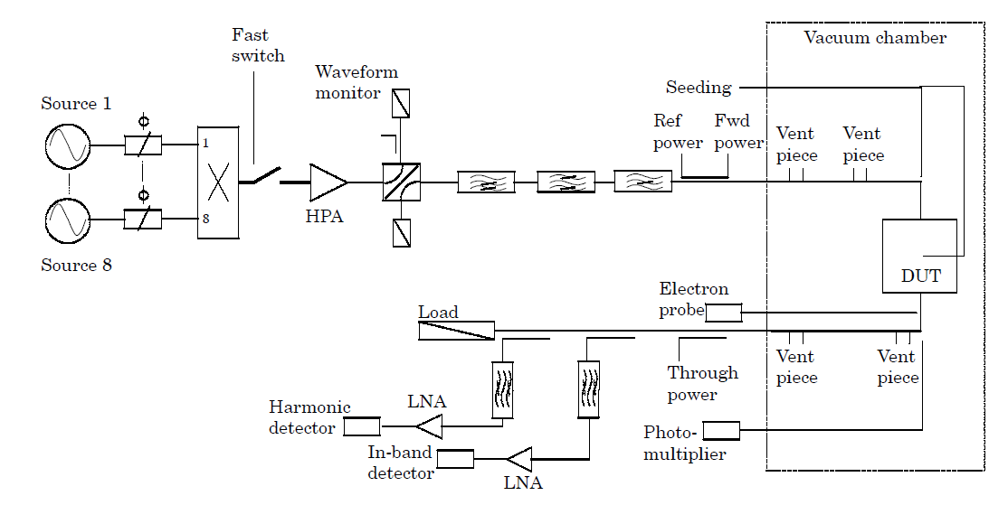
              - : Test configuration (mode 1)

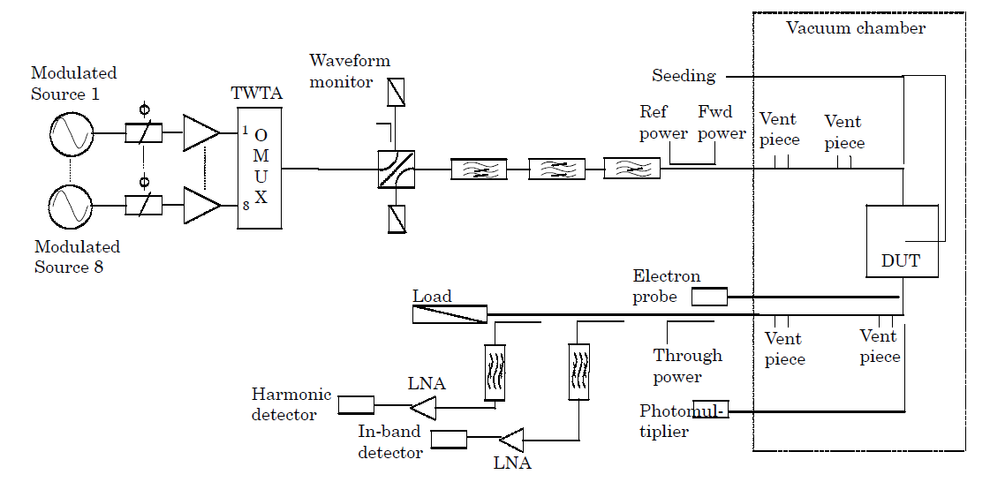
              - : Test configuration (mode 2)
    - Signal generation
      - Overview
The individual carriers are generated from separate synthesized sources, which are all phase locked to a common 10 MHz reference signal. Each low power carrier passes through a phase adjuster to ensure that when operating in a multi-carrier test, the carriers can each be phase aligned to obtain the maximum peak power. All multi-carrier frequency plans are centred at 11,1 GHz and the harmonic detector is tuned to the 3rd harmonic of this frequency.
      - Low power combining (mode 1)
In mode 1 operation, low power carriers are combined in an 8.1 way combining network (power divider used in reverse).The combined multi-carrier signal is then modulated, by means of a fast rise time pin diode switch, before being applied to the high power amplifier (HPA). The switch-HPA combination gives a rise time at the output of the HPA of approximately 4 ns. The HPA consists of an array of 8 × 500 W travelling wave tube amplifiers (TWTA) combined together to generate a high power signal across the 8 GHz - 18 GHz band.
The HPA (mode 1) enables the amplification of a single 4 kW CW carrier or a composite multi-carrier waveform up to a peak power of 4 kW. With a multi-carrier signal each individual TWTA handles the whole composite signal waveform and output power is constrained by voltage limiting within individual TWTAs. Because all the carriers pass through an individual TWTA together, they suffer almost identical phase shifts if the electrical length of the TWTA alters due to thermal effects; so the stability of the shape of the composite waveform in the time domain (in particular the amplitude and width of the main peak) is largely a matter of the stability of the synthesizers.
      - High power combining (mode 2)
Test pieces with larger gap peak powers in excess of 4 kW are driven to reach and exceed the multipaction threshold. Although more TWTAs were available, they only enables the peak power to be increased to about 5 kW. The mode 2 system described here allows peak powers of up to 50 kW to be attained.
In the mode 2 arrangement, each individual carrier is amplified in its own dedicated TWTA. The TWTA outputs are combined at high power in an OMUX. The OMUX used has 11 channels available, of which ten are used. In this way, peak output powers of 10² × 500 W or 50 kW are obtained at the expense of some inflexibility in available frequency plans.
In this arrangement each carrier is amplified in a separate TWTA and the composite waveform is assembled in the OMUX. Each carrier suffers the phase shift of its particular TWTA and, if this changes with time, there is no guarantee that all the TWTAs can track. In practice, it is found that the whole array is only stable for a short time under CW conditions. This stability is improved by reducing the mean output power of the TWTAs operating them at a 6,3 % duty cycle (37 μs pulse, 1,7 kHz repetition rate).
The duty cycle is arranged by pulse modulating individual carriers with pin diode modulators driven from a common source. Phase adjustment per carrier is provided prior to the TWTA.
      - Carrier phasing
During multi-carrier testing, a waveguide switch placed at the output of the HPA/OMUX is used to tune the multi-carrier waveform into a load rather than into the test piece. This enables the waveform to be correctly phased and set to the correct amplitude before being applied to the test piece.
      - Filtering
From previous work, it is known that harmonic generation is a side effect of multipaction and can be reliably used as a diagnostic indication. TWTAs generate high levels of third harmonic and the TWTA output was filtered to prevent the third harmonic detector from being desensitized by the TWTA harmonic. Initial investigations indicate that the harmonic levels generated by a multipaction discharge are very low, so a high order of filtering is specified to protect the detector sensitivity.
Other unwanted signals, including higher harmonics and intermodulation products, are removed by means of a bandpass filter. To enable the detection of noise produced close to the carrier, a narrow notch is placed in the system noise floor by a high order bandstop filter, before the test piece.
      - Waveform monitoring
The monitoring of the composite waveform is arranged using a tunnel diode detector loaded to produce a very fast rise time of approximately 1 ns. The output is monitored by a digital storage scope offering a 5 gigasamples/second, 1 GHz bandwidth single shot performance. A typical multi-carrier waveform, as monitored on the oscilloscope, is shown in Figure D-1. The continuous monitoring of the waveform ensures that the phase can be continuously adjusted to maintain the peak power for the duration of the tests.
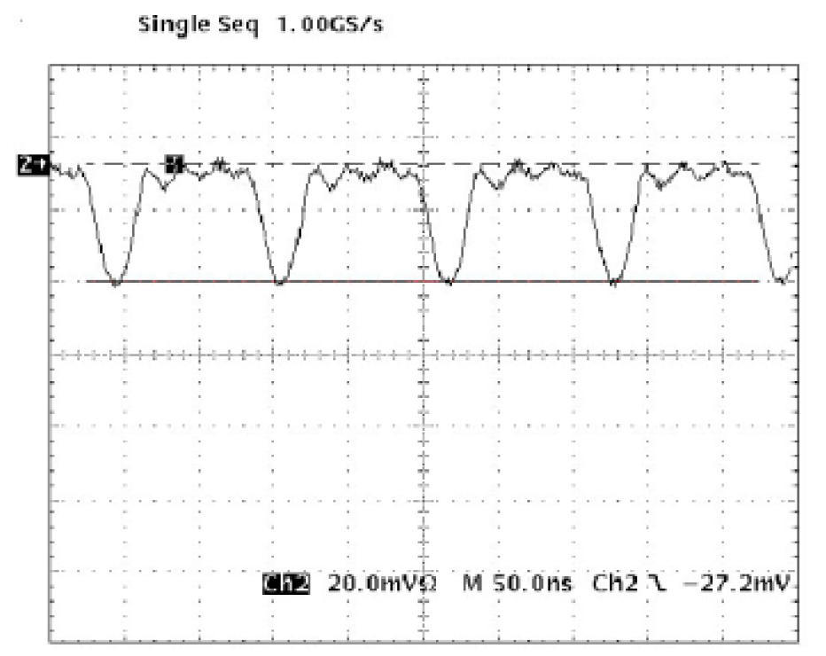
              - : Detected envelope of a five carrier waveform
      - Multipaction detection methods
Three main detection methods are used in the measurement programme,
- close-to-carrier noise,
- third harmonic output, and
- optical emission.
These are supported by a charge probe and mass spectrometer, which are used for diagnostic purposes as they are too slow for detecting fast transient multipaction events.
      - Spectrum analyser
Initial observations show that a spectrum analyser has a number of limitations as a method of detection for both close-to-carrier noise and harmonic output.
The response time of the analyser is not fast enough to detect short duration events, which can only be a few nanoseconds in duration with multi-carrier signals.
The analyser does not produce an indication of the maximum and average noise associated with the discharge due to the time used to sweep the bandwidth of the filter to give the requested sensitivity.
      - Fast detectors
One of the aims of the measurement programme was to find and make use of detectors with sub-nanosecond rise time. For the detection of the close-to-carrier noise and harmonics, a tunnel diode detector was chosen which had a fast rise time with a reasonable degree of sensitivity, so as not to limit the dynamic range of the detection system. Ideally, operation of the diode into a low output impedance is a condition to produce a fast rise time, but this greatly reduces the sensitivity. The DC signal generated by the diode can be amplified using a video amplifier, but this greatly increases the overall rise time. The problem is solved by using a low noise amplifier (LNA) at the input to the diode amplifying the signal prior to detection. The condition for the LNA is to have a rise time comparable to that of the diode to maintain the overall detection response time. HEMTLNAs, which have a rise time of a few ps were chosen.
      - Data acquisition
Having produced detectors with very short rise times (approximately 1 ns), the next step is to monitor the outputs in real time. This is achieved by using a fast digital storage oscilloscope, operating in single acquisition mode, with a time resolution of 200 ps/division. The oscilloscope is able to capture up to 80 screens of data in a single acquisition, and offers post-measurement scanning through the captured data.
The oscilloscope is triggered, to begin storage, by the third harmonic signal. This enables the observation of changes in the intensity of the discharge with time. The time base is adjusted to try to ensure that a high percentage of the pulse length is captured on the oscilloscope, so that the maximum and average noise levels are representative of the complete pulse width. This is not always easy to do because of long and variable delays between the pulse edge and the onset of a discharge.
      - Close-to-carrier noise
As previously mentioned, a narrow notch is placed in the system noise floor by means of a bandstop filter 200 MHz away from the centre frequency of 11,1 GHz on the input side of the test piece. On the output side of the test piece, a 4 port 20 dB coupler is used to sample the signal and the range of frequencies corresponding to the notch selected by a bandpass filter are amplified by an LNA and detected by a tunnel diode detector. The diode detector has a dynamic range limited to approximately 40 dB, by the trade-off between sensitivity and speed.
      - Harmonic output
The harmonic noise emanating from the HPA is reduced to the specification level by a lowpass filter at the input to the test piece. The harmonic signal from the output of the test piece is coupled from the main RF path by a WG17 coupler, with a known coupling figure at 33,3 GHz, which is the third harmonic frequency. The fundamental and harmonic signals are then separated by a WG17-WG22 tapered transition which offers a high degree of isolation against the fundamental signal. The bandwidth of the WG22 part of the system is defined by a bandpass filter centred on 33,3 GHz, amplified by a HEMT LNA and detected by a tunnel diode detector. The dynamic range of the diode is again restricted to approximately 40 dB, limited by the output impedance used for fast rise time operation.
      - Optical detector
The optical detector consists of a UV transmissive quartz fibre optic mounted in the centre of the sidewall of a waveguide bend. The bend is directly attached to the test piece so that the fibre’s field of view is along the length of the test piece, monitoring the reduced height centre section. The light generated by the discharge is predominantly UV; this is detected by means of a photomultiplier tube located outside the chamber operating in the UV region.
The tube and its housing are placed inside a metal box to reduce the light leakage into the tube itself and increase the sensitivity by reducing the dark current.
Although the tube itself has a fairly fast rise time of approximately 4,5 ns, it has a slow initial response time (delay); the difference in response time between the tunnel diode detectors and the optical detector is of the order of hundreds of ns, depending upon the loading of the tube output.
For this reason the harmonic and close-to-carrier noise are used as the principal discharge intensity diagnostics and the optical emissions are used as an auxiliary indication.
      - Charge probe
The rapid increase in the charge density at the onset of multipaction can be used to provide diagnostic information. To monitor the electron density within the wave guide, a small probe biased at 60 V is introduced into the waveguide on the centreline of the narrow wall. A picometer is then used to monitor the current as an indication of the electron density. This form of detector is inherently slow because of the rise time associated with the amplifier circuit. The detector is mostly used for diagnostic purposes rather than as a detection method because of its slow response time. The detector is shown in Figure D-1.
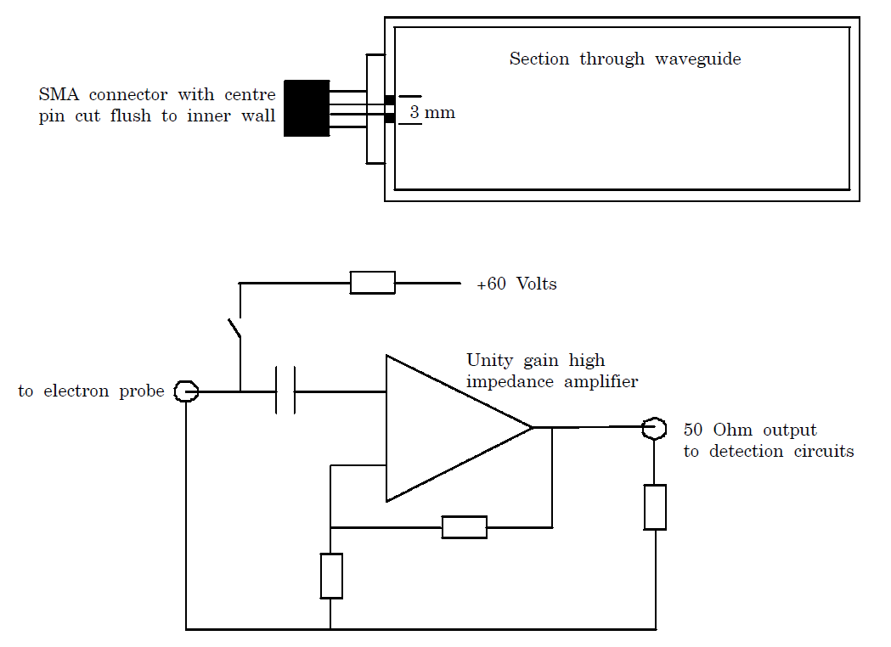
              - : Charge probe
      - Mass spectrometer
Included within the vacuum chamber is a mass spectrometer which is again used as a diagnostic tool rather than a detector for multipaction due to its slow response time.
      - Free-electron seeding
Refer to B.3.5.
  - Test facility validation
Separately from any issues of calibration, the test is not complete without a demonstration and validation that the test configuration was functioning correctly immediately prior to and after test. This is because the usual criterion for a successful test is a null result, i.e. that nothing is detected by the detection system.
A way of achieving such a validation is as follows:
- Firstly, validate that the test site with no device under test in place does not generate any signs of multipaction when subjected to full maximum power. This is done in steps of 1 dB from 3 dB below maximum power.
- Secondly, undertake tests with a standard multipaction generator in the vacuum chamber. This item can be a simple component that was designed for multipaction at a power level 3 dB to 6 dB below the peak power level for the test. Before, after and sometimes during the test sequence, the standard can be switched into the circuit and the correct functioning of the detectors observed at the expected power level.
- (informative)
Secondary electron emission
  - SEY Definition and properties
When an electron of sufficient energy impacts on the surface of a material (primary electron) it can produce the emission of more electrons; this physical process is called secondary electron emission (SEE).
The secondary electron emission coefficient or yield (SEY) of a material surface, usually symbolized as σ, is the ratio of the number of emitted electrons to the number of incident electrons of defined incident energy and angle, in field-free conditions and under vacuum conditions.
For primary energies above ∼100 eV, most emitted electrons are true secondary electrons with low energies, conventionally less of 50 eV, with an emission coefficient δ. For very high primary energies (several keV) δ might become very small and above statement does not hold, but this range is not of relevance for multipactor effect.
Others emitted electrons are known as backscattered, with a coefficient η. They are assumed to be primary electrons backscattered again into vacuum by collisions with the material surface. These emitted electrons can have energies up to the impacting or primary energy. Sometimes those electrons emitted elastically with the same energy of the primary or impacting electron are distinguished as elastically backscattered, with coefficient ε. In this case, σ = δ + η + ε. If ε is considered included in η, then σ = δ + η.
A typical dependence of these coefficients on primary electron energy is shown in E.1.1Figure E-1. Nowadays, the limit of SEY, as primary energy approaches 0 eV, is being studied.
The energy limit of 50 eV between true secondaries and backscattered is somehow arbitrary and a convention, only practical or physically meaningful for primary energies greater than about 100 eV. For lower primary energies, the emission energy ranges of true secondaries and inelastically backscattered seem to overlap significantly and their numbers (intensity) become smaller than that of elastically backscattered electrons.
A spectrum showing the energy distribution of the emitted electrons has more detailed information and is known as Energy Distribution Curve (EDC) [22] and [23], see Figure E-2.
True electrons have an emission angle distribution close to the cosine or Lambert’s law. Backscattered electrons have a modified emission angle distribution law with higher intensity in the reflection direction [24].
All these properties, σ, δ, η, ε, EDC, and emission angle distribution, depend on the incident primary electron energy and angle. These functions are necessary for a detailed and accurate simulation of the multipactor effect. However, the dependence σ(E_{p}) of the total secondary emission on the primary energy E_{p} for normal incidence, usually named SEY, is considered the most important, and the others can be estimated approximately from general empirical laws.
SEY-primary-energy curves are most often so simple that can be characterized by a few parameters: σ_{m} (> 1, usually) and E_{m} for the maximum, and the cross-over energies E₁ and E₂ where σ = 1, i.e., σ(E₁ ≤ E_{p} ≤ E₂) ≥ 1, see E.1.1Figure E-1.
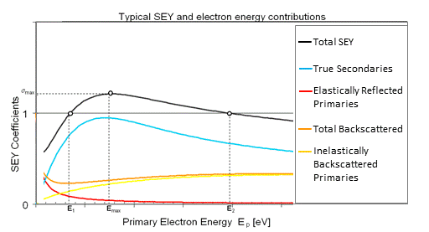
              - : Typical dependence of SEY coefficients on primary electron energy.
Kinetic Energy, eV
              - : Energy distribution of emitted electron from Au target surface submitted to 112 eV electron irradiation [23].
  - SEY and multipactor
Secondary electron emission plays an essential role in multipactor breakdown being the main trigger and sustaining mechanism of the discharge. For example, a change of SEY for a non-standard silver coating varying from E₁ = 40 eV, σ_{m} = 1,71, E_{m} = 265 eV to E₁ = 30 eV, σ_{m}= 2,01, E_{m} = 218 eV, which is due to air exposure [25], decreases the multipactor threshold in about 2,5 dB as predicted by a typical simulation tool.
On the other hand, the secondary electron emission is a surface process and, as such, is often not well characterized. It depends on the type of material but also on the surface finish: surface contaminants and surface morphology. It is strongly influenced by interactions with environment: exposure to the air, humidity, air contaminants, temperature … In space, it may also be influenced by irradiation with electrons, ions or photons. The uncertainty on the secondary electron emission properties is one of the reasons for the use of safety margins in multipactor analysis.
As stated in E.1., multipactor is the resonant growth of an electron cloud or free electron space charge in RF components by secondary electron emission from exposed surfaces. When electrons accelerated by the RF field impacts on a surface, secondary electrons are emitted from the surface. Main definitions and properties of secondary electron emission (SEE and SEY) are given above.
In multipactor ([[7] to [10], [12], [15], [16], [18], [19], [26] to [30]), the electron space-charge avalanche is self-fed by secondary electron emission from the surfaces of the RF component exposed to electron impact. SEE is the electron multiplication mechanism and the RF field supplies the energy accelerating the electrons. This phenomenon occurs wherever some resonance conditions involving the RF signal and the secondary electron emission properties of surface material are met.
The main conditions for the initial exponential growth of the multipactor discharge are:
- the total secondary electron emission coefficient of the surfaces is greater than one for some energy range attainable for the accelerated electrons;
- there is a sufficient phase range of the RF field where secondary electrons from a surface are not accelerated back to the surface from which they are emitted, but they are accelerated towards another surface;
- the RF field phase and amplitude is such that a sufficient amount of these electrons impact on this other surface with a primary energy E_{p}: E₁ < E_{p} < E₂, i.e., such that σ > 1, and with a field phase such that the initial conditions of the secondary emission in the previous originating surface are reproduced again in the secondary emission from this new surface. These initial conditions of a secondary emission event are: incident energy and angle of impacting electron and RF field phase and amplitude respect to the surface normal. In this resonant condition, the distance between the surfaces is an important parameter as can be expected.
These are the strong conditions of Hatch and Williams’s theory of multipaction in parallel plate geometry ([1], [5], [6]). These conditions plus some other simplifying assumptions, like a constant relating emission and impacting energies, leads to a closed zone of multipactor resonant conditions in gap voltage vs. frequency-gap product space (f×d, V_{o}) for each mode (odd integer number of half RF periods for the time between emission and impact for each resonant electron, necessary by resonant condition c. above). The overlapping of these resonant modes produces a typical multipactor susceptibility region in (f×d, V_{o}) space for most material SEE properties.
The growth of the free electron population eventually saturates because of the modification of the resonant conditions by the free electron space charge itself, e.g. by the electrical repulsion between electrons (Coulomb interaction).
The actual multipactor susceptibility region has not so clear-cut boundaries because of several simplifying assumptions of Hatch and Williams’s theory. One of those reasons is that hybrid modes [31] are actually produced where resonant condition c. above, is established between non-consecutive impact-emission SEE events: for example, SEE event (1) → secondary electron → SEE event (2) → secondary electron → SEE event (3), where initial conditions of (1) and (3) are equal but different from (2), and electron trajectories belong to different resonant modes. Also, in the electron cloud there are many electrons which are not in resonant conditions but whose eventual secondary lineage can get into resonant conditions.
The SEY for low primary or impacting energies has most influence on multipactor susceptibility, being E₁ one of the most important parameters to predict Multipactor. If vacuum level inside the device is not very high, free electrons might impact on gas molecules and produce the emission of some of their electrons. The electron trajectories are thus truncated or twisted, and the free electron population increased. Also free gas ions are produced forming a plasma. At higher pressures a Corona discharge might evolve.
  - Factors affecting SEY
For most materials used in critical parts of RF space devices or in particle accelerators, SEY mainly depends on the following factors:
- Surface composition.
SEY depends on the chemical composition, since it is different for different elements or compounds ([11], [17], [32] to [34]). However, secondary electron emission is a surface process occurring in a depth scale of a few nm, where the top atomic layers of the surface have an important influence. Very often the surface composition is different from the bulk (base material) and unknown. It can be affected by gentle treatments which do not modify the bulk and thus remaining unnoticed.
- Air exposure.
In most metals, exposure to the air produces formation of surface oxides (chemical oxygen absorption) and physical adsorption of oxygen-containing molecules and radicals: e.g. O₂, H₂O, HO [25]. This process induces secondary electron yield variation. The SEY depends on exposure to air and surface contamination. Long term variations (aging) in the scale of months or even years cannot be discarded.
- Temperature.
The onboard equipment temperature may also modify the SEY values ([35], [36]). High temperature conditions under vacuum causes mainly desorption of surface contaminants or even decomposition of surface oxides, thus, often modifying values of SEY.
- Electron conditioning.
When electron bombarding of a surface with relatively low energies (hundreds of eV), processes occur which result in a modification of SEY [37].
- Ion conditioning.
Bombarding a surface with noble gas ions of low energies (hundreds of eV) is more drastic than electron conditioning: produces also desorption of oxygen-containing molecules, but in addition decomposition of surface oxides and erosion of surface material. Surface carbon contamination is also eroded away. The result is a cleaner surface (in the sense of more representative of bulk composition). Some surface roughening can also be created. Ion conditioning usually results in a significant modification of SEY.
- Photon conditioning.
Irradiation with energetic photons (hundreds of eV) can cause desorption or chemical reactions thus modifying SEY.
- Surface roughness.
Surface roughness may modify SEY. Under certain circumstances, surface roughness can be used to decrease significantly SEY ([11], [34]). Significant differences in SEY parameters of RF samples may happen for different storage methods. SEY may evolve with increasing immersion time for the different storage methods, except for samples stored in inert atmosphere. Samples stored in air may show most instability in SEY, thereby yielding the highest SEY values. For this reason, it is recommended to store samples in inert atmosphere or vacuum.
SEY for low primary energies originates closer to the surface and thus it is most affected by the above mentioned factors, implying a strong influence on multipactor susceptibility.
For all these effects, SEY can be modified. The fact that this evolution can be an increase or a decrease needs to be proven through measurements on different materials in different test facilities.
  - SEY testing
For measuring the emitted current, a weak electrostatic field is set in order to avoid both low-energy secondary electrons returning back to the surface and 2nd-generation secondary electrons from surrounding surfaces (e.g., collector or vacuum chamber walls) generated by energetic secondary electrons (backscattered electrons). This is achieved by a small negative bias (-10 V to -50 V) to the sample with respect to the surroundings, or by positive bias of the surrounding. Ideally, this field should be spherically symmetrical respect to the emitting spot, i.e., created by a spherical collector or vacuum chamber.
In more complex testing arrangements, spherical grids and collectors (and several electrometers) are used for obtaining field free conditions around the sample to be tested, avoiding 2nd-generation secondary electrons from surrounding surfaces, and measuring both primary and secondary electron currents, all together and simultaneously. However, the usual simpler arrangement described here has sufficient accuracy, see Figure E-1 and Figure E-2.
The red, green, and blue arrows correspond to the primary,
secondary, and sample electron currents.
              - : Experimental arrangement for SEY test with emission collector
An electron gun supplies the primary electrons or electron beam to irradiate the sample. The primary electron energy E_{p} is determined by the potential difference between the sample connected at the ground and the cathode of the electron gun (usually a hot cathode), at V_{g} :
E_{p} = e x |V_{g}| | [E-1]
This is just the “nominal” primary energy. There is an uncertainty of about ±1 eV due to the difference between the work-function (surface potential barrier) values of the sample φ_{s} and the cathode φ_{g}, both being usually 5 eV ±2 eV, since voltage meters measure only potential differences between Fermi levels.
The electron currents coming in and out the sample are: the primary current I_{p} from the e-gun, the emission current I_{σ} going to the surroundings (collector or the analysis chamber walls), and the sample current I_{s} .
A good experimental arrangement is a spherical collector around the sample; as schematized in Figure E-1. Then, I_{σ} as measured in the collector meter positively biased at V_{c}. I_{p} when measured with a Faraday cup in place of the sample, is also always negative. When testing a sample, the sample and the collector all together form a Faraday cup and then:
I_{p} = I_{σ} + I_{s} | [E-2]
This is the condition of no charge accumulation for a conductive sample connected to ground at a constant bias. This is also an approximation. The 2nd-generation secondary emission from the surroundings falling on the sample has been neglected. This is a very good approximation if the appropriate sample bias is set.
I_{s} is measured in the sample meter connected to ground, and has the sign of σ - 1.
The secondary electron emission coefficient or yield (SEY) is then:
$$σ=\frac{I_{σ}}{I_{p}}=\frac{I_{σ}}{I_{σ}+I_{s}}$$ | [E-3]
When a collector is not available, only the sample current I_{s} is measured, see Figure E-2. In this case, the e-gun current I_{p} is previously measured with a Faraday cup or calibrated by a reference sample with well-known SEY properties (equation [E-4]):
$$I_{p}=−\frac{1}{\left(σ_{\text{ref}}−1\right)}I_{s}(\text{ref})$$ | [E-4]
Where σ_{ref} and I_{s}(ref) are respectively the secondary electron emission coefficient and the sample current to ground of a reference sample, usually a Faraday cup.
The red, green, and blue arrows correspond to the primary, secondary, and sample electron currents. Electrometers give positive charge currents
              - : SEY experimental setup (without collector around the sample)

The secondary electron emission coefficient or yield (SEY) is then:
$$σ=\frac{I_{σ}}{I_{p}}=1+\frac{I_{s}}{\left|I_{p}\right|}$$ | [E-5]
For a Faraday cup σ_{ref} ≅ 0 with a precision depending on its design. The Faraday cup set-up has to be well positioned and designed (FC positively biased and positioned directly at the output diaphragm of the e-gun). In case of use of reference samples, the best are noble metals as Pt, Au, Ag, or Cu, used with the same test conditions of the sample to be tested.
A combination of techniques optimized for the particular experimental arrangement is usually the best calibration technique.
The e-gun should be able to supply a stable beam current for all required energies with controlled low dose. These low values are necessary for avoiding surface “conditioning” or modifying by the e-beam. This effect is well known and tends to modify SEY by surface processes. Also the total dose or fluency should be small, for metallic or conductive samples.
In general, for any surface analysis technique, and more important in relation to surface conditioning, ultra-high vacuum is recommended in the analysis chamber.
Minimization of electron dose becomes even more crucial in dielectric or non-conductive samples. Then, primary charge is trapped on the surface and a surface charge potential grows affecting to the real energy of primary electrons thus producing SEY-energy values very different from the uncharged sample one. This effect can be avoided by using a pulsed e-beam with low- dose pulses. The induced image charge on the sample substratum or stage can still be measured with a fast oscilloscope. The charge trapped on the surface on a non-conductive sample in the pulsed method can also be measured by a Kelvin probe detecting the corresponding surface potential.
Some dielectric samples may also be charged by tribo-electrification before irradiation. The surface potential must be in this case measured and removed before SEY measurements.
Apart from the instrumental errors (e.g. in the measurements of e-gun energy and sample currents, noise induced in cables and electric contacts) the main problems in the accuracy of SEY measurements are the accuracy of the e-gun primary current impacting on the sample. This last one becomes crucial for very low primary energies.
Bibliography
- A. Woode & J. Petit, Diagnostic Investigations into the Multipactor Effect, Susceptibility Zone Measurements and Parameters Affecting A Discharge, ESTEC Working Paper 1556, November 1989.
- Abstract Book, Workshop on Multipaction and Passive Intermodulation Products Problems in Spacecraft Antennas, ESTEC, December 1990.
- Final Presentations & Working Meeting: Multipactor & PIM in Space RF Hardware, ESTEC, January 1993.
- A. J. Marrison, R. May, J.D. Sanders, A. D. Dyne, A. D. Rawlins, J. Petit, A study of Multipaction in Multicarrier RF Components, Report no AEA/ TYKB/31761/01/RP/05 Issue 1, January 1997.
- A. J. Hatch and H.B. Williams, J. Appl. Phys. 25, 417 (1954).
- A. J. Hatch and H.B. Williams, Phys. Rev. 112, 681 (1958).
- R. Woo, Multipacting Discharges between Coaxial Electrodes, J. Appl. Phys. 39, 1528-1533 (1968).
- R. Woo, Final Report on RF Voltage Breakdown in Coaxial Transmission Lines, JPL Technical Report 32-1500, October 1970.
- F. Höhn, W. Jacob, R. Beckmann, R. Wilhelm, The Transition of a Multipactor to a low-pressure gas discharge, Phys. Plasma, 4, 940-944 (1997).
- J. M. Meek and J. D. Craggs, Electrical Breakdown of Gases, Wiley (1978).
- L. Galan et al., Study of Secondary Electron Emission Properties of Materials for High RF Power in Space, UAM Final Report, ESTEC Contract 6577/85, July 1990.
- W. Arter and M.P. Hook, Multipaction Threshold Curves for Coaxial Geometries, AEA Technology Report AEA/TYKB/28046/RP/1, 1997.
- L. Galan et al., Study of secondary emission properties of materials used for high power rf components in space, Technical Report, ESTEC 1987.
- Méthode de synthèse de réseaux linéaires et plans rayonnant un diagramme a contour formé, Thesis presented by Cyril MANGENOT on November 30, 1989.
- C. Phillips, A. Woode, P. Woodhouse, A multipactor investigation program at C-band, Estec Working Paper No. 1412, ESA 1985
- J. Petit, Measurements performed on the ERS-1 structural model switching matrix, ESTEC Internal Memo TRI/042/JP
- The detection of organic contamination of surfaces by infra-red spectroscopy. ESA PSS-01-705 Issue 1.
- A Study of Multipaction in Multicarrier RF Components, ESA/ESTEC contract number 10873/94/NL/DS.
- D. Raboso and A. Woode, EUMC.95 .A new method of electron seeding used for accurate testing of multipactor transients.
- S. Anza, C. Vicente, B. Gimeno, V. E. Boria, J. Armendáriz, “Long-term multipactor discharge in multicarrier systems”, Physics of Plasmas, vol. 14, August 2007.
- S. Anza, M. Mattes, D. Wolk, U. Wochner, M. Reglero, B. Gimeno, V. E. Boria, J. Gil, C. Vicente, J. R. Mosig, D. Raboso, "RF Breakdown in Multicarrier Systems", Proceedings of the 6th International Workshop on Multipactor, Corona and Passive intermodulation in Space RF Hardware (MULCOPIM), September 2008, Valencia, Spain.
- L. Galán, I. Montero, E. Román, M. García, P. Lozano: Sec.II, in “Surface Treatments and Coatings for Reduction of Multipactor and Passive Intermodulation (PIM) Effect in RF Components”; Final Report ESA Program 17025/03/NL/EC: ESA, 2006.
- R. Cimino, SLAC-PUB-10350, February 2004.
- H. Seiler «Secondary electron emission in the scanning electron microscope » J. Appl. Phys. 54, R1 (1983);
- L. Aguilera, I. Montero, M. E. Dávila, J. L. Sacedón, V. Nistor, L. Galán, D. Raboso, S. Anza, C. Vicente, J. Gil.: ESA Survey on Secondary Emission Yield of Industry Materials and Their Impact on Multipactor Threshold Multipactor, Corona and Passive Intermodulation, ESA MULCOPIM 11(2011).
- Final Presentations & Working Meeting: Multipactor & PIM in Space RF Hardware, ESTEC, January 1993.
- J. Marrison, R. May, J.D. Sanders, A. D. Dyne, A. D. Rawlins, J. Petit, A study of Multipaction in Multicarrier RF Components, Report no AEA/ TYKB/31761/01/RP/05 Issue 1, January 1997.
- Méthode de synthèse de réseaux linéaires et plans rayonnant un diagramme a contour formé, Thesis presented by Cyril MANGENOT on November 30, 1989.
- S. Anza, C. Vicente, B. Gimeno, V. E. Boria, J. Armendáriz, “Long-term multipactor discharge in multicarrier systems”, Physics of Plasmas, vol. 14, August 2007.
- S. Anza, M. Mattes, D. Wolk, U. Wochner, M. Reglero, B. Gimeno, V. E. Boria, J. Gil, C. Vicente, J. R. Mosig, D. Raboso, "RF Breakdown in Multicarrier Systems", Proceedings of the 6th International Workshop on Multipactor, Corona and Passive intermodulation in Space RF Hardware (MULCOPIM), September 2008, Valencia, Spain.
- A. L. Gillardini, New breakdown modes of the multipacting discharge, J. Appl. Phys. 71(9), pp. 4629-4631 (1992)
- L. Galán, I. Montero, E. Román, M. García, P. Lozano: Sec.II, in “Surface Treatments and Coatings for Reduction of Multipactor and Passive Intermodulation (PIM) Effect in RF Components”; Final Report ESA Program 17025/03/NL/EC:, ESA, 2006.
- N.Díaz, S. Castañeda, I.Montero, L.Galán, and F. Rueda, Coatings to Prevent Multipactor Effect in RF High Power Components for Space, Final Report, ESTEC Contract No. P.O. 162594 (1996).
- L. Galán, I. Montero, E. Román, M. García, P. Lozano: Sec.II, in “Surface Treatments and Coatings for Reduction of Multipactor and Passive Intermodulation (PIM) Effect in RF Components”; Final Report ESA Program 17025/03/NL/EC:, ESA, 2006.
- L. Galán, I.Montero, V.Nistor, L.Aguilera, D.Wolk, U.Ulrich, Optimization of Surface Roughness of Anti-Multipactor Coatings for Low Insertion Losses and Secondary Emission Suppression for High Power RF Components in Satellite Systems ESA ITI B00011822J, 2012.
- M. Belhaj, T.T Tondu, V.Inguimbert, P. Barroy, F. Silva, The effects of incident electron current density and temperature on the total electron emission yield of polycrystalline CVD diamond” Journal of Physics D: Applied Physics, 43 (2010) 135303.
- N. Balcon, D. Payan, M. Belhaj, T. Tondu, V. Inguimbert Secondary, Electron Emission on Space Materials: Evaluation of the Total Secondary Electron Yield From Surface Potential Measurements, IEEE Transactions on Plasma Science 40 (2012) 282.
- B. Henrist, N. Hilleret, C. Scheuerlein*, M. Taborelli “The secondary electron yield of TiZr and TiZrV non-evaporable getter thin film coatings Applied Surface Science 172 (2001) 95-102.
- ECSS-Q-ST-70-01, Space product assurance – Cleanliness and contamination control

