
Space engineering
ECSS Secretariat
ESA-ESTEC
Requirements & Standards Division
Noordwijk, The Netherlands

Two-phase heat transport equipment
Foreword
This Standard is one of the series of ECSS Standards intended to be applied together for the management, engineering and product assurance in space projects and applications. ECSS is a cooperative effort of the European Space Agency, national space agencies and European industry associations for the purpose of developing and maintaining common standards. Requirements in this Standard are defined in terms of what shall be accomplished, rather than in terms of how to organize and perform the necessary work. This allows existing organizational structures and methods to be applied where they are effective, and for the structures and methods to evolve as necessary without rewriting the standards.
This Standard has been prepared by the ECSS-E-ST-31-02C Working Group, reviewed by the ECSS Executive Secretariat and approved by the ECSS Technical Authority.
Disclaimer
ECSS does not provide any warranty whatsoever, whether expressed, implied, or statutory, including, but not limited to, any warranty of merchantability or fitness for a particular purpose or any warranty that the contents of the item are error-free. In no respect shall ECSS incur any liability for any damages, including, but not limited to, direct, indirect, special, or consequential damages arising out of, resulting from, or in any way connected to the use of this Standard, whether or not based upon warranty, business agreement, tort, or otherwise; whether or not injury was sustained by persons or property or otherwise; and whether or not loss was sustained from, or arose out of, the results of, the item, or any services that may be provided by ECSS.
Published by: ESA Requirements and Standards Division
ESTEC, P.O. Box 299,
2200 AG Noordwijk
The Netherlands
Copyright: 2012© by the European Space Agency for the members of ECSS
Change log
ECSS-E-ST-31-02C  12 December 2012 | First issue

Table of contents
Change log 3
Introduction 7
1 Scope 8
2 Normative references 9
3 Terms, definitions and abbreviated terms 10
3.1 Terms defined in other standards 10
3.2 Terms specific to the present standard 10
3.3 Abbreviated terms 14
4 TPHTE qualification principles 15
4.1 TPHTE categorization 15
4.2 Involved organizations 15
4.3 Generic requirements in this standard 16
4.4 Processes, number of qualification units 17
4.5 Thermal and mechanical qualification 17
4.5.1 Temperature range 17
4.5.2 Mechanical qualification 19
5 Requirements 21
5.1 Technical requirements specification (TS) 21
5.1.1 General 21
5.1.2 Requirements to the TS 21
5.1.3 Requirements for formulating technical requirements 22
5.2 Materials, parts and processes 23
5.3 General qualification requirements 23
5.3.1 Qualification process 23
5.3.2 Supporting infrastructure – Tools and test equipment 23
5.4 Qualification process selection 23
5.5 Qualification stage 25
5.5.1 General 25
5.5.2 Quality audits 26
5.5.3 Qualification methods 26
5.5.4 Full and delta qualification programme 28
5.5.5 Performance requirements 28
5.6 Qualification test programme 30
5.6.1 Number of qualification units 30
5.6.2 Test sequence 31
5.6.3 Test requirements 34
5.6.4 Physical properties measurement 37
5.6.5 Proof pressure test 38
5.6.6 Pressure cycle test 38
5.6.7 Burst pressure test 38
5.6.8 Leak test 39
5.6.9 Thermal performance test 40
5.6.10 Mechanical tests 42
5.6.11 Thermal cycle test 44
5.6.12 Aging and life tests 44
5.6.13 Gas plug test 45
5.6.14 Reduced thermal performance test 45
5.7 Operating procedures 46
5.8 Storage 46
5.9 Documentation 46
5.9.1 Documentation summary 46
5.9.2 Specific documentation requirements 46
Annex A (normative) Technical requirements specification (TS) – DRD 49
Annex B (normative) Verification plan (VP) – DRD 52
Annex C (normative) Review-of-design report (RRPT) - DRD 55
Annex D (normative) Inspection report (IRPT) – DRD 57
Annex E (normative) Test specification (TSPE) – DRD 59
Annex F (normative) Test procedure (TPRO) – DRD 62
Annex G (normative) Test report (TRPT) – DRD 65
Annex H (normative) Verification report (VRPT) – DRD 67
Bibliography 69

Figures
Figure 3-1: Tilt definition for HP 13
Figure 3-2: Tilt definition for LHP 13
Figure 4-1: Categories of TPHTE (two-phase heat transport equipment) 16
Figure 4-2: Figure-of-merit (G) for some TPHTE fluids 18
Figure 4-3: Definition of temperature and performance ranges for a HP 19
Figure 5-1: Selection of qualification process 25
Figure 5-2: Qualification test sequence for HP 32
Figure 5-3: Qualification test sequence for CDL 33

Tables
Table 5-1: Categories of two-phase heat transport equipment according to heritage (derived from ECSS-E-ST-10-02C, Table 5-1) 24
Table 5-2: Allowable tolerances 35
Table 5-3: Measurement accuracy 37
Table 5-4: Equipment resonance search test levels 43
Table 5-5: Sinusoidal vibration qualification test levels 43
Table 5-6: Random vibration qualification test levels 44
Table 5-7: TPHTE documentation 48

Introduction
This Standard is based on ESA PSS-49, Issue 2 “Heat pipe qualification requirements”, written 1983, when the need for heat pipes in several ESA projects had been identified. At that time a number of European development activities were initiated to provide qualified heat pipes for these programmes, which culminated in a first heat pipe application on a European spacecraft in 1981 (MARECS, BR-200, ESA Achievements - More Than Thirty Years of Pioneering Space Activity, ESA November 30, 2001), followed by a first major application on a European communication satellite in 1987 (TV-SAT 1, German Communication Satellites).
ESA PSS-49 was published at a time, when knowledge of heat pipe technology started to evolve from work of a few laboratories in Europe (IKE, University Stuttgart, EURATOM Research Centre, Ispra). Several wick designs, material combinations and heat carrier fluids were investigated and many process related issues remained to be solved. From today’s view point the qualification requirements of ESA PSS-49 appear therefore very detailed, exhaustive and in some cases disproportionate in an effort to cover any not yet fully understood phenomena. As examples the specified number of qualification units (14), the number of required thermal cycles (800) and the extensive mechanical testing (50 g constant acceleration, high level sine and random vibration) can be cited.
The present Standard takes advantage of valid requirements of ESA PSS-49, but reflects at the same time today’s advanced knowledge of two-phase cooling technology, which can be found with European manufacturers. This includes experience to select proven material combinations, reliable wick and container designs, to apply well-established manufacturing and testing processes, and develop reliable analysis tools to predict in-orbit performance of flight hardware. The experience is also based on numerous successful two-phase cooling system application in European spacecraft over the last 20 years.
Besides stream-lining the ESA PSS-49, to arrive at today’s accepted set of heat pipe qualification requirements, the following features have also been taken into account:
- Inclusion of qualification requirements for two-phase loops (CPL, LHP),
- Reference to applicable requirements in other ECSS documents,
- Formatting to recent ECSS template in order to produce a document, which can be used in business agreements between customer and supplier.

Scope
This standard defines requirements for two-phase heat transportation equipment (TPHTE), for use in spacecraft thermal control.
This standard is applicable to new hardware qualification activities.
Requirements for mechanical pump driven loops (MPDL) are not included in the present version of this Standard.
This standard includes definitions, requirements and DRDs from ECSS-E-ST-10-02, ECSS-E-ST-10-03, and ECSS-E-ST-10-06 applicable to TPHTE qualification. Therefore, these three standards are not applicable to the qualification of TPHTE.
This standard also includes definitions and part of the requirements of ECSS-E-ST-32-02 applicable to TPHTE qualification. ECSS-E-ST-32-02 is therefore applicable to the qualification of TPHTE.
This standard does not include requirements for acceptance of TPHTE.
This standard may be tailored for the specific characteristic and constrains of a space project in conformance with ECSS-S-ST-00.

Normative references
The following normative documents contain provisions which, through reference in this text, constitute provisions of this ECSS Standard. For dated references, subsequent amendments to, or revision of any of these publications do not apply. However, parties to agreements based on this ECSS Standard are encouraged to investigate the possibility of applying the more recent editions of the normative documents indicated below. For undated references, the latest edition of the publication referred to applies.

ECSS-S-ST-00-01 | ECSS system - Glossary of terms
ECSS-E-ST-31 | Space engineering - Thermal control general requirements
ECSS-E-ST-32 | Space engineering - Structural general requirements
ECSS-E-ST-32-01 | Space engineering- Fracture control
ECSS-E-ST-32-02 | Space engineering - Structural design and verification of pressurized hardware
ECSS-Q-ST-70 | Space product assurance - Materials, mechanical parts and processes
EN 9100:2009 | Aerospace series - Quality management systems - Requirements for Aviation, Space and Defense Organizations

Terms, definitions and abbreviated terms

Terms defined in other standards
For the purpose of this Standard, the terms and definitions from ECSS-E-ST-00-01 apply.
For the purpose of this standard, the following terms and definitions from ECSS-E-ST-10-02 apply:
analysis
qualification stage
review-of-design (ROD)
For the purpose of this standard, the following terms and definitions from ECSS-E-ST-32-02 apply:
burst pressure
differential pressure
external pressure
internal pressure
leak-before-burst (LBB)
pressure vessel (PV)
pressurized hardware (PH)
proof test

Terms specific to the present standard
- capillary driven loop (CDL)
TPL, in which fluid circulation is accomplished by capillary action (capillary pump)
See TPL definition in 3.2.21.
- capillary pumped loop (CPL)
CDL with the fluid reservoir separated from the evaporator and without a capillary link to the evaporator
See CDL definition in 3.2.1.
- constant conductance heat pipe (CCHP)
heat pipe with a fixed thermal conductance between evaporator and condenser at a given saturation temperature
See heat pipe definition in 3.2.7.
- dry-out
depletion of liquid in the evaporator section at high heat input when the capillary pressure gain becomes lower than the pressure drop in the circulating fluid
- effective length
heat pipe length between middle of evaporator and middle of condenser for configurations with one evaporator and one condenser only
Used to determine the heat pipe transport capability (see 3.2.10).
- exposure temperature range
maximum temperature range to which a TPHTE is exposed during its product life cycle and which is relevant for thermo-mechanical qualification
1 The internal pressure at the maximum temperature of this range defines the MDP for the pressure vessel qualification of a TPHTE.
2 The extreme temperatures of this range can be below freezing and / or above critical temperatures of the working fluid.
3 In other technical domains, this temperature range is typically called non-operating temperature range (see clause 4 for additional explanation).
- heat pipe (HP)
TPHTE consisting of a single container with liquid and vapour passages arranged in such a way that the two fluid phases move in counter flow
1 See TPHTE definition in 3.2.20.
2 The capillary structure in a heat pipe extends over the entire container length.
- heat pipe diode (HPD)
heat pipe, which transports heat based on evaporation and condensation only in one direction
See heat pipe definition in 3.2.7.
- loop heat pipe (LHP)
CDL with the fluid reservoir as integral part of the evaporator
1 See CDL definition in 3.2.1.
2 The reservoir can be separated, but has a capillary link to the evaporator.
- heat transport capability
maximum amount of heat, which can be transported in a TPHTE from the evaporator to the condenser
For heat pipes it is the maximum heat load expressed in [Wm] (transported heat x effective length).
- maximum design pressure (MDP)
maximum allowed pressure inside a TPHTE during product life cycle
The product life cycle starts after acceptance of the product for flight.
- mechanical pump driven loop (MPDL)
TPL, in which fluid circulation is accomplished by a mechanical pump
See TPL definitions in 3.2.21.
- product life cycle
product life starting from the delivery of the TPHTE hardware until end of service live
- reflux mode
operational mode, where the liquid is returned from the condenser to the evaporator by gravitational forces and not by capillary forces
- start-up
operational phase starting with initial supply of heat to the evaporator until nominal operational conditions of the device are established
- sub-cooling
temperature difference between average CDL reservoir temperature and the temperature of the liquid line at the inlet to the reservoir
The average CDL reservoir temperature represents the saturation temperature inside the reservoir.
- thermal performance temperature range
temperature range for which a TPHTE is thermally qualified
In the thermal performance temperature range a thermal performance map exists.
- tilt for HP
height of the evaporator (highest point) above the condenser (lowest point) during ground testing
This definition is valid for a configuration with one evaporator and one condenser (see Figure 3-1).
Figure 3-1: Tilt definition for HP
- tilt for LHP
height of the evaporator (highest point) above the reservoir (lowest point) during ground testing
See Figure 3-2.
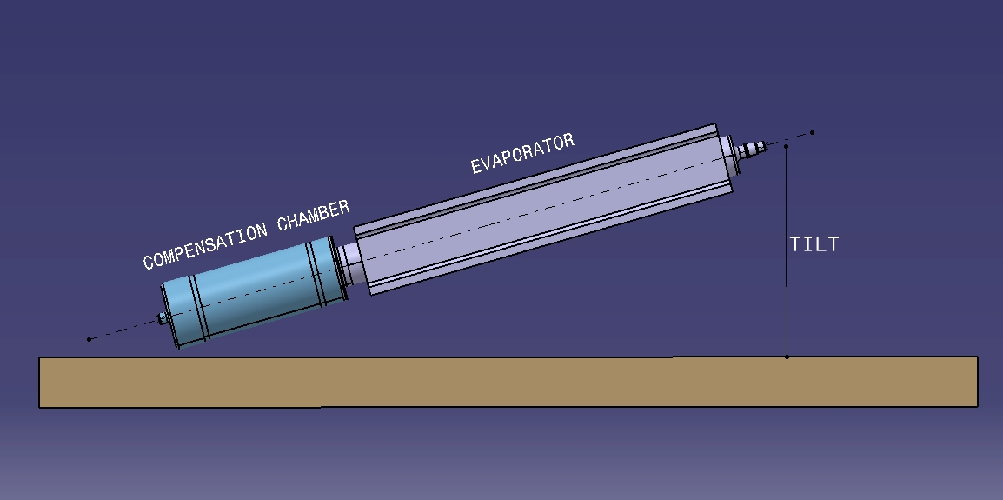
Figure 3-2: Tilt definition for LHP
- two-phase heat transport equipment (TPHTE)
hermetically closed system filled with a working fluid and transporting thermal energy by a continuous evaporation/condensation process using the latent heat of the fluid
1 A fluid evaporates in the heat input zone (evaporator) and condenses in the heat output zone (condenser).
2 This is in contrast to a single-phase loop where the sensible heat of a liquid is transported (a liquid heats up in the heat input zone and cools down in the heat output zone).
- two-phase loop (TPL)
TPHTE with physically separated vapour and liquid transport lines forming a closed loop
See TPHTE definition in 3.2.20.
- variable conductance heat pipe (VCHP)
heat pipe with an additional non-condensable gas reservoir allowing a variable thermal conductance between evaporator and condenser
1 See heat pipe definition in 3.2.7.
2 The variation in thermal conductance is generally accomplished by regulating the volume of a non-condensable gas plug reaching into the condenser zone, which in turn varies the effective condenser length.
3 The variation of the gas volume can be performed by active or passive means.

Abbreviated terms
The following abbreviations are defined and used within this standard:
Abbreviation | Meaning
CCHP | constant conductance heat pipe
CDL | capillary driven loop
CPL | capillary pumped loop
CTE | coefficient of thermal expansion
DRD | document requirements definition
HP | heat pipe
HPD | heat pipe diode
LBB | leak before burst
LHP | loop heat pipe
MDP | maximum design pressure
MPDL | mechanical pump driven loop
MSPE | metallic special pressurized equipment
NDI | non-destructive inspection
PH | pressurized hardware
ROD | review-of-design
SPE | special pressurized equipment
TCS | thermal control (sub)system
TPHTE | two-phase heat transport equipment
TPL | two-phase loop
TS | technical requirement specification
VCHP | variable conductance heat pipe
VP | verification plan

TPHTE qualification principles

TPHTE categorization
TPHTE are considered special pressurized hardware, as defined in clause 3. Requirements of ECSS-E-ST-32-02 are included in this Standard for this reason.
The TPHTE are categorized in Figure 4-3 according to their design and functional principle.
Heat pipes consist of a single container with a capillary structure extending over the entire container length. Liquid and vapour passages are arranged in such a way that the two fluid phases move in counter flow.
Capillary driven loops (CDL) have separate evaporator and condenser sections, which are connected by dedicated vapour and liquid tubing. At least one capillary structure is located in the evaporator section, which serves as capillary pump to circulate the fluid in a true loop configuration.
The mechanically pumped two-phase loop (MPDL) has a configuration, which is similar to the CDL, except that the circulation of the fluid is accomplished by a mechanical pump.
Requirements for MPDL are not included in the present version of this Standard.

Involved organizations
The qualification process of TPHTE is generally carried out by a specialized equipment manufacturer (called in this document “supplier”) and controlled by the qualification authority, which is called in this document the “customer”.
The qualification activity is embedded in the supplier’s product assurance and quality organization and in most cases the supplier's quality assurance plan has been established and approved for space activities independently from the TPHTE qualification process specified in this document. It is the task of the supplier’s PA authority to introduce / approve adequate product assurance provisions at his subcontractor(s). The existence of an approved PA Plan is precondition for commencing qualification activities.
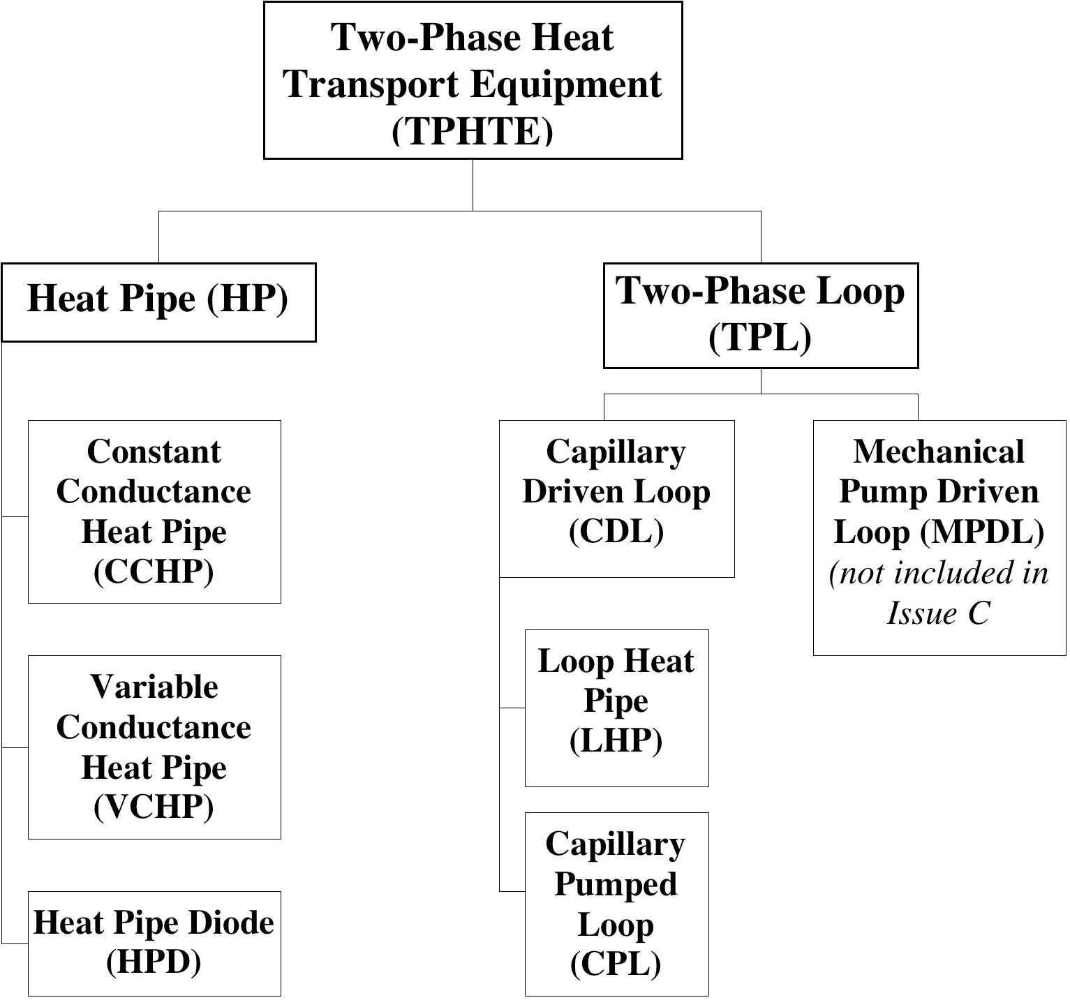
Figure 4-3: Categories of TPHTE (two-phase heat transport equipment)

Generic requirements in this standard
The present document provides generic, i.e. not project specific requirements for formal qualification of TPHTE. It is therefore important to select overall and enveloping qualification requirements in order to support a maximum of spacecraft application without the need for delta qualification.

Processes, number of qualification units
The qualification of TPHTE is based on qualified manufacturing processes (e.g. cleaning, surface treatment, welding and leak testing) and covers in general the following areas:
- Performance over long operation time (compatibility between fluid and wall material, space radiation, leak tightness)
- Mechanical performance (strength, pressurized hardware)
- Thermal performance (e.g. heat transport capability, start-up behaviour, heat transfer coefficients)
In this context the number of TPHTE units to be produced for the qualification program are evaluated and selected by the supplier. There are no general applicable sources, which specify the minimum of units to be used to undergo identical qualification testing in order to arrive at a successful qualified product. The question to be answered for each TPHTE configuration is: How many identical units need to be built and tested in order to verify that production processes provide reproducible performance results.
The following are possible selection criteria:
- Experience of the manufacturer in production of similar products,
- Simplicity of the configuration,
- TPHTE design features, which have inherent capability for good repeatability of the production processes (e.g. simple axial grooved heat pipes).
This Standard specifies the number of needed units submitted to the qualification process for configurations, which are currently used in several spacecraft applications. It is recommended that the supplier performs the selection for other configurations and provide argumentation to the customer for agreement of his choice.
Compared to full qualification of a new product the number of units can be reduced for delta qualification of an existing but modified product.

Thermal and mechanical qualification

Temperature range
In contrast to most of electronic equipment the performance of a TPHTE varies with its operating temperature, because properties of the used heat carrier are temperature dependent. For heat pipes as an example, important fluid properties can be grouped into a figure-of-merit (G), which is the product of surface tension, heat of vaporization and liquid density divided by the liquid viscosity (for more information see references in Bibliography). G is plotted for some fluids over the temperature in Figure 4-4. The heat transport capability of a capillary pumped loop is proportional to these curves.

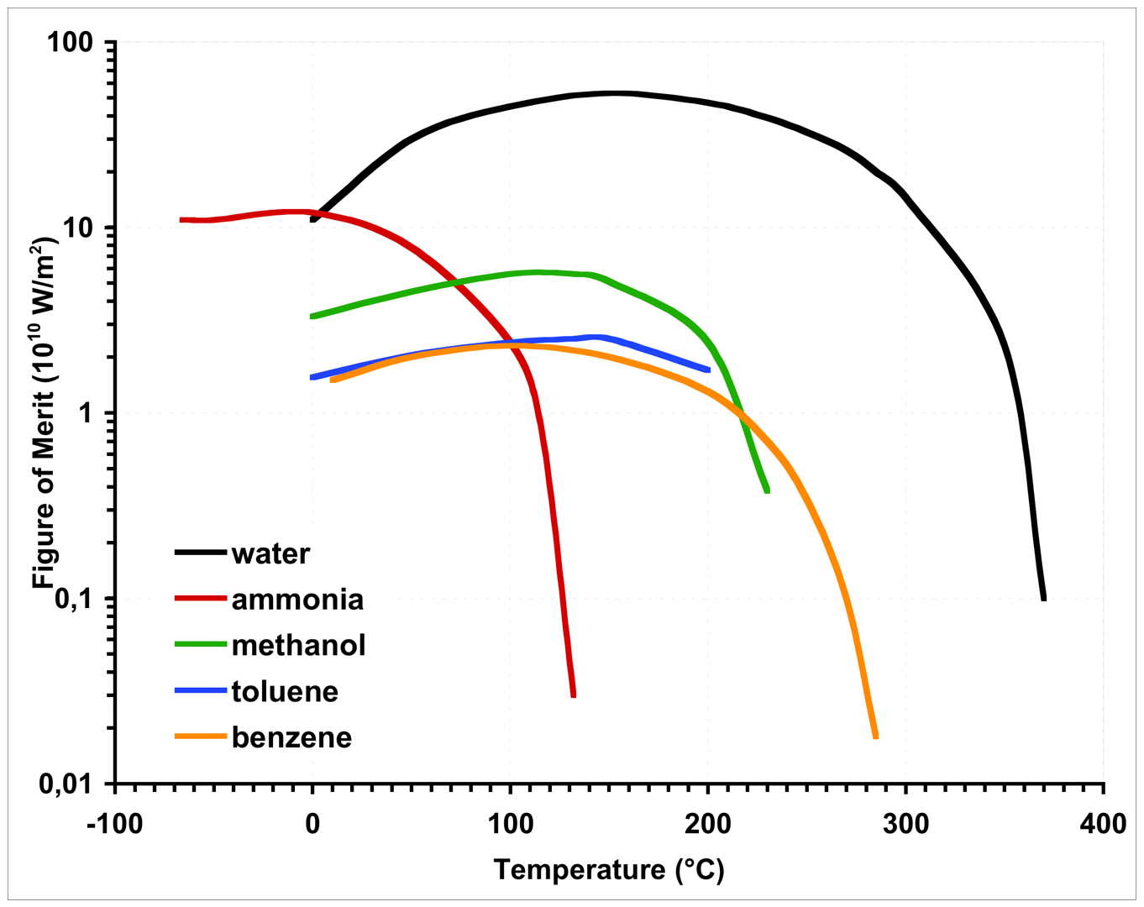
Figure 4-4: Figure-of-merit (G) for some TPHTE fluids
Generally, the applicable temperature range of a TPHTE is subdivided into a thermally and a mechanically relevant regime.
The thermal performance temperature range, which is used for thermal qualification, is defined within the theoretical operating temperature range, confined by the freezing and the critical temperature of the used fluid. Lower and upper temperature limits of the qualification range are selected in such a way that a useful map of thermal performance data can be established. Within this range the maximum transport capability for qualification will be determined. For a specific space application the operating temperature range (within the thermal performance temperature range) and the maximum required heat transport capability are specified.
For thermo-mechanical qualification the temperature range is relevant, to which the device is exposed to during the life cycle. In most cases this exposure temperature range is wider than the above-mentioned thermal performance temperature range. The minimum temperature of this range can be below the freezing temperature of the used heat carrier and it is important to take into account possible damage caused by the freezing or thawing effects. The upper exposure temperature can be even above the critical temperature of the heat carrier. This temperature determines in general the maximum internal pressure for design and qualification of the device.
The mentioned temperature ranges and associated heat transport capabilities are illustrated in Figure 4-5.
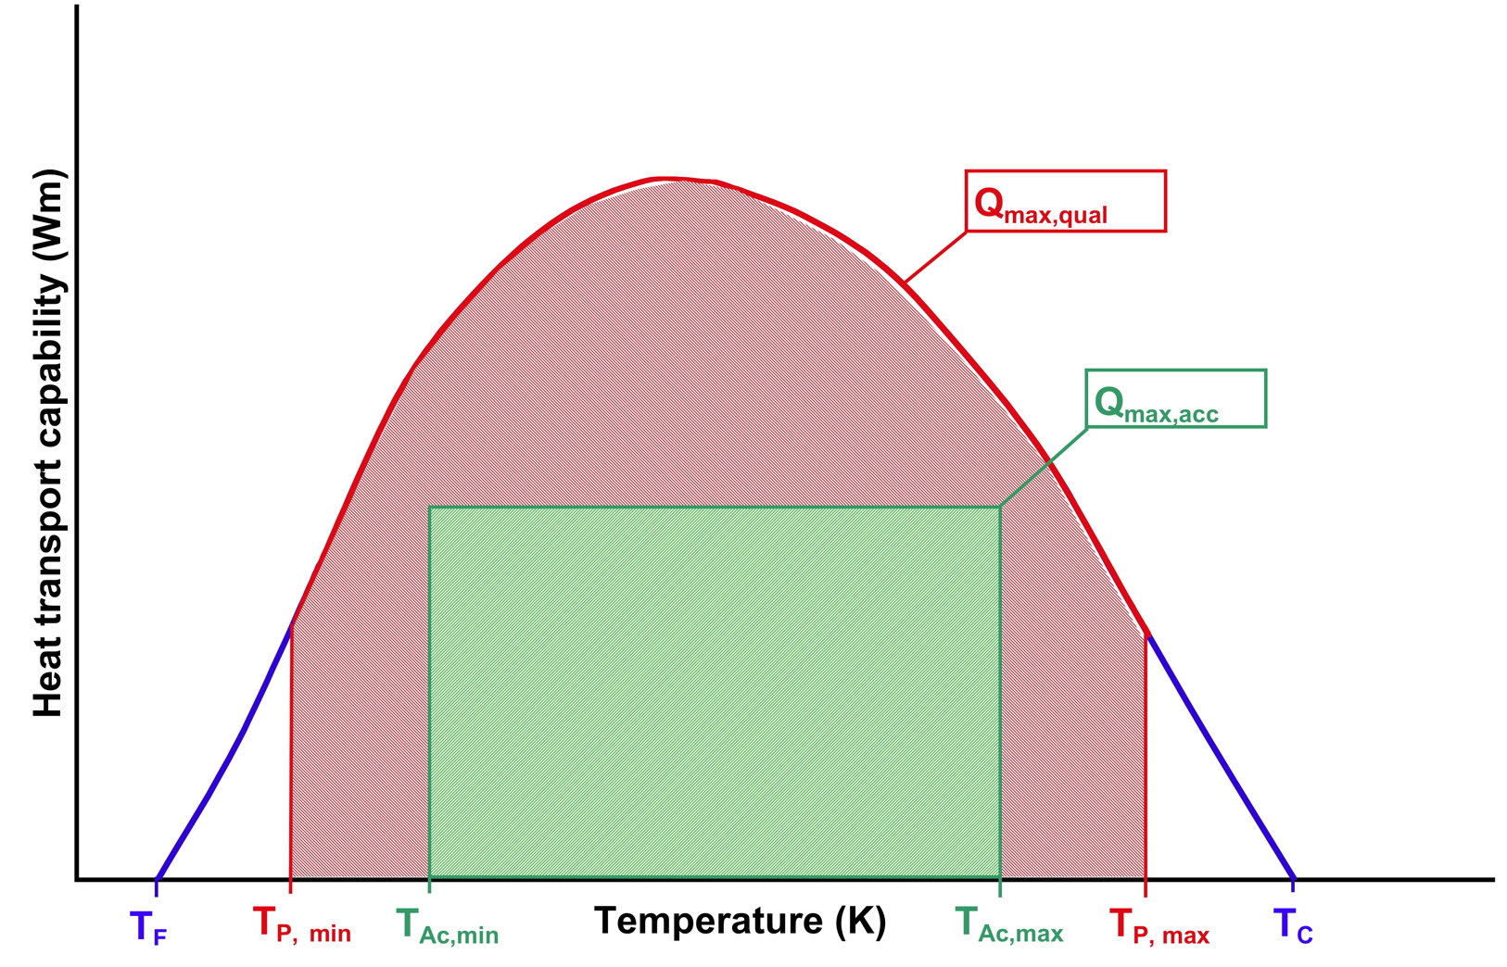
Legend
Q_{max,qual} Maximum transport capability for qualification
Q_{max,acc} Maximum transport capability for acceptance (specified for a specific project)
T_{F}, T_{C} Freezing and critical temperature of a selected fluid
T _{P, min,} T _{P, max} Minimum and maximum performance temperature
T _{Ac, min,} T _{Ac, max} Minimum and maximum acceptance temperature (specified for a specific project)

T _{P,min}  T _{P,max} Performance temperature range
T _{Ac,min}  T _{Ac,max} Acceptance temperature range (specified for a specific project)
Figure 4-5: Definition of temperature and performance ranges for a HP

Mechanical qualification
TPHTE are classified as pressurized component and relevant mechanical requirements are specified in ECSS-ST-E-32-02 and are applied in the present Standard for all TPHTE types.
For qualification of a TPHTE as pressurized component the main characteristic is the internal pressure, which varies in relation to the exposure temperature of the unit (temperature dependent saturation pressure of the heat carrier liquid).
ECSS-ST-E-32-02 specifies qualification requirements for heat pipes (see figure 4.12). The present Standard selects qualification requirements for TPHTE, which have seen proof pressure tests ≥ 1,5 MDP. Testing is the preferred method rather than qualification by fracture control analysis.
For qualifying a TPHTE with respect to external mechanical environment the following mechanical tests are considered:
- Constant or static acceleration
- Sine vibration
- Random vibration
For these tests the qualification unit needs to be rigidly mounted to the test equipment (vibration table). However, such mounting provisions can have only reduced similarity to real applications in spacecrafts and the meaningfulness of such tests is, therefore, very often reason for discussion under experts. For heat pipes it is common understanding not to perform these tests on long heat pipe profiles for the following reasons:
- The length of the test heat pipe is adapted to the test equipment and is therefore shorter as in many realistic spacecraft applications.
- The application of heat pipe is often for embedding them in sandwich structures. Mechanical loads for these applications are quite different as can be simulated with a rigidly fixed single heat pipe profile.
- Several capillary structures, in particular axial groove heat pipes, are quite insensitive to mechanical loads and tests as suggested in existing procedures can be unnecessary.
For many TPHTE applications (in particular for devices with simple capillary structures, e.g. axial grooves) the formal mechanical qualification can be therefore performed with the first structural model on satellite level. In case the risk for such a late qualification is high, pre-qualification can be performed on unit or part level in particular for the following cases:
- The TPHTE, in particular a heat pipe, has a capillary structure, which is sensitive towards mechanical loads, e.g. arterial wick. In such a case a short piece of the heat pipe profile is selected for mechanical qualification testing (sine, random vibration).
- An evaporator of a LHP or CPL can be separately tested (sine, random vibration) to verify that mechanical requirements are met.
- Equally this can be true for a two-phase loop condenser, in particular for configurations where the condenser tubing is embedded into a structural panel.
The Standard does not therefore not specify at which model level vibration testing is to be performed. The supplier and customer are asked to agree on a logical qualification plan, which may include testing at higher than equipment level.

Requirements

Technical requirements specification (TS)

General
          - The qualification process shall be based on a technical requirements specification, approved by the customer.
Usually the technical specification evolves from the functional requirements of the customer and defines the technical performances for the proposed solution as part of a business agreement.
          - The technical requirements specification specified in 1.1.1a shall be written in accordance with DRD in Annex A.

Requirements to the TS
          - The specification shall be identifiable, referable and related to a TPHTE product.
          - The following entity shall be responsible for the TS:
            - the supplier for a generic TPHTE specification, which is not related to a specific application;
            - the customer for a specific TPHTE specification, which is related to a specific application.
A delta qualification can be necessary, if the generic specification does not completely meet the requirements for a specific application.
          - Each technical requirement shall be separately stated.
          - Abbreviated terms used in requirements shall be defined in a dedicated section of the specification.
          - The technical requirements shall be consistent and not in conflict with the other requirements within the specification.
          - The technical requirements shall not be in conflict with other requirements contained in business agreement documents.
          - The specification shall be complete in terms of applicable technical requirements and reference to applicable documents.
          - The specification shall be under configuration management.
          - Quantity of units required for the qualification process shall be specified in the TS.
TS exclude requirements such as cost, methods of payment, time or place of delivery.

Requirements for formulating technical requirements
          - Each technical requirement shall be described in quantifiable terms.
          - The technical requirements shall be unambiguous.
          - Each technical requirement shall be unique.
          - A unique identifier shall be assigned to each technical requirement.
          - Each technical requirement shall be separately stated.
          - A technical requirement shall be verifiable using one or more approved verification methods.
          - The tolerance shall be specified for each parameter/variable.
The technical requirement tolerance is a range of values within which the conformity to the requirement is accepted.
          - Technical requirements should be stated in performance or “what-is-necessary” terms, as opposed to “how-to" perform a task, unless the exact steps in performance of the task are essential to ensure the proper functioning of the product.
          - Technical requirements should be expressed in a positive way, as a complete sentence (with a verb and a noun).
          - The verbal form “shall” shall be used whenever a provision is a requirement.
          - The verbal form “should” shall be used whenever a provision is a recommendation.
          - The verbal form “may” shall be used whenever a provision is a permission.
          - The verbal form “can” shall be used to indicate possibility or capability.
          - The following terms shall not be used in a TS requirement: “and/or”, “etc”, “goal”, “shall be included but not limited to”, “relevant”, “necessary”, “appropriate”, “as far as possible”, “optimize”, “minimize”, “maximize”, “typical”, “rapid”, “user-friendly”, “easy”, “sufficient”, “enough”, “suitable”, “satisfactory”, adequate”, “quick”, “first rate”, “best possible”, “great”, “small”, “large”, and “state of the art”.

Materials, parts and processes
          - Materials, parts and processes for TPHTE to be qualified shall be documented in the following lists (see Table 5-7):
            - Declared materials list
            - Declared mechanical parts list
            - Declared processes list

General qualification requirements

Qualification process
          - The qualification stage shall be completed before launch.

Supporting infrastructure – Tools and test equipment
          - Tools to be used to support the qualification process shall be validated for their intended use.
          - The validation shall be performed under expected environmental conditions and operational constraints.
          - Compatibility of tools and test equipment interfaces with flight qualification hardware shall be verified by test.
          - Calibration of laboratory equipment shall be verified prior to their use.
          - Tools and test equipment that is modified and used in a new application shall be re-verified according to 1.1.1bb to 1.1.1ee.
          - Test facilities, tools and instrumentation shall be designed to avoid adverse effects on the qualification objectives.
Examples of these are: Thermocouples, strain gauges, heater mounting, cooling devices, support structures.

Qualification process selection
          - The scope of the qualification process shall be adapted to the qualification heritage of the product.
          - For categorization of the heritage the product categories of Table 5-1 shall be used.
          - The qualification process shall be structured according to Figure 5-6.
Table 5-1: Categories of two-phase heat transport equipment according to heritage (derived from ECSS-E-ST-10-02C, Table 5-1)
Category | Description | Qualification programme | Remarks related to the present Standard
A | Off-the-shelf product without modifications and  - The product is qualified to requirements at least as severe as those imposed by the actual technical specification  - The product is produced by the same manufacturer and using identical tools and manufacturing processes | None
B | Off-the-shelf product without modifications.  However:  - The product is qualified to requirements less severe or different to those imposed by the actual technical specification  Or  - The product is produced by a different manufacturer or using different tools and manufacturing processes  Or  - The product has substitution parts and materials with equivalent reliability *) | Delta qualification programme, decided on a case-by-case basis in agreement between the customer and the supplier | This category relates for example to TPHTE hardware, which is identical to already qualified hardware but has been qualified to lower mechanical loads or narrower operating temperature ranges as required by an actual project.  The category relates also to situations, where TPHTE manufacturing technology is transferred from a qualified supplier to a new manufacturer.  *) Any substitution parts and materials fulfilling the same procurement specification does not require delta-qualification.
C | Off-the-shelf product with design modifications | Delta or full qualification programme, decided on a case-by-case basis depending on the impact of the modification in agreement between the customer and the supplier | Examples for category C are:  Heat pipes with identical capillary structure but different diameters, smaller bent radius,  CDL with different fluid line configurations or dimensions or different condenser configurations (radiator lay out).
D | New designed and developed product. | Full qualification programme. | Applicable for any new developed TPHTE, including existing systems with new capillary structures or material combinations.

Category A equipment?
Category B equipment?
Category C equipment?
TPHTE to be qualified
No qualification programme required
Delta qualification programme
(Clause 5.5.4.2)
Delta qualification programme
(Clause 5.5.4.2)
or Full qualification programme
(Clause 5.5.4.1)
Category D
equipment
Full qualification
programme
(Clause 5.5.4.1)
Review-of-design (Clause 5.5.3.4)
No
No
No
Yes
Yes
Yes
Similarity analysis (Clause 5.5.3.3.2)
Similarity analysis (Clause 5.5.3.3.2)
For category definition see Table 5-1.

Figure 5-6: Selection of qualification process

Qualification stage

General
          - Qualification shall demonstrate that the design of the TPHTE meets the requirements of the technical specification.
The qualification can be supported by in-orbit demonstration to verify requirements, which are affected by zero-g environment.
          - When a requirement is verified by qualification at lower level, the traceability to the lower level verification evidence shall be provided.
This concerns manufacturing processes as well as parts, materials and sub-units of a TPHTE.
          - Formal close-out of qualification at lower level shall be performed prior to close-out at higher level.

Quality audits
          - The supplier shall allow quality audits in support to the qualification process in accordance with EN 9100-2009 clause 4.6.4.2.
          - Quality audits shall be conducted such that the supplier’s know-how and proprietary data are protected.
As a general rule audits should be performed by quality assurance personnel of the customer and not by experts in the field.

Qualification methods

Overview
          - A verification plan (VP) shall be prepared in conformance with the DRD in Annex B and agreed with the customer.
          - The qualification of TPHTE shall be accomplished by one or more of the following verification methods:
            - Test (including demonstration), as specified in 5.5.3.2.
            - Analysis (including similarity), as specified in 5.5.3.3.
            - Review-of-design, as specified in 5.5.3.4.
            - Inspection, as specified in 5.5.3.5.
          - The selected qualification methods shall be defined in a verification plan specified in 1.1.1pp.

Test
          - Verification by test shall consist of measuring product performance and functions under representative simulated environments.
          - All safety critical functions shall be verified by test.
          - Qualification shall be carried out on hardware, which is representative of the end item in terms of design, materials, tooling and methods.
          - TPHTE subject to qualification test shall be manufactured applying qualified processes.

Analysis

General
          - Verification by analysis shall consist of performing theoretical or empirical evaluation using techniques agreed with the customer.
          - Analysis shall be performed to predict specified performance parameter of the TPHTE.
          - Analytical prediction results shall be correlated with qualification test results.
Result correlations lead to software tool validation, which can reduce follow-on qualification processes.
          - Discrepancies between analytical prediction and test results shall be analysed in order to demonstrate that the objective of the qualification is not compromised.
          - Mechanical and thermal performance analysis and test prediction shall be documented in a dedicated report in conformance with ECSS-E-ST-31, Annex C.
Analysis and test prediction can be split in two documents.

Similarity
          - For a product that is similar to already qualified products, a similarity analysis shall be performed to identify differences requiring complementary qualification activities.
          - Qualification by similarity shall not be performed on a product that has been previously qualified by similarity.

Review-of-design (ROD)
          - For verification by ROD existing records and evidence shall be used to demonstrate that requirements are met.
Existing records and evidence are validated design documents, approved design reports, technical description, engineering and manufacturing drawings.
          - Verification by ROD shall be documented in a Review-of-Design report in conformance with the DRD in Annex C.

Inspection
          - For verification by inspection visual determination of physical characteristics shall be used to demonstrate that requirements are met.
Physical characteristics include constructional features, hardware conformance to document drawing and workmanship requirements, physical conditions.
          - Verification by inspection shall be documented in an Inspection Report in conformance with the DRD in Annex D.

Full and delta qualification programme

Full qualification programme
          - Equipment for which a full qualification programme is required as per Table 5-1 shall be qualified by test according to clause 5.5.3.2 and 5.6 and by analysis according to clause 5.5.3.3.

Delta qualification programme
          - Equipment for which a delta qualification programme is required as per Table 5-1 shall undergo a delta qualification programme, which is a subset of the full qualification programme of clause 5.5.4.1.
          - The delta qualification programme shall be selected on a case-by-case basis and based on the modifications to existing qualified hardware.
          - The delta qualification programme shall be agreed with the customer.

Performance requirements

Generic requirements
          - The following generic performance characteristics of a TPHTE shall be determined and verified against specified data:
            - Ability to sustain the combination of the predicted worst mechanical loads:
              - External mechanical loads.
              - Internal loads due to the saturation pressure of the heat carrier fluid within the TPHTE exposure temperature range.
              - Thermo-mechanical loads due to temperature cycling and CTE mismatch within the TPHTE exposure temperature range.
              - Loads imposed by volume change due to freezing/thawing of the heat carrier within the TPHTE exposure temperature range.
            - Safe life item and fatigue-life demonstration
              - Safe life item demonstration, performed by analysis or test or both in conformance with ECSS-E-ST-32-01 for TPHTE not submitted to a proof pressure or for which the proof factor used in the proof pressure test is less than 1,5.
              - Fatigue-life demonstration, performed by analysis or test or both in conformance with ECSS-E-ST-32 for TPHTE for which the proof factor used in the proof pressure test is equal or larger than 1,5.
            - Thermal parameters:
              - Minimum and maximum heat transport capability over the TPHTE thermal performance temperature range.
For heat pipes only the maximum heat transport capability is of interest.
              - Evaporator heat flux over the TPHTE thermal performance temperature range.
              - Heat transfer coefficient in the evaporator and condenser.
              - Overall thermal resistance of the device.
            - Operational characteristics
              - Maximum heat load applied in one step at discrete temperatures over the specified range.
              - Start-up behaviour from frozen conditions, if the exposure temperature range includes freezing of the working fluid.
              - For cryogenic TPHTE, start-up from the super-critical state of the working fluid.
            - Leak-before-burst.
            - Lifetime performance:
              - Long-term compatibility between fluid and wetted materials (materials in contact with the fluid).
              - Space radiation effects in order to demonstrate that fluid de-composition does not adversely affect specified TPHTE performance during the product life cycle.

Specific requirements
          - For CCHP the following specific performance characteristics shall be determined and verified against specified data:
            - Reduction of transport capability due to heat pipe bending at the minimum specified radius.
            - Reduction of transport capability due to tilt (see Figure 3-1).
To item 1: The minimum bending radius is defined by the supplier.
          - For VCHP, the following specific performance characteristics shall be determined and verified against specified data:
            - The characteristics specified in 1.1.1mmm,
            - Maximum transport capability in fully-on conditions,
            - Heat leak from condenser to evaporator in off-mode,
            - Thermal resistance between condenser and reservoir,
            - Ability to regulate the evaporator temperature with passive and active methods.
Passive methods include devices with non-heated gas reservoirs, active methods include devices with heated/cooled gas reservoirs.
          - For HP Diode, the following specific performance characteristics shall be determined and verified against specified data.
            - The characteristics specified in 1.1.1mmm,
            - Maximum heat transport capability in forward mode,
            - Time and energy to move from forward to reverse mode,
            - Time and energy to move from reverse to forward mode,
            - Heat leak from condenser to evaporator in reverse mode.
          - For CDL, the following specific performance characteristics shall be determined and verified against specified data
            - Minimum heat load applied under which start-up is possible over the specified temperature range,
            - Sensitivity of the minimum heat load in relation to the thermal mass attached to the evaporator,
            - Minimum heat load applied under which nominal operation is possible over the specified temperature range,
            - Sub-cooling conditions to guarantee specified performance,
            - Impact on performance due to tilt (see Figure 3-2) and adverse elevation (evaporator above condenser),
            - Heat leak from condenser to evaporator in off-mode,
            - Ability to regulate the evaporator temperature with passive and active methods.
Passive methods include devices with passive regulation (by-pass) valves in TPL. Active methods include devices with heated/cooled liquid reservoirs, heated regulation valves and TPLs with thermo-electric cooler (TEC) on the liquid reservoir.

Qualification test programme

Number of qualification units
          - The number of TPHTE units submitted to the qualification programme test units shall be in accordance with Figure 5-7 and Figure 5-8.

Test sequence
          - Equipment for which a full qualification programme is required as per Table 5-1 shall be verified by qualification testing according to the test sequence as defined in Figure 5-7 for HP and Figure 5-8 for CDL.
          - For an equipment where a delta qualification programme is required as per Table 5-1, the supplier shall derive from the test sequence of Figure 5-7 for HP and Figure 5-8 for CDL a reduced test sequence for delta qualification.
          - The delta qualification sequence shall be agreed with the customer.
Test item preparation
Test plan and Qualification Test Readiness Review (5.6.3.1)
Qualification test programme
Manufacturing of qualification hardware
according to documented processes
Reduced acceptance test of hardware for qualification:
- Physical property measurement (5.6.4)
- Proof pressure test (5.6.5)
- Leak test (5.6.8)
- Gas plug test (5.6.13)
- Reduced thermal performance test (5.6.14.1 to 5.6.14.4)
Selection of test item configuration and quantity
(5.6.1)
Heat Pipe:
5 functional units
- 3 units straight configuration
- 2 units bent configuration
2 units for material compatibility testing
2 pressure samples
Full thermal performance test (5.6.9.1 to 5.6.9.4)
Mechanical test
(5.6.10)
Leak test
(5.6.8)
Thermal cycle test
(5.6.11)
Gas plug test
(5.6.13)
Reduced thermal performance test (5.6.14.1 to 5.6.14.4)
Aging test
(5.6.12)
Full thermal performance test (5.6.9.1 to 5.6.9.4)
Functional tests
(3 straight, 2 bent)
Material compatibility tests
(2 units) (2 HP)
Pressure tests
(2 samples)
Pressure cycle test
(5.6.6)
Burst pressure test
(5.6.7)
Life test incl. Gas plug test (5.6.12 & 5.6.13)
Reduced thermal performance test
(5.6.14.1 to 5.6.14.4)
Reduced thermal performance test
(5.6.14.1 to 5.6.14.4)
Leak test
(5.6.8)
Verification Report
(Table 5-7)
Post Test Review
(1.1.1vvv)
Figure 5-7: Qualification test sequence for HP
Qualification test programme
Test item preparation
Reduced acceptance test of hardware for qualification:
● Physical property measurement (5.6.4)
● Proof test (5.6.5)
● Leak test (5.6.8)
● Reduced thermal performance test (5.6.14)
Full thermal performance test (5.6.9.1 & 5.6.9.5)
Mechanical test
(5.6.10)
Leak test
(5.6.8)
Reduced thermal performance test (5.6.14.1 & 5.6.14.5)

Thermal cycle test
(5.6.11)
Full thermal performance test
5.6.9.1 & 5.6.9.5)
Test plan and Qualification Test Readiness Review
(5.6.3.1)
Functional tests
(1 CDL)
Material compatibility tests
(1 CDL)

Pressure tests
(1 sample)

Pressure cycle test
(5.6.6)
Burst pressure test
(5.6.7)
Life test
(5.6.12)
Reduced thermal performance test (5.6.14.1 & 5.6.14.5)
Reduced thermal performance test (5.6.14.1 & 5.6.14.5)
Verification Report
(Table 5-7)
Post Test Review
(1.1.1vvv)
Manufacturing of qualification hardware
according to documented processes
Selection of test item configuration and quantity
(5.6.1)
CDL:
1 functional unit
1 unit for material compatibility testing
1 unit as pressure sample
Leak test
(5.6.8)
Figure 5-8: Qualification test sequence for CDL

Test requirements

Test specification and reviews
          - Before starting the qualification test campaign the following preconditions shall be met:
            - Establishing of a test specification in conformance with the DRD in Annex E,
            - Establishing of test procedures in conformance with the DRD in Annex F, and
            - Conductance of test readiness review.
          - At completion of the test sequence a post-test review shall be conducted.
          - Test documentation shall be agreed with the customer.

Test conditions

Test tolerances
          - The test tolerances specified in Table 5-2 shall be applied to the nominal test values specified.
          - For the purpose of 1.1.1xxx, test tolerances shall include test instrumentation accuracy.
The tolerances specified in Table 5-2 are the allowable ranges within which the test parameters can vary. The values in the table are inclusive of instrumentation accuracy.
Table 5-2: Allowable tolerances
Test parameters | Tolerances
1. Temperature | Low High
above +100 °C | $T_{{\text{min}}_{−4}^{+0}}$ $T_{{\text{max}}_{−0}^{+4}}$
-73 °C < T ≤ +100 °C | $T_{{\text{min}}_{−3}^{+0}}$ $T_{{\text{max}}_{−0}^{+3}}$
-100 K (-173 °C) < T ≤ 200 K (-73 °C) | ± 2 K (2 °C)
40 K (-233 °C) < T ≤ 100 K (-173 °C) | ± 1 K (1 °C)
10 K (-263 °C) ≤ T ≤ 40 K (-233 °C) | < 0,5 K (0,5 °C)
T< 10 K (-263 °C) | Tolerance to be defined case by case
2. Relative humidity | ± 10 %
3. Pressure (in vacuum chamber)
> 1,3 hPa | ± 15 %
1,3 10⁻³ hPa to 1,3 hPa | ± 30 %
< 1,3 10⁻³ hPa | ± 80 %
4. Acceleration | -0 / +10 %
5. Static Load | -0 / +10 %
6. Sinusoidal vibration
Frequency (20 Hz to 2000 Hz) | ± 2 %
Amplitude | ± 10 %
Sweep rate (Oct/min) | ± 5 %
7. Random vibration
Frequency | ± 5 % (or 1 Hz whichever is greater)
Amplitude (PSD)
20 Hz - 100 Hz (max control bandwidth 10 Hz) | -1/ +3 dB
100 Hz - 1000 Hz (10 % of midband frequency) | -1/ +3 dB
1000 Hz - 2000 Hz (max control bandwidth 100 Hz) | ± 3,0 dB
Random overall g r.m.s. | ± 10%
8. Acoustic noise
Sound pressure level, Octave band centre (Hz) | Test tolerances (dB)
31,5 | -2/+4
63 | -1/+3
125 | -1/+3
250 | -1/+3
500 | -1/+3
1000 | -1/+3
2000 | -1/+3
Overall | -1/+3
9. Microvibration susceptibility
Quasi-static force or torque | ± 5 % To be related to the external forces that are applied to extrapolate the transfer functions
Dynamic forces | ±10 % To be related to the external forces that are applied to extrapolate the transfer functions
Sound-power (1/3 octave band centre frequency)
32,5 Hz - 160 Hz | ±3 dB
160 Hz – 10000 Hz | ±2 dB
10. Shock
Response spectrum amplitude (1/12 octave centre frequency)
Shock level
≤ 3000 Hz | - 3, + 6 dB
≥ 3000 Hz | - 3, + 9 dB
Shock duration
≤ 20 ms | 0/+ 20 %
> 20 ms | 0/+ 10 %
11. Solar flux
in reference plane | ± 4 % of the set value
In reference volume | ± 6 % of the set value
12. Infrared flux
Mean value | ± 3 % on reference plane(s)
13. Test time | -0/+10 %

Measurement accuracy
          - The accuracy of test instrumentation shall be verified in accordance with approved calibration procedures.
          - All test instrumentation shall be within the normal calibration period at the time of the test.
Table 5-3: Measurement accuracy
Test parameters | Accuracy
1. Mass | ± 0,1 %
2. Centre of gravity (CoG) | Within a 1 mm radius sphere
3. Moment of inertia (MoI) | ± 3 %
4. Leak rate | ± 10⁻⁵ Pa m³ s⁻¹ of Helium at 1013 hPa pressure differential or at least a factor of two with respect to the leak rate to be measured.

Test results
          - Test results shall be monitored and compared across major test sequences for trends or evidence of anomalous behaviour of the test set up.
          - Test reports shall be established for each test performed in conformance with the DRD in Annex G.

Test data management
          - Performance test, leak test and long duration test results shall be used to perform trend analysis to detect long-term gradually increasing defects and failures.

Physical properties measurement
          - The following properties of the test unit shall be measured, recorded and compared to specification in relevant drawings:
            - Completeness of configuration,
            - Materials as specified,
            - Dimension of unit and interfaces,
            - Mass,
            - Flatness of heat input and heat output zones,
            - Fluid amount (from manufacturing records),
            - Centre of gravity,
            - Momentum of inertia.
The determination of centre of gravity and moment of inertia can be performed by analysis.
          - For the physical properties measurement the test unit shall not include test specific items.

Proof pressure test
          - Proof pressure test shall be performed applying 1,5 times MDP as specified in ECSS-E-ST-32-02 for duration of 15 minutes.
During manufacturing processes (e.g. curing of panels with embedded heat pipes) the pressure can be higher than MDP, as long as the unit material stays in the elastic domain.
          - Pressure shall be generated on the sealed unit by increasing the temperature of the unit and thus the saturation pressure of the heat carrier fluid (hot proof pressure test).
When the pressure target leads to a temperature higher than the critical temperature than the cold pressure test (before unit sealing) can be considered to reach the proof pressure requirement and a reduced proof factor can be accepted for the hot pressure test on the sealed unit.
          - In cases where proof pressure test is not feasible, margins against mechanical failure shall be verified by analysis in accordance with ECSS-E-ST-32-02.

Pressure cycle test
          - The pressure cycle test shall consist of 2000 cycles between 1 bar and MDP at ambient temperature.
          - The supplier shall analyse the number of cycles above the 2000 cycles, to which the TPHTE can be exposed before reaching the Woehler curve.

Burst pressure test
          - Burst pressure test shall be performed applying 2,5 times MDP for duration of 15 minutes.
          - No rupture or leak shall occur during burst pressure test.
          - Burst pressure test shall be carried out with burst pressure samples manufactured from the same material batch and according to processes, which are identical to the ones used for the functional qualification unit.
          - Burst pressure samples shall include all features of the flight configuration.
For example representative bends, welds and joints.
          - Burst pressure test shall be performed at the maximum exposure temperature by increasing the internal pressure until the required burst pressure is reached.
Burst pressure testing at lower temperatures may be performed, when a factor corresponding to differences in material properties between test and maximum exposure temperature is taken into account.
          - After the 15 minutes hold-time, the pressure shall be further increased until rupture occurs and the pressure at rupture shall be recorded.
          - If burst pressure tests are performed at sub-unit level, the burst pressure test processes shall include all parts of the product including all joints, welds, end fittings.
For example, if it is performed at the level of the evaporator or reservoir of a TPL.

Leak test
          - Leak test shall be performed at ambient temperature using a detection method agreed with the customer.
          - The maximum leak rates versus pressure values shall be established through a detailed analysis such that operation of the system is ensured throughout the specified lifetime.
          - Leak rate of all TPHTE hardware shall conform to the level defined in 1.1.1tttt.
Pressurized hardware containing hazardous fluids reach end of safe-life when leakage occurs.
          - During the leak test, the pressure level shall be maintained for 30 minutes as a minimum.

Thermal performance test

General
          - Thermal performance test results, obtained under 1-g conditions, shall be correlated to predict 0-g (on-orbit) performance.
          - For thermal performance tests at ambient conditions, it shall be demonstrated that the conditions specified in 1.1.1wwww do not have an influence on in-orbit performance.
For a specific application the customer can require a thermal performance test in vacuum.
          - During ground test the unit shall be insulated and the remaining heat exchange with the environment shall be determined.
          - When establishing the maximum heat transport capability, the vapour temperature shall be varied in increments within the specified operational temperature range such that a performance over temperature curve is generated.
          - For each temperature step, the temperatures along the length of the unit shall be measured and recorded.
          - Maximum performance shall be declared, when temperature excursions in the evaporator indicate the beginning of a non-nominal operational condition.
Temperature excursions are generally caused by dry-out conditions in the evaporator.
          - Temperature readings during performance testing in combination with the applied heat load (corrected for heat exchange with the environment) shall be used to determine heat transfer coefficients in the evaporator and the condenser.
          - Performance shall be measured as function of the orientation of evaporator versus condenser in the gravitational field.
          - Test evaluation and data correlation shall be performed for each test and documented in a TCS analysis report in conformance with the DRD in Annex C of ECSS-E-ST-31.

Specific tests for CCHP

Maximum heat transport capability
          - Maximum heat transport capability shall be measured with
            - Straight HP.
            - Bent HP.
            - Uniform heat input and output.
            - One-sided heat input and one-sided heat output, as follows:
              - combination of heat input on top of the HP and heat output on bottom of the HP (with respect to gravity),
              - combination of heat input on bottom of the HP and heat output on top of the HP (with respect to gravity), and
              - side heat input and opposite side heat output.
          - The supplier shall define performance degradation at the minimum allowed bending radius.

Performance under tilt
          - The maximum heat transport capability shall be measured for tilt heights from zero to a value at which the heat transport capability falls to a value <5 % of the maximum heat transport capability (at the test temperature).
          - Measurement shall be performed at sufficient tilt intervals as to create a smooth curve of performance over tilt height.
          - Test results at different tilt heights shall be extrapolated to zero tilt.
The graphical extrapolation of tilt performance to zero tilt (horizontal position) is assumed to be the zero-g (in-orbit) performance.

Start-up test
          - A start-up test at the minimum thermal performance temperature by applying 50 % of the maximum heat load specified at that temperature shall be performed and the time until nominal operation shall be determined.

Start-up procedure
          - After a full depriming (emptying the capillary structure), a start-up procedure shall be determined.

Performance in reflux mode
          - The heat transfer coefficients in the evaporator and condenser areas shall be derived as a function of power input and temperature.
          - Test shall be performed by applying power at to the bottom of the liquid pool and measuring the temperature profile along the pipe.

Specific tests for VCHP
          - For VCHP, the following tests shall be performed:
            - The tests specified in clause 5.6.9.2.1 to 5.6.9.2.4.
            - Aging tests before charging the device with the control gas.
            - Maximum heat transport capability with the gas front located outside the condenser (between condenser and reservoir).
            - Residual conductance with the gas front outside the condenser (between condenser and evaporator).

Specific tests for HP Diode
          - For HP Diode, the following tests shall be performed:
            - The tests specified in clause 5.6.9.2.1 to 5.6.9.2.4.
            - A test to determine the time-to-shutdown of the HP Diode, as follows:
              - apply pre-defined heat loads to the nominal condenser;
              - vary the vapour temperature in suitable increments within the specified operational temperature range in order to generate a smooth performance over temperature curve;
              - ensure that the pre-defined heat loads are 10 %, 30 %, 50 % and 80 % of the derived Qmax in nominal mode for the specific heat pipe profile;
              - derive the energy needed for shutdown for each of the above tests.
            - A test to determine the time to start-up the heat pipe diode, as follows:
              - apply pre-defined heat loads to the nominal evaporator;
              - ensure that the pre-defined heat loads are 10 %, 30 %, 50 % and 80 % of the derived Qmax in nominal mode for the specific heat pipe profile.

Specific tests for CDL
          - Start-up with low power shall be verified by testing with and without thermal inertia on the evaporator heater system.
          - The specified performance of a CDL shall be verified under the following test conditions:
            - Simulation of large heat load variations (increase and decrease of heat load).
            - Simulation of large condenser temperature variations.
            - Different orientations with respect to gravity including tilt for LHP.
            - Different parasitic heat inputs in the liquid line and into the reservoir.
to subbullet 3: For the tilt definition see Figure 3-2.

Mechanical tests

General
          - Sinusoidal, random vibration and shock tests shall be performed on higher than unit level, if the supplier in agreement with the customer demonstrates that tests at unit level produce unrealistic results.
Tests are generally not meaningful for long heat pipe profiles, for heat pipes, which are later embedded in structural panels and for CDL, for which the configuration in the intended application cannot be represented on unit level (for example: large distance between evaporator and condenser).
          - Sinusoidal, random vibration and shock tests shall be performed on component level in order to verify critical details of the device.
A deflection test to replace sinusoidal and random testing can be agreed with the customer. For example: TPHTE with capillary structures, which have an inherent characteristic to be damaged by mechanical loads.
          - Sinusoidal and random vibration tests shall be performed for the three orthogonal axes of the device.
          - Sinusoidal and random vibration tests shall be performed at the maximum internal pressure, which the device is exposed to during ascent.
          - A resonance search shall be performed before and after the sinusoidal and random vibration test to determine resonance frequencies, as specified in Table 5-4.
          - If meaningful and agreed with the customer constant acceleration and acoustic tests shall be performed.
Table 5-4: Equipment resonance search test levels
Frequency (Hz) | Level | Sweep rate
5 to 2 000 | 0,5 g | 2 octave per min

Sinusoidal vibration
          - The test levels and duration for the sinusoidal vibration test, for generic equipment qualification, independent of the launcher or space element, shall be as specified in Table 5-5.
Table 5-5: Sinusoidal vibration qualification test levels
Frequency (Hz) | Level | First frequency > 100 MHz | First frequency ≤100 MHz
5 to 21 | 11 mm (0 to peak) | No notching | With notching
21 to 60 | 20 g (0 to peak) | No notching | With notching
60-100 | 6 g (0 to peak) | No notching | With notching

Random vibration
          - The test levels and duration for the random vibration test, for generic equipment qualification, independent of the launcher or space element, shall be as specified in Table 5-6.
Table 5-6: Random vibration qualification test levels
Location | Duration | Levels
Equipment located on external panelª or with unknown location | Vertical^{b}  2,5 min/axis | (20 - 100) Hz  (100 - 300) Hz  (300 - 2 000) Hz | +3 dB/octave  PSD(M)^{c} = 0,12 g²/Hz × (M+ 20 kg)/(M + 1 kg)  -5 dB/octave
 | Lateral^{b}  2,5 min/axis | (20 - 100) Hz  (100 - 300) Hz  (300 - 2 000) Hz | +3 dB/octave  PSD(M)^{c} = 0,05 g²/Hz × (M+ 20 kg)/(M + 1 kg)  -5 dB/octave
Equipment not located on external panelª | All axes  2,5 min/axis | (20 - 100) Hz  (100 - 300) Hz  (300 - 2 000) Hz | +3 dB/octave  PSD(M)^{c} = 0,05 g²/Hz × (M+ 20 kg)/(M + 1 kg)  -5 dB/octave
ª Panel directly excited by payload acoustic environment.
^{b} Equipment vertical axis = perpendicular to fixation plane.
Equipment lateral axis = parallel to fixation plane.
^{c} M = equipment mass in kg, PSD = Power Spectral Density in g²/Hz.

Thermal cycle test
          - The thermal cycle test shall consist of 8 full cycles over the exposure temperature range with a hold-time of 1 hour.
Cycle tests of TPHTE can be performed under ambient conditions.

Aging and life tests
          - TPHTE shall be operated in a long duration life test as specified in 1.1.1cccccc in order to confirm the specified performance over the product life cycle.
Heat pipes are typically operated in reflux mode.
          - For qualification purpose of the device the duration of the life test shall be ≥ 8000 hours.
The life test should be extended beyond the formal qualification programme.
          - Aging tests shall be performed in the functional test sequence as given in Figure 5-7 with a duration of 300 hours.
          - Life and aging tests shall be performed at the maximum specified operation temperature.
          - The amount of produced non-condensable gas shall be determined according to 5.6.13 in periodic intervals agreed with the customer, with shorter intervals especially at the beginning for the life test.
          - Trend analyse according to 5.6.3.3 shall be performed in order to determine the non-condensable gas content at the end of the product life cycle.
          - The TPHTE supplier shall demonstrate that the non-condensable gas content expected at end of product life cycle does not violate the specified performance.

Gas plug test
          - The gas plug test shall be performed during aging and life tests under the following condition:
            - Heat pipe mounted in reflux mode, i.e. vertical orientation with evaporator at the lower end.
            - Condenser is instrumented with temperature sensors in short axial distances.
            - Periodic check of axial temperature profile of the condenser end at lowest operating temperature.
          - The non-condensable gas content shall be determined based on the measured temperature profile.
          - It shall be demonstrated that non-condensable gas generation over the lifetime meets the specification for lifetime performance.

Reduced thermal performance test

General
          - The reduced thermal performance test shall include the general tests specified in 5.6.9.1.

Specific CCHP
          - CCHP shall be tested according to requirements 1, 2, 3 and 4 for one selected configuration.
          - For CCHP, the maximum heat transport capability shall be measured for one tilt between 2,5 mm and 4 mm at two temperatures to be agreed with the customer.

Specific VCHP
          - For VCHP, the following test shall be performed:
            - the test specified in 5.6.14.1 and 5.6.14.2;
            - Thermal performance at fully on condition.

Specific HP diode
          - For HP diode, tests shall be performed as specified in clause to 5.6.9.4 at one vapour temperature and with a heat load of 50 % of Qmax.
          - The test specified in 1.1.1pppppp should be performed at 20 °C.

Specific CDL
          - Start-up with low and maximum power shall be verified for one condenser sink temperature and by simulation of flight-representative thermal inertia on the evaporator heater system.

Operating procedures
          - Operating procedures shall be established for all TPHTE hardware.
          - The procedures specified in 1.1.1ssssss shall be compatible with the safety requirements and personnel control requirements at the facility where the operations are conducted.
          - Step-by-step instructions shall be written with such a detail to unambiguously describe the operation.

Storage
          - When TPHTE hardware is put into storage they shall be protected against:
            - exposure to adverse environments that can cause corrosion or degrade the material;
            - mechanical damages.
          - When TPHTE hardware is put into storage, induced stresses due to storage fixture constraints shall be avoided by storage fixture design.

Documentation

Documentation summary
Table 5-7 presents a summary of all documents required by the present standard.

Specific documentation requirements
          - The following documents shall be written and agreed with the customer before starting the qualification process.
            - technical requirements specification (TS);
            - verification plan (VP).
          - Test procedures shall be established for each test performed.
Several procedures can be grouped in one document.
          - Test reports shall be established for each test performed.
Several reports can be grouped in one document.
          - The design and manufacturing file of the qualification hardware shall be under configuration control and available for customer review.
          - The final outcome of the qualification process shall be documented in the verification report (VRPT) in conformance with the DRD in Annex H, and agreed with the customer.
A customer statement on the successful completion of the qualification process is recommended.
Table 5-7: TPHTE documentation
Title of DRD | DRD reference | Calling requirement in this standard and remarks
Technical requirements specification | Annex A | Requirement 1.1.1b  NOTE: Requirement 5.1.1a requires that the customer approval is needed before starting the qualification process.
Verification plan | Annex B | Requirement 1.1.1pp
Review-of-design report | Annex C | Requirement 1.1.1eee
Inspection report | Annex D | Requirement 1.1.1ggg
Declared materials list | ECSS-Q-ST-70, Annex B | Requirement 1.1.1.11
Declared mechanical parts list | ECSS-Q-ST-70, Annex C | Requirement 1.1.1.12
Declared processes list | ECSS-Q-ST-70, Annex D | Requirement 1.1.1.13
Mechanical and thermal performance analysis and test prediction report | ECSS-E-ST-31, Annex C | Requirement 1.1.1aaa  NOTE: The report can be split in two documents.
Test specification | Annex E | Requirement 1.1.1.11.
Test procedure | Annex F | Requirement 1.1.1.12.  NOTE: Requirement 1.1.1yyyyyy requires one procedure for each test. Several procedures can be grouped in one document.
Test report | Annex G | Requirement 1.1.1cccc.  NOTE: Requirement 1.1.1zzzzzz requires one test report for each test. Several reports can be grouped in one document.
Test evaluation and data correlation report | ECSS-E-ST-31, Annex C | Requirement 1.1.1eeeee
Verification report | Annex H | Requirement 1.1.1bbbbbbb  NOTE: This requirement requires that the Verification report is agreed with the customer.

- (normative)
Technical requirements specification (TS) – DRD
  - DRD identification
    - Requirement identification and source document
This DRD is called from ECSS-E-ST-31-02, requirement 1.1.1b.
    - Purpose and objective
The technical requirements specification (TS) establishes the intended purpose of a product, its associated constraints and environment, the operational and performance features for each relevant situation of its life profile, and the permissible boundaries in terms of technical requirements.
The TS expresses frozen technical requirements for designing and developing the proposed solution to be implemented. These technical requirements, to be met by the future solution, are compatible with the intended purpose of a product, its associated constraints and environment, and the operational and performance features for each relevant situation of its life profile.
The content of this DRD is taken “as is” from ECSS-E-ST-10-06 Annex A.
  - Expected response
    - Scope and content
          - Introductions
          - The TS shall contain a description of the purpose, objective, content and the reason prompting its preparation.
          - Applicable and reference documents
          - The TS shall list the applicable and reference documents in support of the generation of the document.
          - User’s need presentation
          - The TS shall present the main elements that characterize the user’s need for developing the product as a background for those requirements that are defined in detail in the dedicated section.
          - The TS shall put the product into perspective with other related products.
          - If the product is independent and totally self-contained, i.e. able to match the final user’s need, it should be so stated here.
          - If the TS defines a product that is a component of a higher tier system, the TS shall recall the related needs of that larger system and shall describe the identified interfaces between that system and the product.
A nonexhaustive checklist of general questions that should be answered at the early stages of the TS is:
- What is the product supposed to do? It is fundamental but critically important to make sure that every actor has a complete understanding of what the product has to do.
- Who is going to use this product? It is important to indicate who is going to use the product, why they are going to use it and for what it is going to be used.
          - Selected concept / product presentation
          - The technical specification shall describe the concept, the expected product architecture and the functioning principles on which it is based.
          - Life profile description
          - The TS shall list and describe the different chronological situations of the product’s life profile.
1 For a spacecraft, the life profile includes:
- AIT related life events;
- transportation to launching area;
- conditioning and tests;
- installation on launcher;
- prelaunch phase;
- launching phase;
- self-transfer to its operating position;
- inorbit functioning;
- endoflife (e.g. deorbitation).
2 An identifier can be associated with each situation in order to be able to link each requirement to at least one situation in which it applies. Such an approach enables sorting and filtering of the requirements per situation.
          - Environment and constraints description
          - The TS shall describe the different environments and constraints for each situation in the life profile that the product is expected to encounter.
An identifier can be associated with each product environment in order to be able to link each requirement to at least the worst environment to which it applies. Such an approach enables sorting and filtering the requirements per environment.
          - Requirements
          - The TS shall list all the technical requirements necessary for the product to satisfy the user’s needs.
Interfaces requirements can be rolled-out of the TS in form an interface requirement document (IRD), see ECSS-E-ST-10 Annex M.
          - The technical requirements shall be expressed according to ECSS-E-ST-31-02 clauses 5.1.2 and 5.1.3.
For instance, for all TS and for each requirement, the following characteristics have been selected:
- identifiability;
- performance and methods used to determine it;
- configuration management;
- traceability;
- tolerance;
- verification.
    - Special remarks
None.
- (normative)
Verification plan (VP) – DRD
  - DRD identification
    - Requirement identification and source document
This DRD is called up from ECSS-E-ST-31-02, requirement 1.1.1pp.
    - Purpose and objective
The Verification Plan contains the overall verification approach, the model philosophy, the product matrix, the verification strategies for the requirements (the interrelation between different methods/levels/stages of verification to be used to demonstrate status of compliance to requirements), the test, inspection, analysis and review-of-design programme with the relevant activity sheets and planning, the verification tools, the verification control methodology, the involved documentation, the verification management and organization.
The content of this DRD is taken “as is” from ECSS-E-ST-10-02 Annex A.
  - Expected response
    - Scope and content
          - Introduction
          - The VP shall contain a description of the purpose, objective, content and the reason prompting its preparation.
          - Open issues, assumptions and constraints relevant to this document shall be stated and described.
          - Applicable and reference documents
          - The VP shall list the applicable and reference documents in support to the generation of the document.
          - Definitions and abbreviations
          - The VP shall list the applicable dictionary or glossary and the meaning of specific terms or abbreviations utilized in the document.
          - Verification subject
          - The VP shall briefly describe the subject of the verification process.
          - Verification approach
          - The VP shall describe the basic verification concepts and definitions (methods, levels and stages).
          - Model philosophy
          - The VP shall describe the selected models and the associated model philosophy, product matrix.
          - Verification Strategy
          - The VP shall describe the selected combination of the different verification methods at the applicable verification levels and stages, in general and for each requirement type/group (including software).
          - The allocation of the requirements to the specific verification tasks shall be given.
          - Verification programme
          - The VP shall document the verification activities and associated planning in the applicable verification stages.
          - Analysis, reviewofdesign, inspection and test programmes should be detailed through dedicated activity sheets, or through reference to the AIT Plan.
          - Verification tools
          - The VP shall describe high level definitions of the verification tools to be used, such as S/W facilities, special tools, simulators, analytical tools.
          - Verification control methodology
          - The VP shall describe the proposed methodology to be utilized for verification monitoring and control including the use of a verification data base.
          - Documentation
          - The VP shall list the involved verification documents and describe their content.
          - Organization and management
          - The VP shall describe the responsibility and management tools applicable to the described verification process.
          - It shall describe the responsibilities within the project team, the relation to product assurance, quality control and configuration control (including anomaly handling and change control) as well as the responsibility sharing with external partners.
          - The relevant reviews shall be planned and responsibilities described.
    - Special remarks
          - The Verification Plan may be combined with the AIT Plan in one single AIV Plan.
In this case VP and AIT plans do not exist anymore as single entities.
- (normative)
Review-of-design report (RRPT) - DRD
  - DRD identification
    - Requirement identification and source document
This DRD is called up from ECSS-E-ST-31-02, requirement eee.
    - Purpose and objective
The review-of-design report describes each verification activity performed for reviewing documentation.
The review-of-design report contains proper evidence that the relevant requirements are verified and the indication of deviations.
The content of this DRD is taken “as is” from ECSS-E-ST-10-02 Annex D.
  - Expected response
    - Scope and content
          - Introduction
          - The RRPT shall contain a description of the purpose, objective, content and the reason prompting its preparation.
          - Open issues, assumptions and constraints relevant to this document shall be stated and described.
          - Applicable and reference documents
          - The RRPT shall list the applicable and reference documents in support to the generation of the document.
          - Definitions and abbreviations
          - The RRPT shall list the applicable dictionary or glossary and the meaning of specific terms or abbreviations utilized in the document with the relevant meaning.
          - Review-of-design summary
          - The RRPT shall describe the review-of-design activity in terms of method and procedures used.
          - Conclusions
          - The RRPT shall summarize
            - the review-of-design results, including:
              - the list of the requirements to be verified (in correlation with the VCD),
              - traceability to used documentation,
              - conformance or deviation including references and signature and date,
            - the comparison with the requirements; and
            - the verification close-out judgment.
          - Open issues shall be clearly stated and described.
    - Special remarks
None.
- (normative)
Inspection report (IRPT) – DRD
  - DRD identification
    - Requirement identification and source document
This DRD is called up from ECSS-E-ST-31-02, requirement ggg.
    - Purpose and objective
The inspection report describes each verification activity performed for inspecting hardware or software.
The inspection report contains proper evidence that the relevant requirements are verified and the indication of deviations.
The inspection report may be embedded in the Test Report if the verification by Inspection is carried-out in combination with Testing.
The content of this DRD is taken “as is” from ECSS-E-ST-10-02 Annex E.
  - Expected response
    - Scope and content
          - Introduction
          - The IRPT shall contain a description of the purpose, objective, content and the reason prompting its preparation.
          - Open issues, assumptions and constraints relevant to this document shall be stated and described.
          - Applicable and reference documents
          - The IRPT shall list the applicable and reference documents in support to the generation of the document.
          - Definitions and abbreviations
          - The IRPT shall list the applicable dictionary or glossary and the meaning of specific terms or abbreviations utilized in the document with the relevant meaning.
          - Inspection summary
          - The IRPT shall describe the product configuration data of the inspected item.
          - Conclusions
          - The IRPT shall summarize the:
            - inspection results, including:
              - the list of the requirements to be verified (in correlation with the VCD),
              - traceability to used documentation,
              - inspection event location and date,
              - expected finding,
              - conformance or deviation including proper references and signature and date.
            - comparison with the requirements, and
            - verification close-out judgement.
          - Open issues shall be clearly stated and described.
    - Special remarks
None.
- (normative)
Test specification (TSPE) – DRD
  - DRD identification
    - Requirement identification and source document
This DRD is called from ECSS-E-ST-31-02, requirement 1.1.1.11.
    - Purpose and objective
The test specification (TSPE) describes in detail the test requirements applicable to any major test activity. In particular, it defines the purpose of the test, the test approach, the item under test and the set-up, the required GSE, test tools, test instrumentation and measurement accuracy, test conditions, test sequence, test facility, pass/fail criteria, required documentation, participants and test schedule.
Since major test activities often cover multiple activity sheets, the structure of the TSPE is adapted accordingly.
The TSPE is used as an input to the test procedures, as a requirements document for booking the environmental test facility and to provide evidence to the customer on certain details of the test activity in advance of the activity itself.
The TSPE is used at each level of the space system decomposition (i.e. equipment, space segment element).
The TSPE provides the requirements for the activities identified in the AITP (as defined in Annex A of ECSS-E-ST-10-03).
The TSPE is used as a basis for writing the relevant test procedures (as defined in Annex F) and test report (as defined in Annex C of ECSS-E-ST-10-02).
In writing the test specification potential overlaps with the test procedure is minimized (i.e. the test specification gives emphasis on requirements, the test procedure on operative step by step instructions). For simple tests, merging TSPE and TPRO is acceptable.
The content of this DRD is taken “as is” from ECSS-E-ST-10-03 Annex B.
  - Expected response
    - Scope and content
          - Introduction
          - The TSPE shall contain a description of the purpose, objective, content and the reason prompting its preparation.
          - Any open issue, assumption and constraint relevant to this document shall be stated and described.
          - Applicable and reference documents
          - The TSPE shall list the applicable and reference documents in support to the generation of the document.
          - Definitions and abbreviations
          - The TSPE shall list the applicable dictionary or glossary and the meaning of specific terms or abbreviations utilized in the document.
          - Requirements to be verified
          - The TSPE shall list the requirements to be verified (extracted from the VCD) in the specific test and provides traceability where in the test the requirement is covered.
          - Test approach and test requirements
          - The TSPE shall summarize the approach to the test activity and the associated requirements as well as the prerequisites to start the test.
          - Test description
          - The TSPE shall summarize the configuration of the item under test, the test set-up, the necessary GSE, the test tools, the test conditions and the applicable constraints.
          - Test facility
          - The TSPE shall describe the applicable test facility requirements together with the instrumentation and measurement accuracy, data acquisition and test space segment equipment to be used.
          - Test sequence
          - The TSPE shall describe the test activity flow and the associated requirements.
          - When constraints are identified on activities sequence, the TSPE shall specify them including necessary timely information between test steps.
          - Pass/fail criteria
          - The TSPE shall list the test pass/fail criteria, including their tolerance, in relation to the inputs and output.
          - In the TSPE, the error budgets and the confidence levels to be applied, including tolerance, shall be specified.
          - Test documentation
          - The TSPE shall list the requirements for the involved documentation, including test procedure, test report and PA and QA records.
          - Test organization
          - The TSPE shall describe the overall test responsibilities, participants to be involved and the schedule outline.
Participation list is often limited to organisation and not individual name.
    - Special remarks
None.
- (normative)
Test procedure (TPRO) – DRD
  - DRD identification
    - Requirement identification and source document
This DRD is called from ECSS-E-ST-31-02, requirement 1.1.1.12.
    - Purpose and objective
The Test Procedure (TPRO) gives directions for conducting a test activity in terms of description, resources, constraints and step-by-step procedure, and provides detailed step-by-step instructions for conducting test activities with the selected test facility and set-up in agreement with the relevant AITP and the test requirements. It contains the activity objective, the applicable documents, the references to the relevant test specification and the test facility configuration, the participants required, the list of configured items under test and tools and the step-by-step activities.
The TPRO is used and filled-in as appropriate during the execution and becomes the “as-run” procedure.
The TPRO is prepared for each test to be conducted at each verification level. The same procedure can be used in case of recurring tests.
It incorporates the requirements of the test specification (DRD Annex E) and uses detailed information contained in other project documentation (e.g. drawings, ICDs).
Several procedures often originate from a single test specification. In certain circumstances involving a test facility (for example during environmental tests) several test procedures can be combined in an overall integrated test procedure.
The “as-run” procedure becomes part of the relevant test report (see ECSS-E-ST-10-02).
Overlaps with the test specification are minimized (see Annex E).
The content of this DRD is taken “as is” from ECSS-E-ST-10-03 Annex C.
  - Expected response
    - Scope and contents
          - Introduction
          - The TPRO shall contain a description of the purpose, objective, content and the reason prompting its preparation.
          - Any open issue, assumption and constraint relevant to this document shall be stated and described.
          - Applicable and reference documents
          - The TPRO shall list the applicable and reference documents in support to the generation of the document.
          - Definitions and abbreviations
          - The TPRO shall list the applicable dictionary or glossary and the meaning of specific terms or abbreviations utilized in the document.
          - Requirements mapping w.r.t. the TSPE
          - The TPRO shall provide a mapping matrix to the TSPE giving traceability towards the test requirement.
          - Item under test
          - The TPRO shall describe the item under test configuration, including any reference to the relevant test configuration list, and any deviation from the specified standard.
          - The software version of the item under test shall be identified.
          - Test set-up
          - The TPRO shall describe the test set-up to be used.
          - GSE and test tools required
          - The TPRO shall identify the GSE and test tools to be used in the test activity including test script(s), test software and database(s) versioning number.
          - Test instrumentation
          - The TPRO shall identify the test instrumentation, with measurement accuracy, to be used, including fixtures.
          - Test facility
          - The TPRO shall identify the applicable test facility and any data handling system.
          - Test conditions
          - The TPRO shall list the applicable standards, the applicable test conditions, in terms of levels, duration and tolerances, and the test data acquisition and reduction.
          - Documentation
          - The TPRO shall describe how the applicable documentation is used to support the test activity.
          - Participants
          - The TPRO shall list the allocation of responsibilities and resources.
          - Test constraints and operations
          - The TPRO shall identify special, safety and hazard conditions, operational constraints, rules for test management relating to changes in procedure, failures, reporting and signing off procedure.
          - The TPRO shall describe QA and PA aspects applicable to the test.
          - The TPRO shall contain a placeholder for identifying:
            - procedure variations, together with justification, and
            - anomalies.
          - Step-by-step procedure
          - The TPRO shall provide detailed instructions, including expected results, with tolerances, pass/fail criteria, and identification of specific steps to be witnessed by QA personnel.
          - The step-by-step instructions may be organized in specific tables.
          - When the procedure is automated, the listing of the automated procedure shall be documented to a level allowing consistency check with the TPRO and the TPSE.
    - Special remarks
None.
- (normative)
Test report (TRPT) – DRD
  - DRD identification
    - Requirement identification and source document
This DRD is called up from ECSS-E-ST-31-02, requirement cccc.
    - Purpose and objective
The test report describes test execution, test and engineering assessment of results and conclusions in the light of the test requirements (including pass-fail criteria).
The test report contains the scope of the test, the test description, the test article and set-up configuration, and the test results including the asrun test procedures, the considerations and conclusions with particular emphasis on the closeout of the relevant verification requirements including deviations.
The content of this DRD is taken “as is” from ECSS-E-ST-10-02 Annex C.
  - Expected response
    - Scope and content
          - Introduction
          - The TRPT shall contain a description of the purpose, objective, content and the reason prompting its preparation.
          - Open issues, assumptions and constraints relevant to this document shall be stated and described.
          - Applicable and reference documents
          - The TRPT shall list the applicable and reference documents in support to the generation of the document.
          - Definitions and abbreviations
          - The TRPT shall list the applicable dictionary or glossary and the meaning of specific terms or abbreviations utilized in the document.
          - Test results
          - The TRPT shall contain the test results with supporting data (including the test execution dates, the as run procedure, and the test facility results).
          - The TRPT shall contain the analysis of test data and the relevant assessment.
          - The TRPT shall provide a synthesis of the test results.
          - Anomalies
          - The TRPT shall include the list of deviations to the test procedure, the nonconformance including failures and the problems.
          - Conclusions
          - The TRPT shall summarize:
            - the test results, including:
              - the list of the requirements to be verified (in correlation with the VCD),
              - traceability to used documentation,
              - conformance or deviation including references and signature and date).
            - the comparison with the requirements, and
            - the verification close-out judgment.
          - Open issues shall be clearly stated and described.
          - Separate test analyses shall be cross-referenced.
    - Special remarks
None.
- (normative)
Verification report (VRPT) – DRD
  - DRD identification
    - Requirement identification and source document
This DRD is called up from ECSS-E-ST-31-02, requirement 1.1.1bbbbbbb.
    - Purpose and objective
The Verification Report is prepared when more than one of the defined verification methods (see 5.5.3.1) is utilized to verify a requirement or a specific set of requirements.
It reports the approach followed and how the verification methods were combined to achieve the verification objectives.
The positive achievement constitutes the completion of verification for the particular requirement.
The content of this DRD is taken “as is” from ECSS-E-ST-10-02 Annex F.
  - Expected response
    - Scope and content
          - Introduction
          - The VRPT shall contain a description of the purpose, objective, content and the reason prompting its preparation.
          - Open issues, assumptions and constraints relevant to this document shall be stated and described.
          - Applicable and reference documents
          - The VRPT shall list the applicable and reference documents in support to the generation of the document.
          - Definitions and Abbreviations
          - The VRPT shall list the applicable dictionary or glossary and the meaning of specific terms or abbreviations utilized in the document with the relevant meaning Verification subject.
          - Verification results
          - The VRPT shall describe the verification approach, the associated problems and results with reference to the relevant test, analysis, reviewofdesign and inspection reports.
          - The VRPT shall identify the deviations from the verification plan.
          - Conclusions
          - The VRPT shall list the requirements to be verified (in correlation with the VCD).
          - The VRPT shall summarize verification results, the comparison with the requirements and the verification closeout judgement.
          - Open issues shall be clearly stated and described.
    - Special remarks
None.
Bibliography
ECSS-S-ST-00 | ECSS system - Description, implementation and general requirements
ECSS-E-ST-10 | Space engineering - System engineering general requirements
ECSS-E-ST-10-02 | Space engineering - Verification
ECSS-E-ST-10-03 | Space engineering - Testing
ECSS-E-ST-10-06 | Space engineering - Technical requirements specification
Chi, S. W. | Heat Pipe Theory and Practice, A Sourcebook, McGraw-Hill Book Company, 1976
Faghri, A. | Heat Pipe Science and Technology, Taylor & Francis, 1995
P. D. Dunn, P.D. and Reay D. A. | Heat Pipes, Fourth Edition, Pergamon, 1994
Peterson, G. P. | An Introduction to Heat Pipes: Modelling, Testing, and Applications, John Wiley & Sons, Inc., 1994

