
Space product assurance
ECSS Secretariat
ESA-ESTEC
Requirements & Standards Division
Noordwijk, The Netherlands

Dry heat bioburden reduction for flight hardware

Foreword
This Standard is one of the series of ECSS Standards intended to be applied together for the management, engineering and product assurance in space projects and applications. ECSS is a cooperative effort of the European Space Agency, national space agencies and European industry associations for the purpose of developing and maintaining common standards. Requirements in this Standard are defined in terms of what shall be accomplished, rather than in terms of how to organize and perform the necessary work. This allows existing organizational structures and methods to be applied where they are effective, and for the structures and methods to evolve as necessary without rewriting the standards.
This Standard has been prepared by the ECSS-Q-ST-70-57 Working Group, reviewed by the ECSS Executive Secretariat and approved by the ECSS Technical Authority.
Disclaimer
ECSS does not provide any warranty whatsoever, whether expressed, implied, or statutory, including, but not limited to, any warranty of merchantability or fitness for a particular purpose or any warranty that the contents of the item are error-free. In no respect shall ECSS incur any liability for any damages, including, but not limited to, direct, indirect, special, or consequential damages arising out of, resulting from, or in any way connected to the use of this Standard, whether or not based upon warranty, business agreement, tort, or otherwise; whether or not injury was sustained by persons or property or otherwise; and whether or not loss was sustained from, or arose out of, the results of, the item, or any services that may be provided by ECSS.
Published by: ESA Requirements and Standards Division
ESTEC, P.O. Box 299,
2200 AG Noordwijk
The Netherlands
Copyright: 2013© by the European Space Agency for the members of ECSS
Change log
ECSS-Q-ST-70-57C  30 August 2013 | First issue
Table of contents
Change log 3
Introduction 6
1 Scope 7
2 Normative references 8
3 Terms and abbreviated terms 9
3.1 Terms from other standards 9
3.2 Terms specific to the present standard 9
3.3 Abbreviated terms 11
3.4 Nomenclature 11
4 Principles 12
5 Requirements 14
5.1 General requirements 14
5.2 Product requirements 14
5.2.1 Product compatibility with process 14
5.2.2 Product cleanliness 14
5.2.3 Product packaging 15
5.2.4 Product release 15
5.3 Process requirements 15
5.3.1 Procedure requirements 15
5.3.2 Bioburden reduction cycle requirements 18
5.4 Equipment requirements 18
Annex A (normative) Dry heat bioburden reduction specification - DRD 20
Annex B (normative) Dry heat bioburden reduction proposal - DRD 22
Annex C (normative) Dry heat bioburden reduction report - DRD 24
Annex D (informative) D-values for 2 to 3 orders of magnitude reduction 26
Annex E (informative) Effective D-values for 4 to 6 orders of magnitude reduction 28
Bibliography 30

Figures
Figure 4-1: Dry heat bioburden reduction process overview 13
Figure D-1 : D-values for 2 to 3 orders of magnitude reduction 26
Figure E-1 : Effective D-values for 4 to 6 orders of magnitude surface reduction 28

Tables
Table D-1 : D-values for 2 to 3 orders of magnitude reduction 27
Table E-1 : Effective D-values for 4 to 6 orders of magnitude surface reduction 29

Introduction
The UN Outer Space Treaty of 1967 sets up the general principles applicable to the exploration and use of outer space. Article IX of the Outer Space Treaty constitutes the primary statement of international law:
“States parties shall pursue studies of outer space, including the Moon and other celestial bodies, and conduct exploration of them so as to avoid their harmful contamination and also adverse changes in the environment of the Earth resulting from the introduction of extraterrestrial matter and, when necessary, adopt appropriate measures for this purpose.”
Harmful contamination in that sense is defined as biological contamination, including organic-constituents, to protect the environment in order to allow future exobiology research. The Committee On Space Research (COSPAR) has established some planetary protection guidelines, based on the Outer Space Treaty. These guidelines impose requirements on spaceflight missions according to target body/mission type combinations.
The objective of this Standard is to ensure that proper procedures for reducing the microbiological contamination on flight hardware are in place to meet the planetary protection constraints.

Scope
This standard defines procedures for the reduction of microbiological contamination of flight hardware using heat.
The procedures described in this standard cover:
- Reduction of microbiological contamination on exposed surfaces, mated surfaces and encapsulated in materials.
- Reduction of microbiological contamination in dry, ambient and uncontrolled humidity environments.
This standard also sets requirements for the conditioning of the flight hardware, bioburden reduction cycle development, and equipment to be used for applying a bioburden reduction procedure.
This standard may be tailored for the specific characteristics and constraints of a space project in conformance with ECSS-S-ST-00.

Normative references
The following normative documents contain provisions which, through reference in this text, constitute provisions of this ECSS Standard. For dated references, subsequent amendments to, or revision of any of these publications do not apply. However, parties to agreements based on this ECSS Standard are encouraged to investigate the possibility of applying the more recent editions of the normative documents indicated below. For undated references, the latest edition of the publication referred to applies.

ECSS-S-ST-00-01 | ECSS system - Glossary of terms
ECSS-M-ST-40 | Space project management - Configuration and information management
ECSS-Q-ST-10-09 | Space product assurance - Nonconformances control system
ECSS-Q-ST-70-01 | Space product assurance - Cleanliness and contamination control
ECSS-Q-ST-70-53 | Space product assurance - Materials and hardware compatibility tests for sterilization processes
ECSS-Q-ST-70-55 | Space product assurance - Microbial examination of flight hardware and cleanrooms
ECSS-Q-ST-70-58 | Space product assurance - Bioburden control of cleanrooms
IEST-STD-CC1246D | Institute of environmental science and technology - product cleanliness levels and contamination control program

Terms and abbreviated terms

Terms from other standards
For the purpose of this Standard, the terms and definitions from ECSS-S-ST-00-01 apply.
For the purpose of this Standard, the terms and definitions from ECSS-M-ST-40, ECSS-Q-ST-70-01, ECSS-Q-ST-70-55 and ECSS-Q-ST-70-58 apply, and in particular the following:
Bioburden
Bioburden reduction
Cleanliness level
Product item

Terms specific to the present standard
- ambient humidity
absolute humidity of no more than 12 g/m³
This is equivalent to 70 % relative humidity at 20 °C and 1000 hPa pressure.
- cycle
sequence of individual steps
For the purpose of this standard, the individual steps are preconditioning, heat-up, bioburden reduction as defined by the selected procedure, cool-down. Each steps has associated control and monitoring parameters like time and temperature.
- D-value
time required to achieve inactivation of 90 % of a population of the test microorganisms under stated conditions
- dry humidity
absolute humidity of no more than 1,2 g/m³
This is equivalent to 25 % relative humidity at 0 °C and 1000 hPa pressure or to 7 % relative humidity at 20 °C and 1000 hPa pressure
- effective D-value
used for bioburden reduction of ≥ 4 orders of magnitudes
1 Example: One effective D-value is 4 orders of magnitude reduction, 2 times effective D-value is 5 order of magnitude reduction, 3 times effective D-value is 6 order of magnitude reduction.
2 Attention: There is a substantial difference in the time required between 3 orders of magnitude reduction and 4 orders of magnitude reduction.
3 Reason for the longer time period necessary for ≥ 4 orders of magnitude reduction is a sub-population of typical cleanroom bioburden that is more resistant to heat than the average population.
- encapsulated bioburden
bioburden inside bulk non-metallic materials
Examples: bioburden inside of paints, coatings, adhesives, inserts, ablative material.
- exposed surfaces
internal and external surfaces free for gas exchange
Examples: Free for gas exchange are e.g., exterior surfaces, interior surfaces of boxes with venting holes, surfaces of honeycomb cells, surfaces of the outer and inner plies of multi-layer insulation, open cell foam.
- mated bioburden
surfaces joined by fasteners rather than by adhesives
- parametric release
declaration that a product is at a certain bioburden level, based on records demonstrating that the process parameters were delivered within specified tolerances
Parametric release can be used for achieving bioburden reduction with heat (temperature and time record sufficient, no need for biological test) but is not acceptable for bioburden reduction using chemicals (biological test for process monitoring is mandatory).
- uncontrolled humidity
humidity level that is either not measured or does not conform to ambient humidity or dry humidity

Abbreviated terms
For the purpose of this Standard, the abbreviated terms from ECSS-S-ST-00-01 and the following apply:
Abbreviation | Meaning
COSPAR | Committee on Space Research
ESD | electrostatic discharge

Nomenclature
The following nomenclature apply throughout this document:
- The word “shall” is used in this standard to express requirements. All the requirements are expressed with the word “shall”.
- The word “should” is used in this standard to express recommendations. All the recommendations are expressed with the word “should”.
It is expected that, during tailoring, all the recommendations in this document are either converted into requirements or tailored out.
- The words “may” and “need not” are used in this standard to express positive and negative permissions respectively. All the positive permissions are expressed with the word “may”. All the negative permissions are expressed with the words “need not”.
- The word “can” is used in this standard to express capabilities or possibilities, and therefore, if not accompanied by one of the previous words, it implies descriptive text.
In ECSS “may” and “can” have a complete different meaning: “may” is normative (permission) and “can” is descriptive.
- The present and past tense are used in this standard to express statement of fact, and therefore they imply descriptive text.

Principles
It is expected that every project specifies the high level planetary protection requirements (as needed).
For example: for all ESA projects, those requirements are specified in ESSB-ST-U-001.

The following series of ECSS standards describe the processes and procedures to respond to those bioburden requirements:
- ECSS-Q-ST-70-56 together with the present standard describe the currently approved bioburden reduction processes, i.e. vapour hydrogen peroxide and dry heat, respectively.
- ECSS-Q-ST-70-58 describes how to operate a bioburden controlled environment, like a cleanroom, for the assembly and testing of bioburden controlled flight hardware.
- ECSS-Q-ST-70-55 describes how to measure the biological contamination on flight hardware and in bioburden controlled environments.
- ECSS-Q-ST-70-53 describes how to evaluate the material compatibility with different bioburden reduction processes.
The activities related to dry heat bioburden reduction are shown in Figure 4-1. The related requirements are captured in clause 5. The process can be summarized as follows:
- The customer issues a “bioburden reduction specification” used as an input for the supplier “work proposal for bioburden reduction”.
- Subject for customer approval the supplier prepares and performs the process taking as inputs the hardware requiring bioburden reduction, the quality requirements and the work proposal (output of the previous activity).
- Then the supplier will record and produce a report by comparing the results against the work proposal for bioburden reduction.

Background information for using heat for bioburden reduction and the use of biological indicators for such a process can be found in ISO 20857 and ISO 11138.
Figure 4-1: Dry heat bioburden reduction process overview

Requirements

General requirements
          - The bioburden reduction agent shall be heat.
          - The customer shall provide a dry heat bioburden reduction specification in conformance with the DRD in Annex A.
          - The supplier shall provide a dry heat bioburden reduction proposal in conformance with the DRD in Annex B for the customer approval.
          - Upon approval by the customer, the supplier shall implement the dry heat bioburden reduction.
          - The supplier shall provide a dry heat bioburden reduction report in conformance with the DRD in Annex C.

Product requirements

Product compatibility with process
          - ECSS-Q-ST-70-53 shall be used to evaluate product compatibility with dry heat bioburden reduction.
Pre-conditioning with heat (e.g., bakeout) can be necessary for products releasing a large amount of water vapour (e.g., parachute, airbag) in order to meet the humidity parameter specified in the dry heat bioburden reduction procedure.

Product cleanliness
          - The product shall have a measured particulate and molecular cleanliness level of ≤ 300A, in conformance with requirements from the IEST-STD-CC1246D, before the bioburden reduction process is applied.
Pre-conditioning with heat (e.g., bakeout) can be necessary for products (e.g., harness) releasing volatiles that could contaminate sensitive parts of the product or the equipment.
          - The bioburden of the product shall be measured in conformance with requirements from the ECSS-Q-ST-70-55 before the bioburden reduction process is applied.
Typical bioburden levels before applying a bioburden reduction process are in the range of 3x10² bacterial spores/m² to 1x10⁵ bacterial spores/m².

Product packaging
          - The packaging, if present at the time of bioburden reduction, shall be compatible with the bioburden reduction process.
Pay attention to pressure changes during the bioburden reduction process.
          - The packaging shall be compatible with the cleanliness levels of the product as defined by the customer in the Request for dry heat bioburden reduction in conformance with DRD in Annex A.
          - The packaging shall maintain the bioburden level of the product until it is used.

Product release
          - Labelling to identify products that have been exposed to a bioburden reduction process shall be used.

Process requirements

Procedure requirements

Procedure for 2 to 3 order of magnitude reduction
          - Procedure for 2 to 3 order of magnitude reduction shall be used for a 2 to 3 order of magnitude bioburden reduction.
1 A 2 or 3 order of magnitude reduction is achieved by multiplying the respective D-values in equations [5-1], [5-2], and [5-3] by a factor of 2 or 3, respectively.
2 Graphical and tabular representation of D-values in the temperature range 110 °C to 200 °C are in Annex D.
          - Temperature dependent D-values in minutes for 2 to 3 order of magnitude surface bioburden reduction under dry humidity conditions shall be calculated using equation [5-1] for temperatures ≤ 140 °C and equation [5-2] for temperatures > 140 °C, with the temperature (T) in °C:
$$D(\text{min})=\text{30}×{\text{10}}^{\frac{(\text{125}−T)}{\text{21}}}$$ | [5-1]

$$D(\text{min})=5,\text{79}×{\text{10}}^{\frac{(\text{140}−T)}{(\text{23}×T)/\text{140}}}$$ | [5-2]
          - Temperature dependent D-values in minutes for 2 to 3 order of magnitude surface bioburden reduction under ambient humidity conditions shall be calculated using equation [5-3] for temperatures ≤ 140 °C and equation [5-2] for temperatures > 140 °C, with the temperature (T) in °C:
$$D(\text{min})=5,\text{79}×{\text{10}}^{\frac{(\text{140}−T)}{\text{18}}}$$ | [5-3]
          - Temperature dependent D-values in minutes for 2 to 3 order of magnitude mated bioburden reduction under dry or ambient humidity conditions shall be calculated by multiplying the D-values from equations [5-1], [5-2], or [5-3] with a factor of 2.
Example: to calculate the time to achieve a 3 order of magnitude mated bioburden reduction under dry humidity conditions at 120 °C means to use equation [5-1] with T=120 °C to calculate the D₁₂₀ value (= 52 minutes); D₁₂₀ (52 minutes) times 3 is the time necessary for a 3 order of magnitude reduction for surface bioburden under dry conditions (= 156 minutes); 156 minutes times 2 = 312 minutes is the time required to achieve a 3 order of magnitude mated bioburden reduction under dry conditions at 120 °C.
          - Temperature dependent D-values in minutes for 2 to 3 order of magnitude encapsulated bioburden and surface and mated bioburden reduction under uncontrolled humidity conditions shall be calculated by multiplying the D-values from equation [5-1] or [5-2] with a factor of 10.
Example: to calculate the time to achieve a 3 order of magnitude surface (or mated, or encapsulated) bioburden reduction under uncontrolled humidity conditions at 120 °C means to use equation [5-1] with T=120 °C to calculate the D₁₂₀ value (= 52 minutes); D₁₂₀ (52 minutes) times 3 is the time necessary for a 3 order of magnitude reduction for surface bioburden under dry conditions (= 156 minutes); 156 minutes times 10 = 1560 minutes (26 hours) is the time required to achieve a 3 order of magnitude surface/mated/ encapsulated bioburden reduction under uncontrolled humidity conditions at 120 °C.

Procedure for 4 to 6 order of magnitude reduction
          - Procedure for 4 to 6 order of magnitude reduction shall be used for a 4 to 6 order of magnitude bioburden reduction.
1 A 4, 5, or 6 order of magnitude reduction is achieved by multiplying the respective effective D-values in equations [5-4] or [5-5] by a factor of 1, 2, or 3, respectively.
2 Graphical and tabular representation of effective D-values in the temperature range 110 °C to 200 °C are in Annex E.
3 No humidity control is necessary for 4 to 6 order of magnitude bioburden reduction because of the extended time period at temperature.
          - The minimum temperature for > 4 order of magnitude bioburden reduction shall be > 125 °C.
A maximum of 4 order of magnitude reduction can be credited for temperatures ≤ 125 °C. The full 5 to 6 order of magnitude reduction can be credited for temperatures > 125 °C.
          - Temperature dependent effective D-values in hours for 4 to 6 order of magnitude surface bioburden reduction shall be calculated using equation [5-4] for temperatures ≤ 130 °C and equation [5-5] for temperatures > 130 °C, with the temperature (T) in °C:
$$D(\text{hours})={\text{10}}^{−3,\text{5991}+\frac{\text{2049},\text{0923}}{(T+\text{273})}}$$ | [5-4]

$$D(\text{hours})={\text{10}}^{−\text{19},\text{1595}+\frac{\text{8320},\text{082}}{(T+\text{273})}}$$ | [5-5]
          - Temperature dependent effective D-values in hours for 4 to 6 order of magnitude mated bioburden reduction shall be calculated by multiplying the effective D-values from equations [5-4] or [5-5] with a factor of 2.
Example: to calculate the time to achieve a 5 order of magnitude mated bioburden reduction at 150 °C means to use equation [5-5] with T=150 °C to calculate the D₁₅₀ value (= 3,3 hours); D₁₅₀ (3,3 hours) times 2 is the time necessary for a 5 order of magnitude reduction for surface bioburden (= 6,6 hours); 6,6 hours times 2 = 13,2 hours is the time required to achieve a 5 order of magnitude mated bioburden reduction at 150 °C.
          - Temperature dependent effective D-values in hours for 4 to 6 order of magnitude encapsulated bioburden reduction shall be calculated by multiplying the effective D-values from equation [5-4] or [5-5] with a factor of 10.
Example: to calculate the time to achieve a 6 order of magnitude encapsulated bioburden reduction at 150 °C means to use equation [5-5] with T=150 °C to calculate the D₁₅₀ value (= 3,3 hours); D₁₅₀ (3,3 hours) times 3 is the time necessary for a 6 order of magnitude reduction for surface bioburden (= 9,9 hours); 9,9 hours times 10 = 99 hours is the time required to achieve a 6 order of magnitude encapsulated bioburden reduction at 150 °C.

Bioburden reduction cycle requirements
          - The time for dry heat bioburden reduction shall start after the coldest location on the product reached the temperature and the environment has reached the humidity level required by the selected procedure in conformance with requirements from the clause 4.3.1.
Coldest location is measured on the product item either during the cycle or on a test model in the product specific cycle development.
          - A performance qualification of the system used for bioburden reduction shall demonstrate that the system performs in accordance with the bioburden reduction procedure and cycle requirements.

Equipment requirements
          - The provider of the bioburden reduction service shall demonstrate that the equipment has been installed according to the manufacturer’s specifications.
For more details on installation and operational qualification see chapter 9 in ISO 20857.
          - The provider of the bioburden reduction service shall demonstrate that the equipment operates according to design specifications.
          - The provider of the bioburden reduction service shall demonstrate that the installation and operational qualifications are valid for the activities duration.
          - Support structures for the product shall be designed and used to allow uniform heating.
Support structures are usually racks and holders.
          - The equipment used for bioburden reduction shall include instrumentation to monitor, control and record the following process parameters:
            - Temperature
            - Time
            - Chamber pressure and airflow
            - Humidity, if applicable
          - Instrumentation used to monitor the process parameters shall be calibrated.
          - Details of calibration shall be recorded.
          - Instrumentation used to monitor the process parameters shall be only used within the valid range and time period of the calibration.
          - Any nonconformance shall be recorded in an NCR in compliance with requirements from the clause 5.1. of the ECSS-Q-ST-10-09.
          - NCR shall be processed in conformance with requirements from ECSS-Q-ST-10-09.
- (normative)
Dry heat bioburden reduction specification - DRD
  - DRD identification
    - Requirement identification and source document
This DRD is called from ECSS-Q-ST-70-57, requirement b.
    - Purpose and objective
The purpose of the specification is to request a service to reduce the bioburden of a product. This specification describes the product, constraints to be met during the processing of the product and the bioburden levels that need to be achieved at the end of the bioburden reduction process. The specification is written by the customer.
  - Expected response
    - Scope and content
          - The dry heat bioburden reduction specification shall include:
            - Objective of the bioburden reduction.
            - Identification and description of the product that has to undergo a bioburden reduction, including thermal model.
            - Expected start and end bioburden levels.
            - Identification of selected bioburden reduction procedure in conformance with requirements from the clause 4.3.1 and the temperature to be used.
            - Identification of any pre-conditioning necessary for the product.
            - Identification of any particular or molecular contamination control necessary before, during and after the bioburden reduction process is applied.
            - Identification of any bioburden recontamination control necessary for the product before, during and after the bioburden reduction process is applied, including packaging.
            - Target(s) on the product for which a bioburden reduction is intended.
Targets on the product can be on exposed surfaces, mated surfaces or encapsulated in materials.
            - Locations to measure the temperature on the product.
            - Expected release of volatiles from the product during the bioburden reduction process application.
            - Specification of the packaging materials and related procedures.
Pay attention to ESD issues.
            - Deliverables.
            - Quality standards.
    - Special remarks
None.
- (normative)
Dry heat bioburden reduction proposal - DRD
  - DRD identification
    - Requirement identification and source document
This DRD is called from ECSS-Q-ST-70-57, requirement c.
    - Purpose and objective
The purpose of the proposal is to describe a bioburden reduction process for a product. It is written by a supplier of a bioburden reduction service and is the response to a bioburden reduction specification.
  - Expected response
    - Scope and content
          - The proposal for dry heat bioburden reduction shall include:
            - Bioburden reduction procedure planned to be used.
            - List and description of equipment needed for applying and controlling the bioburden reduction process.
            - Description of the thermal boundary conditions of the equipment for the selected bioburden reduction temperature.
            - Product specific cycle development.
            - Pre-conditioning for the product.
            - Particular and molecular contamination control before, during and after the bioburden reduction process is applied.
            - Bioburden recontamination control for the product before, during and after the bioburden reduction process is applied.
            - The dry heat bioburden reduction cycle, including heat-up time, bioburden reduction temperature and time as defined by the procedure used (see 4.3.1), cool-down time, and temperature set points for the control of the cycle.
1 To achieve this requirement it can be necessary to perform some tests with a thermal representative model equipped with thermocouples under the same conditions as planned for the flight hardware bioburden reduction.
2 Two kinds of temperature measurements are typically used in a dry heat bioburden reduction – one kind to monitor the temperature of the product and another kind to monitor and control the process. In case a representative model is used for the cycle development, the temperature measurement on the product can be done during cycle development.
            - Locations to measure the temperature on the product to establish the dry heat bioburden reduction cycle.
This is usually done based on thermal analysis of the product.
            - The loading pattern of the equipment.
            - Loading pattern specific locations to measure process parameters to control the cycle.
Typical process parameters to control the cycle are temperature and humidity.
            - Values for process parameters and their tolerances to control the bioburden reduction cycle.
Proper monitoring and documentation is necessary to allow parametric release of the product, see 4.2.4.
            - The level of purity of the air or other gases used in the process.
            - Environmental conditions and control of the equipment.
This includes e.g., any level of particulate or molecular contamination control, filtrations systems, use of forced air flow with direction and velocity, use of pumps, pressure level.
            - Deliverables.
            - Quality standards.
    - Special remarks
None.
- (normative)
Dry heat bioburden reduction report - DRD
  - DRD identification
    - Requirement identification and source document
This DRD is called from ECSS-Q-ST-70-57, requirements 5.1e.
    - Purpose and objective
The purpose of the report is to document the bioburden reduction of a product. It is written by the supplier of a bioburden reduction service.
  - Expected response
    - Scope and content
          - The dry heat bioburden reduction report shall include:
            - Description of the product.
            - Bioburden procedure and temperature used.
            - Description of bioburden reduction cycle, including records of raw and processed monitoring and control parameters of the cycle actually used on the product, heat-up time, bioburden reduction temperature and time as defined by the procedure used in conformance with requirements from the clause 4.3.1, cool-down time, and temperature set points for the control of the cycle.
            - Start and end bioburden levels.
            - The loading pattern of the equipment.
            - Loading pattern specific locations to measure process parameters to control the cycle.
            - Values for process parameters and their tolerances to control the bioburden reduction cycle.
            - The measured level of purity of the air or other gases used in the process.
            - Description of equipment used.
            - Description of the Installation qualification of the equipment to be used for bioburden reduction.
            - Record of the environmental conditions and control of the including any level of particulate or molecular contamination control, filtrations systems, use of forced air flow with direction and velocity, use of pumps, pressure level.
            - Status of Operational qualification of the equipment.
            - Calibration/maintenance records for all the equipment used.
            - Particular or molecular contamination control used before, during and after the bioburden reduction process.
            - Bioburden recontamination control used before, during and after the bioburden reduction process.
            - Documented installation qualification.
            - Documented operational qualification.
            - Documented maintenance records.
            - Documented performance qualification.
            - Description of nonconformance or deviations.
            - Applied quality standards.
            - Description and resolution of nonconformances.
    - Special remarks
None.
- (informative)
D-values for 2 to 3 orders of magnitude reduction
Figure D-1 and Table D-1 are graphical and tabular representations of equations [5-1], [5-2], and [5-3].
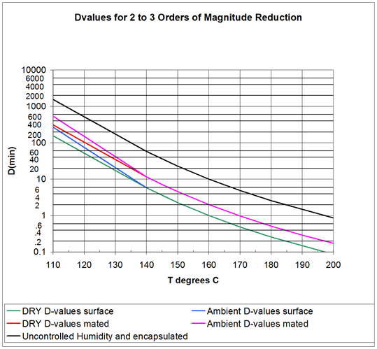
              - : D-values for 2 to 3 orders of magnitude reduction
                - : D-values for 2 to 3 orders of magnitude reduction
Temperature | dry surface | ambient surface | dry mated | ambient mated | uncontrolled humidity (surface, mated) and encapsulated
T (°C) | D_{value} (min) | D_{value} (min) | D_{value} (min) | D_{value} (min) | D_{value} (min)
110 | 155,4 | 268,7 | 310,8 | 537,5 | 1533,8
111 | 139,2 | 236,5 | 278,5 | 473,0 | 1392,5
112 | 124,8 | 208,1 | 249,6 | 416,2 | 1247,9
113 | 111,8 | 183,1 | 223,7 | 366,2 | 1118,3
114 | 100,2 | 161,1 | 200,4 | 322,2 | 1002,1
115 | 89,8 | 141,8 | 179,6 | 283,5 | 898,1
116 | 80,5 | 124,7 | 161,0 | 249,5 | 804,8
117 | 72,1 | 109,8 | 144,2 | 219,5 | 721,2
118 | 64,6 | 96,6 | 129,3 | 193,2 | 646,3
119 | 57,9 | 85,0 | 115,8 | 170,0 | 579,2
120 | 51,9 | 74,8 | 103,8 | 149,6 | 519,1
121 | 46,5 | 65,8 | 93,0 | 131,6 | 465,2
122 | 41,7 | 57,9 | 83,4 | 115,8 | 416,8
123 | 37,4 | 50,9 | 74,7 | 101,9 | 373,6
124 | 33,5 | 44,8 | 67,0 | 89,7 | 334,8
125 | 30,0 | 39,4 | 60,0 | 78,9 | 300,0
130 | 17,3 | 20,8 | 34,7 | 41,6 | 173,4
135 | 10,0 | 11,0 | 20,0 | 22,0 | 100,2
140 | 5,8 | 5,8 | 11,6 | 11,6 | 57,9
145 | 3,6 | 3,6 | 7,1 | 7,1 | 35,7
150 | 2,3 | 3,6 | 4,5 | 4,5 | 22,7
160 | 1,0 | 1,0 | 2,0 | 2,0 | 10,0
170 | 0,5 | 0,5 | 1,0 | 1,0 | 4,88
180 | 0,26 | 0,26 | 0,5 | 0,5 | 2,57
190 | 0,14 | 0,14 | 0,3 | 0,3 | 1,45
200 | 0,09 | 0,09 | 0,2 | 0,2 | 0,86

- (informative)
Effective D-values for 4 to 6 orders of magnitude reduction
E.1.1Figure E-1 and Table E-1 and are graphical and tabular representations of equations [5-4] and [5-5].
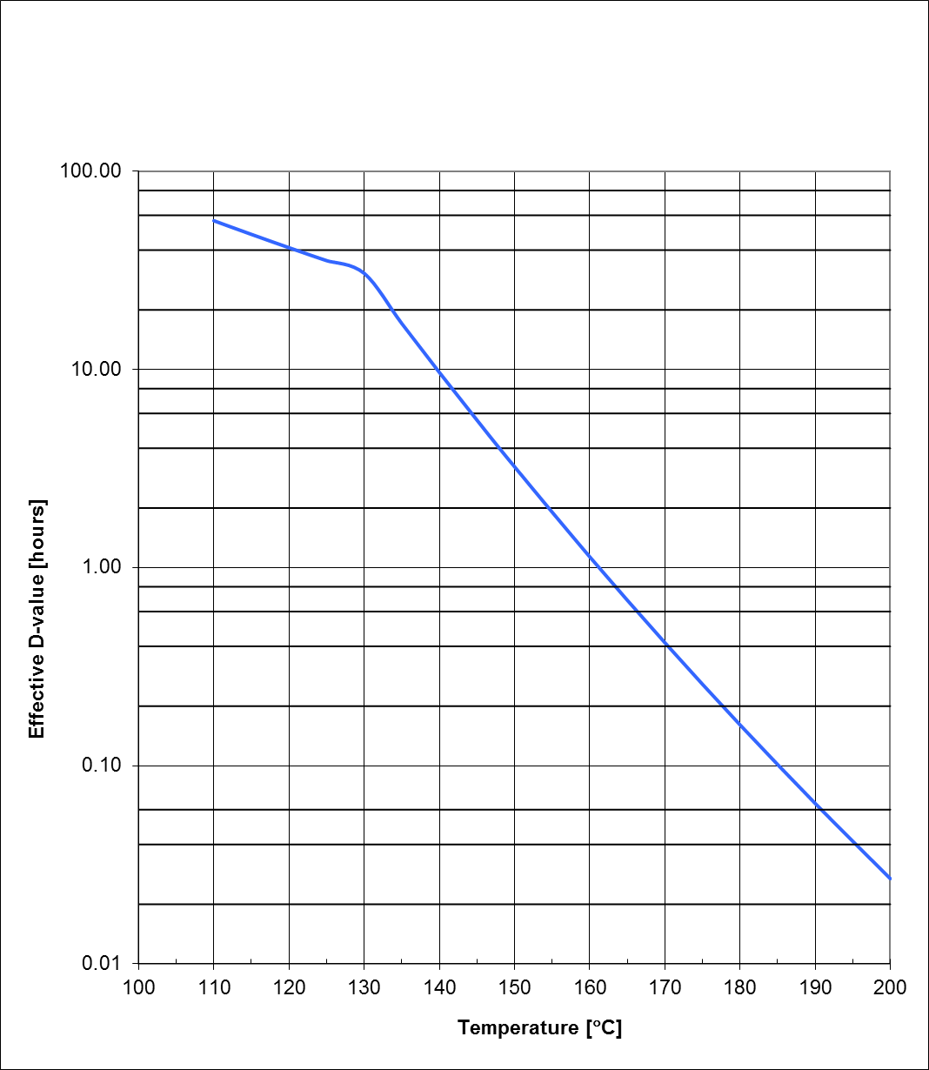
              - : Effective D-values for 4 to 6 orders of magnitude surface reduction
                - : Effective D-values for 4 to 6 orders of magnitude surface reduction
Temperature T (°C) | Effective D_{value} (hours)
110 | 56,4
111 | 54,6
112 | 52,9
113 | 51,2
114 | 49,6
115 | 48,1
116 | 46,6
117 | 45,2
118 | 43,8
119 | 42,5
120 | 41,2
121 | 40,0
122 | 38,8
123 | 37,6
124 | 36,5
125 | 35,4
130 | 30,6
135 | 17,1
140 | 9,7
145 | 5,6
150 | 3,2
160 | 1,1
170 | 0,42
180 | 0,16
190 | 0,065
200 | 0,027

Bibliography
ECSS-S-ST-00 | ECSS system - Description, implementation and general requirements
ESSB-ST-U-001 Issue 1 | ESA planetary protection requirements
ISO 11138:2006 | Sterilization of health care products - Biological indicator systems
ISO 20857:2010 | Sterilization of health care products - Dry heat - Requirements for the development, validation and routine control of a sterilization process for medical devices

