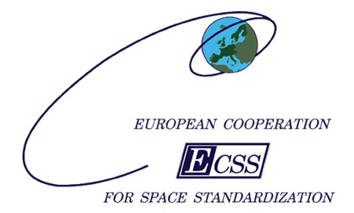
Space product assurance
ECSS Secretariat
ESA-ESTEC
Requirements & Standards Division
Noordwijk, The Netherlands

Kinetic outgassing of materials for space

Foreword
This document is one of the series of ECSS Technical Memoranda. Its Technical Memorandum status indicates that it is a non-normative document providing useful information to the space systems developers’ community on a specific subject. It is made available to record and present non-normative data, which are not relevant for a Standard or a Handbook. Note that these data are non-normative even if expressed in the language normally used for requirements.
Therefore, a Technical Memorandum is not considered by ECSS as suitable for direct use in Invitation To Tender (ITT) or business agreements for space systems development.

Disclaimer
ECSS does not provide any warranty whatsoever, whether expressed, implied, or statutory, including, but not limited to, any warranty of merchantability or fitness for a particular purpose or any warranty that the contents of the item are error-free. In no respect shall ECSS incur any liability for any damages, including, but not limited to, direct, indirect, special, or consequential damages arising out of, resulting from, or in any way connected to the use of this document, whether or not based upon warranty, business agreement, tort, or otherwise; whether or not injury was sustained by persons or property or otherwise; and whether or not loss was sustained from, or arose out of, the results of, the item, or any services that may be provided by ECSS.
Published by: ESA Requirements and Standards Division
ESTEC, P.O. Box 299,
2200 AG Noordwijk
The Netherlands
Copyright: 2011 © by the European Space Agency for the members of ECSS
Change log
ECSS-Q-TM-70-52A  25 Novenber 2011 | First issue

Table of contents
Change log 3
1 Scope 7
2 References 8
3 Terms, definitions and abbreviated terms 9
3.1 Terms from other documents 9
3.2 Terms specific to the present document 9
3.3 Abbreviated terms 10
4 The physics and its modelling 11
4.1 Outgassing 11
4.1.1 Overview 11
4.1.2 Desorption 11
4.1.3 Evaporation 12
4.1.4 Diffusion 12
4.2 Transport 12
4.3 Sticking/condensation 12
4.4 Re-emission 13
5 Test methods available in Europe 14
5.1 Material samples 14
5.1.1 Identification of materials 14
5.1.2 Sampling 14
5.1.3 Cleaning 16
5.1.4 Handling and storage 16
5.2 The CNES test method 17
5.2.1 Introduction 17
5.2.2 Facilities and equipment 17
5.2.3 Test method 18
5.2.4 Test protocol 19
5.2.5 Measurements / Data processing 20
5.3 The ESTEC test method 21
5.3.1 Introduction 21
5.3.2 Test facilities and equipment 22
5.3.3 Test methods 25
5.3.4 Test protocols 26
5.3.5 Measurements/Data processing 28
6 The ASTM test method 30
7 Extraction methods for model parameters 31
7.1 Introduction 31
7.2 Outgassing (no condensation / re-emission) 31
7.2.1 The CNES method 31
7.2.2 The ESTEC method 34
7.3 Ougassing and condensation (methods used during COMOVA development) 36
7.3.1 Outgassing model in use 36
7.3.2 Condensation model in use 37
7.3.3 Parameter extraction 37
7.3.4 Re-emission: a crude approach 38
7.4 Outgassing, condensation and re-emission (COMPEX, non linear methods) 38
8 The European modelling tools 40
8.1 COMOVA 40
8.1.1 Used equations 40
8.1.2 Input and output parameters 40
8.2 SYSTEMA 41
8.2.1 Overview 41
8.2.2 Used equations 41
8.2.3 Input and output parameters 41
Annex A Materials identification card (MIC) - DRD 43
A.1 DRD identification 43
A.1.1 Requirement identification and source document 43
A.1.2 Purpose and objective 43
A.2 Expected response 43
A.2.1 Scope and content 43
A.2.2 Special remarks 44

Figures
Figure 5-1: Example of shaping of various samples depending on their nature and associated cups 16
Figure 5-2: Overview of vacuum chamber and electronic controlling equipment 17
Figure 5-3: Overview of SARTORIUS balance and technical characteristics 18
Figure 5-4: Outgassing tests for HYSOL EA 9321 20
Figure 5-5: VBQC system schematic 22
Figure 5-6: VBQC2 and VBQC3 characteristics 23
Figure 5-7: DOK schematic 24
Figure 5-8: DOK characteristics 24
Figure 7-1: Example of compared test results and simulated results (material HYSOL EA 9321) 33
Figure 7-2: Simulation of isotherms (material HYSOL EA 9321) 33
Figure 7-3: Long-term prediction curves 36
Figure A-1 : Example of filled MIC (figures in the filled fields are examples only and shall not be considered as reference) 45

Tables
Table 5-1: Mass measurements 21
Table 7-1: LP/VB5E software characteristics 32
Table 7-2: basic equations used in LP/VB5E software 32

Scope
This Technical Memorandum defines the state of the art test methods and related modelling for evaluating the long term outgassing characteristics of materials.
The methods that are currently used for temporal and temperature variant sources and collectors are the ESTEC test method, the CNES test method and the ASTM E1559 standard long term outgassing method. These allow accurate temporal profiling of the outgassing and in addition, with the aid of modelling software, in-orbit predictions of emissions, transport and depositions.

References

ECSS‐ST‐S‐00‐01 | ECSS system - Glossary of terms
ECSS-Q-ST-70-02 | Space product assurance - Thermal vacuum outgassing test for the screening of space materials
ASTM E1559-09 | Standard Test Method for Contamination Outgassing Characteristics of Spacecraft Materials
 | "Progress on the Physical Approach to Molecular Contamination Modeling", Journal of Spacecraft and Rockets, 2011 vol. 48 no. 2 (Jean-François Roussel et al.)

Terms, definitions and abbreviated terms

Terms from other documents
For the purpose of this document, the terms and definitions from ECSS-S-ST-00-01 apply.

Terms specific to the present document
- Collected Volatile Condensable Material (CVCM)
quantity of outgassed matter from a test specimen that condenses on a surface maintained at a specific constant temperature, as a function of the outgassing test time
1 CVCM is expressed as a percentage of the initial specimen mass.
2 This is not necessarily the same as the CVCM determined by ECSS-Q-ST-70-02.
- Knudsen cell
container with a cylindrical orifice in which a material sample is placed and heated to the testing temperature(s)
1 The Knudsen cell has a cylindrical orifice from which the evolving gases exit in a controlled way. Sizes of the Knudsen cell, including the orifice, are specified to allow free molecular flow of the evolving gases and to allow predicting the molecular flux from the orifice.
2 Also known as Effusion cell
- Quartz Crystal Microbalance (QCM) ThermoGravimetric Analysis (TGA)
technique in which a QCM is heated at a constant rate and the (remaining) deposited mass is recorded as a function of time and temperature
The aim is to determine the evaporation characteristics of the species in the deposit.
- Recovered Mass Loss (RML)
total mass of material outgassed from a test specimen that is maintained at specified temperature(s) and operating pressure, as a function of the outgassing test time, without the absorbed water
1 RML is expressed as a percentage of the initial specimen mass.
2 This is not necessarily the same as the RML determined by ECSS-Q-ST-70-02.
- Total Mass Loss (TML)
total mass of material outgassed from a test specimen that is maintained at specified temperature(s) and operating pressure, as a function of the outgassing test time
1 TML is expressed as a percentage of the initial specimen mass.
2 This is not necessarily the same as the TML determined by ECSS-Q-ST-70-02.

Abbreviated terms
For the purpose of this document, the abbreviated terms from ECSS-S-ST-00-01 and the following apply:

Abbreviation | Meaning
COMPEX | contamination model parameter extractor
CVCM | collected volatile condensable material
DOK | dynamic outgassing Knudsen cell
FTIR | Fourier transform infrared spectroscopy
GC/MS | gas chromatography / mass spectrometry
GN₂ | gaseous nitrogen
IPA | isopropyl alcohol
MIC | materials identification card
MSE | mean squared error
QCM | quartz crystal microbalance
RGA | residual gas analyser
RH | relative humidity
RML | recovered mass loss
TGA | thermogravimetric analysis
TML | total mass loss
VBQC | vacuum balance quartz crystal
WVR | water vapour regained

The physics and its modelling

Outgassing

Overview
Outgassing is the release into vacuum of molecules that were trapped on or in a material. Several types of mechanisms can lead to outgassing, covered by clauses 3.4.2 to 3.4.4.

Desorption
Desorption is the release into vacuum of molecules that were adsorbed on top of a materials. Molecules are initially linked to the material by weak forces (physisorption) or stronger forces (chemisorption). The random thermal movements of a molecule may allow it to leave the resulting potential wall to vacuum.
As a consequence desorption is considered to follow a first order law:
$$\frac{{\text{dm}}^{α}}{\text{dt}}=−\frac{m^{α}}{τ_{d}^{α}(T)}$$ | [4-1]
with ${{\text{dm}}^{α}}/{\text{dt}}$ : weight loss per surface unit of species α (g.cm⁻²·s⁻¹)
$m^{α}$ : contaminant α available mass per surface unit (g·cm⁻²)
$τ_{d}^{α}(T)$ : outgassing time constant of species α (s)
$T$ : temperature (K)
The desorption time constant is thermally activated (Arrhenius law):
$$τ_{d}^{α}(T)=τ_{d0}^{α} e^{{−E_{d}^{α}}/{\text{RT}}}$$ | [4-2]
with $E_{d}^{α}$ : desorption activation energy of species α on this material (kJ/mol)
$τ_{d0}^{α}$ : Arrhenius pre-exponential factor (s)
$R$ : the gas constant (0,00831 kJ/mol·K)
In practice these laws are only approximate since many phenomena can complicate things: several types of adsorption sites, interactions with other types of contaminants, etc.

Evaporation
Evaporation is the passage of contaminant from its condensed phase (liquid or solid) to gas phase. The contaminant is thus implicitly assumed to be present as a thick layer on top of the material (many monolayers). For a pure chemical compound evaporation follows zero-order Langmuir law:
$$\frac{{\text{dm}}_{\text{evap}}}{\text{dt}}=−0\text{.}\text{044}⋅\sqrt{\frac{M}{T}}P_{s}\left(T\right)$$ | [4-3]
with ${{\text{dm}}_{\text{evap}}}/{\text{dt}}$ : evaporation rate per surface unit (g·cm⁻²·s⁻¹)
$M$ : molar mass (g/mol)
$T$ : surface temperature (K)
$P_{s}(T)$ : vapour pressure (mbar), depends on temperature
The numerical coefficient 0,044 becomes 0,058 if P_{s} is in Torr, and its literal expression is (2πR)^{-1/2}. The vapour pressure varies with temperature following Clausius-Clapeyron law.

Diffusion
Contaminant molecules can be located deep inside a material. The random motion of these molecules within the material is called diffusion. Those reaching the vacuum exposed surface of the material can further be desorbed to vacuum.
In the simplest cases diffusion obeys Fick's law:
$$f(x)=D\frac{\text{dn} (x)}{\text{dx}}$$ | [4-4]
with $f$ : contaminant flux through the material (g·cm⁻²·s⁻¹)
$n$ : the contaminant concentration in the material (g/cm³)
$D$ : the diffusion coefficient (cm²/s)
$x$ : the depth coordinate throughout the material (cm)
The diffusion coefficient is in principle thermally activated (Arrhenius law). In more complex situations diffusion can also be non-fickian.

Transport
Outgassed molecules travel through vacuum or rarefied gas to reach other surfaces on which they can condensate. In space condition molecular mean free path is usually large (larger than the system) and this transport is mostly line of sight. It can thus involve reflection on surfaces and few collisions in gas phase. Describing transport more in detail is beyond the scope of this technical memorandum.

Sticking/condensation
At very short time scale a large fraction of molecules impinging a surface is thought to stick, at least very transiently (typically sub picosecond). Although this may not always be true, in particular for suprathermal velocities, short term sticking is often considered to be total (sticking coefficient = 1).
At longer time scale molecules can be re-emitted (desorption, evaporation). If the re-emission time remains small the sticking - re-emission can be considered as a reflection. As a consequence sticking at longer time scale is usually not considered as total. A sticking coefficient S, comprised between 0 and 1, describes the fraction of impinging molecules that remain condensed on the surface. There is no general agreement on its form.

Re-emission
Condensed molecules can be re-emitted to vacuum. Considering that condensed molecules remain on the material top surface re-emission should be described by desorption (sub monolayer deposit) or evaporation (thick deposit). In case of a mixture of contaminant, Raoult's law should be used to account for mixing effects (limited to an ideal mixture). If condensed molecules undergo diffusion through the material, diffusion should in principle also be taken into account.
In practice re-emission comes after outgassing and condensation and re-emission data are scarce. When non absent, the modelling of re-emission is thus usually limited to a simple law, like first order desorption law:
$${\left(\frac{{\text{dm}}^{α}}{\text{dt}}\right)}_{\text{re}−\text{emission}}=−\frac{m^{α}}{τ_{r}^{α}(T)}$$ | [4-5]
with ${{\text{dm}}^{α}}/{\text{dt}}$ : re-emission per surface unit of species α (g·cm⁻²·s⁻¹)
$m^{α}$ : deposited mass of contaminant α per surface unit (g·cm⁻²)
$τ_{r}^{α}(T)$ : re-emission time constant of species α (s)
$T$ : temperature (K)
Re-emission is thermally activated and $τ_{r}^{α}(T)$ follows an Arrhenius law.

Test methods available in Europe

Material samples

Identification of materials
          - Materials submitted for testing shall be accompanied by a completed material identification card in conformance with Annex A.
          - The MIC shall contain the information from the declared material list (DML), where the materials are described for a specific space project, or microVCM test results according to ECSS-Q-ST-70-02.
          - Dimensions and mass of the sample and, where applicable, of its holder and/or substrate shall be controlled, measured, and documented.
          - The sample mass should be measured with a microbalance with an accuracy of ±10 μg.
          - Fibre volume and inert filler composition shall be reported when used.
          - Identification markings shall not be applied to the sample, unless it is part of the manufacturing process.

Sampling

Preparation
          - If the material is made up of several components, the sample shall be prepared according to the process specification or manufacturer’s data.
          - The material sample shall be made according to the same process parameters as the relevant material to be applied for spacecraft use.
Examples of process parameters are curing and baking temperature, duration and pressure.
          - The following material amounts should be used:
            - mass for bulk material ≥ 30 g
            - surface for coatings, paints, thin films, adhesives, tapes ≥ A4 sheet
            - volume for foams ≥ 1000 cm³
The aim is to allow several tests to be performed (e.g. different tests or repetitions of tests).
          - The geometry of the material sample should be representative of its application geometry.
          - Potting materials and bulky adhesives shall be cast on a PTFE sheet so that a sample of a few millimetres thick can be separated from the PTFE after curing.
          - Samples of potting materials and bulky adhesives shall be cut into cubes or cylinders by using hollow punch.
Typical dimensions for cubes and cylinders:
- cubes: 25 mm x 25 mm, thickness : 2 mm
- cylinders: diameter 30 mm, thickness : 2 mm
          - Thin films, coatings with or without primers, adhesives and adhesive tapes should be applied to a degreased, dried aluminium foil of known thickness and cut into strips 10 mm wide and 25 mm in length.
          - In case of noncuring adhesives, the samples shall be applied between thin metal foils and prepared as per 1.1.1m.
          - When materials are prepared on a substrate that is non-metallic, a sample of that substrate shall be tested separately.
          - Materials where the smallest dimension is less that 1,5 mm, shall be cut into pieces of 10 mm long.
Example of such materials are wires, cables or sleeves.
          - Test materials containing metal parts should be tested without the metal parts.
Example of such materials are electrical wires or connectors.
          - If materials containing metal parts cannot be tested without the metal parts, the ratio of metal mass to total mass shall be stated.
          - When materials cannot be hung or placed directly in the test facility, typically liquids and greases, they shall be placed in a dedicated cup or container.
1 Examples of such cups or containers are shown in Figure 5-1.
2 The provision of an adequate cup is generally not a test’s customer responsibility.
Figure 5-1: Example of shaping of various samples depending on their nature and associated cups

Cleaning
          - The cleaning and any other treatment of the samples shall be the same as that applied to the flight hardware, which the sample is intended to represent, prior to integration into the spacecraft.
          - Material samples shall be tested as received without any further cleaning or treatment, unless otherwise specified by the customer.

Handling and storage
          - No contamination shall be introduced during the handling and storage process.
          - Samples shall only be handled by using tweezers and clean gloves (powder- and lint-free nylon, nitrile or latex).
Handling samples with the bare hands could cause false TML and CVCM results due to the oils from the human skin that are usually volatile and condensable.
          - Samples shall be stored in a controlled area, with an room temperature of (22 ± 3) °C and relative humidity of (55 ± 10) % RH.
          - Coated surfaces shall be shielded from contact by using polyethylene or polypropylene bags or sheets.
          - To avoid physical damage, the polyethylene or polypropylene-wrapped workpieces shall be packed in clean, dust- and lintfree material.
          - Limited-life materials shall be labelled with their shelf life and date of manufacture or date of delivery if date of manufacture is not known.

The CNES test method

Introduction
A dynamic outgassing test method has been developed at CNES to study the kinetics of outgassing of a sample under vacuum using the system called “SARTORIUS test bench”.
This system is based on the use of a vacuum microbalance in order to measure the total mass loss (TML) of the sample.
Several tests are generally performed : a multi-step temperature test where the sample temperature increases from 25 °C to 125 °C by step of 25 °C every 24 hours and three other ones with a time dependent temperature law between room temperature to 125 °C during 12, 18 and 30 hours.

Facilities and equipment
A photograph of the CNES equipment is shown in Figure 5-2.
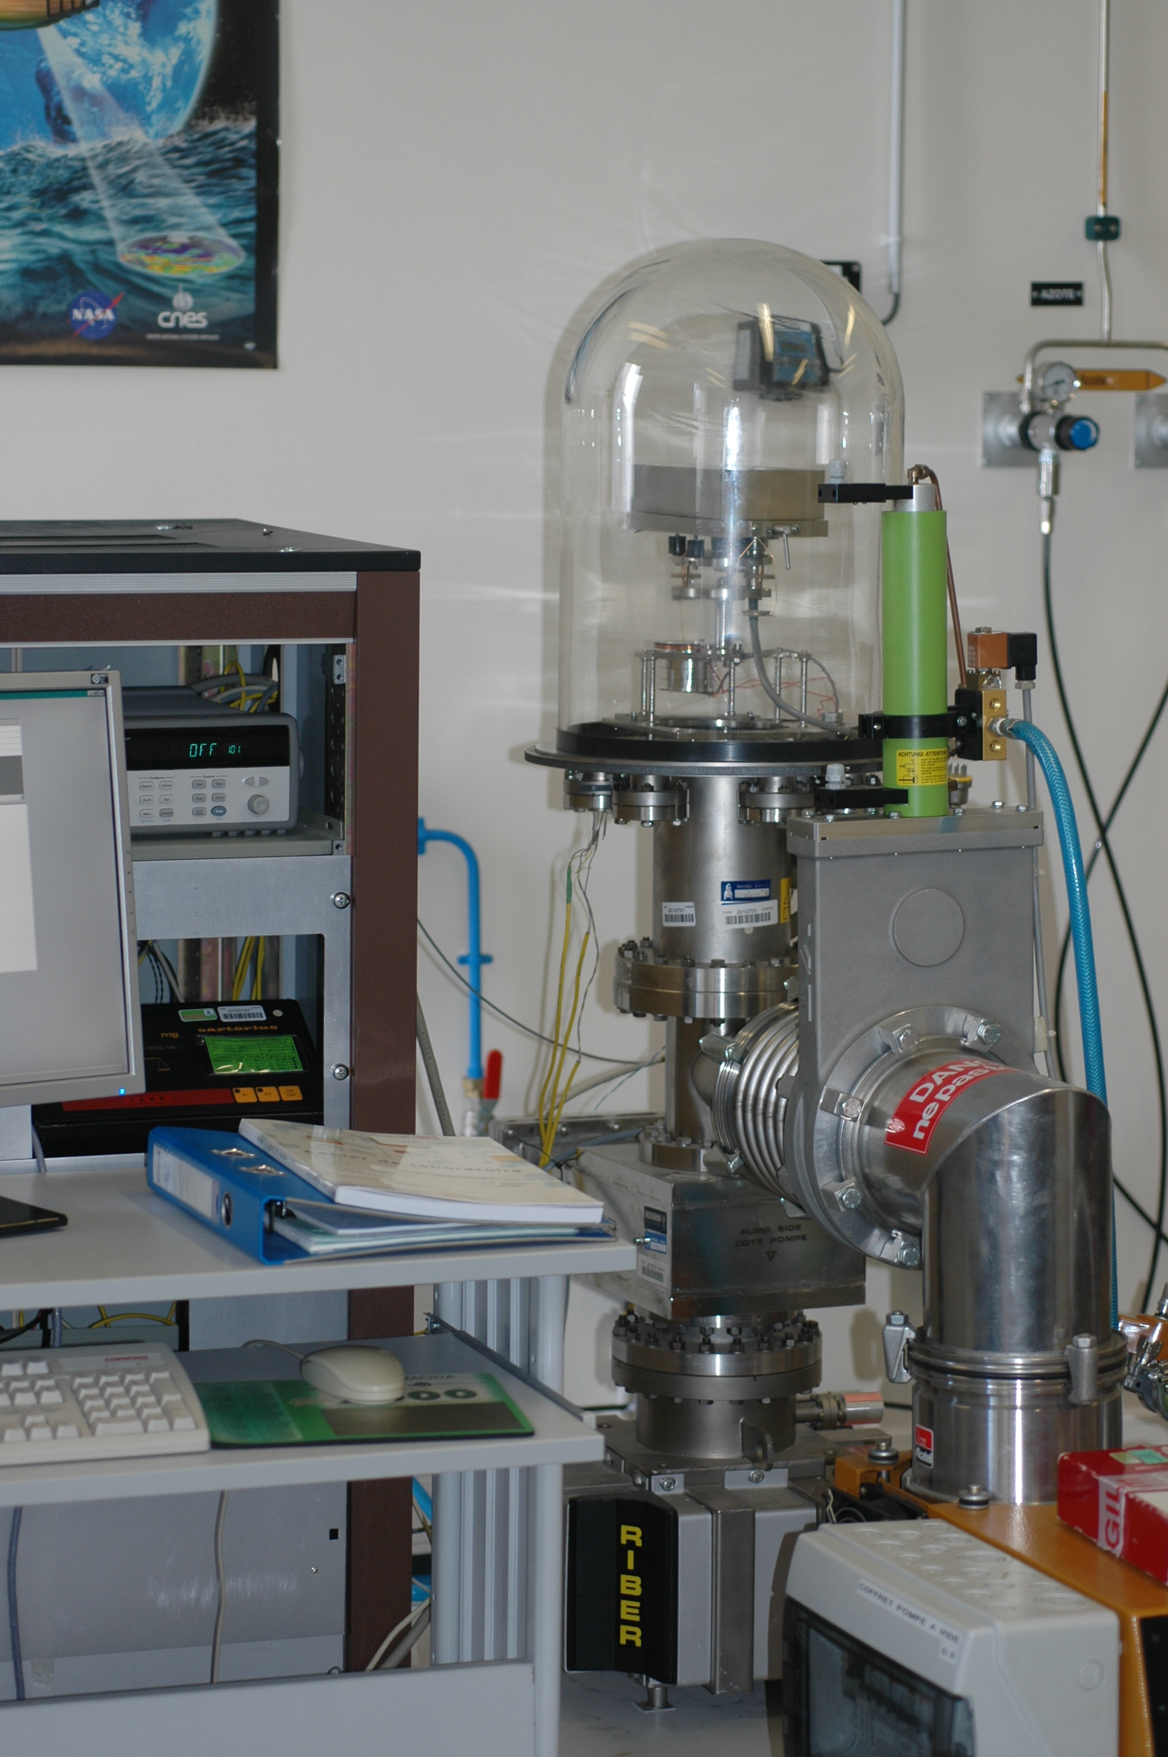
Figure 5-2: Overview of vacuum chamber and electronic controlling equipment
The apparatus can be described into three parts: a vacuum chamber, a pumping system and control and data acquisition systems. The SARTORIUS system characteristics are listed in Figure 5-3.
The vacuum chamber consists of a stainless steel frame with 8 ultra vacuum feedthroughs for interchange of measurement signals, a glass cover (∅: 30 cm ; H: 45 cm), a vacuum microbalance (see technical characteristics on Figure 5-3) and a cylindrical copper effusion cell with an integral heater. A K-type thermocouple monitors the effusion cell temperature from ambient to a maximum temperature of 150 °C. A K-type thermocouple measures the temperature of a reference sample inside the effusion cell.
The chamber is equipped with a backing pump, a turbo molecular pump and a cold cathode gauge (Penning vac transmitter) for pressure measurement so that the vacuum chamber provides a pressure lower than 10⁻⁴ Pa within one hour of pumping. A sputter-ion pump could be used for very long tests.
A high-vacuum gate valve is used to isolate the chamber and to maintain the sample under static vacuum.
A Residual Gas Analyser (RGA) could be used to follow the partial pressure of identified gases during the test.
An electrical cabinet consists of a stabilized power supply (for heater, transmitter electronics), a data acquisition system for pressure, temperature and mass measurements, the electronic parts of the vacuum microbalance, a temperature controller. A computer interfaced with the data acquisition system performs the acquisition scanning at different defined intervals and stores the data.
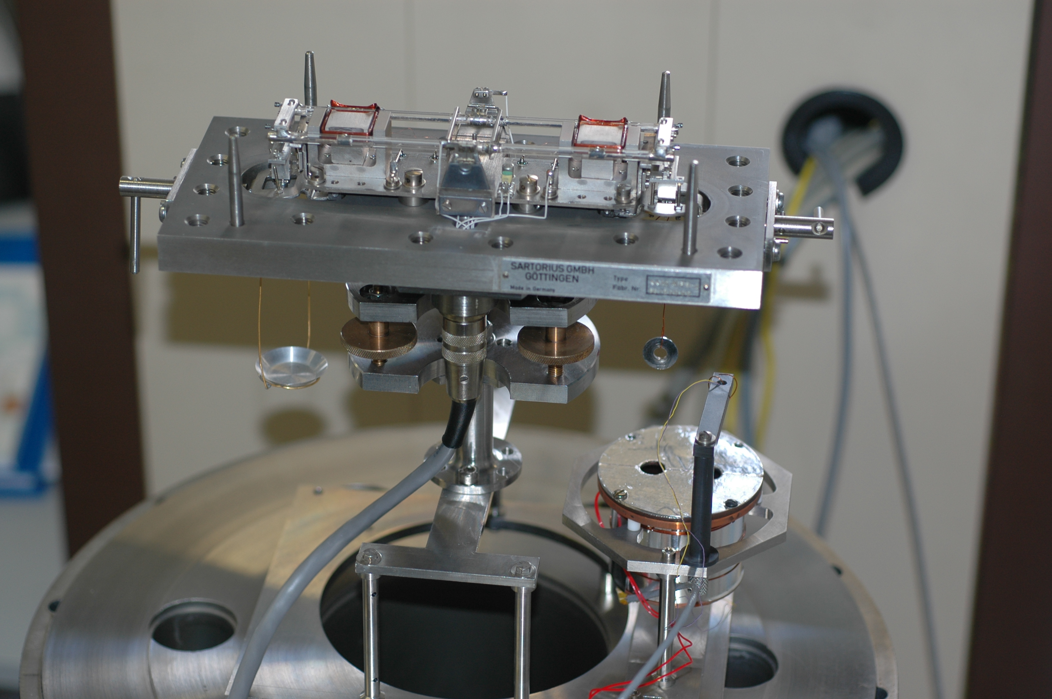 | Vacuum microbalance  SARTORIUS type 4410 MP8  Maximum loading mass : 25 g  Effusion cell  ∅ : 50 mm ; L : 45 mm  orifice : 10 mm
  range | I | II
  TML max (mg) | 1100 | 200
  Readability (µg) | 10 | 1
Figure 5-3: Overview of SARTORIUS balance and technical characteristics
Support equipment /materials are:
- analytical microbalance - typically SARTORIUS MC 21 S with a capacity of 21 g, a readability of 1 μg, and a linearity of 15 μg (to weigh the samples before and after test and conditioning)
- high purity, low NVR solvents (to clean the effusion cell and other hardware before test) Suitable reagent grade solvents include acetone, IPA, chloroform and ethanol.
- powder and lint-free gloves (nylon, nitrile or latex)
- micrometer (to measure sample dimensions)
- dry GN2 (99,9% pure or better) (to backfill the chamber)
- oven (e.g. for the conditioning of cups)

Test method
The test method uses the SARTORIUS test bench described in clause 4.2.2.
Depending on the nature and the shape of the sample, either the material or the cup is hung from the vacuum microbalance.
Four tests are necessary for the comparative outgassing study:
- three tests are based on a time dependent temperature law between room temperature to 125 °C during 12 h, 18 h and 30 h.
- another one is a multi-step temperature test where the sample temperature increases from 25 °C to 125 °C by step of 25°C every 24 hours.

Test protocol

Sample pre- and post-conditioning
Prior to any test, the sample is conditioned at (22 ± 3) °C and a relative humidity of (55 ± 10) % for at least 24 hours.
After the test, the sample is re-placed in the same conditioned environment in order to measure the recovered mass loss (RML).

Test execution
The main steps of the test method are:
- Bake the cups for a couple of hours at 100 °C in an oven
- Clean the test chamber components (effusion cell, specimen cups, screen…) with a compatible solvent
- Weigh the sample before its conditioning for 24 hours at (22 ± 3) °C and (55 ± 10) % RH with an external analytical microbalance located in the same room at the same ambient conditions
- Control the data acquisition system
- Switch on the vacuum microbalance
- Weigh the sample with the external microbalance after its conditioning
- Lock the vacuum microbalance and install the sample onto its hook
- Unlock the balance and select the correct range according to Figure 5-3
- Close the chamber
- Start the data acquisition system and control the first measured data at atmospheric conditions : temperature of the sample, of the effusion cell, mass
- Start pumping down
- Select and start the temperature program depending on the test (multi-step test or test with defined slope)
- After test exposure, stop pumping and the temperature program ; when the temperature of the effusion cell is at 25 °C, vent up the system to atmospheric pressure with GN₂
- Lock the balance and open the chamber
- Remove the sample and weigh it with the external microbalance
- Weigh the sample with the external microbalance after a new conditioning for 24 hours at (22 ± 3) °C and (55 ± 10) % RH
- Clean the test chamber components

Measurements / Data processing

Measurements
For each temperature program applied for the test method, the time evolution of the TML is measured with the vacuum microbalance (see Figure 5-4 with HYSOL EA 9321 as test material).
Figure 5-4: Outgassing tests for HYSOL EA 9321
At the end of each test, the sample is also weighted with an external analytical balance in order to compare the measurements.
After 24 hours of conditioning at (22 ± 3) °C and (55 ± 10) % RH, the RML is measured with the external balance and the WVR is deducted with respect to the following equations:
- TML [%]=100 × (m_{s}(i)-m_{s}(f))/ m_{s}(i)
- RML [%]=100 × (m_{s}(i)- m_{s}(c))/ m_{s}(i)
- WVR [%]=TML [%] - RML [%]
with m_{s}(i): initial mass of the sample (g)
m_{s}(f): mass of the sample at the end of the test (g)
m_{s}(c): mass of the sample at the end of the test, after 24 hours of conditioning (g)

Buoyancy correction
If the sample density is different from the counterbalance used for equilibrium, a buoyancy effect occurs during the depressurization and cause systematically a measurement error, as a change of the mass measurement. Its range is dependent on the density of the sample.
If a sample highly outgases at depressurization, the buoyancy effect may be offset by the mass loss of the sample itself and may not appear on the measurements.
To estimate the shift range and correct the results, it is necessary to reduce the interval of measurements during the beginning step and during the venting step in order to compare the mass loss measured with the vacuum balance (m₃ - m₀) to the mass loss measured with an external analytical balance (m_{f} - m_{i}) as described in Table 5-1. If the results are consistent, all the measurements are corrected taking into account the quasi-instantaneous mass shift at the end of the venting step.
Table 5-1: Mass measurements
External analytical balance | before test: initial mass (m_{i})
 | after test: final mass (m_{f})
 | total mass loss = m_{f} - m_{i}
Vacuum balance | initial mass after equilibrium at atmospheric pressure: m₀
mass at the beginning of depressurization: m₁
negative zero shift; positive mass loss
 | mass at the end of test: m₂
mass after venting with GN₂ (m₃)
positive zero shift; sample mass loss ≈ 0 at the end of the test
total mass loss = m₃ - m₀
mass shift = m₃ - m₂ (≥ m₁ - m₀)

Reporting of test data
Results are reported in a test report.

The ESTEC test method

Introduction
The test method defined at ESTEC to study the kinetics of the outgassing of a sample and of the deposition of the contaminants under vacuum utilizes systems called VBQC (Vacuum Balance Quartz Crystal) and DOK (Dynamic Outgassing Knudsen cell).
The systems are based on the use of QCMs (Quartz Crystal Microbalances) to measure the CVCM (Collected Volatile and Condensable Materials) coming from the sample, coupled with an other QCM (for the DOK system) or a vacuum balance (for the VBQC system) to measure the TML (Total Mass Loss) from the sample due to outgassing.
The standard test performed with these systems is a multi-step temperature test where the sample temperature is increased from 25 °C to 125 °C by step of 25 °C every 24 hours.

Test facilities and equipment

Overview
ESTEC uses 3 facilities to perform dynamic outgassing tests. These facilities are so called:
- VBQC2
- VBQC3
- DOK

VBQC2 and VBQC3
VBQC2 and VBQC3 are based on the same apparatus that consists of a vacuum chamber, a temperature control system, a vacuum microbalance, three QCMs and a data acquisition system. The schematic of the facility is shown in Figure 5-5.
The QCMs are used to measure the CVCM and the vacuum balance to measure the TML.
The VBQC system is equipped with a backing pump and a turbo pump and associated gauges (pirani and cold cathode gauges). The vacuum chamber provides a pressure lower than 5 · 10⁻⁴ Pa.
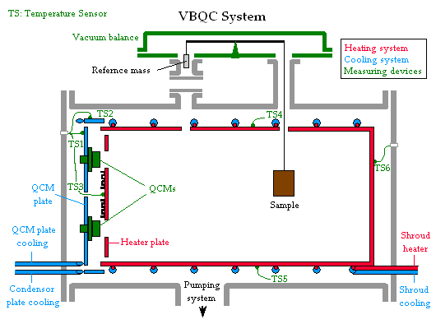
Figure 5-5: VBQC system schematic
The heating system is used to heat the sample by radiation. It is divided in two parts: the main shroud and the heater plate. In both parts the temperature is controlled and measured using temperature sensors (Pt100) associated with a controller device.
The cooling system is composed of the QCM plate on which the QCMs are mounted, the condenser plate (VBQC3 only) and the shroud cooling.
The QCM plate is used to cool down the QCMs using a cryostat bath. The condenser plate is used as contaminant trap, and is cooled down using a cryostat bath as well. The cooling shroud is normally not used but allows cooling down the sample to start at a lower temperature than room temperature.
The QCMs are built with Peltier or heater element inside which allows cooling down or heating up of the QCM relative to the temperature of the QCM plate.
The VBQC system characteristics are listed in Figure 5-6.

VBQC 2  Vacuum microbalance  SARTORIUS type 4433  Maximum loading mass: 2,54 g  3 QCMs  Mark 10 Thermoelectric Quartz Crystal Microbalance (MK10 TQCMTM), 15 MHz crystal. Each QCM contains two crystals (one for mass collection and one for reference), the oscillator electronics, and a temperature sensor (Pt100).  Sensitivity: 1,96 · 10⁻⁹ g/Hz · cm²  Peltier element built inside | VBQC 3  Vacuum microbalance  SARTORIUS type M 25D-V  Maximum loading mass: 28 g  3 QCMs  Mark 10 Thermoelectric Quartz Crystal Microbalance (MK10 TQCMTM), 15 MHz crystal. Each QCM contains two crystals (one for mass collection and one for reference), the oscillator electronics, and a temperature sensor (Pt100).  Sensitivity: 1,96 · 10⁻⁹ g/Hz · cm²  Peltier element built inside
  range | I | II | III
  TML max (mg) | 280 | 28 | 2.8
  Readability (µg) | 10 | 1 | 0,1
  Range | I | II
  TML max (mg) | 1100 | 200
  Readability (µg) | 10 | 1
Figure 5-6: VBQC2 and VBQC3 characteristics
A computer interfaced (via RS232) with a data acquisition control unit performs the acquisition scanning at the desired interval. The computer also controls the sample temperature changes.

DOK
The DOK (Dynamic Outgassing Knudsen cell) facility has been designed according to ASTM E-1559 and consists of a vacuum chamber, a vacuum interlock chamber, a temperature control system, an effusion cell (Knudsen cell), four Quartz Crystal Microbalances (QCM’s), a Residual Gas Analysis (RGA) and a data acquisition system.
Three QCMs are used to measure the CVCM. A fourth QCM, so called “cryoQCM” because it is maintained at cryogenic temperature, measures the TML.
Figure 5-7 shows a picture of the DOK apparatus. The main chamber is equipped with a backing pump and a turbo pump and associated gauges (pirani and cold cathode gauges). The main vacuum chamber provides a pressure in the range of 10⁻⁶ Pa.
A high-vacuum gate valve is used to isolate the main chamber from the interlock chamber and allows withdrawing and inserting the Knudsen cell into the main chamber without the loss of high vacuum in the main chamber. The interlock is equipped with a backing pump that allows reaching a primary vacuum.
Two QCMs are mounted at 20° and two at 10° with respect to the normal of the cell orifice, so that the active surface of any QCM cannot “see” the active surface of any other QCM. The QCM that is operating at cryogenic temperature for measuring the total outgassing rate is installed on a cryo plate cooled down via liquid Nitrogen. The other three QCMs are operating at defined temperatures for the measurement of the deposition of outgassing condensable. These are installed on a plate thermally decoupled from the QCM cryo plate and cooled down by a cryo-bath.
The shroud and the QCM cryo-plate are cooled down via liquid Nitrogen.
The Knudsen cell is cylindrical and has an integral heater capable of uniformly heating the cell itself up to 500 °C.
The RGA is used to identify the gases present in the vacuum during the execution of the test.
Three Pt100s monitor the temperature of the cryo-shroud, the QCM cryo-plate and the QCM cold plate. Three K-type thermocouples measure the Knudsen cell temperature in three different spots.
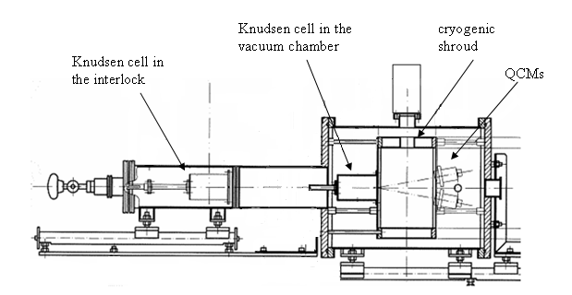
Figure 5-7: DOK schematic
The DOK system characteristics are listed in Figure 5-8.

DOK
Knudsen cell
Ø 60 x L 95 mm
Orifice: Ø 3 mm
Maximum loading mass: 500 g

4 QCMs
Mark 10 Thermoelectric Quartz Crystal Microbalance (MK10 TQCMTM), 15 MHz crystal. Each QCM contains two crystals (one for mass collection and one for reference), the oscillator electronics, and a temperature sensor (Pt100).
Sensitivity: 1,96 · 10⁻⁹ g/Hz · cm²
Peltier element built inside
Figure 5-8: DOK characteristics
A computer interfaced (via RS232) with a data acquisition control unit performs the acquisition scanning at the desired interval. The computer also controls the sample temperature changes.

Support equipment and materials
- Analytical microbalance - with a 200 g or greater tare, a readability of 10 μg or better is required for recording mass changes of the samples
- Oil-free aluminium foil - non-outgassing substrate/shielding material
- Gloves - powder- and lint-free nylon, nitrile or latex
- Micrometer - to measure sample dimensions
- Low NVR IPA and swabs (with a low NVR) - to clean QCM surfaces
- Dry GN₂ (99,9% pure or better) - to backfill the interlock chamber/main chamber.

Test methods

Overview
There are two dynamic outgassing test methods: the VBQC test method and the DOK test method.
At the end of a dynamic outgassing test thermogravimetric measurements are performed.

The VBQC test method
The VBQC test method uses the VBQC systems, described in clause 4.3.2. The sample is hanged from the vacuum microbalance and in line of sight of the QCMs. The size of the sample should not exceed 12x12 cm and the maximum loading mass, given in Figure 5-6. In order to obtain the highest accuracy, based on the mass of the sample (TML given in %) or on the surface of the sample (TML given in mg/cm2), it is recommended to have a sample close to the maximum size or mass. However a sample which is representative for the actual used hardware is recommended.
The VBQC test is a multi-step temperature test where the sample temperature is increased from 25 °C to 125 °C by step of 25 °C every 24 hours.
All QCMs are cooled using a cryostat bath and stabilized at -25 °C, -50 °C and -75 °C with Peltier elements. The test duration is 120 hours.
A blank test is run at the some conditions prior to the outgassing test in order to measure the facility background and subtract the chamber contribution to the sample data. During the blank preparation, the vacuum chamber is empty and handled as if a sample were to be hanged.

The DOK test method
The DOK test method uses the DOK system, described in clause 4.3.2. The sample is placed in the Knudsen cell via the interlock chamber and then introduced into the main chamber at a pre-defined distance and angle with respect to the QCM surfaces. The sample size and weight should not exceed the Knudsen cell specifications, given in Figure 5-8. In order to obtain the highest accuracy, based on the mass of the sample (TML given in %) or on the surface of the sample (TML given in mg/cm2), it is recommended to have a sample close to the maximum size or mass. However a sample which is representative for the actual used hardware is recommended.
The DOK test, like the VBQC one, is a multi-step temperature test where the sample temperature is increased from 25 °C to 125 °C by step of 25 °C every 24 hours.
Three QCMs are cooled using a cryostat bath and stabilized at -25 °C, -50 °C and -75 °C with Peltier elements. The fourth QCM is maintained at liquid Nitrogen temperature (-177 °C) for the measurements of the TML. The shroud is maintained at -175 °C.
The test duration is 120 hours.
A blank test is run at the same conditions prior to the outgassing test in order to measure the facility background and subtract the chamber contribution to the sample data. During the blank preparation, the effusion cell is empty and handled as if a sample were to be loaded.

QCM TGA measurements
QCM TGA measurements are performed at the end of the outgassing test in order to retrieve additional information on the composition of the outgassed/condensed contaminants. It consists in the evaporation from the surface of each QCM, one by one at a specific rate and starting from the coldest one, of deposited contaminants.

Test protocols

Sample pre- and post-conditioning
Prior to any test, the sample is conditioned at (22 ± 3) °C and a relative humidity of (55 ± 10) % for at least 24 hours.
After the test, the sample is re-placed in the same conditioned environment in order to measure the recovered mass loss (RML).

Test execution

VBQC test method
The main steps of the VBQC test methods are:
- Clean the test chamber components before assembly
- Weigh the sample, previously conditioned at (22 ± 3) °C and (55 ± 10) % RH for at least 24 hours, according to 4.3.4.1, with an external analytical balance
- Install Al foil for subsequent FTIR and/or GC/MS analyses
- Lock the vacuum microbalance and install the sample onto its hook
- Unlock the vacuum microbalance and select the correct range according with Figure 5-6
- Close the VBQC facility
- Connect the QCM and temperature cables
- Connect the cooling bath to the QCM plate
- Start the data acquisition program: the sample temperature is controlled by the computer according to the following: 24 h @ 25 °C, 24 h @ 50 °C, 24 h @ 75 °C, 24 h @ 100 °C, 24 h @ 125 °C, i.e. 120 hours in total
- Measure the first data point at atmospheric conditions
- Start pumping down
- When pressure is in the range of 1·10⁻² Pa, start cooling the cryobath to -80 °C
- Start cooling the QCMs at 1°C/min to -25 °C, -50 °C, -75 °C respectively
- After 120 hours of dynamic outgassing test, the program will set the sample temperature to 20 °C
- When the sample temperature is at 40°C, start TGA of QCMs at 1°C/min:
            - first from -75 °C to 80 °C,
            - second from -50 °C to 80 °C, and
            - finally from -25 °C to 80 °C
- At the end of QCM TGAs set QCMs to 20 °C at 7 °C/min
- When the QCMs are at 20 °C, stop pumping and venting with GN₂
- When chamber is re-pressurised, set cooling bath to +20 °C
- When the cooling bath is at 20 °C, lock the balance and open the VBQC facility
- Remove the sample and weigh it with an external analytical balance
- Place the sample into an environmentally controlled cabinet with (22 ± 3) °C and (55 ± 10) % RH, according to 4.3.4.1
- Remove the Al foil and store it into clean container for GC/MS and/or FTIR analyses
- Take a rinse of the QCM plate with IPA and collect it into a clean petri-dish for FTIR analysis
- Perform a cleaning of the facility

DOK test method
The main steps of the DOK test methods are:
- Clean the test chamber components before assembly
- Install Al foil for subsequent FTIR and/or GC/MS analyses
- Start pumping down
- When the pressure is in the range of 1 · 10⁻² Pa, set the cooling bath to -40 °C
- When the cooling bath is at -40 °C, set the shroud to -175 °C
- When the shroud is at -175 °C, set the cryoQCM plate to -177 °C
- Set the QCMs’ temperatures to -25 °C, -50 °C, -75 °C at 7 °C/min
- Weigh the sample, previously conditioned at (22 ± 3) °C and (55 ± 10) % RH for at least 24h, according to 4.3.4.1, with an external analytical microbalance
- Vent the interlock chamber with clean, dry GN₂
- Open the load port of the interlock chamber and open the effusion cell; continue to purge the interlock chamber with GN₂
- Place the test sample in the effusion cell and close it
- Start the data acquisition program and verify that the QCMs and the data acquisition system are operating properly. The sample temperature is controlled by the computer according to the following: 24 h @ 25 °C, 24 h @ 50 °C, 24 h @ 75 °C, 24 h @ 100 °C, 24 h @ 125 °C, i.e. 120 hours in total
- Move the effusion cell into the main chamber
- After 120 hours of dynamic outgassing test, the program will set the temperature of the effusion cell to 20 °C
- Move the effusion cell to the interlock chamber
- Backfill the interlock chamber with clean, dry GN₂
- Remove the sample and weigh it with an external analytical balance
- Place the sample into an environmentally controlled cabinet with (22 ± 3) °C and (55 ± 10) % RH, according to 4.3.4.1
- start TGA of QCMs at 1°C/min:
            - first from -75 °C to 80 °C,
            - second from -50 °C to 80 °C, and
            - finally from -25 °C to 80 °C

Facility and hardware cleaning
          - The work area shall be air filtered and clean from dust as achieved with normal house-keeping.
          - All vacuum systems shall be cleaned in accordance with good vacuum practices before assembly.
          - The facility shall be cleaned by wiping the internal surfaces with acetone first and then IPA and by performing a dedicated vacuum bake-out using the internal shroud (when it is part of the system) and external heaters.
          - In case there is still residue on the QMC crystal after heating with the Peltier element only, the crystal should be physically cleaned using alcohol or hexane dipped Q-tip and brushing the crystal very lightly.
It can happen that the deposition of some contaminants onto the QCM crystal can result in an undesirable residue, which might be impossible to clean by vacuum bake-out using the Peltier element only.
          - Acetone shall never be used in the physical cleaning of the QCM crystal.

Reporting of test data
Results are reported in a test report.

Measurements/Data processing

VBQC test method
With the VBQC test method the time evolution of the TML is measured with the vacuum balance and compared with the measurements of the external analytic balance. The RML and WVR are measured with the external analytic balance only.
The following equations are used:
- TML[%] = 100 × (m_{s}(i)-m_{s}(f))/ m_{s}(i)
- RML[%] = 100 × (m_{s}(i)- m_{s}(c))/ m_{s}(i)
- WVR[%] = TML[%] - RML[%]
with m_{s}(i): initial mass of the sample (g)
m_{s}(f): mass of the sample at the end of the test (g)
m_{s}(c): mass of the sample at the end of the test, after 24 hours of conditioning (g)
The time evolution of the CVCMs is measured with the three QCMs and calculated with the following equation:
$$\text{CVCM} [\text{\%}]=\text{100}×\left[\frac{\text{VF}⋅K_{s}[f(T_{q},T_{s},t)−f(T_{q},T_{s},0)]}{m_{s}(i)}\right]$$
with VF: view factor of the QCM (cm²)
K_{s:} QCMs mass sensitivity factor (g·cm⁻²·Hz⁻¹)
f(T_{q},T_{s},t): QCM frequency at time t (Hz)
f(T_{q},T_{s},0): QCM frequency at time 0 (Hz)
m_{s}(i): initial mass of the sample (g)

DOK test method
With the DOK test method the time evolution of the TML is measured with the cryo-QCM and compared with the measurements of the external analytic balance. The RML and WVR are measured with the external analytic balance only and calculated according to the equations in paragraph 4.3.5.1.
The following equation is used for the calculation of the TML:

$$\text{TML} [\text{\%}]=\text{100}×\left[\frac{{\text{VF}}_{\text{cryo}}⋅K_{s}[f(T_{q},T_{s},t)−f(T_{q},T_{s},0)]}{m_{s}(i)}\right]$$
with VF_{cryo}: view factor of the cryo-QCM to the effusion cell orifice (cm²)
K_{s}: cryo-QCM mass sensitivity factor (g·cm^{-2·}Hz⁻¹)
f(T_{q},T_{s},t): cryo-QCM frequency at time t (Hz)
f(T_{q},T_{s},0): cryo-QCM frequency at time 0 (Hz)
m_{s}(i): initial mass of the sample (g)
The time evolution of the CVCMs is measured with the three (non cryogenic) QCMs and calculated as for the VBQC method, see paragraph 4.3.5.1.

Corrections
All mass measurements are corrected for drift, in the case of the balance, and by subtracting the background measurements, in the case of QCMs; both balance drift and QCMs’ background measurements are taken during a blank test.
The mass values measured by the vacuum balance in the VBQC test method are also corrected for the buoyancy effect. The initial mass is considered to be the first value measured after depressurisation of the chamber, whilst the final mass is the last value before re-pressurisation.

The ASTM test method
The ASTM test method for dynamic outgassing is fully described in ASTM E1559-09, Standard Test Method for Contamination Outgassing Characteristics of Spacecraft Materials. In brief, the method consists in measuring on QCMs the deposition of contaminants originating from a sample material in an effusion cell. The temperatures of the outgassing material and of the QCMs are maintained constant over a few days. Different temperatures are tested for the emitter and the receiver. QCM TGA measurements are usually performed at the end of the test to obtain information on the volatility of the condensed contaminants.
Two test methods are defined, Test Method A, the standard procedure that uses prescribed configurations and temperatures, and Test Method B, allowing for the use of spacecraft system specific temperatures, configurations, and QCM collector surface finishes. The methods defined in this standard can be used to produce the data necessary to support mathematical models used for the prediction of molecular contaminant generation, migration, and deposition.
The approach provided by the ASTM standard for the contamination assessment for a space mission is a direct empirical approach based on test results. Worst case temperatures are selected in the datasets with respect to flight data, i.e. the next warmer temperature for the source and the next colder for the deposition surface. The corresponding experimental data, extending over a few days, are then mathematically extrapolated to many year missions, through some power law or logarithmic law.

Extraction methods for model parameters

Introduction
The physical equations of clause 4 have many parameters, specific to each species and material. Contrarily to most aspects of transport, the determination of these parameters for outgassing, deposition and re-emission necessarily relies on experiments.
Historically the first tests were focussed on outgassing. Fitting TML curves by outgassing laws led to optimal outgassing parameters. Outgassing was usually modelled through the desorption of about six pseudo-species (cf. clause 6.2). In numerical tools sticking was often supposed perfect (as e.g. in Outgassing, clause 7.2) while re-emission parameters were rather arbitrarily derived from outgassing ones.
When dynamical CVCM data became available, the characterisation of condensation was made possible. Clause 6.3 reports how outgassing and condensation parameters were extracted from CVCM curves for COMOVA code (clause 7.1) consistently with its governing equations. By lack of data re-emission remained crudely assessed.
Finally the emergence of re-emission data, typically through TGAs, shall lead to a very significant improvement, both of the re-emission modelling and of the species separation. The state of the art of this new approach is briefly sketched in clause 6.4.

Outgassing (no condensation / re-emission)

The CNES method
A method has been defined at CNES to determine, for a given material, a coherent set of outgassing kinetic coefficients from different tests results. A software called LP/VB5E has been developed and is used for the extraction of the outgassing parameters and the simulation of different isothermal outgassing kinetics. Its characteristics and inputs and outputs are described in Table 7-2. Globally, these results allow analysing the outgassing behaviour of a material under vacuum and different thermal constraints and durations and predicting the effect of a pre-treatment.
Table 7-2: LP/VB5E software characteristics
environment | Windows
language | Visual Basic 5
inputs | Post-processed test results  time (s) ; mass loss (%) ; sample temperature (K)
outputs | - Coefficients ( µ, E, A, τ )_{1 to 5}  - 2D graphs :  TML vs. time  TML_{expo (i)} vs. time  - 3D graphs :  TML vs. (temperature, time)
The LP/VB5E software consists of three parts: computation, simulation and database.
The ‘computation part’, based on different hypotheses (first order desorption law, consideration of 5 outgassed chemical species with decreasing volatility, linear temperature slope), enables to find the coefficients (µ, E, A)_{1 to 5} from the multi-step test (see Figure 7-9) according to the basic equations of the Table 7-3. These coefficients are adjusted to minimise the mean squared error (MSE) of the other test results (‘test 12 h’, ‘test 18 h’, ‘test 30 h’). Then the results are synthesised to extract the mean coefficients with their uncertainties.
The ‘simulation part’ enables to simulate outgassing graphs for a given material (see Figure 7-10) using either CNES inputs (coefficients (µ, E, A)_{1 to 5}) or ESABASE/outgassing software inputs (coefficients (µ, E, τ)_{1 to 5}) with different temperature profiles (e.g. isothermal, multi-step or slope profiles). The simulated tests can be compared to the real tests.
All the results are stored in a database in such a format to be re-used for other computation.
Table 7-3: basic equations used in LP/VB5E software
mass equation for a chemical species i | $$\frac{{\text{dµ}}_{i(t)}}{\text{dt}}=k_{i_{(t)}}(µ_{i}−µ_{i(t)}) \text{initial}\text{} \text{conditions} µ_{i(t_{0})}=0$$
Arrhenius law | $$k_{i(t)}=A_{i}e^{−E_{i}{\text{RT}}_{(t)}}$$
time constant at reference temperature | τ_{i(t) =} 1/ k_{i(t)}
solution of the mass equation for n chemical species | $$µ_{(t)}=\sum_{i=1}^{n}{ \int_{t_{0}}^{t}{(µ_{i}−µ_{i(t)})\text{.}(1−e^{k_{i(t)}\text{dt}})}}$$
with i : index of species
n: number of chemical species
µ(t): outgassed total mass (%)
µ_{i} : initial mass that could be potentially outgassed (%)
µ_{i}(t) : outgassed mass at time t (%)
k_{i}(t) : rate constant at time t (s⁻¹)
τ_{i} : outgassing time constant at reference temperature (s)
A_{i} : pre factor (s⁻¹)
E_{i} : activation energy (cal·mol⁻¹)
R : gas constant (R= 1,986 cal·mol⁻¹·K⁻¹)
T : temperature (K)
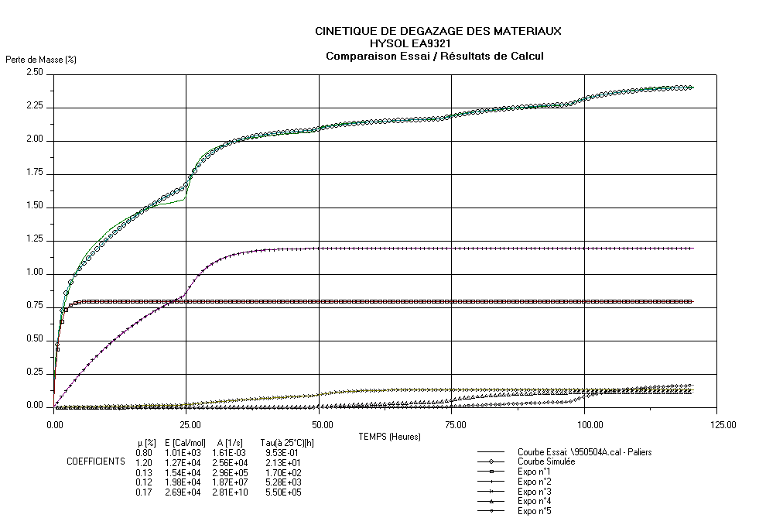
Figure 7-9: Example of compared test results and simulated results (material HYSOL EA 9321)
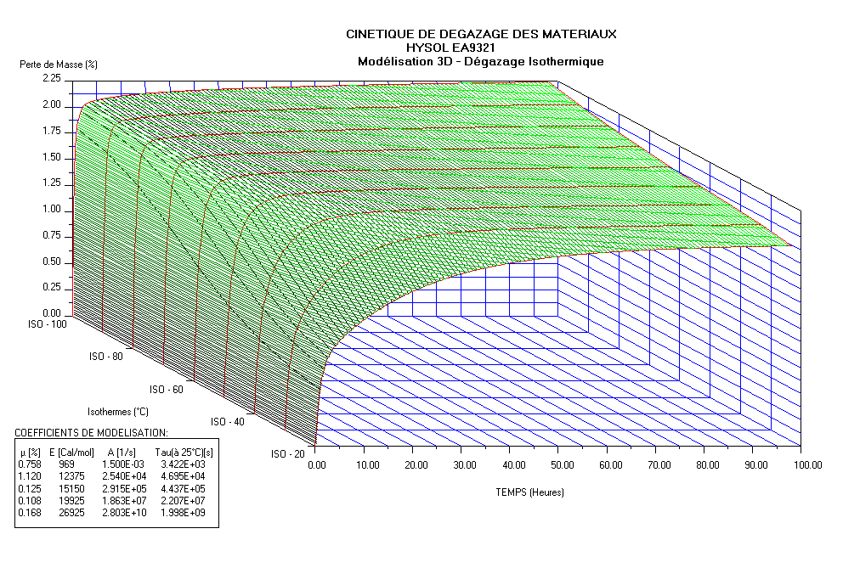
Figure 7-10: Simulation of isotherms (material HYSOL EA 9321)

The ESTEC method

Introduction
In the past years, the mathematical treatment of data obtained from dynamic outgassing tests was performed through different Microsoft® Excel worksheets. The execution of the complete sequence required rather lot of manual intervention guided by a work instruction procedure but also requiring subjective operator decisions.
To allow a more straightforward and standardized data treatment, minimizing the manual intervention and the risk behind subjective choices without however loosing the control of the process, a MATLAB® application has been recently developed and its major process steps are described in the following clauses.

The data input step
The input data file that contains measurement data for the complete test is loaded by the application and split into the single isothermal steps of the test. Mass losses are referred to the initial sample mass and TMLs over time are computed.

The data fitting step
The TML for each isothermal step is analysed by the software and data corresponding to temperature transients (at the beginning of each step) are systematically discarded. Remaining data are fitted with a sum of exponential equations of the form:
$$\text{TML}=\sum_{i}{m_{0,i}⋅(1−{\text{exp}}^{{−t}/{τ_{i}}})}$$ | [7-6]
with $m_{0,i}$ : the initial mass of species i contributing to the outgassing (g)
t : time (s)
$τ_{i}$ : outgassing time constant of species i (s)
Usually 6 chemical species, with decreasing volatility, are considered.

The calculation of acceleration factors and activations energies
For each temperature increase, an acceleration factor K_{a} is calculated by dividing the TML rate at the beginning of the new step and the TML rate at the end of the previous one.
According to the expression of the acceleration factor that is obtained combining equations [4-1] and [4-2] for two different temperatures:
$$k_{a}=\frac{{\left(\frac{\text{dm}}{\text{dt}}\right)}_{T_{2}}}{{\left(\frac{\text{dm}}{\text{dt}}\right)}_{T_{1}}}=e^{\frac{E_{a}}{R}⋅\left(\frac{T_{2}−T_{1}}{T_{1}⋅T_{2}}\right)}$$ | [7-7]
with $k_{a}$ : acceleration factor
$\frac{\text{dm}}{\text{dt}}$ : TML rate (g·s⁻¹)
T : temperature (K)
$E_{a}$ : ‘averaged’ (as for a single component composition) activation energy (kJ/mol)
R : the gas constant (0.00831 kJ/mol·K)
the activation energy E_{a}, for each temperature change, is calculated.

The long-term predictions step
For each isothermal step j, an accelerated time can be calculated from the acceleration factors by means of the following equation:
$$t_{\text{acc},T_{j}}=t_{T_{j}}+\sum_{k=j+1}^{n}{\left(t_{T_{k}}\prod_{m=j+1}^{k}{{\left(k_{a}\right)}_{T_{m},T_{m−1}}}\right)}$$ | [7-8]
with $t_{\text{acc},T_{j}}$ : accelerated time at temperature T_{j}
$t_{T_{j}}$ : actual time at temperature T_{j}
$t_{T_{k}}$ : actual time at temperature T_{k} for each step k that follows step j
n : total number of temperature steps
$k_{a}$ : acceleration factor
In the standard routine, the temperature of the first step (namely 25 °C) is defined as the reference temperature T_{ref} and an accelerated time is calculated for T_{ref} only. An accelerated isothermal TML at T_{ref} is then obtained by coupling the TML data actually measured all along the test and the accelerated time.
The new curve is fitted with a sum of exponential equations of the same form of equation [7-6] so that a new set of m_{0,i} and τ_{i} can be calculated for the long-term predictions at T_{ref}.
Finally, for each species i, time constants at different temperatures (typically the ones of the test) are calculated with the following formula:
$$τ_{T}=τ_{T_{\text{ref}}}⋅e^{−k_{e}⋅\left(T−T_{\text{ref}}\right)}$$ | [7-9]
that is based on the empirical law:
$$\text{ln}k_{a}=k_{e}⋅\left(T−T_{\text{ref}}\right)$$ | [7-10]
and long-term prediction curves are computed for the same set of temperatures, as shown in the example of Figure 7-11.
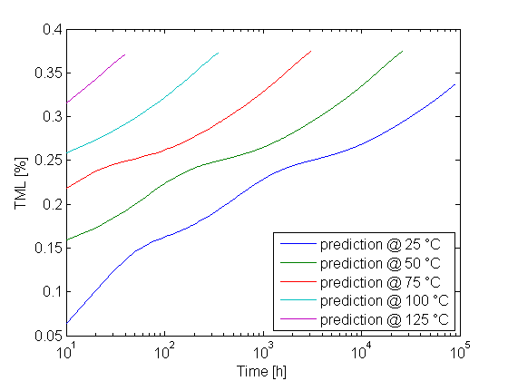
Figure 7-11: Long-term prediction curves

Ougassing and condensation (methods used during COMOVA development)

Outgassing model in use
Concerning outgassing, the model implemented in COMOVA followed the classical ESTEC approach. Parameter extraction of course had to use the same laws. Outgassing was modelled through the desorption law [4-1]. The temperature dependence of the desorption time constant was simplified wrt the Arrhenius law [4-2] into:
$$τ_{d}^{α}(T)=τ_{d0}^{α} e^{−k_{d}^{α}(T−T_{0})}$$ | [7-11]
with $T_{0}$ : reference temperature (K)
$τ_{d0}^{α}$ : outgassing time constant at reference temperature (s)
$k_{d}^{α}$ : empirical coefficient for temperature effects (K⁻¹)
At constant temperature, this yields an exponential decay of the remaining contaminant:
$$m(t,T)=\sum_{α}{m^{α}}(t,T)=\sum_{α}{m_{0}^{α}}e^{{−t}/{\left(τ_{d0}^{α} ⋅e^{−k_{d}^{α}⋅(T−T_{0})}\right)}}$$ | [7-12]
with $m(t,T)$ : total contaminant mass remaining in/on the material at time t after outgassing at temperature T (g·cm⁻²)
$m^{α}(t,T)$ : mass of species α remaining in/on the material at time t after outgassing at temperature T (g·cm⁻²)
$m_{0}^{α}$ : initial mass of contaminant species α in/on the material (g·cm⁻²)
Increasing the temperature simply results in a time acceleration by a factor exp($k_{d}^{α}$·ΔT), which may be uniform if all species have the same $k_{d}^{α}$, as it is commonly assumed in practice.

Condensation model in use
Concerning condensation, a sticking coefficient was defined as a function of temperature:
$$S^{α}(T)=\frac{1}{2}\left(1−\text{tanh}\left(\frac{T−T_{C}^{α}}{2{ΔT}_{C}^{α}}\right)\right)$$ | [7-13]
with $T_{C}^{α}$ : the captation temperature for species α (K)
${ΔT}_{C}^{α}$ : the transition width for species α (K)
The sticking coefficient $S^{α}(T)$ has a transition from 1 much below $T_{C}^{α}$ to 0 much above, with a transition width around${ΔT}_{C}^{α}$.
The deposit on a QCM at temperature $T_{\text{QCM}}$ results from [7-12] and [7-13] for outgassing at temperature T (and time accelerated otherwise):
$m_{\text{deposit}}(t,T,T_{\text{QCM}})=\sum_{α}{S^{α}⋅(T_{\text{QCM}})⋅\left(m_{0}^{α}−m^{α}(t,T)\right)⋅F}=$  $=\sum_{α}{S^{α}⋅(T_{\text{QCM}})⋅m_{0}^{α}⋅\left(1−e^{{−t}/{\left(τ_{d0}^{α} ⋅e^{−k_{d}^{α}⋅(T−T_{0})}\right)}}\right)}F$ | [7-14]
with $m_{\text{deposit}}(t,T,T_{\text{QCM}})$ : total contaminant deposit on a QCM at temperature T_{QCM} at time t after outgassing at temperature T (g·cm⁻²)
$F$ : view factor from contaminant source to QCM for source and deposit expressed as fluxes (-)

Parameter extraction
Experimental data available for each material were a TML and usually three CVCMs for three different QCM temperatures, -25 °C, -50 °C and -75 °C.
TML was handled following the classical ESTEC approach (the used parameters were those extracted by the classical method of clause 6.2.2 at the time of the experiments at ESTEC). In brief in this approach the temperature coefficients $k_{d}^{α}$ are derived from the TML slope changes at the temperature steps (a single common coefficient for all species outgassed by a material). The outgassing time constants at reference temperature,$τ_{d0}^{α}$, are "manually" determined, and the initial contaminant masses $m_{0}^{α}$ are determined by a least square fit of the linear combination of functions [7-12].
For CVCM treatment a simplified method was developed to assess sticking coefficients. In a first step they can be considered to be 6 × 3 = 18 unknowns $S^{α}(T_{\text{QCM}})$, for 6 species, α = 1 to 6, and 3 QCMs, i = 1 to 3. Since they appear linearly in eq. [7-14] an ordinary least square method could be used for a direct determination. It can however be checked that in practice the spreading of outgassing time constants makes the contributions of each species somewhat disjoint. More precisely in the interval
[${τ_{0}^{α}}/2$, $t_{0}^{α}$], almost only the species α is outgassed. This allowed an even simpler method by simply approximating the sticking coefficient of species a as the CVCM to TML ratio during that time interval:
$$S^{α}(T_{\text{QCMi}})\text{\sim }\frac{m_{\text{deposit}}(τ_{0}^{α},T,T_{\text{QCMi}})−m_{\text{deposit}}\left(\frac{τ_{0}^{α}}{2},T,T_{\text{QCMi}}\right)}{\left(m\left(\frac{τ_{0}^{α}}{2},T\right)−m(τ_{0}^{α},T)\right)⋅F}$$ | [7-15]
where $m_{\text{deposit}}(t,T,T_{\text{QCMi}})$ is the total contaminant deposit on QCM i at temperature T_{QCMi} at time t after outgassing at temperature T; is indeed the CVCM measured on this QCM
$m(t,T)$ is the total contaminant mass remaining in/on the material at time t after outgassing at temperature T; it has an opposed variation wrt the measured TML
Once, for each species α, the sticking coefficients were known for the 3 QCM temperatures, they only had to be fitted by eq. [7-13] to find the optimal $T_{C}^{α}$ and${ΔT}_{C}^{α}$. The basic method consisted in using an asymptotic development of [7-13] for T larger than $T_{C}^{α}$, i.e.
$S^{α}(T)≈ e^{−(T−T_{C}^{α})/{{ΔT}_{C}^{α}}}$ for $T−T_{C}^{α}\text{>>}{ΔT}_{C}^{α}$ | [7-16]
which simplified the fit in a linear regression in logarithmic coordinates. Corrections had eventually to be added since this mathematical fit sometimes led to unrealistic values ($T_{C}^{α}$ below 0 K or ${ΔT}_{C}^{α}$ negative).

Re-emission: a crude approach
In COMOVA re-emission of each species is modelled following first order desorption laws of the type [4-5], with re-emission time constants different from outgassing time constants. However no experimental re-emission data were available at COMOVA development time (late 1990s). A very crude approximation was thus to be made. It was considered that re-emission was faster than outgassing, since outgassing necessarily involves some slowing through diffusion, whether modelled or not. Re-emission time constants were thus simply set so that re-emission at temperature T has the same time constants as outgassing at temperature T + 50 K.

Outgassing, condensation and re-emission (COMPEX, non linear methods)
The physical laws of clauses 4 and 6 all involve simplifications and may be improved. This section does not deal with this kind of physical improvements but of the mathematical methods for deriving the parameters of the physical law from experimental data.
The mathematical methods of clauses 6.1 and 6.3 may all be improved. They are mostly based on linear least square methods and rather crude methods for parameters whose effect is not linear. It results in constraints on the parameters (like having the same $k_{d}^{α}$ for all species), or probably in sub-optimal values (e.g. for $τ_{d0}^{α}$ or $T_{C}^{α}$).
The main idea for improving that consists in taking advantage of the increasing power of computers to use methods suitable for non linear parameters. Typical methods are gradient methods where the fit of the experimental data is optimised iteratively by progressively modifying the parameters, i.e. moving them in the space of parameters.
A difficulty of such methods is the starting point. If the initial parameter set is too far from its optimal value, the algorithm is usually unable to find the optimum since the gradient to it is not visible. The approximate methods above can be a good way to find reasonable starting values.
Such methods are particularly well suited for extracting parameters with non linear effects (e.g. $τ_{d0}^{α}$ or $k_{d}^{α}$, as opposed to $m_{0}^{α}$) or for non linear effects (like species mixing effects). They were e.g. recently applied to global outgassing - deposition - re-emission parameter optimisation through COMPEX code (COntamination Model Parameter Extractor).

The European modelling tools

COMOVA

Used equations
COMOVA models contamination deposits and fluxes (and also column densities) in two steps:
- computation of mass transfer factors in rarefied flow regime taking into account direct view, reflections on surfaces and gas phase collisions. Semi-enclosed cavities can be accurately modelled thanks to a formal summation of processes involving an arbitrary number of reflections,
- deposits integration over the mission taking into account outgassing, partial sticking and re-emission.
The equations used for the second step in COMOVA are among the ones described above. Outgassing is described by first order desorption law [4-1] and the simplified temperature dependence of time constants [7-11]. Condensation is ruled by the sticking coefficient of eq. [7-13]. Finally re-emission also obeys to a first order law of the type [4-5] with a simplified temperature dependence of time constants of the type [7-11].

Input and output parameters
For each material, the following contamination parameters are needed:
- N number of emitted species (maximum 10)
- h₀ reference thickness (m)
- T₀ reference temperature (°C)
Next, for each emitted species, the input parameters are the ones needed by the equations governing their emission, deposition and possible re-emission (with units sometimes differing from those mentioned above). Concerning outgassing the parameters are the following:
- $m_{0}^{α}$ initial mass of contaminant species α in/on the material (% of material mass)
- $τ_{d0}^{α}$ the outgassing time constant at reference temperature (h)
- $k_{d}^{α}$ the empirical coefficient for temperature effects on outgassing (K⁻¹)
Concerning the sticking, the input parameters are the following for each species:
- $T_{C}^{α}$ the captation temperature for species α (K)
- ${ΔT}_{C}^{α}$ the transition width for species α (K)
and for re-emission:
- $τ_{r}^{α}(T)$ the re-emission time constant of species α (h)
- $k_{r}^{α}$ the empirical coefficient for temperature effects on re-emission (K⁻¹)

SYSTEMA

Overview
The Systema / Outgassing computes deposits and column density induced by material outgassing in space. It consists in a two steps approach:
- Mass transfer factors computation assuming that the flow is rarefied. The computation takes into account direct transport from one surface to another and scattering by the ambient atmosphere (assuming on collision)
- Deposits integration over the mission taking into account the material properties and the temperatures evolution of the surfaces

Used equations
The equations used in Systema / Outgassing are among the ones described above. Outgassing is described by first order desorption law [4-1] and the simplified temperature dependence of time constants [7-11]. Finally desorption also obeys to a first order law of the type [4-5] with a simplified temperature dependence of time constants of the type [7-11].

Input and output parameters
The input parameters are the ones needed by the equations under use. Concerning outgassing each material involves several species. Two similar models: CNES and ESA are used to describe the kinetics of emission and re-emission. The model parameters for the ESA model are:
for each material
- N number of pseudo-species
- h₀ reference thickness (m)
- T₀ reference temperature (K)
for each pseudo-species
for emission:
- $m_{0}^{α}$ initial mass of contaminant species α in/on the material (% of material mass)
- $τ_{d0}^{α}$ the outgassing time constant at reference temperature (h)
- $k_{d}^{α}$ the empirical coefficient for temperature effects on outgassing (K⁻¹)
for re-emission:
- $τ_{r}^{α}(T)$ the re-emission time constant of species α (h)
- $k_{r}^{α}$ the empirical coefficient for temperature effects on re-emission (K⁻¹)
for scattering:
- Mα the molar mass of the species α (g/mol)
- Φα the molar diameter of the species α (m)
Output parameters are, as function of time:
- The remaining mass of each outgassing species on each mesh (kg)
- The deposited mass of each outgassing species on each mesh (kg)
- The density of each outgassing species along each point for column density computation (kg/m³)
- Materials identification card (MIC) - DRD
  - DRD identification
    - Requirement identification and source document
This DRD is called from ECSS-Q-TM-70-52, requirement 1.1.1a.
    - Purpose and objective
The purpose of this document is to uniquely identify and to provide the properties of the material under testing.
  - Expected response
    - Scope and content
          - Description and history of sample
          - The materials identification card shall contain the following information:
            - Trade name and number
            - Manufacturer
            - Type of product
            - Chemical nature
            - Processing details.
          - Sample batch
          - The materials identification card shall contain the following information:
            - Batch number
            - Sample quantity (surface, thickness, total mass + masses of different outgassing components)
            - Sample configuration
            - Preparation date
            - Prepared by.
          - Material and substrate
          - The materials identification card shall contain the following information:
            - Material density (total + densitiy of different outgassing components)
            - Substrate density
            - Substrate material
            - Fibre/inert filler information (material, density).
          - Miscellaneous
          - The materials identification card shall contain the following information:
            - Contractor/Experimenter (to be filled by the testing laboratory)
            - Sample code (according to the project DML)
            - Project/cost code
            - Originator name and signature
            - Application
            - Test specification number
            - Quality control sample or evaluation sample.
          - Outgassing screening data
          - The materials identification card shall contain the following outgassing screening properties:
            - TML
            - RML
            - CVCM.
          - Test reference number
          - The materials identification card shall contain a test reference number.
    - Special remarks
An example of a materials identification card for kinetic outgassing test is shown in A.2.2Figure A-1.

Materials identification card
Description and history of sample  a. Trade name + number  b. Manufacturer  c. Type of product  d. Chemical nature  e. Processing details:  e.g. ‐ joining method  ‐ heat treatment  ‐ cure and post-cure  - additional pre-treatments  ‐ cleaning method  ‐ relevant spec. no | a. Aeroglaze Z306 + Pyrolac P123 | b. Lord Corporation / Akzo
 | c. Paint, conductive, black, Primer yellow | d. Polyurethane / Epoxy
e. Mix ratio: Primer P123 : Hardener = 100 : 25
Paint S125 : Z306 : MEK = 50 : 100 : 60
Cure: 24 hours at room temperature + 6 days at 65 °C
Cleaning with IPA
Batch number  Sample quantity (surface, thickness, total mass + masses of different outgassing components)  Sample configuration  Preparation date  Prepared by | 1108447  A4 sheet, 0,5 mils, 0,74 g (total outgassing mass; estimated from surface and density info)  1-side outgassing surface  6/4/2009  Name Surname (Organisation) | Material density (total + density of different outgassing components)  Substrate density  Substrate material  Fibre/inert filler information (material, density, etc.) | 0,95 kg/m³ (total)  2,70 kg/m³ and 0,0432 g/cm2  Aluminium foil 16 μm  N/A
Contractor/Experimenter  Sample code (refer to the DML item number of the project) | Contractor  XYZ-CO-LI-0001, issue2.0, item 12.02 | Project/Cost code | XYZ project
 | Contractor  XYZ-CO-LI-0001, issue2.0, item 12.02 | Originator name and signature | Originator
Application | Coating optical equipment
Test specification number | ECSS-Q-TM-70-52A, DOK test method | Quality control sample or evaluation sample | Evaluation
For materials and processes division use  Date received: 13/4/2009 Test date: 20/4/2009  Responsible section: TEC-QTE Test number: ESTEC 834  Report number: TEC-QTE-4747 |  | microVCM test results (acc. to ECSS-Q-ST-70-02C): Reference: TEC-QTE-4707  TML = 1,55 %  RML = 0,47 %  CVCM = 0,00 %
              - : Example of filled MIC (figures in the filled fields are examples only and shall not be considered as reference)

